**PROJECT REPORT TEMPLEATE**

**BUILD AN EMPLOYEE TRAVEL APPROVAL APPLICATION FOR CORPORATES**

**TEAM ID : NM2023TMID19559**

**1.INRODUCTION**

**1.1 Overview :**

The project aim is to provide real-time knowledge for all the students who have basic knowledge of salesforce and looking for a real-time project. This project will also help to those professionals who are in cross-technology and wanted to switch to salesforce with the help of this project they will gain knowledge and can include into their resume as well.

In this project we will learn,

1. Real time sales force project
2. Object & relationship in salesforce

**2.PURPOSE**

This project helps in sending your travel approval requests to your manager in place of Emails.

A travel request form helps gather employee trip details and allows you to reject or approve their travel and reimburse their expenses.

TRAVEL APPROVAL SAMPLE APPLICATION

* + - * About the sample application
      * Prerequisites
      * Installing the sample application
      * Defining the use of an external web browser
      * Starting the sample application
      * Logging in as an employee for requesting a business trip
      * Entering a travel request with flight and hotel information
      * Adding additional expenses to your travel request
      * Logging in as a manager for approving travel requests
      * Approving a travel request.

**2. Problem Definition & Design Thinking**

**2.1 Empathy map** :

 An empathy map is a collaborative visualization used to articulate what we know about a particular type of user. It externalizes knowledge about users in order to

1) create a shared understanding of user needs, and

2) aid in decision making

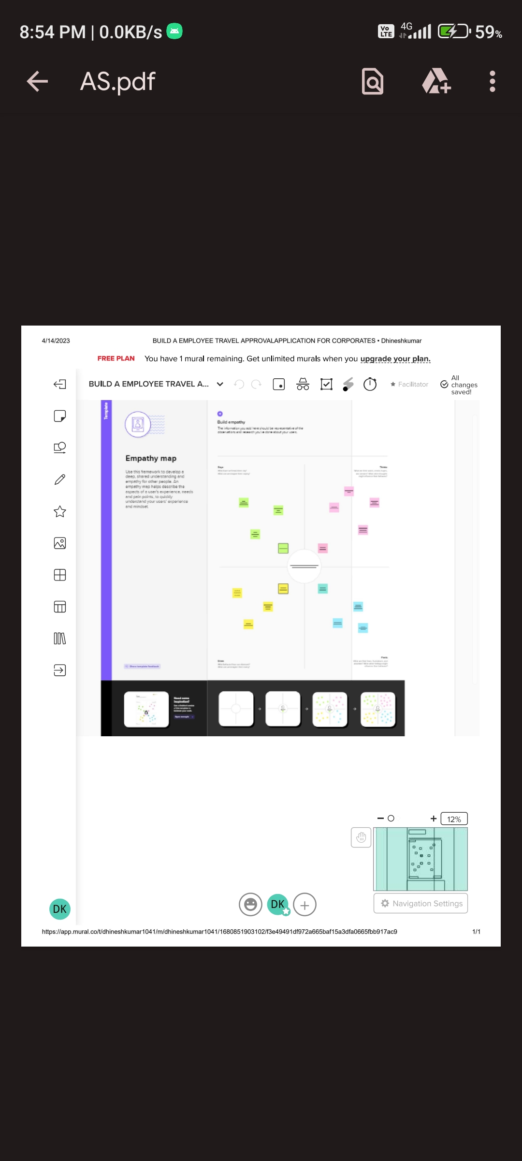

**2.2 Brainstorming :**

Brainstorming is a group problem-solving method that involves the spontaneous contribution of creative ideas and solutions. This technique requires intensive, freewheeling discussion in which every member of the group is encouraged to think aloud and suggest as many ideas as possible based on their diverse knowledge.

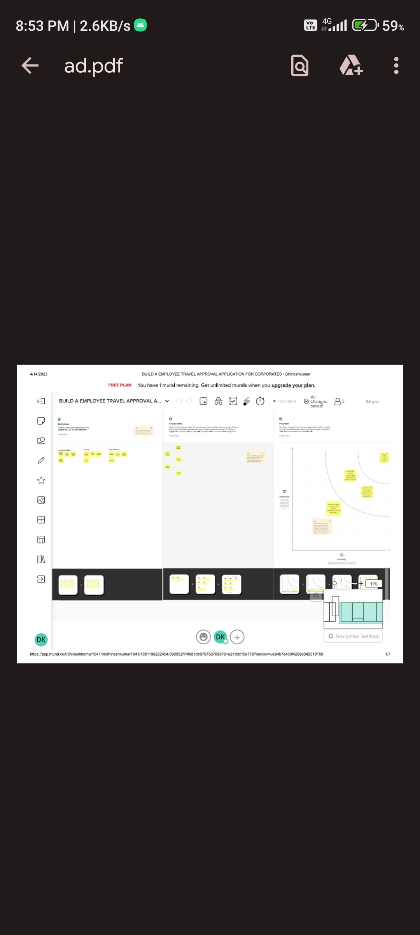

**3. RESULT**

**3.1 Data Model :**

|  |  |  |  |  |
| --- | --- | --- | --- | --- |
| Object name | Fields in the object | | | |
| Account |  | | | |
|  | Field label | Data type |  |
| Travel Approval | Lookup |  |
| Account |  | | | |
|  | Field label | Data type |  |
| Expense type  field | picklist |  |

**3.2 Activity & Screenshort :**

**report**

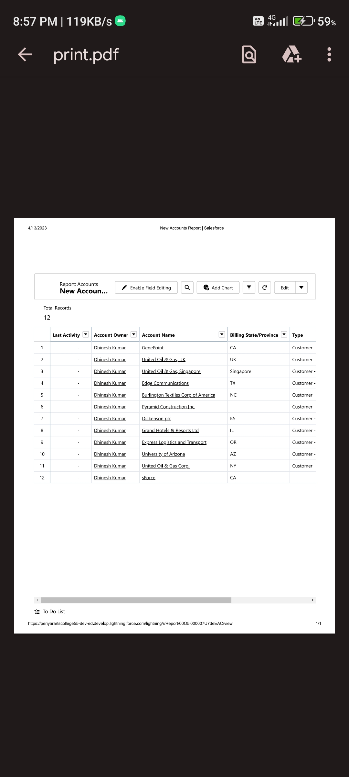

**dashboard**

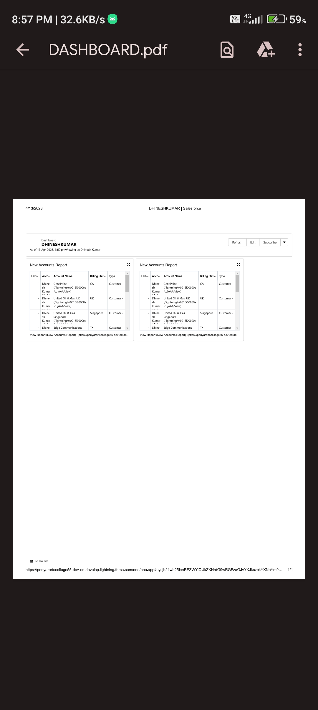

**4. TRAILHEAD PROFILE PUBLIC URL**

Team Leader – <https://trailblazer.me/id/dkumarafra>

Team Member 1 - <https://trailblazer.me/id/ksingaravel>

Team Member 2 - <https://trailblazer.me/id/jbalan20>

# Advantages & Disadvantages:

Due to a rapid boom in technology and evolution in business ventures, one has to international corporate travel around the world. Some choose to go on their own and some opt for corporate travel consultant or corporate business travel for assistance to have a comfortable and safe trip.

The motivation can be either incentives, promotion or just traveling but what was once called a business travel, is now more or less a fun solo vacation. The travel expense is mostly covered, the hotel stay is paid for, and all the meals are paid for. However, there is more to traveling than expenses and money.

Here are a few benefits of traveling for work

Meeting new people: On a business trip, it is hard to expect anything because it is a new country, a new language, a new world altogether. It might get a little complicated with the whole new atmosphere, but eventually, you will start meeting so many people with different backgrounds which will provide a sense of oneness

even on a business trip. It might as well help you form a long-lasting relationship with a stranger in some other country.

Limited expense traveling: When people get a chance to travel for work, it is mostly an all expense vacation, especially on business. Expenses covered would include the hotel costs, all the meals ((breakfast, lunch, and dinner) for a period of time. Not many get an all-expense business trip, but you are one such executive, cheers.

Unfortunately, with the benefits come the downsides. Work can get to you; time and money can bother you; jetlags, unhealthy food and stay, just to name a few can get on your nerves when everything is on a tight schedule.

Here are a few disadvantages of traveling:

Sleeping: Jetlags can be one of the reasons, but not everyone is blessed to sleep everywhere and anywhere. Staying awake in the hotel room is one of the common traits of a business traveler. Be it a for a short or long business trip, it does take some time to get accustomed to the time zones.

Stay: Unless and until the business trip is planned through a corporate travel consultant, finding the right hotel room will be a challenge.

From a travel perspective, the benefits by far outweigh the downsides. But again it depends on where, why and how you are traveling to other countries. Although, if you are offered an all-expense paid opportunity to travel for a week or two, I’d recommend taking advantage of the opportunity.

# Applications:

This tutorial explains how to use the travel approval sample application.

The Travel Support System (this is the name that you can see on the screen when executing the application) is a small sample application for NaturalONE. As a sample application, its focus is to show NaturalONE functionality rather than being a full-fledged travel support application.

The Travel Support System (TSS) allows you to request and approve business trips. Flights, hotels and even more external information such as cell phone expenses or car rentals can be entered with the trip request. For the destination, weather information can be queried. A manager can do both, request own trips as well as approve trips that have been requested by employees. After the manager has approved single or multiple requests, the manager can print an itinerary or receive the itinerary as a PDF file.

# Conclusion:

In this project we learnt about,

* To create custom objects
* To create field and relationships
* To create tabs
* To create import departments
* To create customize user interface
* Use customization
* To create validation rule
* Roll up summary fields
* Reports and dashboards

# Future Scope:

The Scope of Travel agencies in the futures is likely to change due to several factors, including the on going covid 19 pandemic and the growth of online travel booking platform .

Many travel agencies have to had to adapt their business models to focus an online bookings virtual tours, and some have closed permanently.

However there is still a market for travel agencies that specialize in niche areas, such as luxury travel or adventure travel.

According to international data corporation , the salesforce economy is set to create 1.9 million direct and indirect job by 2024 .

*************************************