**Biosensors (BE5435) – Assignment 2**

*Home use blood glucose sensing strips are used by millions every day. These strips represent convergence of various technologies to manufacture disposable biosensors with clinically acceptable accuracy and sensitivity.*

*Identify the primary bio sensing components of home use blood glucose strip provided to you. Take a close up picture of the strip and point to each component and briefly describe form and function of the component.*

Introduction:

**Blood glucose monitoring** is a way of testing the concentration of [glucose](https://en.wikipedia.org/wiki/Glucose) in the blood ([glycemia](https://en.wikipedia.org/wiki/Blood_sugar" \o "Blood sugar)). Particularly important in the care of [diabetes mellitus](https://en.wikipedia.org/wiki/Diabetes_mellitus), a blood glucose test is performed by piercing the [skin](https://en.wikipedia.org/wiki/Skin) (typically, on the finger) to draw blood, then applying the blood to a chemically active disposable 'test-strip'. Different manufacturers use different technology, but most systems measure an electrical characteristic, and use this to determine the glucose level in the blood. The test is usually referred to as capillary blood glucose.

Specifications:

TRUE track Blood Glucose Test Strip is the brand of the provided sensor. The specifications provided by the company are

* It has beveled tip for exceptional sample precision and first-test success.
* Small, one microliter blood sample is enough to detect the glucose level.
* Compatible with TRUE track blood glucose meter.
* High and low control solution available.

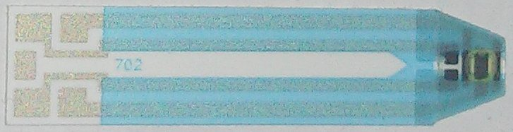

**Figure 1: Close up photo of the Glucose sensor strip**

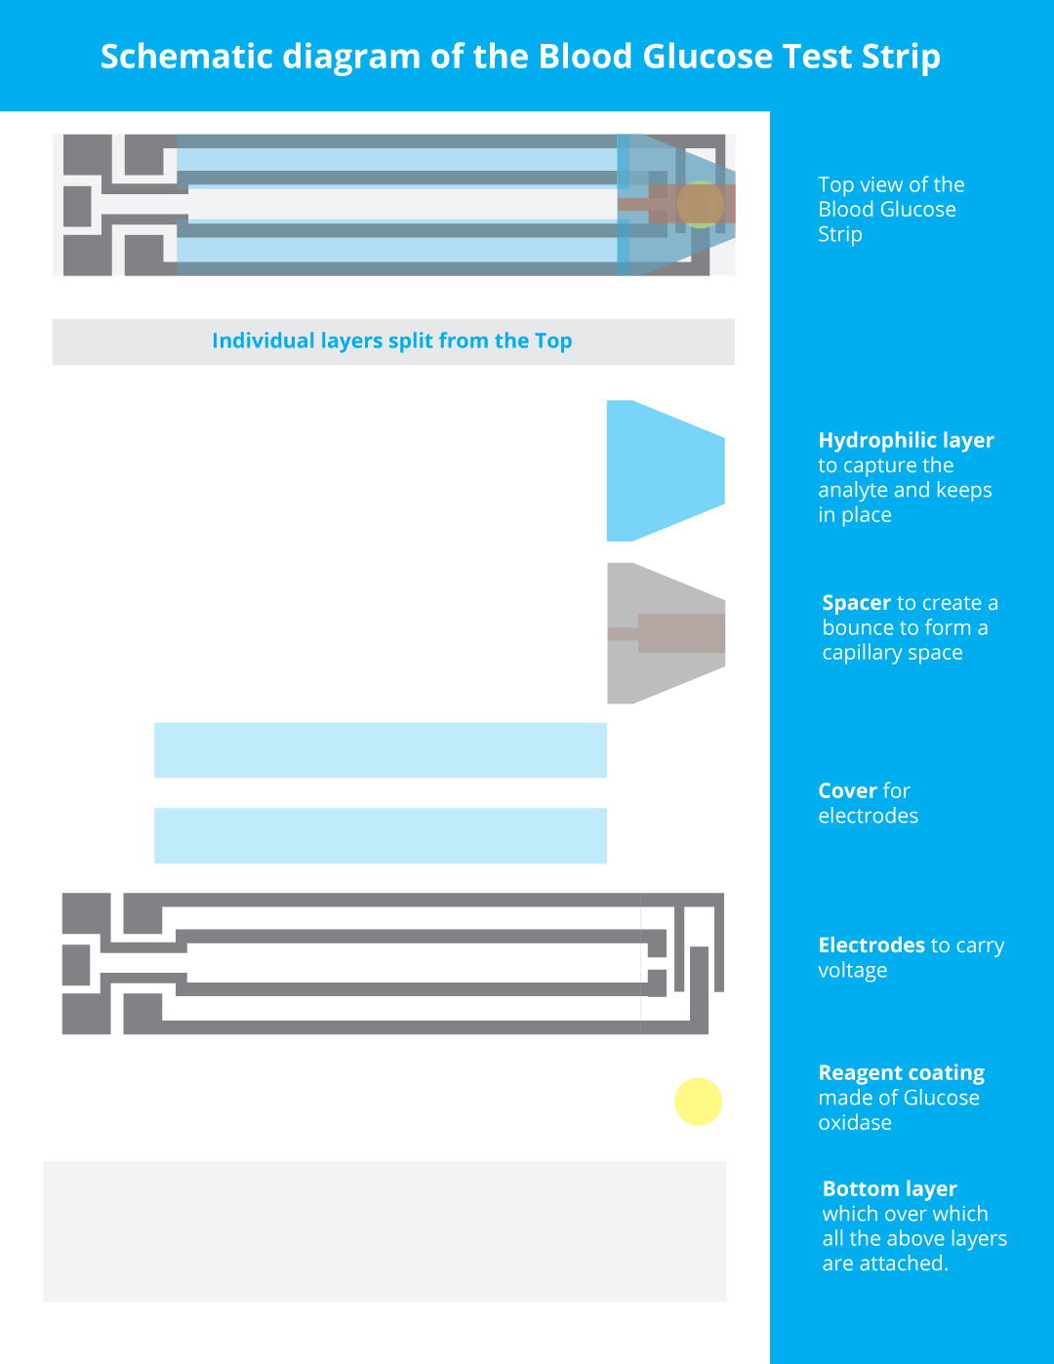

**Hydrophilic layer** which is the top most layer helps in keeping the analyte in position

**Spacer** which a thick layer helps in formation of the capillary space with the bottom substrate layer.

**Cover for electrodes** which helps in preventing short circuiting of the electrodes by human interaction.

**Electrodes** which are the carriers of the current change occurring in the enzyme portion to the Analog and Digital Convertor. Here there are two set of electrodes.

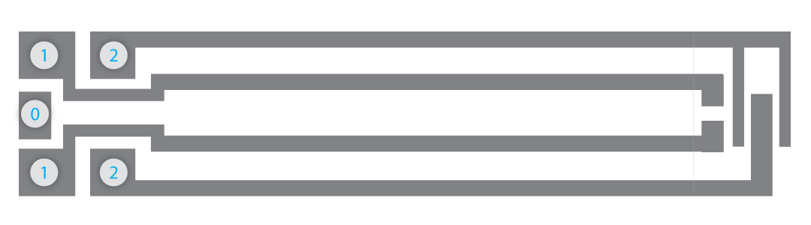

Electrode 0: Reference electrode

Electrode 1: Both the electrodes are used to make sure the capillary space is filled enough to carry out the chemical reactions and measure the potential difference. Once the capillary space is filled it will reach the end of opened electrodes which will create a closed circuit so that it will then pass current to the Electrode 2 and hence further electrochemical reaction will takes place.

Electrode 2: These electrodes will hold the actual transducer enzyme which upon reaction with the glucose in the blood will create the potential change which will be the measure of blood glucose level

**Reagent coating** which is usually made up of Glucose oxidase which is spread between two electrodes, so that the change in the potential can be measured.

Working:

Glucose sensor strips primarily uses two types of measurement process. They are Colorometric method and Amperometric method.

This sensor uses Amperometric method to measure the Glucose level. The basic principle behind this method is Electro chemical reaction. Amperometric biosensors function by the production of a current when a potential is applied between two electrodes.

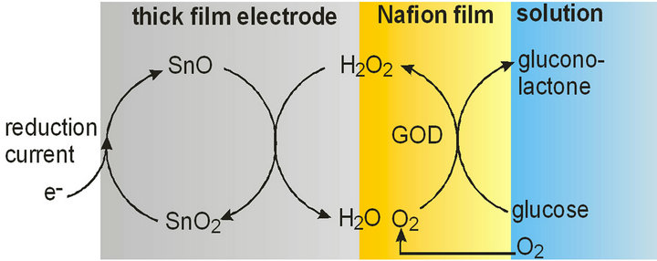

Figure 3

The above figure explains the interaction of Glucose in the blood with the transducer enzyme which on chemical reaction will result in reduction current which will be measured. The variation from the initial current will give the measure of glucose level in the blood. The current produced with blood glucose will be in proportion with the amount of chemical reaction that takes place with the enzyme.

**Bottom layer** which is mostly made of plastic or fiber in most cases. It will be hydrophilic, good enough to hold the transducer enzyme.