**Biosensors (BE5435) – Assignment 3**

*Optical transduction method is widely used in biosensing. A number of home use biosensing strips utilize optical transducers to qualitatively or quantitatively detect biomolecules in bodily fluids. Typically, these biosensing strips utilize colorimetric (absorption or fluorescence) optical biosensing methods in which color change occurs in proportion to the concentration of the analyte in the bodily fluid.*

*An example of home use biosensing strip is a urine ketone testing strip. The active substrate on the strip changes color in proportion to ketone level in sample urine. You were given a ketone testing strip and accompanying segmented (discrete) color chart provided by the manufacturer to semi-quantitatively measure ketone level.*

*Your task is to convert the segmented color chart into a continuous and quantitative color chart using the processing method discussed in class. Plot the colorimetric response curve (color signal vs concentration).*

**Introduction**

Testing urine for ketones is a quick and easy way to determine if you are at immediate risk for [diabetic ketoacidosis (DKA)](http://www.diabetesforecast.org/diabetes-101/diabetic-ketoacidosis.html). This can occur when people with Type-I diabetes don’t take insulin for long periods of time, when insulin pumps fail to deliver insulin and the wearer does not monitor blood glucose, or during serious illness (in type 1 or [type 2](http://www.diabetesforecast.org/diabetes-101/type-2-diabetes.html)) when insulin doses are missed or not increased appropriately for the stress of illness. Without enough insulin, the cells in the body can’t absorb glucose and go into starvation mode, breaking down fats for energy. Ketones are a by-product of fat breakdown, and high levels can be toxic. Ketone testing strips check for the presence in urine of one type of ketone, called acetoacetic acid.

Task:

clc  
close all  
clear all  
%Reading the color chart  
color_chart=imread('color_chart.jpg');  
figure(1);  
imshow(color_chart),title('Color chart');  
whos;  
red = color_chart(15,1:240,1);  
figure(2)  
plot(red,'r--'),xlabel('color signal'),ylabel('concentration'),title('Response chart');  
hold on;  
blue = color_chart(15,1:240,2);  
plot(blue,'b');  
hold on;  
green = color_chart(15,1:240,3);  
plot(green,'g--');

Name Size Bytes Class Attributes  
  
 color_chart 30x240x3 21600 uint8

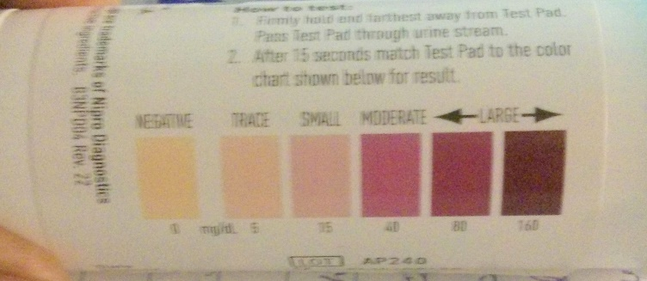

Picture of test kit



cropped and processed in photo shop

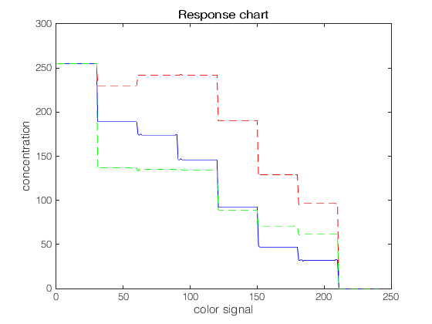

**How do I test?**

Get a sample of your urine in a clean container.

Place the strip in the sample (you can also pass the strip through the urine stream).

Gently shake excess urine off the strip.

Wait for the strip pad to change color. The directions will tell you how long to wait.

Compare the strip pad to the color chart on the strip bottle. This gives you a range of the amount of ketones in your urine. Record your results.