OPTIC: A Rapid and Efficient Semi-automated Toolbox for Multicellular Calcium Imaging Analysis

Noriaki Fukatsu¹, Yuta Tanisumi², Dennis Cheung², Yutaro Saito¹, Akari Hashimoto^{1,2}, Nana Takahashi^{1,2}, Ikuko Takeda¹, Mio Inoue¹, Hiroaki Wake^{1,2,3,}

¹ | Department of Anatomy and Molecular Cell Biology, Nagoya University Graduate School of Medicine, Nagoya, 466-8550, Japan.
² | Division of Multicellular Circuit Dynamics, National Institute for Physiological Sciences, Okazaki 444-8585, Japan.
³ | Department of Physiological Sciences, Graduate University for Advanced Studies, SOKENDAI, Hayama, 240-0193, Japan.
*Correspondence:
Hiroaki Wake, M.D., Ph.D.
Department of Anatomy and Molecular Cell Biology, Nagoya University Graduate School of Medicine, Tsurumai-cho 65, Showa-ku, Nagoya, Japan. Telephone: +81-52-751-2003 Fax: +81-75-751-2003
E-mail: wake.hiroaki.r9@f.mail.nagoya-u.ac.jp

Summary
Two-photon imaging enables deep tissue visualization of neural activity and cellular dynamics in living tissue, generating exponentially increasing volumes of neuroscience data, which necessitate the development of efficient and scalable analysis tools. Although existing tools, including Suite2p, automate the extraction of regions of interest (ROIs), downstream validation and multisession tracking remain manual processes. We present an optimized toolbox for image-based cellular analysis (OPTIC), a comprehensive Python-based toolkit comprising three specialized graphical user interface (GUI) applications: OpticROICuration for ROI classification, OpticROITracking for automated cross-session tracking, and OpticRawTracking for analyzing microglial dynamics. OPTIC integrates advanced libraries for image registration and optimal transport-based ROI matching, enabling automated and accurate tracking across imaging sessions. We validated OPTIC using two-photon calcium and microglial imaging data from mice, demonstrating higher accuracy than commonly used existing approaches (CellReg and TrackMate). OPTIC features an intuitive GUI that is fully customizable and requires no programming expertise. OPTIC was released as open-source software for neuroscience research.

Keywords
graphical user interface, neuroscience data, two-photon imaging, cell tracking, microglia, image registration, optimal transport

Introduction
Observation of neuronal Ca²⁺ activity using in vivo 2-photon microscopy has become a standard workhorse technique in neuroscience research^{1, 2, 3}. Key advantages of this method include its minimal invasiveness and its ability to monitor the activity of hundreds of neurons simultaneously. These characteristics make longitudinal tracking of neuronal circuit dynamics over days to months possible, albeit via periodic imaging sessions^{4, 5}.
However, matching corresponding neuronal ROIs (regions of interest) across imaging sessions remains a core bottleneck in such experiments. Even when the imaging window quality is well maintained (i.e., avoiding inflammation, swelling, bleeding, and lens fogging), minor session-to-session variations in factors such as head position and animal hydration are difficult to control. Although these introduce only subtle distortions in the field of view (FOV), this still markedly increases the difficulty of accurate ROI tracking.
At present, typical workflows heavily rely on manual curation to verify and match ROIs extracted by automated tools such as Suite2p⁶ and CaImAn⁷, or by specialized methods for morphologically complex structures such as GraFT⁸. As the scale of data continues to increase exponentially^{9, 10}, manual intervention is becoming increasingly unfeasible, time-consuming, and prone to user-dependent biases that impair reproducibility^{11, 12, 13, 14, 15}. Indeed, the continued technological advancement in large-scale and ultra-high-speed imaging will only exacerbate this problem^{16, 17}. While computational tools such as CellReg¹⁸ and TrackMate¹⁹ exist for ROI matching, they were not specifically designed with the unique challenges of longitudinal multi-session Ca²⁺ imaging in mind. Consequently, their performance is often suboptimal, particularly when dealing with the significant representational drift and complex morphological inconsistencies inherent in such datasets^{20, 21}.
To address these limitations, we developed the new automated analysis platform OPTIC (Optimized Toolbox for Image-Based Cellular Analysis). Our approach utilizes a sequential workflow that first addresses geometric misalignment followed by mathematical matching. We use the ITKElastix package^{22, 23} to perform rigid, affine, or b-spline transformations to correct for physical brain distortions, effectively warping the field of view from two different sessions into a similar geometry. We then use the Python Optimal Transport package²⁴ to identify the globally optimal correspondences between ROIs by minimizing the total transportation cost between cell centroids. Finally, to facilitate ROI matching across multiple (more than two) sessions, we use a novel graph theory-based algorithm to resolve ROI identity inconsistencies.
OPTIC is designed to function as a downstream processing step that integrates directly with established ROI identification and curation platforms like Suite2p⁶ and CaImAn⁷. Once ROIs have been extracted and verified through these existing pipelines, OPTIC handles the subsequent cross-session registration and matching. Furthermore, this approach is robust enough to be adapted for tracking axonal boutons and morphologically complex non-neuronal cells (astrocytes and microglia) in addition to standard neuronal somas. We have packaged these capabilities into a single software suite with a graphical user interface (GUI), ensuring these independent analysis tools are accessible within a unified environment.

Results

Overview of OPTIC’s workflow
OPTIC utilizes a five-step workflow to match corresponding regions of interest (ROIs) across separate calcium-imaging sessions of the same field of view (FOV) (Figure 1A):
(1) ROI import, where ROIs from two imaging sessions are imported, typically from Suite2p or CaImAn outputs.
(2) Curation, where users can optionally review and quality-control imported ROIs (e.g., by inspecting Ca²⁺ activity and its alignment with experimental events) and assign user-defined metadata tags (e.g., cell type) for downstream analysis.
(3) Image registration between sessions, where geometric alignment of imaging sessions is performed through various geometric transformation methods.
(4) ROI identity assignment, where corresponding image registered ROIs are matched using optimal transport theory.
(5) Multi-session alignment, where pairwise ROI matches across multiple imaging sessions are evaluated for identity consistency, and inconsistencies are resolved using a graph theory framework.
The key principles that inform the design of OPTIC’s user experience are accessibility for users with limited coding experience, direct compatibility with established Ca²⁺ imaging analysis platforms (Suite2p and CaImAn), and the option to sanity-check (where relevant) and manually correct data. Accordingly, OPTIC includes a graphical user interface (GUI) wrapper around the first four workflow steps, allowing users to directly visualize, inspect, and interrogate the data.

ROICuration module: Data import and curation
In OPTIC’s ROICuration module, ROI profile maps and Ca²⁺ trace files (Suite2p⁶: Fall.mat; CaImAn⁷: *.hdf5) from an imaging session are imported via a GUI (Figure 1B and Figure S1A), together with its static background images (*.tiff, up to two channels) and frame-length matched experiment/behaviour event logs (*.npy, Boolean NumPy arrays in Suite2p format). The data are visualized across three panels: View (middle), Canvas (left), and Table (right) (Fig S1).
The Canvas panel displays the selected ROI’s Ca²⁺ trace in a three-tiered layout (Figure S1B). The top tier allows zooming and panning for detailed waveform inspection. The middle tier shows the full-session trace. The bottom tier presents time-aligned event logs (0 = no event, 1 = event). This facilitates identification of ROIs with event-correlated activity. The View panel overlays ROI profile maps with background images. This enables assessment of ROI boundary accuracy (main channel, green), and inference of cell type through co-localization with structural markers (optional channel, red) (Figure S1C). Brightness and contrast are independently adjustable for each channel. Individual ROIs are selected via mouse interaction. The Table panel supports ROI metadata annotation using radio classification buttons, check boxes and a free text memo field. Its structure is customizable, allowing additional columns to be defined to suit experimental needs (Figure S1D). These ROI metadata are saved as a “ROICuration~.mat” file, with automatic version history recording timestamps and usernames for reproducibility and traceability.

ROITracking module: Image registration and ROI matching
In OPTIC’s ROITracking module, ROI profile maps (Suite2p: Fall.mat; CaImAn: *.h5) from two imaging sessions are imported via a GUI (Figure 1C and Figure S2A), together with their static background images (*.tiff, main channel only). The data are visualized in side-by-side panels, with the earlier- and later-acquired sessions displayed on the left and right, respectively. ROI profile maps are overlaid onto their corresponding background images, with each ROI uniquely color coded and numbered. By convention, the earlier and later sessions are referred to as “primary” and “secondary,” respectively.
Corresponding primary and secondary ROIs are matched in a two-step process:
(1) Image registration, where the secondary background image and ROI profiles are registered against the primary session through geometric transformations.
(2) ROI matching, where the transformed secondary ROI centroids are matched to the primary ROI centroids using an optimal transport algorithm.
Following this, the primary panel is updated with the transformed secondary image (red) and ROIs (uniform blue) overlaid onto the primary view, where the primary background (green) and ROIs retain their original color coding (Figure 2A). Matched ROIs are connected by white lines for immediate visual confirmation and listed in an automatically appended "Cell ID Match" column of the ROI metadata table (Figure 2B). The metadata table can optionally inherit existing annotations by importing a previously saved ROICuration~.mat file. Users can manually override ROI matches in the table, with updates immediately reflected in the primary panel.

Image registration methodology and performance assessment
OPTIC’s ROITracking module uses the ITKElastix toolbox (Python implementation)^{22, 23}, to perform separate registration of background images and ROI profiles. Three transformation approaches of increasing complexity are available: rigid, affine, and B-spline (Figure 2C). Rigid transformation incorporates translation, rotation, and scaling while preserving ROI morphology, making it suitable for datasets with minimal deformation of individual ROIs between acquisitions, but some uniform FOV shift. Affine transformation extends this model by incorporating shearing and non-uniform scaling, enabling correction of geometric distortions such as those introduced by variations in head angle or imaging plane orientation. B-spline transformation allows flexible, non-linear local deformations, making it suitable for correcting complex tissue changes such as compression or expansion. For all transformation types, OPTIC’s ROITracking module provides a configuration GUI for tuning parameters such as iteration count, spatial sampling density, and penalty coefficients.
To visualize and evaluate the different transformation approaches to image registration, we analysed representative neuronal Ca²⁺ imaging data from mouse cortex across two imaging sessions separated by ≈ 2 to 3 weeks (Figure 2C). The three different geometric approaches were visualized by a deformation field analysis, which represents the transformation as two-dimensional displacement vectors at each pixel. For visualization, vectors were averaged over 8 × 8 pixel blocks (Figure 2D). Rigid and affine transformations produced largely uniform deformation patterns, typically showing consistent directional shifts across the image, indicative of global misalignment. In contrast, B-spline transformation produced spatially heterogeneous deformation patterns, capturing localized distortions with high granularity (Figure 2D).
Registration accuracy was quantitatively evaluated using Pearson’s correlation coefficients between the unaltered primary and transformed secondary images, where a coefficient of 1 indicates perfect spatial alignment. Across 27 session pairs from six mice, mean correlation coefficients were 0.608 ± 0.027 (unregistered), 0.652 ± 0.024 (rigid), 0.691 ± 0.023 (affine), and 0.757 ± 0.028 (B-spline) (Figure 2F). When averaged per mouse, the values were 0.614 ± 0.037, 0.658 ± 0.027, 0.703 ± 0.027, and 0.767 ± 0.033, respectively (Figure 2E). These results demonstrate that B-spline transformation consistently achieves the highest registration accuracy, followed by affine and rigid transformations.
Although B-spline transformation achieved the highest accuracy, its nonlinear deformation can alter ROI shapes. To assess this effect, we compared ROI properties before and after B-spline registration (Figure S3A). Several Suite2p-derived metrics, including compactness, aspect ratio, standard deviation, and skewness, showed substantial changes after registration. These findings indicate that recalculating ROI parameters from registered images would introduce bias into the original physiological signals. Therefore, OPTIC retains these ROI parameter values extracted from the unregistered images and uses registration solely for cross-session ROI matching.
We benchmarked OPTIC against PatchWarp²⁵, a currently available registration tool for Ca²⁺ imaging data. PatchWarp performs two-stage registration using a global Euclidean transformation followed by affine transformations applied to small image subfields, referred to as "patches". Overall, OPTIC (rigid, affine, and B-spline with parameter tuning) achieved higher registration accuracy than PatchWarp (Figure S4A–S4D). While PatchWarp successfully registered with some session pairs, it occasionally produced substantial misalignments, thus lowering its overall performance. OPTIC also scored well when assessed by PatchWarp metrics: mean correlation with mean image (mCM) and mean max intensity difference (mMD) (Figure S5A–S5D). mCM quantifies the correlation between registered frames and the mean image, whereas mMD measures the reduction in intensity differences after registration. OPTIC also provides an optional data quality assessment feature, which helps detect substantial changes in ROI patterns across sessions caused by issues such as z-axis displacement (Figure S6).

ROI matching methodology and performance assessment
ROI matching in OPTIC’s ROITracking module is based on optimal transport theory, computing the minimal mapping cost between primary (unaltered) and secondary (transformed) ROI centroids. This is implemented using the “OT_partial” algorithm from the Python Optimal Transport (POT) package²⁴. OT_partial transports only a fraction (m) of the total “mass”, making it suitable for multi-session Ca²⁺ imaging data where ROI counts may vary between sessions. Downstream to OT_partial, additional processing steps exclude one-to-many and many-to-one assignments, ensuring one-to-one correspondence between primary and secondary ROIs as described below.
In ROI matching, which follows ITKElastix registration, a Euclidean distance matrix is first computed from the centroid coordinates of all possible primary-secondary ROI pairs. Pairs separated by more than a user-defined threshold (e.g., 10 pixels) are considered biologically implausible and are reassigned a prohibitive cost of 1.0×10¹². This modified matrix quantifies the spatial proximity between primary (unaltered) and secondary (transformed) ROIs after geometric alignment into a common coordinate space. Next, this matrix serves as the ground cost for the OT_partial algorithm, which computes a transport plan that minimizes the aggregate cost to establish optimal ROI correspondences. Finally, post-processing extracts matching pairs, enforcing one-to-one correspondence by retaining only the lowest-cost assignment per ROI. ROIs without valid matches are left unassigned.
Whether this approach is robust or hypersensitive to variations in ROI properties and parameter choices is a critical consideration. Sensitivity to ROI centroid jitter arising from session-to-session differences in ROI morphology (due to imaging quality) was evaluated. A representative example shows ten neuron-classified ROIs (Suite2p) within a 180×180 pixel field of view that were accurately tracked by OT_partial in multiple image sessions over a 20-day period, as confirmed by blinded manual verification (Figure 3A). ROI tracking performance was also stable across a range of distance thresholds and mass parameters, with degradation observed only at extreme values (Figures S7A–S7D). Somewhat surprisingly, different optimal transport implementations achieved comparably high performance as compared to OT_partial (Figures S7E–S7F). Finally, high accuracy was still maintained in some densely populated datasets, with no significant relationship between the ROI count and tracking performance (Figures S8A–S8F), supporting the robustness of the approach.
Subsequently, OPTIC was benchmarked against previously published tools, CellReg¹⁸ and TrackMate¹⁹. CellReg is designed specifically for Ca²⁺ imaging ROI tracking, whereas TrackMate is a general-purpose object tracking tool. All three platforms were evaluated using a neuronal Ca²⁺ imaging ground truth dataset comprising 21 session pairs from five mice (3–4 sessions each). Ground truth correspondences were defined for all ROIs reliably tracked across sessions through careful manual annotation (2079 ROIs in total). Performance was assessed using recall, precision, and F1 score (the harmonic mean of precision and recall).
OPTIC, CellReg and TrackMate achieved the following F1 scores of 0.940 ± 0.032, 0.444 ± 0.169, and 0.210 ± 0.038; recall values of 0.962 ± 0.025, 0.460 ± 0.188, and 0.191 ± 0.026; and precision values of 0.921 ± 0.041, 0.535 ± 0.148, and 0.261 ± 0.055, respectively (Figure 3B). Similarly, session-pair analysis yielded F1 scores of 0.943 ± 0.009, 0.585 ± 0.061, and 0.398 ± 0.041; recall values of 0.970 ± 0.009, 0.572 ± 0.072, and 0.475 ± 0.062; and precision values of 0.918 ± 0.012, 0.719 ± 0.052, and 0.404 ± 0.035, respectively (Figure 3C). Pairwise t-tests with Bonferroni correction confirmed that OPTIC outperformed both comparative tools across all metrics with statistical significance. These results demonstrate that OPTIC provides a substantial improvement in ROI tracking accuracy and robustness over existing tools.
OPTIC was developed primarily using Suite2p outputs, but it is also compatible with other ROI extraction pipelines. We further verified that OPTIC achieves consistent tracking performance using ROIs extracted by CaImAn instead of Suite2p (Figures S9A-S9E).

Graph-based multi-session ROI alignment
OPTIC’s multi-session alignment module integrates pairwise ROI matches from the ROITracking module into consistent ROI identities across three or more imaging sessions using a graph theory-based framework. For a dataset consisting of N imaging sessions, the ROITracking module is first applied to every session pair, yielding N(N−1)/2 pairwise matches. The framework then translates these pairwise matches into a graph representation, where each ROI in each session is represented as a node, and each matched ROI pair is represented as an edge connecting the corresponding nodes. This generates multiple independent subgraphs, where each node within a given subgraph necessarily originates from a different imaging session. Consequently, each candidate ROI identity tracked across multiple sessions is represented by a single subgraph, while ROIs with no inter-session matches appear as isolated nodes.
ROI subgraphs are then evaluated for internal consistency based on the principle of logical transitivity (Figure S10A-S10B). Ideally, each subgraph forms a complete graph wherein every node is directly connected to every other node by a verified edge. Missing edges indicate a candidate ROI identity fails to be maintained consistently across all imaging sessions. This arises from either a ROI identity-switch mismatch or a false-positive match to noise artefact in at least one of the pairwise comparisons between imaging sessions. Importantly, the absence of a ROI in a given imaging session does not affect graph completeness but only reduces the number of nodes in the subgraph.
Finally, complete graphs are consolidated in a tracking table where each row represents a single ROI identity and each column corresponds to an imaging session. Entries contain the ROI ID for that session, with a null value (-1) indicating absence of the ROI in that session. Because only complete subgraphs are retained, the table includes only ROIs with fully consistent correspondences, while still allowing for transient absence across sessions.

Axonal bouton tracking using OPTIC
Although originally developed for Ca²⁺ imaging in neuronal somas, OPTIC should theoretically be applicable to any ROI-tracking context. However, its underlying mechanics have specific edge-case sensitivities that may be exacerbated by certain data characteristics. Image registration by ITKElastix relies on hierarchical alignment across multiple resolution scales involving recursive downsampling and Gaussian blurring. As such, small or dim structures risk being averaged into the background and ignored during registration. Separately, the Optimal Transport algorithm is less robust to outliers when applied to sparse distributions. While earlier characterization showed no correlation between ROI density and tracking accuracy (Figure S8A-S8F), even the “sparse” datasets here are relatively dense by comparison.
Thus, to rigorously evaluate OPTIC’s performance across more challenging ROIs, benchmarking was repeated using a ground-truth axonal bouton Ca²⁺ imaging dataset (Figure 4A-4B) – a context specifically chosen to exploit identified weaknesses regarding signal intensity and spatial sparsity. This dataset comprised 21 session pairs derived from six mice (3-4 sessions each). Ground-truth correspondences were defined for all ROIs reliably tracked across sessions through careful manual annotation (963 ROIs in total).
OPTIC’s registration accuracy was quantitatively evaluated using Pearson’s correlation coefficients. When averaged per mouse (n=6), mean correlation coefficients were 0.172 ± 0.045 (unregistered), 0.476 ± 0.052 (rigid), 0.511 ± 0.049 (affine), and 0.552 ± 0.031 (B-spline) (Figure 4C-4D). When all 21 session pairs were pooled, these values were 0.162 ± 0.025, 0.479 ± 0.031, 0.512 ± 0.030, and 0.592 ± 0.021, respectively (Figure 4E).
OPTIC’s ROI matching was benchmarked against CellReg and TrackMate by calculating F1 scores, recall, and precision. When averaged per mouse (n=6), OPTIC, CellReg, and TrackMate achieved F1 scores of 0.974 ± 0.009, 0.208 ± 0.102, and 0.019 ± 0.019; recall of 0.981 ± 0.019, 0.196 ± 0.090, and 0.011 ± 0.011; and precision of 0.968 ± 0.015, 0.268 ± 0.160, and 0.056 ± 0.056, respectively (Figure 4F). When all 21 session pairs were pooled, these values were F1 scores of 0.957 ± 0.007, 0.241 ± 0.058, and 0.122 ± 0.024; recall of 0.959 ± 0.012, 0.229 ± 0.058, and 0.088 ± 0.021; and precision of 0.956 ± 0.007, 0.343 ± 0.086, and 0.271 ± 0.054, respectively (Figure 4G). These results demonstrate OPTIC’s tracking performance remains robust even for challenging datasets.

Astrocyte tracking using OPTIC
One variable not captured by the preceding neuronal soma or axonal bouton Ca²⁺ imaging datasets is the impact of complex ROI morphology. Compared to spherical cells, ROI profile reconstruction in morphologically complex cells is more sensitive to fluctuations in the signal-to-noise ratio, which can artifactually shift the estimated centroid. Moreover, Ca²⁺ activity in these cells is often spatially restricted at the subcellular level (e.g. localised to astrocyte processes or end-feet), further compromising ROI profile stability^{26, 27}. The resulting centroid jitter may affect OPTIC’s accuracy because the Optimal Transport matching algorithm, only considers a ROI’s centroid coordinates rather than its full spatial profile. While OPTIC effectively handles the modest centroid jitter observed in neuronal somas (Figure 3A), this instability is expected to be considerably more pronounced in morphologically complex cells like astrocytes.
Thus, benchmarking for OPTIC was repeated using a ground-truth astrocyte Ca²⁺ imaging dataset derived from Glt1^{GCaMP7/GCaMP7} transgenic mice²⁸. Due to neuronal expression leak, OPTIC’s ROICuration module was first used to exclude neuronal ROIs based on morphological and Ca²⁺ trace criteria (Figure 5A-5B). The cleaned dataset comprised 15 session pairs derived from five mice (3 sessions each). Ground-truth correspondences were defined for all astrocyte ROIs reliably tracked across sessions through careful manual annotation (1856 ROIs in total).
OPTIC’s registration accuracy was once again quantitatively evaluated using Pearson’s correlation coefficients. When averaged per mouse (n=5), mean correlation coefficients were 0.843 ± 0.032 (unregistered), 0.901 ± 0.012 (rigid), 0.906 ± 0.013 (affine), and 0.933 ± 0.016 (B-spline) (Figure 5C). When all 15 session pairs were pooled, these values were 0.843 ± 0.022, 0.901 ± 0.014, 0.906 ± 0.014, and 0.933 ± 0.013, respectively (Figure 5D).
OPTIC’s ROI matching was again benchmarked against CellReg and TrackMate by calculating F1 scores, recall, and precision. When averaged per mouse (n=5), OPTIC, CellReg, and TrackMate achieved F1 scores of 0.951 ± 0.022, 0.462 ± 0.167, and 0.112 ± 0.061; recall of 0.984 ± 0.016, 0.419 ± 0.174, and 0.077 ± 0.043; and precision of 0.921 ± 0.030, 0.630 ± 0.165, and 0.210 ± 0.110, respectively (Figure 5E). When all 15 session pairs were pooled, these values were F1 scores of 0.946 ± 0.010, 0.547 ± 0.096, and 0.177 ± 0.023; recall of 0.976 ± 0.009, 0.504 ± 0.099, and 0.138 ± 0.021; and precision of 0.919 ± 0.013, 0.689 ± 0.088, and 0.303 ± 0.053, respectively (Figure 5F). These results demonstrate OPTIC’s tracking performance remains robust even for cells with complex morphologies.
Furthermore, the ROITracking module supports dual-channel calcium imaging, enabling users to select which channel to use for registration. We validated this functionality using simultaneous imaging of neurons and astrocytes in separate channels, demonstrating that OPTIC achieves high tracking performance in both channels (Figures S11A-S11E).

Modifying OPTIC for generalized-case ROI tracking
OPTIC’s robust performance against diverse and challenging Ca²⁺ imaging datasets indicates its potential as a universal tool for ROI tracking across any cell type. To realize this, OPTIC’s ROICuration and ROITracking modules were duplicated and integrated into a modified standalone OpticRawTracking module (Figure 1D and Figure S12A). Bidirectional compatibility with ImageJ was also added to support typical workflows in general ROI tracking.
Unlike the original modules, OpticRawTracking directly processes raw time-series imaging data (*.tiff, XYCT format) from the two imaging sessions to be compared, with the option to overlay additional associated background images (*.tif). ROIs can be extracted within OpticRawTracking manually via the GUI (akin to ImageJ), through Cellpose²⁹ models with fully adjustable parameters, or imported directly from ImageJ’s ROI Manager³⁰. Image registration is also more flexible, allowing either the main or an additional data channel to be used as the reference. All other aspects of the analysis workflow are essentially the same (Figure 6A-6B).
OpticRawTracking’s performance in general ROI tracking was evaluated using an in vivo microglia imaging ground truth dataset derived from Cx3cr1e^{GFP/+} transgenic mice³¹. Microglia were visualized through their expression of eGFP (main channel, green), while vessel structures were visualized using Texas Red dextran (optional channel, red). The dataset comprised 524 session pairs from 15 mice (8-9 sessions each). Ground-truth correspondences were defined for all microglia ROIs reliably tracked across sessions through careful manual annotation (7559 ROIs in total). Microglia were chosen as an authentic yet challenging dataset due to their high motility and dynamic, complex morphology.

OpticRawTracking module image registration performance
OpticRawTracking’s registration accuracy of microglial ROIs in the main channel was evaluated for two distinct cases where either the main channel (microglia) or the optional channel (blood vessels) was used as the reference. For rigid and affine transformations, both cases yielded comparable results achieving satisfactory alignment with broadly similar deformation patterns. For B-spline transformations, microglia-referenced registration achieved satisfactory alignment, whereas vessel-referenced registration introduced substantial misalignments. Moreover, B-spline transformations produced locally heterogeneous deformations, indicative of more complex spatial adjustments.
Subsequently, registration accuracy was again quantitatively evaluated using Pearson's correlation coefficients. When averaged per mouse (n=15), mean correlation coefficients for vessel-referenced (optional channel) registration were 0.217 ± 0.021 (unregistered), 0.554 ± 0.023 (rigid), 0.593 ± 0.020 (affine), and 0.436 ± 0.031 (B-spline) (Figure 6G). For microglia-referenced (main channel) registration, these values were 0.217 ± 0.021, 0.545 ± 0.023, 0.578 ± 0.021, and 0.613 ± 0.023, respectively (Figure 6I). When all 524 session pairs were pooled, mean correlation coefficients for vessel-referenced registration were 0.216 ± 0.006 (unregistered), 0.554 ± 0.006 (rigid), 0.593 ± 0.006 (affine), and 0.436 ± 0.009 (B-spline) (Figure 6H). For microglia-referenced registration, these values were 0.216 ± 0.006, 0.545 ± 0.007, 0.577 ± 0.007, and 0.612 ± 0.008, respectively (Figure 6J). Notably, similar registration effects were also observed on the vessel channel (Figure S13A-S13H).
Finally, the possibility that image registration might artifactually alter or obscure the true dynamics of microglia migration was evaluated using a session pair from one mouse within the larger dataset. This session pair underwent more intensive manual annotation to provide a ground truth of 137 microglia where the absolute migration distances for each microglia were manually measured. Cells with migration distances of 30 pixels or more were classified as moved (n=98), those with less than 30 pixels as unmoved (n=12), and those that could not be tracked between sessions as untracked (n=27) (Figure 6K).
The deformation vectors representing the spatial transformations applied during image registration were then compared at the ROI coordinates for the moved and unmoved groups. Hotelling's T² test was used to assess multivariate differences in vector patterns, accounting for both magnitude and direction. Analysis for rigid, affine, and B-spline transformations yielded p-values of 0.129, 0.129, and 0.428, respectively, showing no significant differences (P > 0.05) (Figure 6L). These results show that the transformation patterns applied to different groups of microglia did not differ significantly and thus did not artificially bias observed migration distances.

OpticRawTracking module ROI tracking performance
OpticRawTracking’s ROI matching for microglia soma in the microglia and vessel ground-truth dataset (13 mice, 452 session pairs after quality control) was benchmarked against CellReg and TrackMate by calculating F1 scores, recall, and precision. The impact of using either the main channel (OPTIC_MICROGLIA) or the optional channel (OPTIC_VESSEL) as the reference for image registration (affine) was also evaluated. When averaged per mouse (n=13), OPTIC_VESSEL, OPTIC_MICROGLIA, CellReg, and TrackMate achieved F1 scores of 0.902 ± 0.016, 0.906 ± 0.015, 0.340 ± 0.097, and 0.021 ± 0.010; recall of 0.829 ± 0.026, 0.839 ± 0.023, 0.289 ± 0.087, and 0.012 ± 0.006; and precision of 0.995 ± 0.004, 0.990 ± 0.005, 0.495 ± 0.119, and 0.092 ± 0.043, respectively (Figure 7A). When all 452 session pairs were pooled, these values were F1 scores of 0.903 ± 0.003, 0.902 ± 0.002, 0.501 ± 0.017, and 0.369 ± 0.009; recall of 0.834 ± 0.004, 0.839 ± 0.004, 0.468 ± 0.017, and 0.326 ± 0.008; and precision of 0.989 ± 0.001, 0.979 ± 0.002, 0.641 ± 0.017, and 0.495 ± 0.009, respectively (Figure 7B). Pairwise t-tests with Bonferroni correction confirmed that OPTIC outperformed both comparative tools across all metrics with statistical significance. Furthermore, the lack of significant performance differences between vessel-based and microglia-based registration indicates that using either channel for registration is robust for accurate ROI tracking.

Discussion
In this study, we introduced OPTIC, a novel and comprehensively validated platform for tracking ROIs across longitudinal sessions separated by days or weeks. Our results demonstrate that OPTIC significantly outperforms equivalent tools, providing a robust solution for maintaining ROI identity even when imaging is interrupted or non-consecutive and hence frequently impacted by non-uniform ROI locations. While OPTIC was initially developed to address the specific challenges of Ca²⁺ imaging, our validation confirms that its underlying architecture is robust enough for general-purpose ROI tracking across varied imaging modalities.

OPTIC’s underlying framework
OPTIC’s considerable outperformance of comparable tools may be attributed to its hierarchical approach to the cell registration problem. It deconstructs spatial misalignment into two distinct scales: large-scale global trends and fine-grained local jitter. While CellReg¹⁸ and TrackMate¹⁹ rely on a single mathematical framework to address all forms of spatial variance, OPTIC utilizes a dual-stage pipeline. Initially, ITKElastix^{22, 23} is employed to resolve macroscopic tissue drift and global misalignments. Following this global correction, Optimal Transport²⁴ is applied to manage local stochastic jitter. The use of Optimal Transport ensures that global geometric awareness is maintained even when making fine-scale local assignments, thereby mitigating the impact of localized outliers and preventing the stochastic errors frequently encountered in single-stage analysis approaches.
The different mathematical representation of ROIs by OPTIC compared to CellReg and Trackmate is also an important factor. CellReg utilizes a Bayesian framework based on the spatial correlation between ROI footprints. This approach is well suited for ROIs that maintain stable shapes across sessions, but performance can degrade when ROI patterns and morphology vary substantially, as demonstrated in our benchmarks using axonal boutons, astrocytes, and microglia, where OPTIC achieved markedly higher tracking accuracy. In contrast, TrackMate utilizes a Linear Assignment Problem (LAP) based on centroid coordinates. However, TrackMate does not include an image registration step, leaving session-to-session drift uncorrected. Because LAP relies on spatial proximity for matching, this uncorrected drift directly impairs cross-session tracking accuracy.
OPTIC occupies a unique “Goldilocks” zone by combining the computational economy of point-based tracking with the structural intelligence of global optimization. Like TrackMate, OPTIC matches ROIs using only their centroid coordinates, avoiding the heavy pixel-wise computation required by approaches like CellReg. However, OPTIC’s underlying mathematics diverges fundamentally from standard LAP. By treating the collection of centroids as a probability mass and minimizing the Wasserstein distance (transport cost), OPTIC handles ROI movement as a fluid geometric flow rather than a series of independent point-to-point links. Through the implementation of Partial Optimal Transport with a mass of 0.99 (m=0.99), the algorithm establishes a global noise budget. This allows OPTIC to identify and ignore the most suspicious 1% of matches as outliers, preserving the integrity of the remaining 99% based on the collective movement of the population. This hybrid architecture allows OPTIC to achieve high-precision ROI matching that is both robust against experimental noise and scalable for large-scale longitudinal datasets.

Key innovations
The technical innovation of OPTIC lies in its specific architectural implementation of the ITKElastix and Python Optimal Transport (POT) libraries. To minimize computational cost, OPTIC applies OT to ROI centroids rather than full pixel masks. This pivot to point-mass transport makes the framework’s hierarchical, two-step workflow essential. By using ITKElastix to first correct macroscopic spatial distortions, OPTIC ensures that the subsequent OT stage operates in a refined coordinate space, avoiding the local assignment errors that typically degrade tools like TrackMate.
To facilitate ROI tracking across multiple imaging sessions, OPTIC introduces a novel graph-theory-based approach. This framework is mathematically verified to ensure ROI identity consistency whilst also being immune to the common experimental issue of ROIs appearing or disappearing across sessions.
Finally, to confirm the reliability of the entire system, OPTIC was validated against a series of high-quality, manually curated datasets. These data were specifically designed to challenge the algorithm’s potential failure points, ensuring that OPTIC’s accuracy and robustness hold up under rigorous, real-world imaging conditions.

User friendly design
OPTIC’s modular design philosophy stems from the intent to complement and integrate with existing workflows rather than functioning as a closed application. As an extension for established packages like Suite2p⁶ and CaImAn⁷, it allows researchers to add ROI tracking capabilities to current pipelines with minimal friction. While initially developed for Ca²⁺ imaging, OPTIC has been additionally optimized and validated for general-purpose ROI tracking across various modalities. This versatility is supported by direct integration with ImageJ³⁰ and the use of Cellpose²⁹ for ROI extraction, providing a unified pipeline that connects initial image processing with longitudinal analysis.
OPTIC’s graphical user interface (GUI) lowers the technical barrier for adoption and provides the option for manual oversight at relevant stages of the analysis workflow. This allows users to quickly verify and correct parameter settings or tracking errors before committing to automated batch processing. By providing a simple way to fix isolated mistakes, the GUI enables users to refine results and adjust parameters for specific experimental needs without a programming background.
We offer the platform freely to users and welcome refinement and feedback. OPTIC organizes intermediate outputs into standardized dataset formats to simplify data curation and facilitate the use of downstream tools, such as deep learning models for ROI classification^{32, 33}. The inclusion of Jupyter Notebook files provides an interactive environment to facilitate users to adapt the workflow to specialized analyses, while maintaining a clear record of their computations. Ultimately, OPTIC provides a practical framework that integrates seamlessly with existing research ecosystems and provides an improved platform to support analysis of longitudinal imaging datasets that are increasingly informing neuroscience and other biomedical science fields.

Resource availability

Lead contact
Correspondence and requests for materials should be addressed to N.F. (fukatsu.noriaki.y9@f.mail.nagoya-u.ac.jp) and H.W. (wake.hiroaki.r9@f.mail.nagoya-u.ac.jp).

Material availability
All materials are available from authors upon reasonable request.

Data and code availability
The raw imaging datasets used in this study, along with the MATLAB format output files generated by OPTIC and the figure-generation scripts, are publicly available at the following GitHub repository: (https://github.com/dhino2000/optic_figure and https://github.com/dhino2000/optic_dataset). This repository includes both neuronal and microglial datasets and is provided to support reproducibility, transparency, and further development by the research community.
The source code for OPTIC is openly available at the following GitHub repository: https://github.com/dhino2000/optic. Detailed installation instructions, usage tutorials, and documentation are available at: https://optic-doc.readthedocs.io/en/latest.

Acknowledgements
We thank T. Kobayashi, T. Sugiyama, M. Hayashi, M. Izumichi, and T. Tatematsu for their assistance with animal experiments and facility maintenance. We are grateful to L. Hou, A. Hou, and Z. Guo for testing the software, identifying bugs, and providing valuable feedback. We thank A.J. Moorhouse (University of Sydney, Australia) for helpful comments on the manuscript. This work was supported by Grant-in-Aid for Scientific Research (A) Grant Number JP25H01217; JST, CREST Grant Number JPMJCR22P6; Japan Agency for Medical Research and Development, CREST Grant Number JP23gm1410011; programs for Bridging the gap between R&D and the IDeal society (society 5.0) and Generating Economic and social value (BRIDGE); Moonshot R&D Program Grant Number JP24zf0127012; Moonshot R&D Program Grant Number JP24zf0127010; Moonshot R&D Program Grant Number JPMJMS2012-3-4-1; Adopting Sustainable Partnerships for Innovative Research Ecosystem Grant Number JP23jf0126004; Nagoya University CIBoG WISE program from MEXT; Takeda Science Foundation; and Research Foundation for Opto-Science and Technology. The funders had no role in study design, data collection and analysis, decision to publish, or preparation of the manuscript.

Author contributions
N.F., Y.T., and H.W. conceived and designed the study. N.F. performed the programming and software development. Y.T., Y.S., and A.H. collected the data. N.F., D.C. and H.W. wrote and reviewed the manuscript. All of the authors read and discussed the manuscript.

Declarations of interests
The authors declare no competing interests.

Declaration of generative AI and AI-assisted technologies
During OPTIC development, we supplementarily use generative AI models, including ChatGPT (OpenAI) and Claude (Anthropic). These tools contributed to improving the efficiency of algorithm implementation, refining user interface design, and assisting with documentation creation and explanatory text. Their use was limited to supportive tasks, and all scientific decisions, validations, and implementations were performed by the authors.

STAR METHODS

Key resource table
REAGENT or RESOURCE | SOURCE | IDENTIFIER
Plasmids for virus
pAAV-syn-GCaMP8s-WPRE | Generated by the authors | NA
pAAV-syn-GCaMP8s | Generated by the authors | NA
pAAV-GfaABC1D-RCaMP3 | Generated by the authors | NA
pAAV-CaMK2-Cre | Generated by the authors | NA
pAAV-CAG-flex-tdTomato-WPRE | Generated by the authors | NA
pAAV-CAG-flex-jGCaMP7s | Generated by the authors | NA
pAAV-eSyn-RCaMP3 | Generated by the authors | NA
Chemicals
CE-2 feed | CLEA Japan, Inc  Tokyo, Japan | Cat#CE-2
Dextran Texas Red™ 10,000 MW Lysine Fixable | Invitrogen, Thermo Fisher Scientific  Waltham, MA, USA | Cat#D1863
D-PBS (-) | Nacalai Tesque | Cat#14249-24
G-CEM ONE neo | GC Corporation  Tokyo, Japan | Cat#228AKBZX00104000
ketamine | Daiichi Sankyo  Tokyo, Japan | Cat#S3-008800
Norland Optical Adhesive-61 | Norland Products Inc.  Jamesburg, NJ, USA | Cat#37-322
Super-Bond CATALYST V | Sun Medical  Shiga, Japan | Cat#8070
Super-Bond monomer solution | Sun Medical  Shiga, Japan | Cat#8071
Super-Bond polymer | Sun Medical  Shiga, Japan | Cat#8072
xylazine | Elanco Japan  Tokyo, Japan | Cat#E138910
Organisms/strains
C57BL/6J | Japan SLC, Inc  Shizuoka, Japan | C57BL/6JmsSlc
Cx3cr1^{eGFP/+} | The Jackson Laboratory  Sacramento, CA, USA | Strain#:005582  JAX:005582
Glt1^{GCaMP7/GCaMP7} | RIKEN Brain Science Institute  Saitama, Japan | C57BL/6-Tg(Slc1a2-G-CaMP7)Bsi  RBRC#: RBRC09650
Softwares
CaImAn v1.11.4 | Andrea G, Eftychios A P, Johannes F, Changjia C, Kushal K, Pat G | https://github.com/flatironinstitute/CaImAn
Cellpose v3.1.0 | Pachitariu + Stringer lab | https://github.com/MouseLand/cellpose
CellReg v1.5.9 | Sheintuch L | https://github.com/zivlab/CellReg
Excel v2504 | Microsoft  Redmond, WA, USA | https://www.microsoft.com/
FIJI/ImageJ 1.54f | National Institutes of Health  Bethesda, MD, USA | https://imagej.net/software/fiji/downloads
Illustrator v27.9 | Adobe Inc.  San Jose, CA, USA | https://www.adobe.com/
ITK v5.4.0 | Insight Software Consortium | https://github.com/InsightSoftwareConsortium/ITK
ITKElastix v0.20.0 | Insight Software Consortium | https://github.com/InsightSoftwareConsortium/ITKElastix
NetworkX v3.4.2 | Aric H, Dan S, Pieter S | https://github.com/networkx/networkx
NIS Elements AR v5.11.03 | NIKON  Tokyo, Japan | https://www.microscope.healthcare.nikon.com/products/software/nis-elements/nis-elements-advanced-research
PatchWarp v1.3.3 | Ryoma H, Takaki K | https://github.com/ryhattori/PatchWarp
Pingouin v0.5.5 | Vallet R | https://pingouin-stats.org/build/html/index.html
POT v0.9.5 | PythonOT | https://github.com/PythonOT/POT
Python 3.8.19 | Python Software Foundation | https://www.python.org/
PyTorch v2.3.1 | Facebook AI Research | https://pytorch.org/
PyQt v5.15.10 | Riverbank Computing | https://www.riverbankcomputing.com/software/pyqt/
Suite2p v0.14.4 | Pachitariu + Stringer lab | https://github.com/MouseLand/suite2p
TrackMate v7.9.2 | Image Analysis Hub | https://imagej.net/plugins/trackmate/
Equipment
CFI75 LWD 16X W, Objective lens | NIKON | Cat#MRP07220
CFI75 Apo 20XC W, Objective lens | NIKON | Cat#MRD77226
CFI75 Apo 25XC W 1300, Objective lens | NIKON | Cat#MRD77225
Cover glass window (φ 2 mm or 4.5 mm) | Matsunami Glass  Osaka, Japan | NA (Customized order)
Two-photon microscope | NIKON | A1R MP+
Two-photon microscope | NIKON | AX R MP

EXPERIMENTAL MODEL AND STUDY PARTICIPANT DETAILS

Animals
Adult C57BL/6 mice (Japan SLC, Shizuoka, Japan) were used for the neuronal imaging, axonal bouton imaging, and dual-channel imaging experiments. Neuronal imaging was performed in the primary somatosensory cortex (S1) at 6 weeks of age or older, or in the secondary visual cortex lateral area (V2L) either from P16 or P17 following neonatal interventions on postnatal day 2 (P2) or at 8–16 weeks of age. Axonal bouton imaging was performed in S1. Dual-channel imaging in C57BL/6 mice was performed in V2L at 10–12 weeks of age. For astrocyte imaging and dual-channel imaging, we used Glt1^{GCaMP7/GCaMP7} transgenic mice (C57BL/6 background), which express the genetically encoded calcium indicator GCaMP7 specifically in astrocytes and in certain neurons²⁸. Imaging in Glt1^{GCaMP7/GCaMP7} mice was performed in S1 at 6 weeks of age or older. For microglial imaging, we used Cx3cr1^{eGFP/+} transgenic mice (C57BL/6 background), which express enhanced green fluorescent protein (eGFP) under the control of the Cx3cr1 promoter³¹, facilitating direct visualization of the microglia.
All mice were housed in a temperature-controlled environment with a 12-hour light/dark cycle (lights on at 6:00 and off at 18:00). Food was available ad libitum, and water was provided following training and recording sessions. Body weights were monitored to ensure they remained above 85% of their initial weight.
All animal experiments were conducted in accordance with institutional and national guidelines. Experiments performed at the National Institute for Physiological Sciences were approved by the Animal Research Committee (approval number: 24A074). Experiments performed at Nagoya University Graduate School of Medicine were conducted in accordance with the protocols approved by the institution’s Animal Care and Use Committee.
METHOD DETAILS

Surgery and AAV injection
Neural imaging (S1) group: For imaging in the primary somatosensory cortex (S1), adult mice were anesthetized with ketamine (74 mg/kg, intraperitoneally [i.p.] ) and xylazine (10 mg/kg, i.p.). After exposing and cleaning the skull, a custom-made headplate was firmly attached using dental cement (G-CEMONE; GC, Tokyo, Japan). The intact skull surface was subsequently coated with an acrylic-based dental adhesive resin cement (Super Bond; Sun Medical, Shiga, Japan) to prevent dehydration. This headplate enabled secure attachment of the mouse to a stainless-steel frame, facilitating both circular craniotomy and subsequent two-photon imaging in the awake state. Following head plate implantation, circular craniotomy was performed under isoflurane anesthesia over the primary somatosensory cortex (S1, centered at 1.5 mm posterior and 3.3 mm lateral from bregma). To visualize neuronal activity in L2/3 excitatory neurons of S1, a total of 1.5 µL of recombinant adeno-associated virus (AAV) encoding the genetically encoded calcium indicator GCaMP8s under the synapsin promoter AAVDJ-syn-GCaMP8s-WPRE (6.0 × 10¹² vector genomes/mL, diluted 1:10 in phosphate-buffered saline [PBS]) was injected at three sites in the L2/3 (at a depth of 300 µm below the cortical surface) using a glass pipette (tip diameter, 25–30 µm). After viral injection, the craniotomy was sealed with a cranial window consisting of two glass coverslips (2–2.5 and 3–3.5 mm in diameter; Matsunami Glass, Osaka, Japan) bonded together with an ultraviolet curable adhesive (NOR-61, Norland). The window edges were sealed with a combination of dental cement and adhesive resin cement (Super Bond; Sun Medical, Shiga, Japan). The mice were housed individually after surgery, and imaging experiments were initiated approximately 3–4 weeks post-operatively.
Neural imaging (V2L) group: For neonatal interventions, P2 mice were anesthetized via hypothermia. A total of 2–3 µL of AAV1-Syn-GCaMP8s (1.0 × 10¹³ vector genomes/mL, diluted 1:10 in PBS) was intracerebroventricularly injected using a glass pipette, targeting the cortical region between the primary somatosensory cortex and primary visual cortex. After injection, the scalp was sutured, and the mice were placed back in their home cages with their mothers. At P16 or P17, craniotomy and lens implantation procedures were performed following the same protocol as that described for the S1 imaging group. The cranial window was positioned over the secondary visual cortex lateral area (V2L), centered at 2.8 mm posterior and 3.8 mm lateral from bregma. Imaging sessions were conducted across over three sessions over a 2-week period.
Astrocyte imaging group: Glt1^{GCaMP7/GCaMP7} transgenic mice were used for astrocyte imaging without AAV injection. The surgical procedures followed the same protocol as that described for the S1 imaging group. The cranial window was positioned over S1, and imaging experiments were initiated at 6 weeks of age or older.
Axonal bouton imaging group: For axonal bouton imaging, surgical procedures were performed at 6 weeks of age following the same protocol as that described for the S1 imaging group. A mixture of AAV1-CaMK2-Cre (9.53 × 10¹² vector genomes/mL, diluted 1:100 in PBS), AAV1-CAG-FLEX-tdTomato-WPRE (8.00 × 10¹² vector genomes/mL), and AAV1-CAG- FLEX -jGCaMP7s (4.44 × 10¹⁴ vector genomes/mL) was prepared. Two mixing ratios were used: 2:3:3 µL or 2:2:6 µL. AAV injection was performed either in VL (centered at 1.1 mm posterior and 1.25 mm lateral from bregma) or in contralateral primary motor cortex (M1) (centered at 1.2 mm anterior and 1.0 mm lateral from bregma). The cranial window was positioned over M1 for all animals. Imaging experiments were initiated approximately 3–4 weeks post-operatively.
Dual channel imaging group: For dual-channel imaging in C57BL/6 mice, AAV injection was performed at 6 weeks of age. A 1:1 mixture of AAVDJ-hSyn-GCaMP8s (1.18 × 10¹³ vector genomes/mL) and AAV8-GfaABC1D-RCaMP3 (4.10 × 10¹³ vector genomes/mL) was prepared, and a total of 400 nL was injected targeting V2L. The surgical procedures followed the same protocol as that described for the S1 imaging group. Imaging experiments were conducted 4–6 weeks after AAV injection. For dual-channel imaging in Glt1^{GCaMP7/GCaMP7} transgenic mice, neonatal interventions were performed on P2 following the same protocol as that described for the V2L imaging group. A total of 2–3 µL of AAVDJ-eSyn-RCaMP3 (2.86 × 10¹³ vector genomes/mL, diluted 1:10 in PBS) was intracerebroventricularly injected. Imaging experiments were conducted approximately 6 weeks after AAV injection.
Microglia imaging group: The surgical procedures for microglial imaging followed the same protocol as that described for the S1 imaging group. The cranial window was positioned over the somatosensory cortex to facilitate longitudinal imaging of microglial dynamics.

Lipopolysaccharide (LPS) injection and vascular labeling
This procedure was also performed as part of the microglial imaging experiments. The mice were divided into four experimental groups: (1) LPS-7d group: LPS injection (1 mg/kg, i.p.) once daily for seven consecutive days; (2) LPS-3d group: LPS injection for the first three days, followed by saline injections for the remaining four days; (3) LPS-1d group: A single LPS injection on the first day, followed by saline injections for the remaining six days; and (4) Control group: saline injections once daily for seven consecutive days. To visualize the cerebral vasculature during imaging sessions, 10-kDa Texas Red-conjugated dextran was administered via intravenous (i.v.) injection immediately before imaging.

Two-photon imaging
S1 imaging group: For imaging the primary somatosensory cortex (S1), a Ti:sapphire laser (λ = 920 nm, Mai Tai DeepSee; Spectra-Physics, Santa Clara, CA) was used to excite the genetically encoded calcium indicator GCaMP8s. The laser power at the sample ranged from 30 to 60 mW. Imaging was performed using a high-speed resonant galvanometer to scan the XY plane (512 × 512 pixels) with a frame acquisition period of 33.3 ms. The field of view was visualized through a 25× water-immersion objective lens (N.A. 1.1; Nikon). Imaging sessions were conducted 3–4 times over a 2–3-week period for longitudinal analysis.
V2L imaging group: For imaging the secondary visual cortex lateral area (V2L), a Ti:sapphire laser (λ = 950 nm, Mai Tai DeepSee; Spectra-Physics, Santa Clara, CA) was used to excite GCaMP8s. The laser power at the sample ranged from 30 to 60 mW. Imaging was performed using a galvanometer-based scanner to capture the XY plane (512 × 512 pixels) with a frame acquisition period of 500 ms. The field of view was captured using a 16× objective lens (Nikon) with an additional 1.5× digital magnification. Imaging sessions were conducted 3–4 times over a 2–3-week period for longitudinal analysis.
Astrocyte imaging group: For imaging astrocyte calcium dynamics in Glt1^{GCaMP7/GCaMP7} transgenic mice, the imaging procedures followed the same protocol as that described for the S1 imaging group.
Axonal bouton imaging group: For imaging axonal boutons in the primary motor cortex (M1), a Ti:sapphire laser (λ = 920 nm, Mai Tai DeepSee; Spectra-Physics, Santa Clara, CA) was used to excite jGCaMP7s. The laser power at the sample ranged from 5 to 10 mW. Imaging was performed using a high-speed resonant galvanometer to scan the XY plane (512 × 512 pixels) at 15 Hz with 5× digital zoom. The field of view was visualized through a 25× water-immersion objective lens (N.A. 1.1; Nikon). Imaging sessions were conducted 3–4 times over a 2–3-week period for longitudinal analysis.
Dual channel imaging group: Dual-channel calcium imaging was performed using two experimental configurations. For C57BL/6 mice, imaging was performed in V2L using a two-photon microscope (AX R MP; Nikon) equipped with a 25× water-immersion objective lens. Two excitation wavelengths (920 nm and 1040 nm; Chameleon Discovery NX, Coherent) were used simultaneously at 10–15 mW each to excite GCaMP8s (green channel, neurons) and RCaMP3 (red channel, astrocytes). Imaging was performed using a galvanometer-based bidirectional scanner to capture the XY plane (512 × 512 pixels) at 2 Hz. For Glt1^{GCaMP7/GCaMP7} transgenic mice, imaging was performed in S1 using a two-photon microscope (A1R MP+; Nikon) equipped with a 16× objective lens with 1.12× digital zoom. A single excitation wavelength (950 nm) was used, and green and red fluorescence signals were separated using emission filters to simultaneously image astrocytes (green channel, GCaMP7) and neurons (red channel, RCaMP3). Imaging was performed using a galvanometer-based bidirectional scanner to capture the XY plane (512 × 512 pixels) at 2 Hz.
Microglial imaging group: For imaging microglial dynamics, a Ti:sapphire laser (λ = 950 nm, Insight X3; Spectra-Physics, Santa Clara, CA) was used to excite fluorescent proteins and vascular dyes. The laser power at the sample was maintained between 10 and 12 mW. Imaging was performed using a galvanometer-based scanner to acquire the XY plane (1024 × 1024 pixels) with a 2,000 ms frame period and 4× frame averaging. A 20× objective lens (N.A. 1.0; Nikon) was used, with either 1× or 2× digital zoom magnification. Dual-channel acquisition enabled simultaneous imaging of green and red fluorescence signals. Images were acquired at 1 µm intervals across a depth range of 100–200 µm to generate XYZC stack data. Imaging sessions were conducted 8–9 times over a period of approximately 3 weeks for longitudinal analysis.

Dataset preparation and data preprocessing
Neural dataset: The neural dataset was generated from the S1 and V2L imaging groups. For the S1 group, data were collected from three animals, each imaged in three sessions over a period of 2–3 weeks. For the V2L group, data were collected from three animals, each imaged in four sessions over a period of 2–3 weeks. In total, the dataset included six animals and 27 session pairs, which were used for evaluating the OpticROICuration and OpticROITracking tools. The imaging data had a resolution of 512 × 512 pixels at 0.50 µm/pixel. For ROI tracking validation, animals with insufficient imaging quality for reliable tracking were excluded, resulting in a final dataset of five animals and 21 session pairs. Raw imaging data (nd2 files) were processed using Suite2p⁶ with default parameters to extract ROIs. ROI extraction was performed independently for each session of each animal, and the resulting data were saved as Fall.mat files were created for subsequent analysis.
Dense neural dataset: A dense neural dataset was generated from the V2L imaging group using C57BL/6 mice. Data were collected from five animals, each imaged in 3–4 sessions over a period of 2–3 weeks, resulting in 21 session pairs. The imaging data had a resolution of 512 × 512 pixels at 1.06 µm/pixel.
Astrocyte dataset: The astrocyte dataset was generated from the astrocyte imaging group using Glt1^{GCaMP7/GCaMP7} transgenic mice. Data were collected from five animals, each imaged in three sessions over a period of 2–3 weeks, resulting in 15 session pairs. The imaging data had a resolution of 512 × 512 pixels at 1.55 µm/pixel.
Axonal bouton dataset: Axonal bouton dataset: The axonal bouton dataset was generated from the axonal bouton imaging group using C57BL/6 mice. Data were collected from six animals, each imaged in 3–4 sessions over a period of 2–3 weeks, resulting in 21 session pairs. The imaging data had a resolution of 512 × 512 pixels at 0.28 µm/pixel. ROI extraction was performed using Suite2p with the ‘dendrites/axons’ detection mode enabled.
Dual channel dataset: The dual-channel dataset was generated from the dual-channel imaging group using both C57BL/6 and Glt1^{GCaMP7/GCaMP7} transgenic mice. Data were collected from five animals, each imaged in 3–4 sessions, resulting in 21 session pairs. The imaging data had a resolution of 512 × 512 pixels at 1.38 µm/pixel.
Microglia dataset: The microglial dataset was generated from the microglial imaging group using Cx3cr1^{eGFP/+} transgenic mice. Data were collected from 15 animals, each imaged 8–9 times over approximately 3 weeks, resulting in 524 session pairs for evaluating OpticRawTracking. The imaging resolution was 1024 × 1024 pixels; among the animals, 12 had a spatial resolution of 0.32 µm/pixel, and 3 had a resolution of 0.64 µm/pixel. For quality control, two animals were excluded due to suboptimal imaging quality, resulting in a final dataset of 13 animals with 452 session pairs available for analysis. Raw imaging data (nd2 files) were first converted into TIFF stack in the XYCZT format. Maximum intensity projections were then applied along the Z dimension to convert the stacks into XYCT format for ROI tracking and further analysis.

Image registration
Registration process: A consistent image registration strategy was applied across all the datasets to enable accurate alignment of imaging sessions. In this process, the earlier session was designated as the fixed image, and the later session as the moving image. The moving image was aligned to match the fixed image using transformation-based registration. In OpticROITracking, registration was performed independently for each session pair from the same animal. In OpticRawTracking, the first session was designated as the fixed reference, and all subsequent sessions were treated as moving images, ensuring the alignment of all session images with the common reference (the first imaging session). The transformation parameters calculated during image registration were then applied to adjust the coordinates of the corresponding ROIs, ensuring spatial consistency across sessions.
In OpticRawTracking, the blood vessel channel was used for registration, and the resulting transformation parameters were applied to the microglial channel. Conversely, when the microglial channel served as the registration reference, the transformation parameters were applied to the blood vessel channel. This approach ensured spatial consistency between dual imaging channels.
Transformation parameters: Three transformation models were implemented using the ITKElastix^{22,23} package: rigid, affine, and B-spline transformations. For rigid and affine registration, default parameter settings were used. For B-spline transformation, the "Metric1Weight" parameter was adjusted to 100.0 to optimize the trade-off between accuracy and distortion. All transformation methods were applied with the goal of minimizing image distortion while achieving accurate alignment across sessions and channels.

Deformation vector analysis
For the neural dataset with an image resolution of 512 × 512 pixels, we extracted pixel-wise deformation vectors in the xy-direction using the transformation output from the ITKElastix package. To visualize the deformation field, the image was divided into 8 × 8 pixel regions, and the average deformation vector within each region was computed and plotted. For the microglia dataset (image resolution: 1024 × 1024 pixels), the same procedure was applied, with deformation vectors averaged over 16 × 16 pixel regions to accommodate the higher resolution. To analyze local deformation experienced by individual microglia, we identified the deformation vector closest to the central coordinates of each microglial ROI and used it to represent the local displacement. This approach enabled the analysis of tissue distortion at both regional and single-cell levels.

Image correlation coefficient
To quantitatively assess the accuracy of image registration, we calculated the Pearson’s correlation coefficients between image pairs before and after registration (as a quantitative indicator of registration accuracy). Each image was first flattened into a one-dimensional vector using a row-major (flattened) operation. The correlation coefficient was then calculated between corresponding pre- and post-registration image pairs.

mCM and mMD metrics calculation
We computed the mCM and mMD metrics, which were introduced in PatchWarp²⁵. For mCM calculation, the registration transformation parameters were first computed from the mean images of Day X (fixed) and Day Y (moving). The transformation parameters were then applied to each frame of Day Y, and correlation coefficients were calculated between each transformed frame and the Day X mean image. The mCM was obtained as the mean of all correlation coefficients across frames. For mMD calculation, Day Y frames were downsampled by 50-frame non-overlapping moving averaging, and a max-projection image was created from the downsampled images. The transformation parameters were applied to the max-projection image, and mMD was calculated as the difference in mean pixel intensity between the pre- and post-registration max-projection images.

Ground truth dataset creation
For all Suite2p-based datasets (neural, astrocyte, axonal bouton, and dual-channel), ground truth labels were established using OpticROICuration. ROI tracking was performed using image registration based on an affine transformation, and all tracking results were manually verified to ensure accuracy.
Neural dataset: The ROIs were classified as either valid cells or noise artifacts based on morphological characteristics, calcium trace properties, and Suite2p-derived parameters (e.g., skew, compact)³⁴. Only ROIs identified as valid cells were included in the tracking evaluation.
Astrocyte dataset: The ROIs were classified as astrocytes based on morphological characteristics and the slower and longer-lasting calcium waves compared to neurons. When multiple ROIs originating from different branches of a single astrocyte were detected, only the ROI containing the largest portion of the soma was accepted.
Axonal bouton dataset: The ROIs were identified as axonal boutons based on the swollen varicosities along axonal processes. ROIs that exhibited substantial distortion due to drift during imaging were excluded from the analysis.
Dual channel imaging dataset: Each channel was independently processed using Suite2p. The classification of neurons and astrocytes was based on the comparison of traces between the primary (F and Fneu) and secondary channels (F_chan2 and Fneu_chan2), and ROIs were refined to ensure no spatial overlap between neuronal and astrocytic ROIs.
Microglial dataset: For the microglial dataset, ground truth labels were established using the OpticRawTracking application. ROI extraction was performed using Cellpose²⁹, followed by manual corrections where necessary to refine segmentation accuracy. ROI tracking was conducted across all session pairs, and each tracking result was manually verified to construct a reliable ground truth dataset.

ROI tracking algorithm using optimal transport theory
To establish correspondences between ROIs across imaging sessions, we implemented a tracking algorithm based on optimal transport theory, utilizing the Python Optimal Transport (POT) POT package²⁴. First, we calculated the Euclidean distance matrix between the center coordinates of all ROIs in the source and target sessions. This distance matrix served as the cost matrix for the transport plan. To prevent biologically implausible matches, we applied a distance threshold by assigning a large constant value (1.0 × 10¹², effectively treated as infinity) to all ROI pairs exceeding the threshold. The distance thresholds were set based on dataset type and spatial resolution; neural dataset: 10 pixels and microglial dataset: 20 pixels for images with 0.32 µm/pixel resolution and 40 pixels for images with 0.64 µm/pixel resolution.
This thresholding constrained the transport plan to consider only physically plausible ROI pairings within a localized region. We implemented the following calculation algorithms as follows:
Earth mover's distance ("emd"): This algorithm is the simplest approach to compute the transport plan. If we define the number of ROIs in the source session as $a$ and the number of ROIs in the target session as $b$, the source and target histograms in optimal transport are given as uniform vectors $a$ and $b$, respectively. Next, we define a cost matrix $M$ whose elements represent the Euclidean distances between the ROIs in the source and target. Based on these, the transportation plan $γ$ is defined as follows:
$$\begin{aligned}γ=arg\min_{γ}{〈γ,M〉}_{F}\#\left(1\right)\end{aligned}$$
${〈γ,M〉}_{F}$ the Frobenius inner product, which is defined as follows:
$$\begin{aligned}{〈γ,M〉}_{F}=\sum_{i,j}{γ_{i,j}M_{i,j}}\#\left(2\right)\end{aligned}$$
Additionally, $γ$ is subject to the following constraints:
$$\begin{aligned}γ1=a\#\left(3\right)\end{aligned}$$
$$\begin{aligned}γ^{T}1=b\#\left(4\right)\end{aligned}$$
$$\begin{aligned}γ≥0\#\left(5\right)\end{aligned}$$
Partial Wasserstein distance ("partial_wasserstein"): This algorithm extends the traditional Wasserstein framework to accommodate distributions with different total mass (unbalanced optimal transport). Unlike the standard EMD approach, which utilizes the entire mass of both source and target distributions, the partial Wasserstein method allows only a fraction of the total mass to be transported, defined as m. This approach effectively addresses the imbalance that occurs between the distributions of different masses during transportation. The transport plan $γ$ is defined by equation (2), subject to the following constraints:
$$\begin{aligned}s.t. γ1≤a\#\left(6\right)\end{aligned}$$
$$\begin{aligned}γ^{T}1≤b\#\left(7\right)\end{aligned}$$
$$\begin{aligned}γ≥0\#\left(8\right)\end{aligned}$$
$$\begin{aligned}1^{T}γ^{T}1=m≤min⁡\{{\left\|a\right\|}_{1},{\left\|b\right\|}_{1}\}\#\left(9\right)\end{aligned}$$
Partial Wasserstein distance with Lagrangian cost ("partial_wasserstein_lagrange"): The partial Wasserstein distance with Lagrangian cost further extends the unbalanced optimal transport framework by introducing a Lagrangian cost term, $λ$. This approach modifies the original cost matrix to dynamically regulate the amount of mass transported between source and target distributions. By adjusting $λ$, the amount of mass to be transported can be controlled. The constraints on $γ$ are defined by equations (6), (7), (8), and (9), and $γ$ is defined as follows:
$$\begin{aligned}γ=arg\min_{γ}{〈γ,(M-λ)〉}_{F}\#\left(10\right)\end{aligned}$$
For this study, we exclusively used "partial_wasserstein" with the mass parameter m set to 0.99.
After calculating the transport plan, multiple post-processing steps were applied to derive one-to-one ROI correspondences suitable for downstream analysis. The procedure consisted of the following steps. 1. Reference selection: The session with the smaller number of ROIs (either source or target) was selected as the reference to ensure that each ROI in the reference session was matched to at most one ROI in the other session; 2. Thresholding low-weight assignments: ROI pairs with transport costs below a threshold (1.0 × 10⁻⁵) were excluded (this step eliminated weak or spurious associations resulting from noise or low confidence in the transport plan; and 3. Conflict resolution for multiple matches: In cases where a single ROI in the reference session was matched to multiple ROIs in the other session, only the pair with the lowest transport cost (that is shortest Euclidean distance) was retained (this ensured a one-to-one mapping and minimized the risk of ambiguous pairings).

Graph-based multi-session ROI alignment
To integrate pairwise ROI correspondences obtained from the ROITracking module into multi-session tracked ROI IDs, we implemented a graph-theoretic alignment procedure using the NetworkX package³⁵.
Let a dataset consist of $N$ imaging sessions, denoted $S_{1},S_{2},…,S_{N}$. The temporal order among sessions was determined from the primary/secondary designations recorded in the ROITracking output files. This procedure requires all $N(N-1)/2$ pairwise ROITracking results as input.
From the pairwise matching results, an undirected graph representation was constructed as follows. For each session $S_{i}$, every ROI was represented as a node, encoded as a pair $(S_{i},r)$, where $r$ denotes the ROI ID within that session. For each pairwise ROITracking result, an edge was added between $(S_{i},r)$ and $(S_{j},r')$ if ROI $r$ in session $S_{i}$ was matched to ROI $r^{'}$ in session $S_{j}$. ROIs that were not matched in any session pair (encoded as −1 in the tracking output) remained as isolated nodes without edges. The resulting graph therefore consisted of multiple independent subgraphs, where each subgraph corresponded to a group of ROIs linked by matching relationships. ROIs that were not matched in any session pair remained as isolated nodes.
Each subgraph was then evaluated for completeness. A subgraph is termed a complete graph if every node is directly connected to every other node by an edge; conversely, it is termed an incomplete graph if at least one such edge is missing. Let $n_{k}$and $m_{k}$denote the number of nodes and edges in subgraph $k$, respectively. The subgraph was classified as a consistently tracked ROI ID under one of two conditions. For a subgraph containing only a single node:
$$\begin{aligned}n_{k}=1\#\left(11\right)\end{aligned}$$
the ROI was retained as a single-session entry. For a subgraph containing two or more nodes:
$$\begin{aligned}n_{k}≥2, m_{k}=\frac{n_{k}(n_{k}-1)}{2}\#\left(12\right)\end{aligned}$$
the subgraph was required to form a complete graph. Incomplete graphs were excluded from the final output to ensure that tracked ROI IDs are based exclusively on fully consistent pairwise correspondences.
The retained subgraphs were assembled into a consolidated tracking table in which each row corresponds to one consistently tracked ROI group and each column corresponds to one session $S_{i}$. Each cell in the table contains the session-specific ROI ID for that group in session $S_{i}$, or −1 if the ROI was not detected in that session.

ROI tracking recall, precision, and f1 Score
To evaluate the accuracy of ROI tracking, we computed standard classification metrics: recall, precision, and F1 score, based on the comparison between predicted and ground truth ROI correspondences. For ROIs that were trackable across all sessions, we defined True Positive (TP), False Positive (FP), and False Negative (FN) based on whether the ROI ID correspondences across all sessions matched the ground-truth data. For the session pair analysis, TP, FP, and FN were determined based on the correspondence between ROI IDs in the first session and their corresponding ROI IDs in the second session.
We defined recall, precision, and F1 score using the following equations:
$$\begin{aligned}Recall=\frac{TP}{TP+FN}\#\left(13\right)\end{aligned}$$
$$\begin{aligned}Precision=\frac{TP}{TP+FP}\#\left(14\right)\end{aligned}$$
$$\begin{aligned}F1 score=2*\frac{(Recall*Precision)}{Recall+Precision}\#\left(15\right)\end{aligned}$$

Integration with ImageJ ROI Manager
To facilitate compatibility with commonly used image analysis workflows, we implemented a function to read and save ROI zip files created with the ImageJ ROI Manager³⁰ using the roifile Python module. ROI tracking was managed using a naming convention that encodes both the cell identity and the session number, following a unified format of "M{3-digit number}_S{2-digit number}.” "M" identifies the individual cell ID, while "S" indicates the session number. When the same cell was tracked across multiple imaging sessions, it was assigned the same M identifier with different S values, ensuring that longitudinal correspondence was preserved. To maintain data consistency and prevent identifier conflicts, the system was designed to disallow the creation of ROIs with duplicate combinations of M and S. This safeguard ensures the integrity of ROI tracking across sessions and simplifies downstream data analysis and visualization.

Analysis and parameter settings for CellReg and TrackMate
For the CellReg¹⁸, we generated input mask data in MATLAB-format, containing only those ROIs classified as neurons by OPTIC for the neural dataset, and as microglia for the microglial dataset. These masks served as the basis for CellReg registration and tracking. In all experiments, we selected "Non-rigid" as the registration method in CellReg and retained the default parameter settings for all other configuration options.
For TrackMate¹⁹, we prepared ROI mask data in XYT TIFF format for both neuronal and microglial datasets. These masks represented the central positions of detected ROIs across time points (sessions), enabling object tracking across frames. We used a LoG detector for object detection and an LAP tracker for tracking. For the neural dataset, astrocyte dataset, axonal bouton dataset and dual channel dataset, we set the detector's "Estimated object diameter" to 5 pixels, the tracker's "Max distance of Frame to frame linking" to 30 pixels, and "Max distance of Track segment gap closing" to 15 pixels. For the Microglia dataset, we used values of 15, 100, and 100 respectively for subjects with 0.32μm/pixel resolution, and 7.5, 50, and 50 for subjects with 0.64μm/pixel resolution.

Analysis and parameter settings for PatchWarp
For PatchWarp²⁵, we used the mean images (meanImg) stored in Fall.mat files for registration. All parameters, including warp_blocksize, warp_overlap_pix_frac, and norm_radius, were set to their default values. We evaluated two registration configurations: “PatchWarp-euclid,” which applied only the first-stage Euclidean transformation, and “PatchWarp-affine,” which applied the first-stage Euclidean transformation followed by the second-stage patchwork affine transformation. The registration performance was evaluated using the neural dataset.

Analysis and parameter settings for CaImAn
For CaImAn⁷, we modified the provided Jupyter notebook file to accommodate our imaging data. All analysis parameters were set to default values. Each imaging dataset was processed to generate the hdf5 output file. CaImAn provides three quality metrics for extracted ROIs: SNR, rval, and cnn. We used these metrics to select ROIs that most closely matched the results obtained from Suite2p processed with OpticROICuration. Specifically, we performed a grid search across 125 parameter combinations using SNR values of [0.1, 1.0, 2.5, 5.0, 10.0], rval values of [0.1, 0.3, 0.5, 0.7, 0.8], and cnn values of [0.1, 0.3, 0.5, 0.7, 0.9] and identified the combination that minimized the mean absolute error compared to the curated results. Compatibility with CaImAn was evaluated using the neural dataset.

QUANTIFICATION AND STATISTICAL ANALYSIS
All statistical analyses were performed using the Penguin Python module. To evaluate differences in image correlation coefficients, F1 scores, recall, and precision across experimental conditions, we conducted pairwise t-tests, applying the Bonferroni correction to adjust for multiple comparisons and control the family-wise error rate. For the statistical analysis of deformation vectors, we employed Hotelling’s T-² test, a multivariate generalization of the t-test that accounts for both magnitude and direction of vectors. This test enabled robust comparison of spatial deformation patterns across sessions or groups.

Programming languages and packages
All OPTIC development and data analysis were performed using Python (version 3.8). The GUI was implemented using PyQt (version 5.15.10), providing an interactive and user-friendly environment for non-programmer researchers. For core computational components, image registration was performed using ITKElastix (version 0.20.0), ROI-matching based on optimal transport theory utilized the POT library (version 0.9.5) algorithms, graph-based multi-session ROI alignment was implemented using NetworkX (version 3.4.2), and automatic ROI extraction was conducted with Cellpose (version 3.1.0). For data analysis and visualization, statistical tests were carried out using the Penguin module (version 0.5.5), ROI file compatibility with ImageJ was enabled via the roifile module (version 2023.5.12), and figures were generated using custom scripts built on Matplotlib. For comparative benchmarking, we used CellReg (version 1.5.9) for ROI-based cell registration and tracking, and TrackMate (version 7.9.2) software for object detection and tracking analysis in ImageJ.

References
- Grienberger, C., Giovannucci, A., Zeiger, W., and Portera-Cailliau, C. (2022). Two-photon calcium imaging of neuronal activity. Nat. Rev. Methods Primers 2, 67.
- Brawek, B., Liang, Y., Savitska, D., Li, K., Fomin-Thunemann, N., Kovalchuk, Y., Zirdum, E., Jakobsson, J. and Garaschuk, O. (2017). A new approach for ratiometric in vivo calcium imaging of microglia. Sci. Rep. 7, 6030.
- Hierro-Bujalance, C., Bacskai, B. J., and Garcia-Alloza, M. (2018). In vivo imaging of microglia with multiphoton microscopy. Front. Aging Neurosci. 10, 218.
- Thornton, M.A., Futia, G.L., Stockton, M.E., Budoff, S.A., Ramirez, A.N., Ozbay, B., Tzang, O., Kilborn, K., Poleg-Polsky, A., Restrepo, D., et al. (2024). Long-term in vivo three-photon imaging reveals region-specific differences in healthy and regenerative oligodendrogenesis. Nat Neurosci. 27, 846-861.
- Bollimunta, A., Santacruz, S.R., Eaton, R.W., Xu, P.S., Morrison, J.H., Moxon, K.A., Carmena, J.M., and Nassi, J.J. (2021). Head-mounted microendoscopic calcium imaging in dorsal premotor cortex of behaving rhesus macaque. Cell Rep. 35, 109239.
- Pachitariu, M., Stringer, C., Schröder, S., Dipoppa, M., Rossi, L.F., Carandini, M. and Harris, K.D. (2016). Suite2p: beyond 10,000 neurons with standard two-photon microscopy. bioRxiv, 061507v2. https://doi.org/10.1101/061507
- Giovannucci, A., Friedrich, J., Gunn, P., Kalfon, J., Brown, B.L., Koay, S.A., Taxidis, J., Najafi, F., Gauthier, J.L., Zhou, P. (2019). CaImAn an open source tool for scalable calcium imaging data analysis. eLife 8, e38173.
- Charles, A.S., Cermak, N., Affan, R.O., Scott, B.B., Schiller, J. and Mishne, G. (2022). GraFT: Graph Filtered Temporal Dictionary Learning for Functional Neural Imaging. IEEE Trans. Image Process. 31, 3509–3524.
- Landhuis, E. (2017). Neuroscience: Big brain, big data. Nature 541, 559–561.
- Van Horn, J.D., and Toga, A.W. (2014). Human neuroimaging as a "Big Data" science. Brain Imaging Behav. 8, 323-331.
- Hageter, J., DelGaudio, A., Leathery, M., Johnson, B., Raupp, T., Holcomb, J., Treviño, A.F., Jonaitis, J., Bridi, M.S., Dacks, A. and Horstick, E.J. (2025). MCA: A Multicellular analysis Calcium Imaging toolbox for ImageJ. bioRxiv, 2025.08.19.671108. https://doi.org/10.1101/2025.08.19.671108
- Romano, S.A., Pérez-Schuster, V., Jouary, A., Boulanger-Weill, J., Candeo, A., Pietri, T. and Sumbre, G. (2017). An integrated calcium imaging processing toolbox for the analysis of neuronal population dynamics. PLoS Comput. Biol. 13, e1005526.
- Cantu, D.A., Wang, B., Gongwer, M.W., He, C.X., Goel, A., Suresh, A., Kourdougli, N., Arroyo, E.D., Zeiger, W. and Portera-Cailliau, C. (2020). EZcalcium: Open-Source Toolbox for Analysis of Calcium Imaging Data. Front. Neural Circuits 14, 25.
- Péter, M. and Héja, L. (2024). FluoAnalysis: An Open-Source MATLAB Toolbox for Analysis of Calcium Imaging Measurements of Oscillatory Astrocytic and Neuronal Networks. Brain Sci. 14, 830.
- Bowen, Z., Magnusson, G., Diep, M., Ayyangar, U., Smirnov, A., Kanold, P.O. and Losert, W. (2023). NeuroWRAP: integrating, validating, and sharing neurodata analysis workflows. Front. Neuroinform. 17, 1082111.
- Ota, K., Oisi, Y., Suzuki, T., Ikeda, M., Ito, Y., Ito, T., Uwamori, H., Kobayashi, K., Kobayashi, M., Odagawa, M., et al. (2021). Fast, cell-resolution, contiguous-wide two-photon imaging to reveal functional network architectures across multi-modal cortical areas. Neuron 109, 1810-1824.e9.
- Prevedel, R., Verhoef, A.J., Pernía-Andrade, A.J., Weisenburger, S., Huang, B.S., Nöbauer, T., Fernández, A., Delcour, J.E., Golshani, P., Baltuska, A. et al. (2016). Fast volumetric calcium imaging across multiple cortical layers using sculpted light. Nat. Methods 13, 1021-1028.
- Sheintuch, L., Rubin, A., Brande-Eilat, N., Geva, N., Sadeh, N., Pinchasof, O., and Ziv, Y. (2017). Tracking the same neurons across multiple days in Ca²⁺ imaging data. Cell Rep. 21, 1102-1115.
- Tinevez, J.-Y., Perry, N., Schindelin, J., Hoopes, G.M., Reynolds, G.D., Laplantine, E., Bednarek, S.Y., Shorte, S.L., Eliceiri, K.W. (2017). TrackMate: An open and extensible platform for single-particle tracking. Methods 115, 80-90.
- Geva, N., Deitch, D., Rubin, A., and Ziv, Y. (2023). Time and experience differentially affect distinct aspects of hippocampal representational drift. Neuron. 111, 2357-2366.
- Marks, T.D., and Goard, M.J. (2021). Stimulus-dependent representational drift in primary visual cortex. Nat. Commun. 12, 5169.
- Ntatsis, K., Dekker, N., Van Der Valk, V., Birdsong, T., Zukíczukíc, D., Klein, S., Staring, M. and McCormick, M. (2023). itk-elastix: Medical image registration in Python. Proc. Python Sci. Conf. 101-105.
- Shamonin, D.P., Bron, E.E., Lelieveldt, B.P., Smits, M., Klein, S., Staring, M. and Alzheimer's Disease Neuroimaging Initiative. (2014). Fast parallel image registration on CPU and GPU for diagnostic classification of Alzheimer's disease. Front. Neuroinform. 7, 50.
- Flamary, R., and Courty, N. (2021). POT Python Optimal Transport library. J. Mach. Learn. Res. 22, 1-8.
- Hattori, R., and Komiyama, T. (2022). PatchWarp: Corrections of non-uniform image distortions in two-photon calcium imaging data by patchwork affine transformations. Cell Rep. Methods 2, 100205.
- Wang, Y., DelRosso, N.V., Vaidyanathan, T.V., Cahill, M.K., Reitman, M.E., Pittolo, S., Mi, X., Yu, G. and Poskanzer, K.E. (2019). Accurate quantification of astrocyte and neurotransmitter fluorescence dynamics for single-cell and population-level physiology. Nat. Neurosci. 22, 1936-1944.
- Mi, X., Chen, A.B.Y., Duarte, D., Carey, E., Taylor, C.R., Braaker, P.N., Bright, M., Almeida, R.G., Lim, J.X., Ruetten, V.M., et al. (2025). Fast, accurate, and versatile data analysis platform for the quantification of molecular spatiotemporal signals. Cell 188, 2794–2809.
- Monai, H., Ohkura, M., Tanaka, M., Oe, Y., Konno, A., Hirai, H., Mikoshiba, K., Itohara, S., Nakai, J., Iwai, Y., et al. (2016). Calcium imaging reveals glial involvement in transcranial direct current stimulation-induced plasticity in mouse brain. Nat. Commun. 7, 11100.
- Stringer, C., and Pachitariu, M. (2025). Cellpose3: one-click image restoration for improved cellular segmentation. Nat. Methods 22, 592-599.
- Ferreira, T. (2013). ROI Manager Tools. ImageJ macro toolset. https://imagej.nih.gov/ij/macros/toolsets/ROI%20Manager%20Tools.txt
- Jung, S., Aliberti, J., Graemmel, P., Sunshine, M.J., Kreutzberg, G.W., Sher, A. and Littman, D.R. (2000). Analysis of fractalkine receptor CX(3)CR1 function by targeted deletion and green fluorescent protein reporter gene insertion. Mol. Cell. Biol. 20, 4106-4114.
- Koos, K., Oláh, G., Balassa, T., Mihut, N., Rózsa, M., Ozsvár, A., Tasnadi, E., Barzó, P., Faragó, N., Puskás, L., et al. (2021). Automatic deep learning-driven label-free image-guided patch clamp system. Nat. Commun. 12, 936.
- Beau, M., Herzfeld, D.J., Naveros, F., Hemelt, M.E., D’Agostino, F., Oostland, M., Sánchez-López, A., Chung, Y.Y., Maibach, M., Kyranakis, S., et al. (2025). A deep learning strategy to identify cell types across species from high-density extracellular recordings. Cell 188, 2218-2234.e22.
- Benisty, H., Song, A., Mishne, G. and Charles, A.S. (2022). Review of data processing of functional optical microscopy for neuroscience. Neurophotonics 9, 041402.
- Hagberg, A.A., Schult, D.A., and Swart, P.J. (2008). Exploring network structure, dynamics, and function using NetworkX. Proc. 7th Python Sci. Conf. (SciPy2008), 11–15.

Figures and figure legends

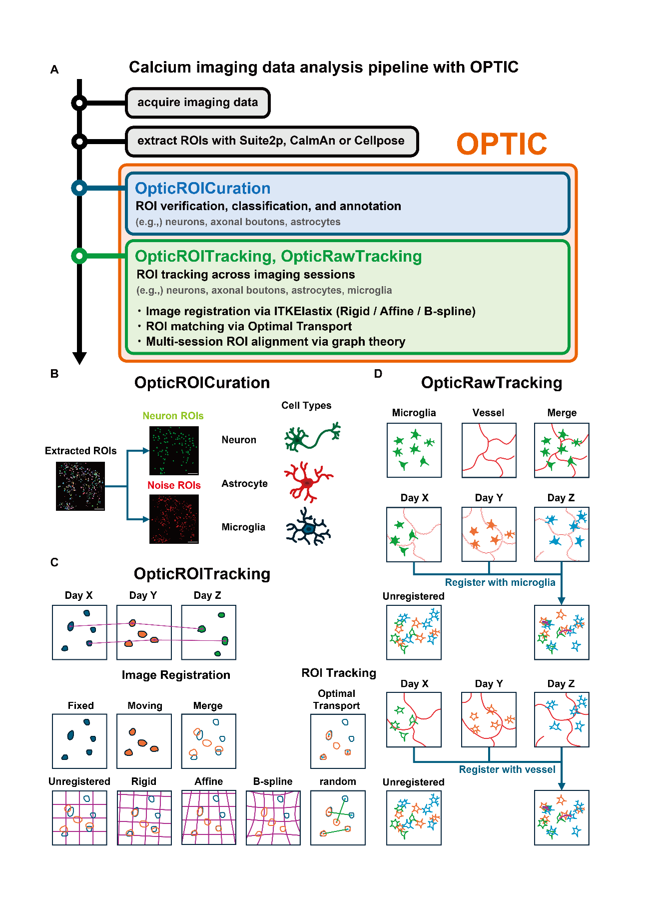Fig. 1
Fig. 1 Overview of calcium imaging data analysis workflow and OPTIC.
（A） Calcium imaging data analysis pipeline, and the scope of processing covered by each OPTIC application. (B) Overview of OpticROICuration. This application classifies ROIs extracted using Suite2p or CaImAn from calcium imaging videos into neuronal and non-neuronal noise ROIs. In addition to neurons, it also supports the classification of other cell types, such as astrocytes and microglia. (C) Overview of OpticROITracking. This application tracks identical ROIs across multiple datasets obtained from the same subject on different dates. Misalignments between sessions are corrected through image registration by transforming the moving images to align with the fixed images. Three transformation methods are available: rigid, affine, and B-spline. After image registration, automated ROI tracking is performed using the optimal transport theory. (D) Overview of OpticRawTracking. This application processes imaging data that includes microglia and additional reference channels, such as blood vessels. Image registration can utilize either a microglial channel or a reference channel containing stable structures with minimal morphological changes, such as blood vessels.

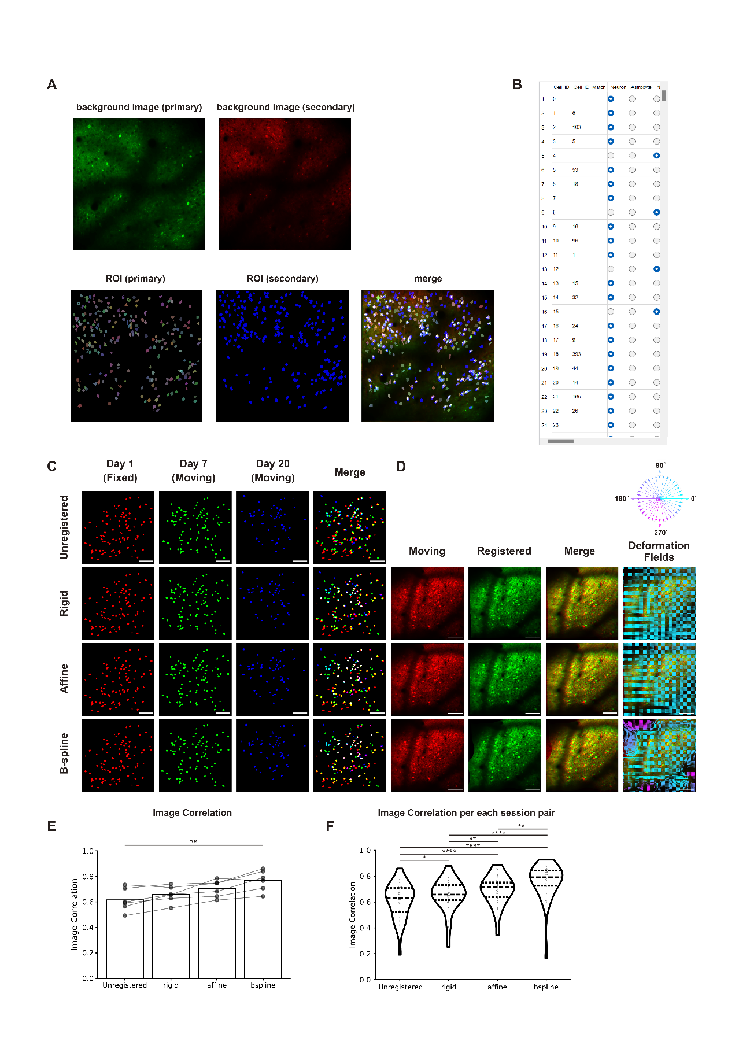
Fig. 2
Fig. 2 OpticROITracking corrects image misalignments between sessions using background images.
(A) View (primary) of the application. The primary background image is displayed in the green channel (top left), whereas the secondary background image is displayed in the red channel (top middle). Primary ROIs are color-coded (bottom left), whereas the secondary ROIs are uniformly displayed in blue (bottom middle). These overlaid images (bottom right) shows white lines connecting corresponding ROIs between the primary and secondary sessions. (B) Table (Primary) section of the application, formatted similarly to OpticROICuration. A distinctive feature is the "Cell_ID_Match" column, which shows the Cell_ID of the corresponding secondary ROI. (C) Calcium imaging results across 20 days and image registration outcomes using day 1 as the fixed image. Each row shows the unregistered image, rigid transformation result, affine transformation result, and B-spline transformation result. Scale bar = 100 µm. (D) Image transformation and deformation field results from image registration. Vector colors represent the directional information of the deformation vectors. (E-F) Comparison of image correlation coefficients between unregistered and registered groups (rigid, affine, and B-spline).
Paired t-test with Bonferroni correction. * P < 0.05, ** P < 0.01, *** P < 0.005, **** P < 0.001. n = 6 mice/27 session pairs.
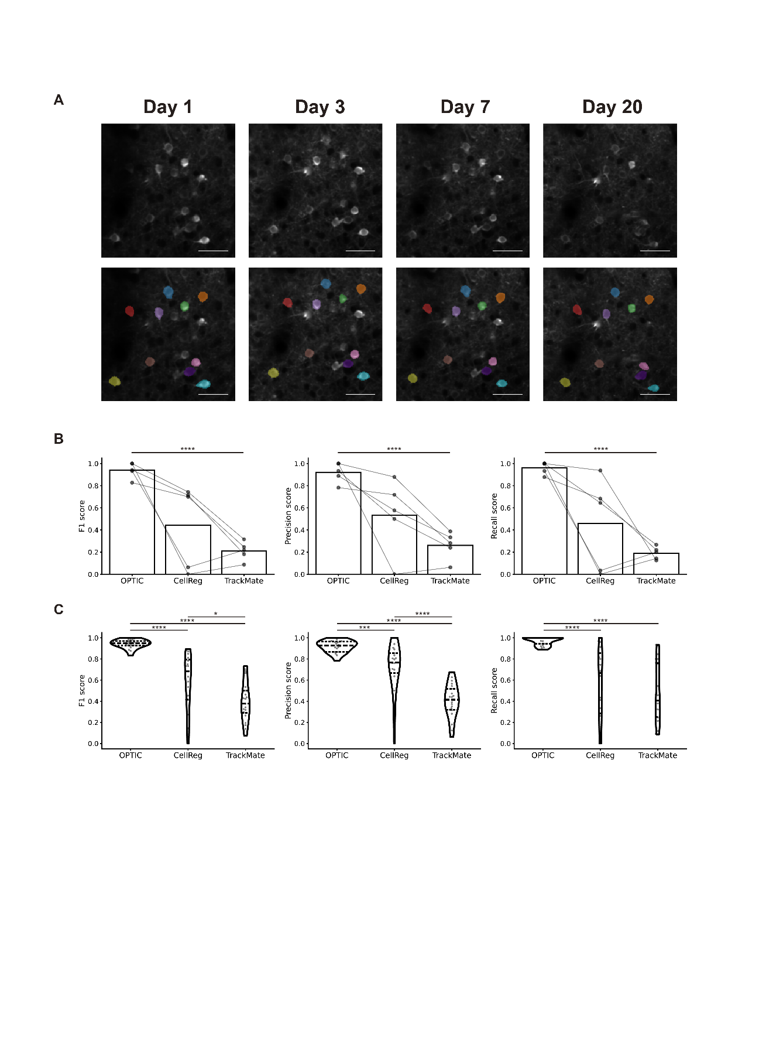Fig. 3
Fig. 3 OpticROITracking enables automated ROI tracking using optimal transport.
(A) ROIs tracked across a 20-day period along with corresponding imaging data. Ten representative ROIs are displayed, with consistent coloring used to indicate the same ROI across different time points. Scale bar = 40 µm. (B-C) F1 scores, precision, and recall values for ROI tracking performance compared among OPTIC, CellReg, and TrackMate.
Paired t-test with Bonferroni correction. * P < 0.05, ** P < 0.01, *** P < 0.005, **** P < 0.001. n = 5 mice/21 session pairs.

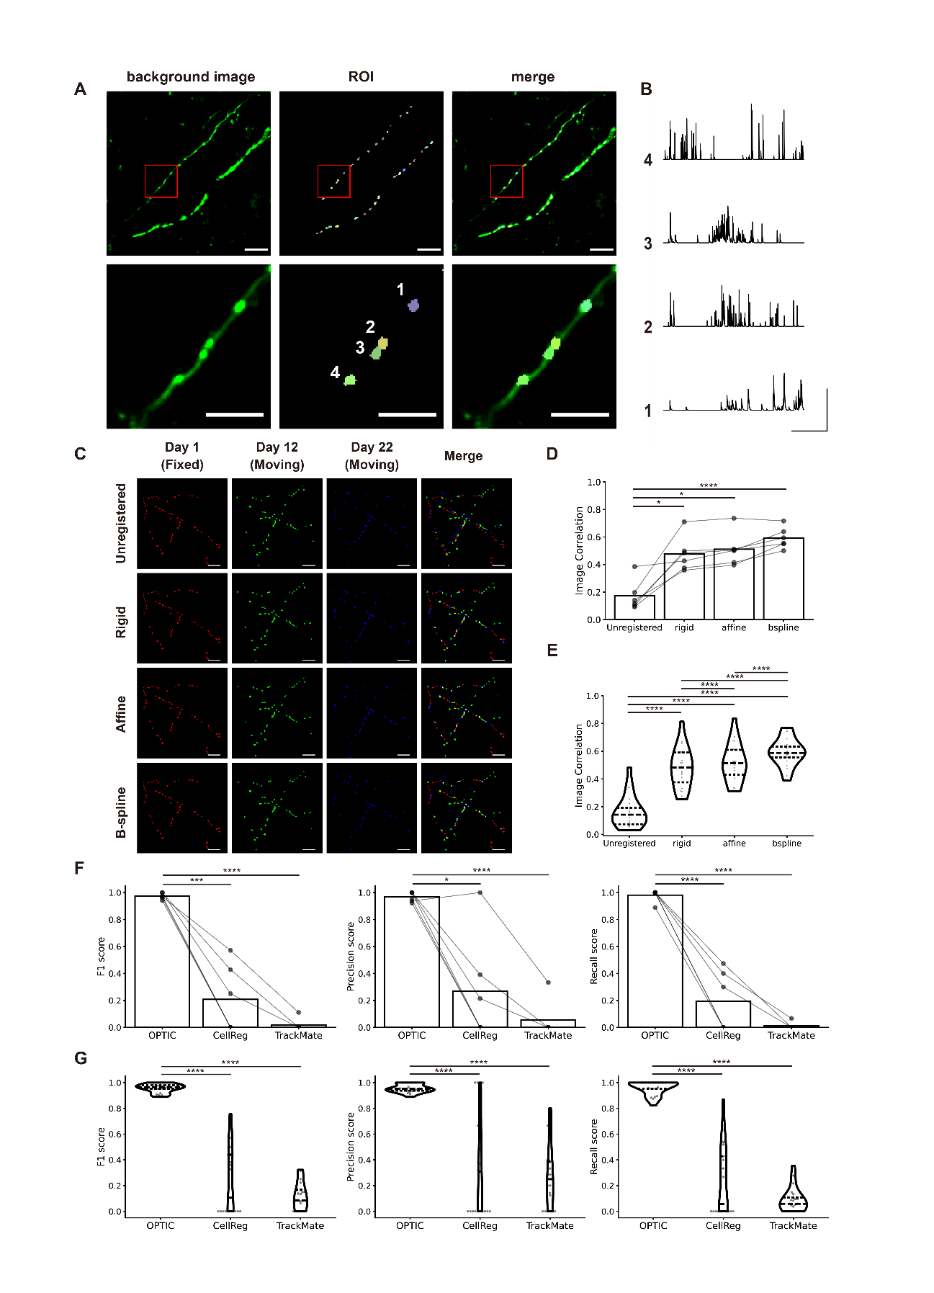
Fig. 4
Fig. 4 OpticROITracking enables accurate tracking of axonal bouton ROIs
(A) Representative axonal bouton imaging data. Top row: background image (left), ROIs (middle), and merged image (right). Bottom row: magnified views of the boxed regions. Scale bars: 20 µm (top), 10 µm (bottom). (B) Calcium traces of the four numbered ROIs. Scale bars: 60 s (horizontal), 200% ΔF/F (vertical). (C) Axonal bouton imaging results across 22 days and image registration outcomes using Day 1 as the fixed image. Each row shows the unregistered image, rigid transformation result, affine transformation result, and B-spline transformation result. Scale bar: 20 µm. (D-E) Comparison of the image correlation coefficients between the unregistered and registered groups (rigid, affine, and B-spline). Paired t-test with Bonferroni correction. * P < 0.05, ** P < 0.01, *** P < 0.005, **** P < 0.001. n = 6 mice/21 session pairs. (F-G) F1 scores, precision, and recall values for axonal bouton ROI tracking performance compared among OPTIC, CellReg, and TrackMate. Paired t-test with Bonferroni correction. * P < 0.05, ** P < 0.01, *** P < 0.005, **** P < 0.001. n = 6 mice/21 session pairs.
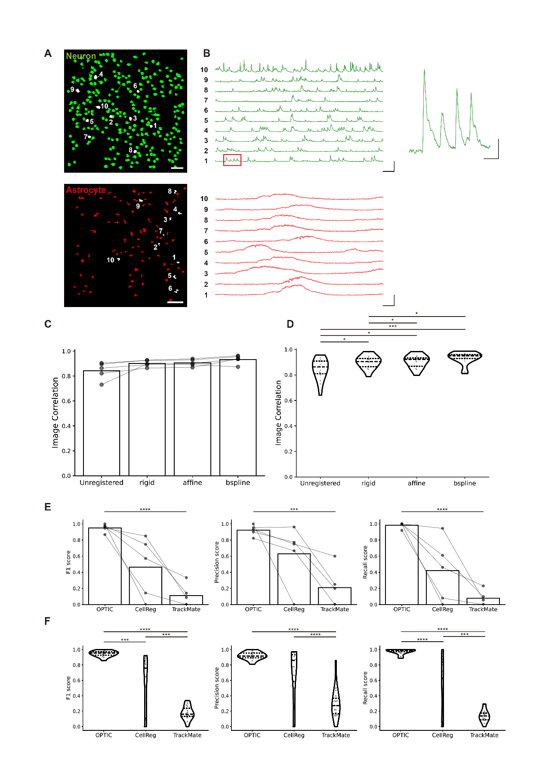Fig. 5
Fig. 5 OpticROITracking enables accurate tracking of astrocyte ROIs.
(A) Representative image showing neuronal (top row) and astrocytic (bottom row) ROIs. Ten neuronal ROIs and ten astrocytic ROIs are highlighted in white for trace visualization. Scale bars: 50 µm (neurons), 100 µm (astrocytes). (B) Calcium traces of the ten highlighted neuronal ROIs (top left), magnified view of the traces indicated by the red box (top right), and ten astrocytic ROIs (bottom). Scale bars: 10 s (horizontal), 500% ΔF/F (vertical) for neuronal traces; 3 s (horizontal), 50% ΔF/F (vertical) for magnified view; 1 s (horizontal), 300% ΔF/F (vertical) for astrocyte traces. (C-D) Comparison of the image correlation coefficients between the unregistered and registered groups (rigid, affine, and B-spline). Paired t-test with Bonferroni correction. * P < 0.05, ** P < 0.01, *** P < 0.005, **** P < 0.001. n = 5 mice/15 session pairs. (E-F) F1 scores, precision, and recall values for astrocytic ROI tracking performance compared among OPTIC, CellReg, and TrackMate. Paired t-test with Bonferroni correction. * P < 0.05, ** P < 0.01, *** P < 0.005, **** P < 0.001. n = 5 mice/15 session pairs.

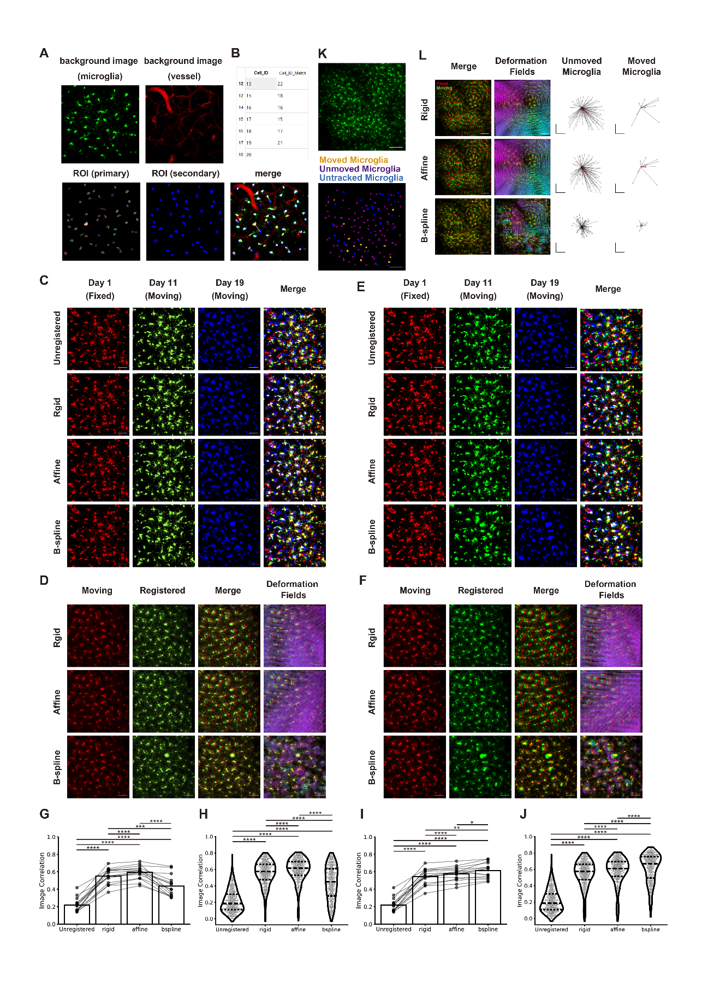
Fig. 6
Fig. 6 OpticRawTracking enables image registration using both microglial and blood vessel channel images.
(A) View (primary) section of the application. The microglial channel image is displayed in green (top left), whereas the blood vessel channel image is displayed in red (top middle). Primary ROIs are shown in distinct colors (bottom right), whereas secondary ROIs are displayed in blue (bottom middle). The overlaid image depicts white lines connecting corresponding ROIs between the primary and secondary sessions. (B) Table (primary) section. Columns display primary ROI identifiers (Cell_ID) and their corresponding secondary ROI identifiers (Cell_ID_Match). (C) Microglial images acquired over 19 days and corresponding registration results using the day 1 vessel image as the fixed reference. Each row shows (from top to bottom): the unregistered image, rigid transformation result, affine transformation result, and B-spline transformation result. Scale bar = 50 µm. (D) Image transformation and deformation fields derived from image registration. Scale bar = 50 µm. (E) Microglial images acquired over 19 days and corresponding registration results using the day 1 microglial image as the fixed reference. Each row shows (from top to bottom): the unregistered image, rigid transformation result, affine transformation result, and B-spline transformation result. Scale bar = 50 µm. (F) Image transformation and deformation field results for the microglial channel. Scale bar = 50 µm. (G-H) Comparison of image correlation coefficients on the microglial channel using vessel-channel reference, between unregistered and registered groups (rigid, affine, and B-spline). (I-J) Comparison of image correlation coefficients on the microglial channel using microglial-channel reference, between unregistered and registered groups (rigid, affine, and B-spline). (K) Images showing moved microglia (orange), unmoved microglia (purple), and untracked microglia (blue). Scale bar = 100 µm. (L) Comparison of deformation fields across registration methods (rigid, affine, and B-spline), and vector analyses comparing deformation in unmoved and moved microglia.
Paired t-test with Bonferroni correction. * P < 0.05, ** P < 0.01, *** P < 0.005, **** P < 0.001. n = 15 mice/524 session pairs. Hotelling's T² test. n = 12 (moved) and 98 (unmoved). Scale bar = 100 µm.

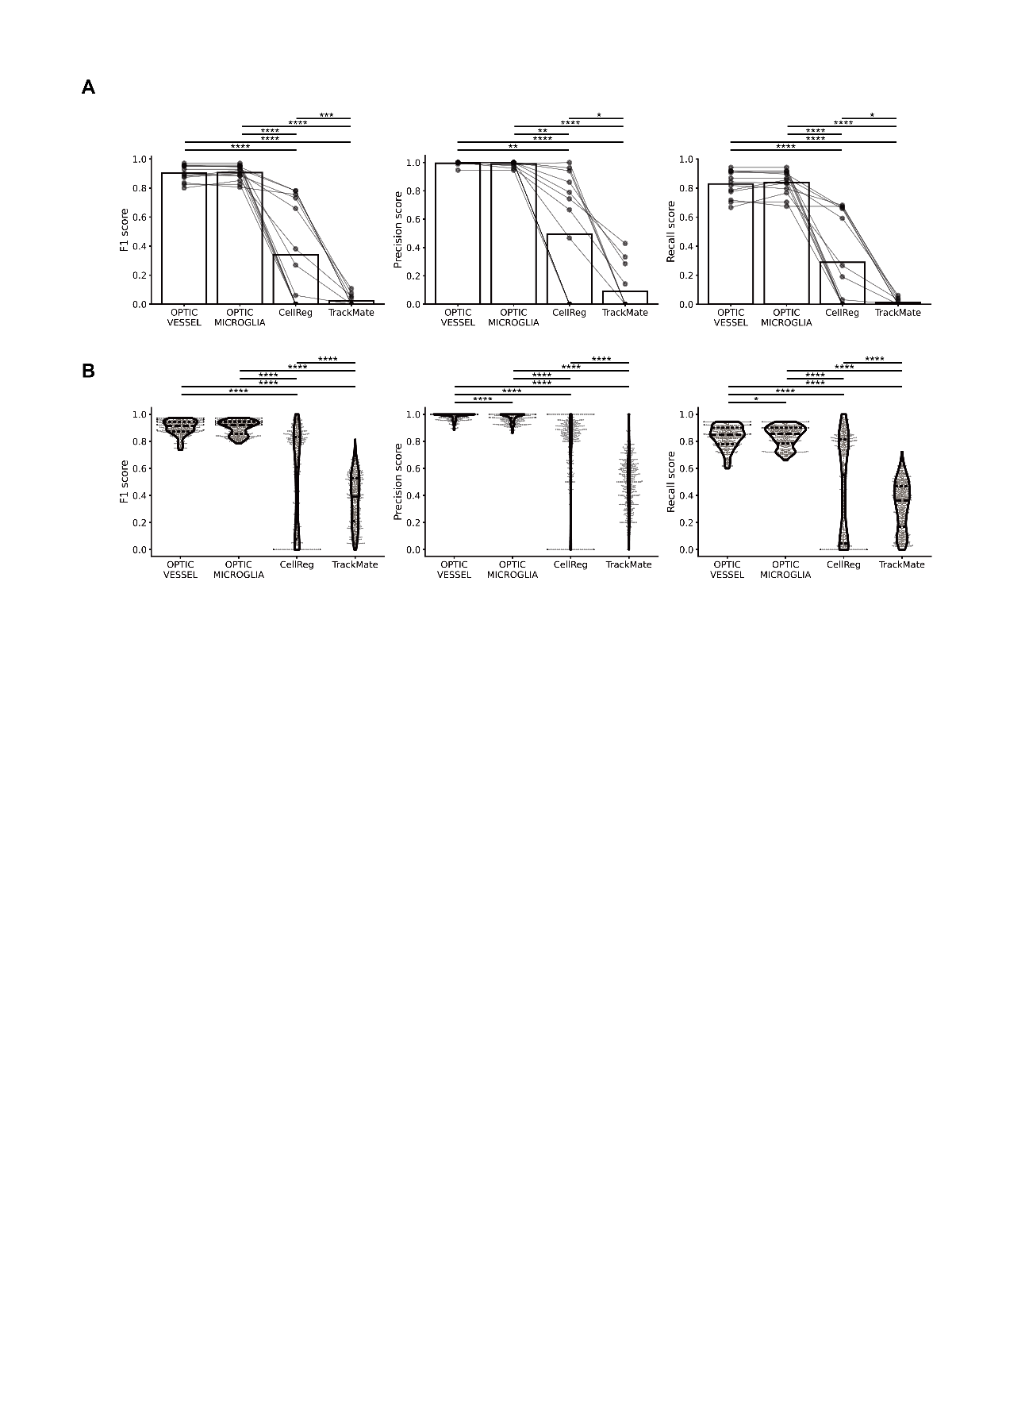Fig. 7
Fig. 7 OpticRawTracking enables automated microglia ROI tracking using optimal transport.
(A-B) ROI tracking performance evaluated across four methods: OPTIC using a blood vessel channel for registration (OPTIC_VESSEL), OPTIC using a microglia channel for registration (OPTIC_MICROGLIA), CellReg, and TrackMate. Tracking accuracy was assessed using F1 scores, precision, and recall values. OPTIC_VESSEL and OPTIC_MICROGLIA represent variations of the OPTIC framework leveraging different registration channels.Paired t-test with Bonferroni correction. * P < 0.05, ** P < 0.01, *** P < 0.005, **** P < 0.001. n = 13 mice/452 session pairs.

