Coffee:

AFFOGATO. Espresso poured on a vanilla ice cream. ...

AMERICANO (or ESPRESSO AMERICANO) Espresso with added hot water (100–150 ml). ...

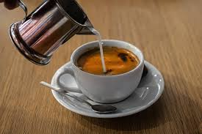

CAFFÈ LATTE. A tall, mild 'milk coffee' (about 150-300 ml). ...

CAFFÈ MOCHA. ...

CAFÈ AU LAIT. ...

CAPPUCCINO. ...

COLD BREW COFFEE. ...

DOUBLE ESPRESSO (DOPPIO)

