Desserts:

Apple Pie. Just when you thought apple pie couldn't get any better, this recipe raises the bar like no other. ...

Almond Malai Kulfi. ...

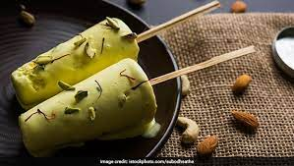

Lemon Tart. ...

Pistachio Phirni. ...

Fudgy Chewy Brownies. ...

Low Fat Tiramisu. ...

Coconut Kheer. ...

Chocolate Coffee Truffle.

