**Experiment no. 5**

**Aim: To implement String Operators in SQL**

1) select Authorname from

books

where Authorname like 'J%';  
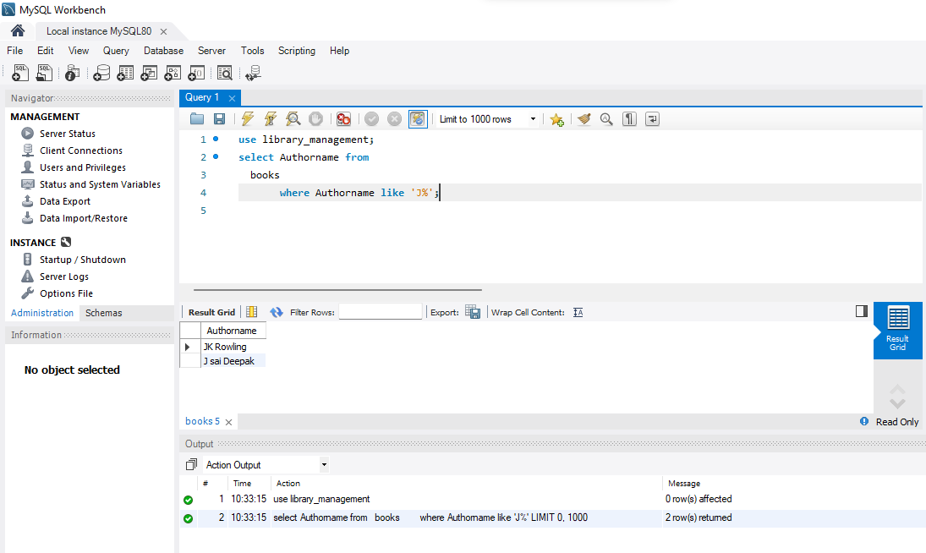

2) select Authorname from

books

where Authorname like '_o%';

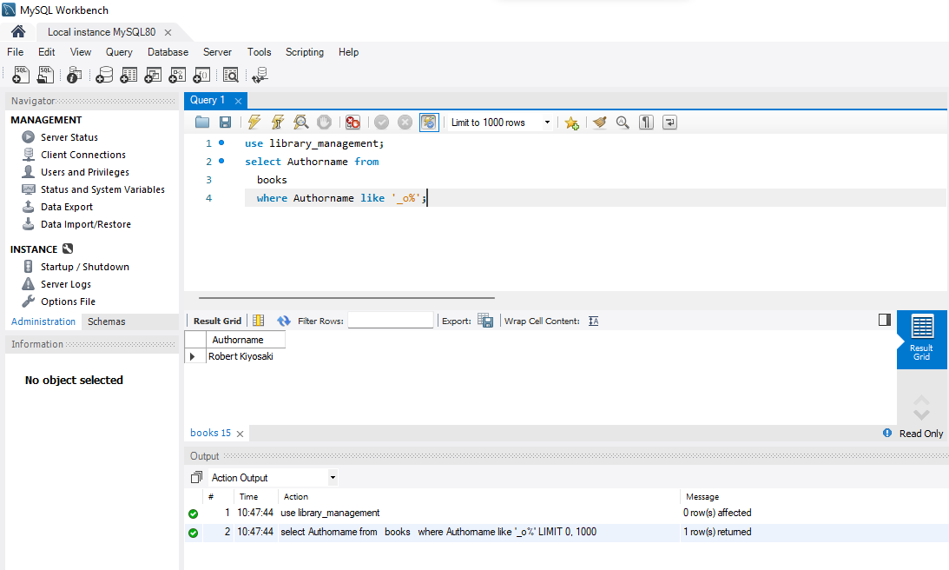

3) select Authorname from

books

where bookname like '%Pig%';

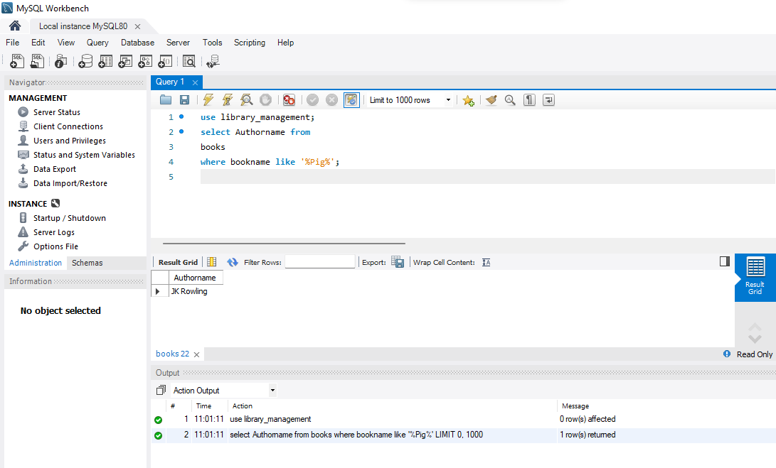

4) select Authorname from

books

where Authorname like '_o%' or '_k%';

