**Experiment no 6**

**Aim: To implement join in SQL**

1. **Cross Join**  
   select * from books cross join supplier;

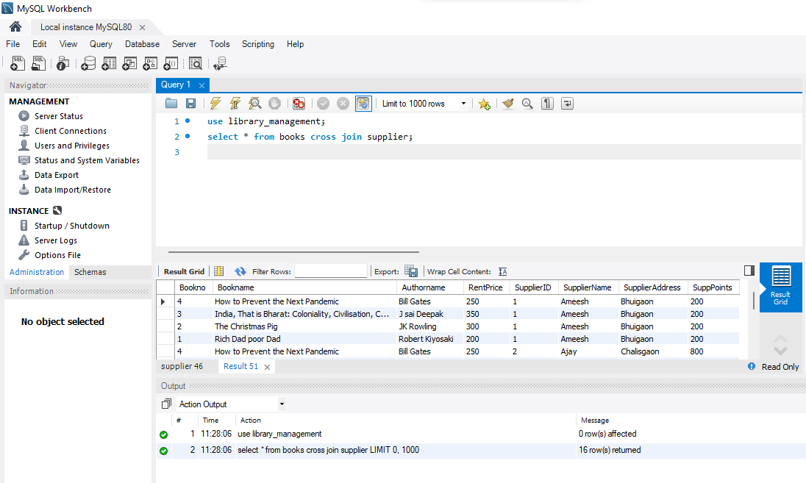

1. **Equi Join**

select b.Bookno, b.Bookname,

s.SupplierID, s.SupplierName

from books as b

JOIN supplier AS s

ON b.Bookno=s.SupplierID;

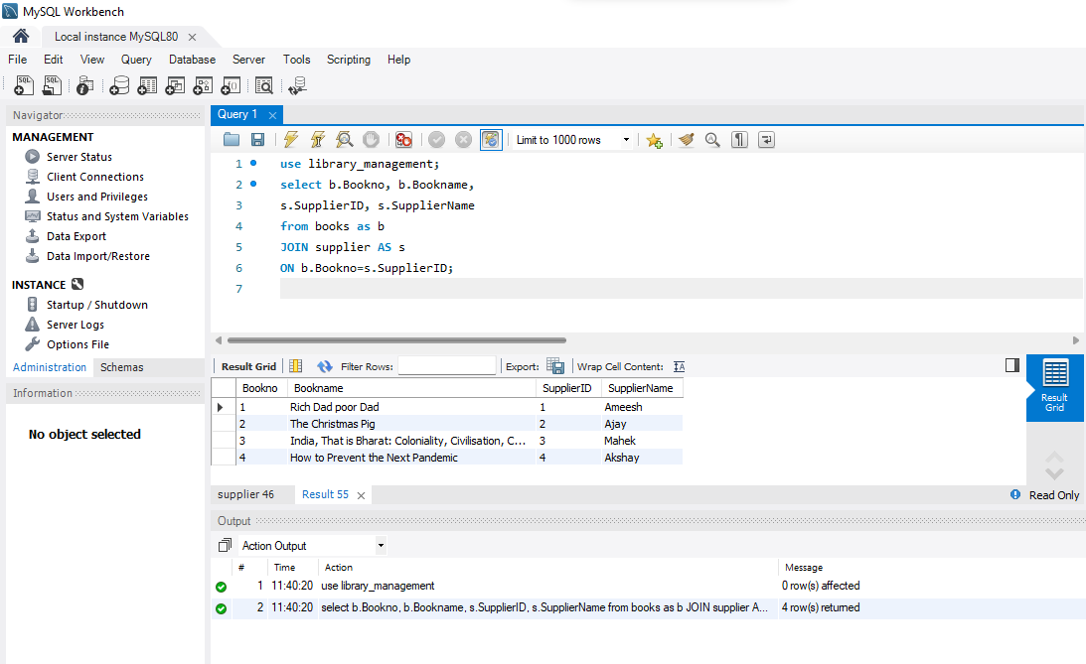

1. **Left Join**

SELECT books.bookname, supplier.supplierID

FROM books

LEFT JOIN supplier ON books.bookno = supplier.supplierID

order by books.bookname;

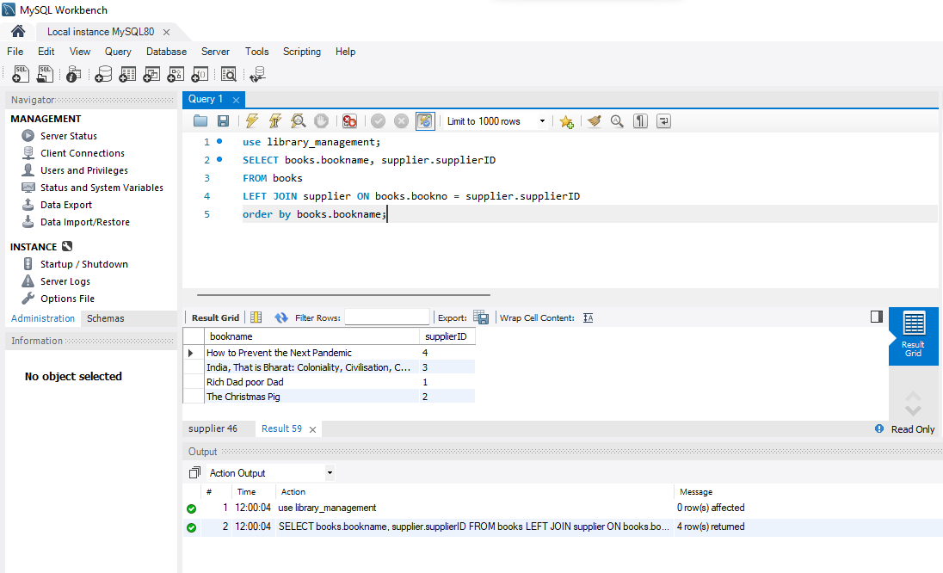

1. **Right Join**

SELECT books.bookname, supplier.supplierID

FROM books

RIGHT JOIN supplier ON books.bookno = supplier.supplierID

order by books.bookname;

