**Experiment no 7**

**Aim: To implement set theory operations in SQL**

1. **Union**

SELECT Bookname FROM Books

UNION

SELECT Bookname FROM Books2

ORDER BY bookname;

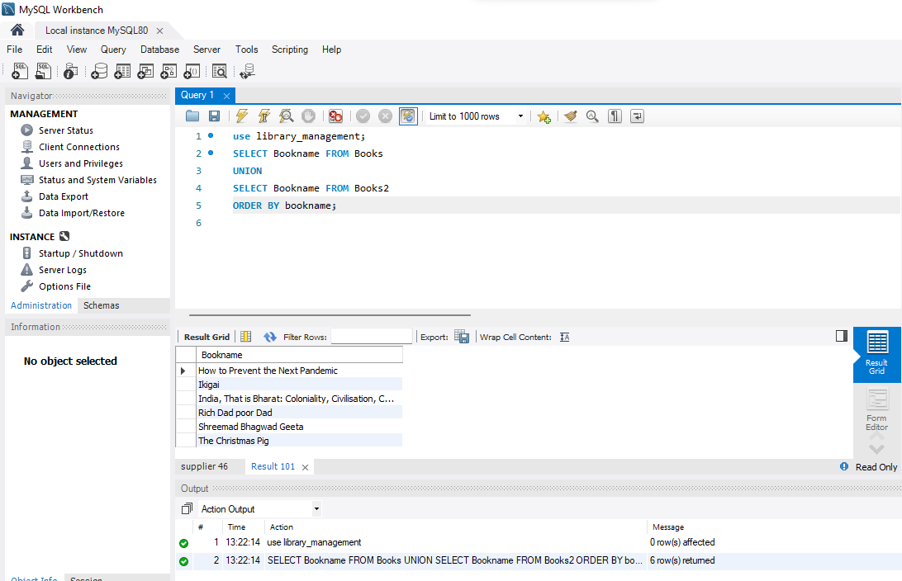

1. **Intersection**

SELECT bookname from books

where (bookname) in (select bookname from books2);

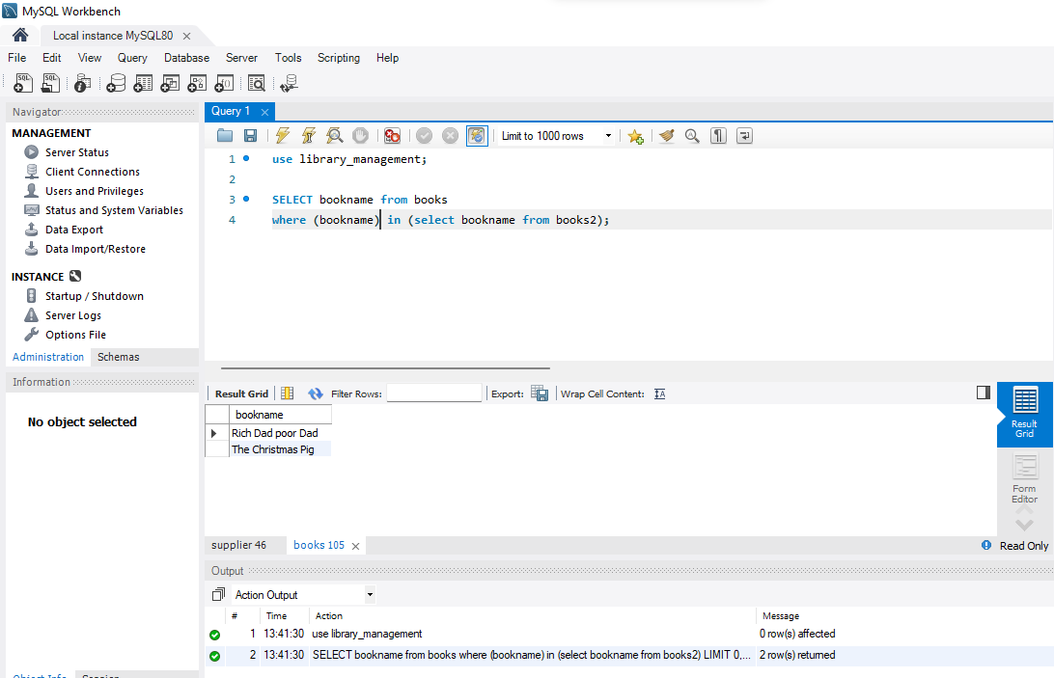

1. Difference

SELECT bookname from books

where (bookname) not in (select bookname from books2);

