**Experiment no 8**

**Aim: To implement Clauses in SQL**

1. **Order By**

SELECT * FROM books

ORDER BY Bookno DESC;

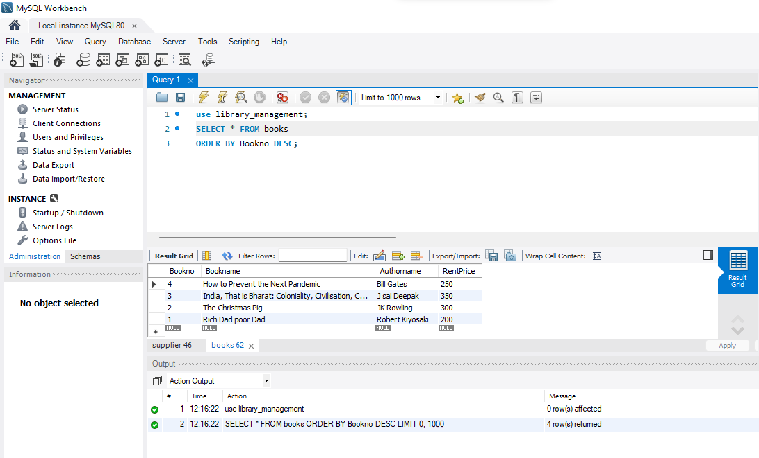

1. **Having**

select bookno, bookname, Authorname, Rentprice

from books

having RentPrice < 300;

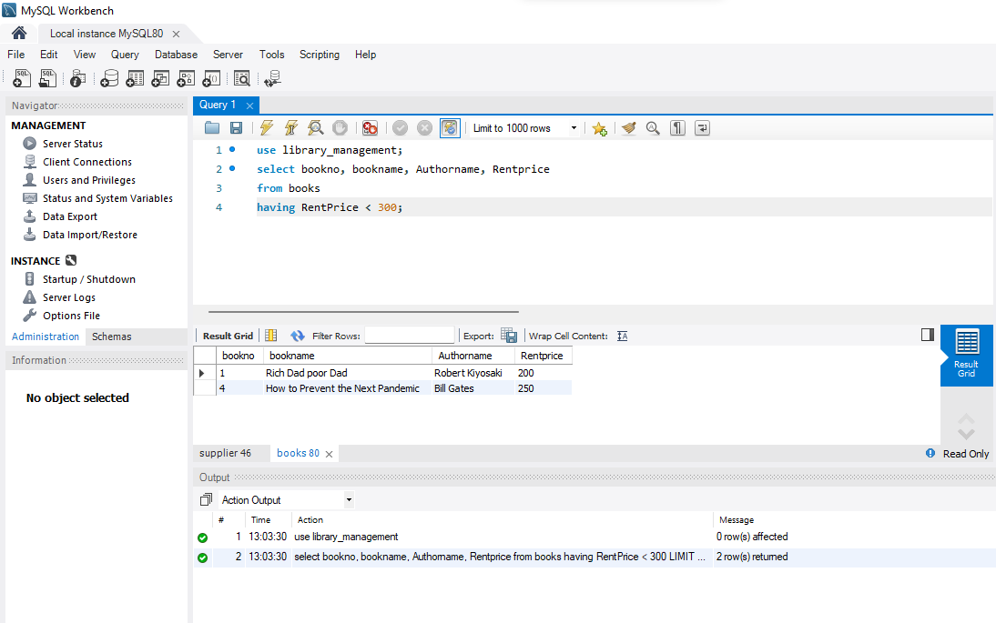

1. **Group By**

select Bookno, Bookname, Authorname

from books

Group by bookno;

