**Experiment No. 6**

**Aim: Installation of Prolog (SWI-Prolog) in Windows.**

**Prolog:**Prolog is considered as a declarative language rather than programming language as it is not used to solve computational problems. It is used to solve logical problems which use rules or facts. The full form of prolog is programming in logic. Prolog is used in much artificial intelligence, natural language processing, and machine learning problems. Prolog is used to write facts or rules for problems and then prolog’s run time system checks those facts and rules whenever that problem is asked and returns a true or false statement for success or failure of the problem.

**Step 1:**Visit*swi-prolog.org*website using any web browser. Click on Download which is adjacent to Home, dropdown list will appear then click on SWI-Prolog.

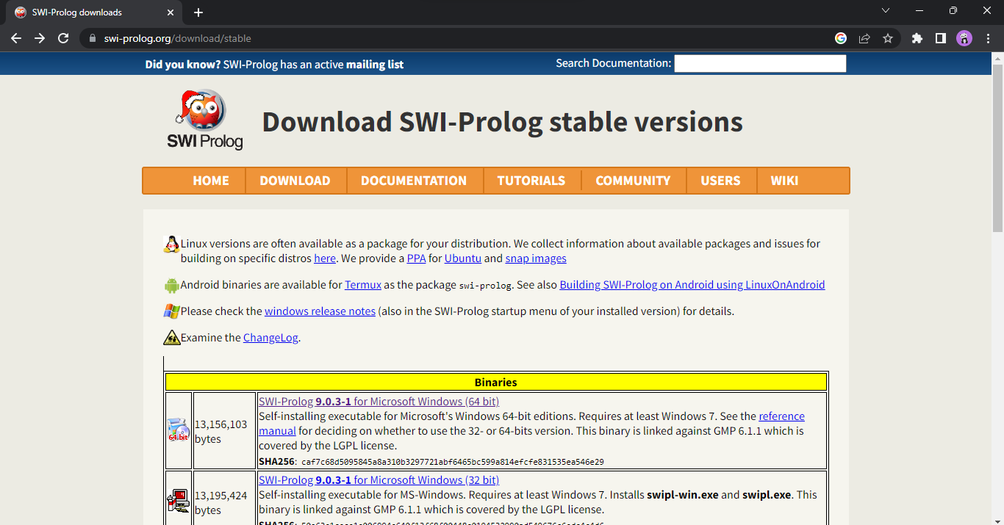

**Step 2:** Now check for the executable file in downloads in your system and run it. It will prompt confirmation to make changes to your system. Click on Yes. Setup screen will appear, click on Next.

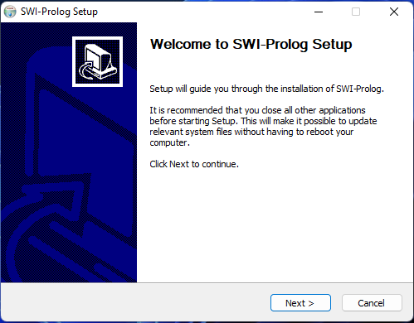

**Step 3:**The next screen will be of License Agreement, click on I Agree.

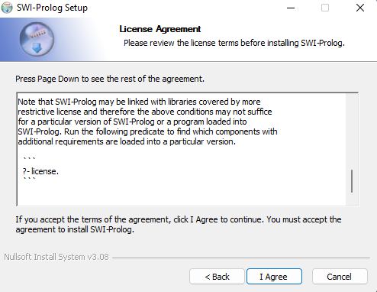

**Step 4:**After it there will be screen of installing options so check the box for Add swipl to the system path for all users, and also check the box for create a desktop icon and then click on the Next button.

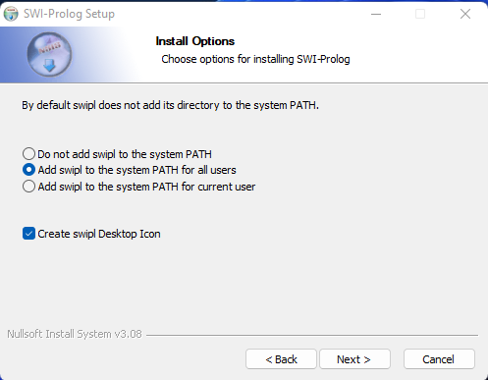

**Step 5:**The next screen will be of installing location so choose the drive which will have sufficient memory space for installation. It needed only a memory space of 50 MB.

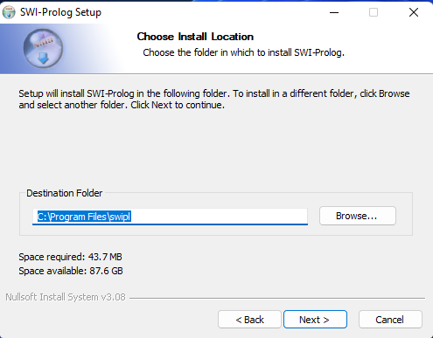

**Step 6:**Next screen will be of choosing Start menu folder so don’t do anything just click on Next Button.

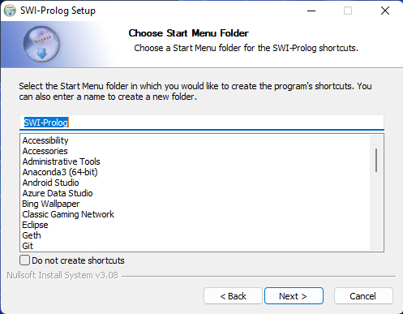

**Step 6:**This last screen is of choosing components, all components are already marked so don’t change anything just click on Install button.

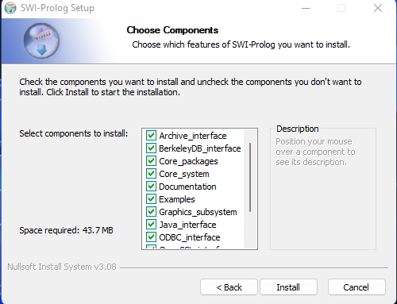

**Step 7:** After this installation process will start and will hardly take a minute to complete the installation. Click on Finish after the installation process is complete.

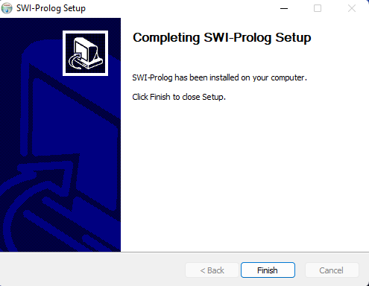

**Step 8:**SWI Prolog is successfully installed on the system and an icon is created on the desktop. Run the software and see the interface.

