**BOOK DOCTOR APPOINTMENT**

**BPMN2.0 Workflow automation-POC**

**-K..Abirami**

**Development Manager -DHIRA Software Labs**

**Table of Contents**

1. Basic Operation
   * Book Appointment flow
   * Self-Pay Flow
   * Insurance Flow
2. Technology Stack
   * Front End: React.js
   * Back End: Spring Boot
   * Camunda 8 Integration with Zeebe client and Elastic search DB
3. High-Level Architecture Diagram
4. Sequential Flow Diagram
   * Including expert list retrieval and payment processing via REST API with Camunda orchestration
5. Screenshots & Flow Details
   * Self-Pay Flow Screens
   * Insurance Flow Screens
   * Artifact Links

**Basic operation:**

"Book appointment"

🡪Shows list of experts  🡪 select expert 🡪

🡪Select “Payment Type” -🡪"Request appointment" 🡪

if(Self_pay)collects information --> "Pay Now" ---> Payment Successful, orderId

else (insurance) 🡪 alert msg

**Technology :**

**Front End:** React.js (Communicating with Spring Boot with REST API calls)

**Back End:** Spring Boot (Communicating with React.js in REST API calls and with Camunda 8 with SDK package using Zeebee client gRpc calls) not used any DB… just storing value in temp variable.

**Camunda 8:** communicating with Spring boot through SDK and tracking with Camunda UI. Now using its inbuilt Elastic search DB

**High Level Architecture Diagram:**

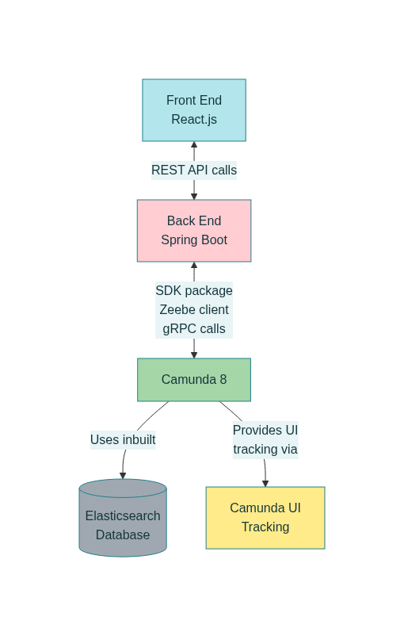

**Sequential Flow Diagram:**

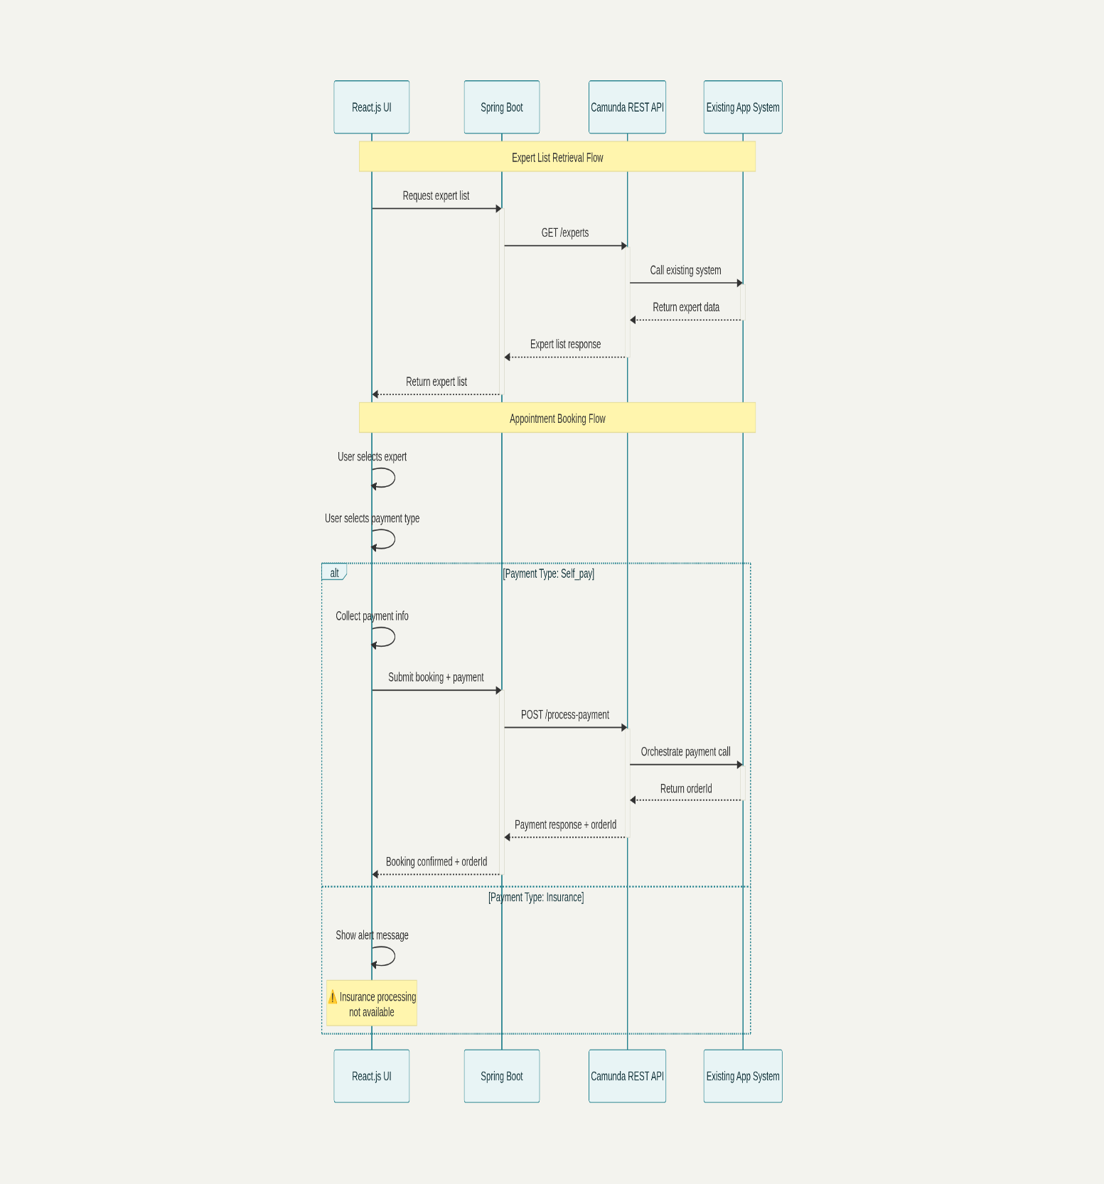

Self-Pay Flow:

Insurance Flow:

**Artifactory Links:**

React Source code : <https://github.com/dhira-io/React_Docterapp>

Spring Boot Source code : https://github.com/dhira-io/SpringBoot_DocterApp

Node.js :

https://github.com/dhira-io/Camunda_MHM_POC/tree/main/MHM_POC/MHM_POC

Common BPMN Files :https://github.com/dhira-io/BPMN_POC