Steps:

**Using ThinBackup plugin in Jenkins**

* Go to manage plugins and search for ThinBackup Plugin as shown below:

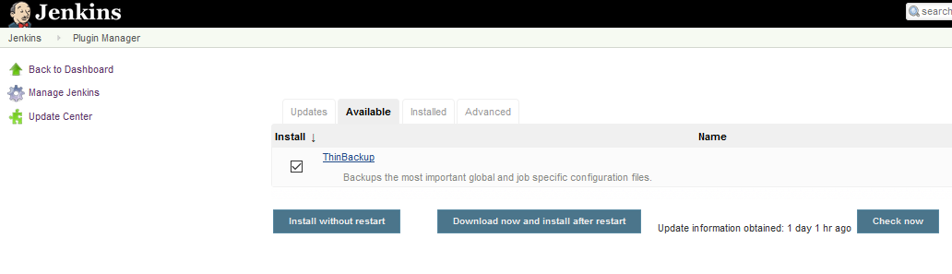

* Install the plugin
* Go to Jenkins server machine and create a backup folder as shown below

*mkdir /apps/jenkins_backup*

*chown jenkins:jenkins /apps/jenkins_backup*

* Now go to manage Jenkins and look for ThinBackUp as shown below and click on it.



* Click on Settings

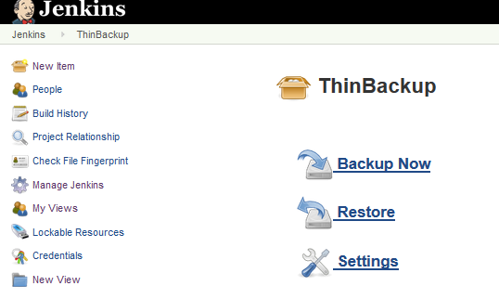

* Apply the settings as below and click on save

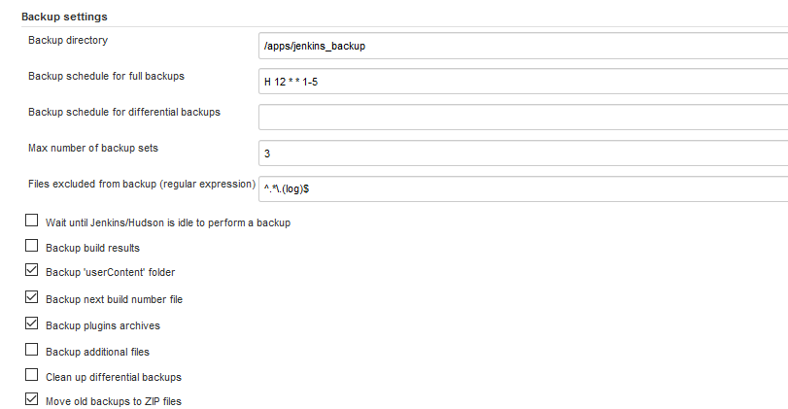

* It should have three options like Backup ,Restore and Settings

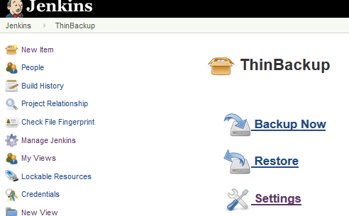

* When you manually click on **Backup Now** option, it will create backup under /apps/jenkins_backup
* As you see below, a backup is created.



* When you click backup now again then a zip file of former is created. See below

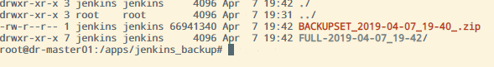

**RESTORE**

* Suppose, some files of Jenkins server is either deleted or crashed.



* Now , Click on restore link of Jenkins and select the backup folder

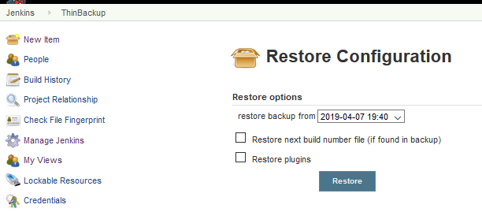

* Click on Restore. See below the missing file is successfully restored.

