Steps

=============================

1. Install the plugin "**Deploy to container**"
2. Install Tomcat8 Server.
3. Go to Tomcat8/conf folder and open tomcat-user.xml file, add below lines

*<role rolename="manager-script"/>*

*<role rolename="manager-gui"/>*

*<user username="admin" password="admin" roles="manager-script,manager-gui"/>*

1. Save and close, restart tomcat.
2. Go to Jenkins Job and add the repository
3. Under **Build Section**-->Invoke top level maven and define below goals i.e. clean, install, compile, test and package
4. Go to Post build section --->**Select Deploy war/ear container**
5. **Under Select Deploy war/Ear Container**, define the below as shown

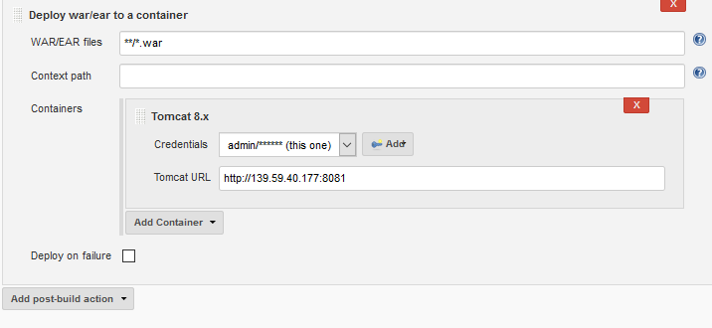

1. Save
2. Click on Build now
3. Build should be success.
4. Go to tomcat server and verify that war file is automatically deployed under webapps folder.