1. Add the Junit plugin.
2. Create a maven job and define goals
3. Go to workspace of project and copy the path of surefire reports.

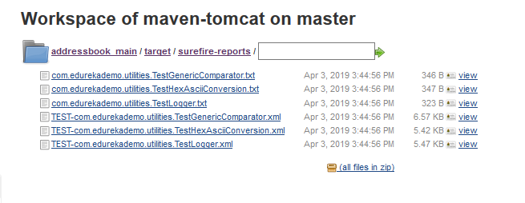

1. Sure-fire path is **“addressbook_main/target/surefire-reports/*.xml”**
2. **Go to jenkins –> configure->post build action and select “publish junit test result report**
3. paste the surefire report path copied above as shown:

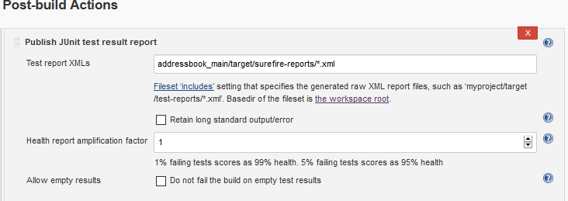

1. Click on save
2. Click on build now.
3. Go to build and on left side of screen select test result link as shown

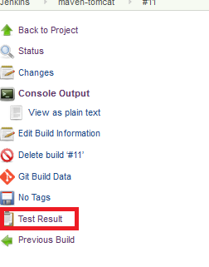

1. Test re[ort should be like this:

