PROJECT REPORT ON

**“Movement Pattern Analysis Using Qualitative Calculus”**

Submitted on partial fulfilment of requirement

For the Degree Of

**BATCHELOR OF ENGINEERING**

**COMPUTER SCIENCE AND ENGINEERING**

**OF**

**DIBRUGARH UNIVERSITY**

**SESSION 2014-15**



Under the guidance of

**RUPAM BARUAH**

(H.O.D-Dept of Computer Science &Engg)

Submitted by

**Richard KashyapDeka, Jor-CSc-37/11**

**Dhiraj Kumar Deka, Jor-CSc-40/11**

**JORHAT ENGINEERING COLLEGE**

**DEPARTMENT OF COMPUTER SCIENCE AND ENGINEERING**

**JORHAT- 785007, ASSAM**

**CERTIFACATE**

JORHAT ENGINEERING COLLEGE

DIBURARH JORHAT



GOVERNMENT OF ASSAM

DEPARTMENT OF COMPUTER SCIENCE AND ENGINEERING

JORHAT ENGINEERING COLLEGE

JORHAT-07, ASSAM

This is to certify that the dissertation titled “**Movement Pattern Analysis Using Qualitative Calculus**”, submitted by Richard KashyapDeka (roll no: Jor-CSc 37/11) and Dhiraj Kumar Deka (roll no: Jor-CSc 40/11) of Jorhat Engineering College, Dibrugarh, Assam is accepted in partial fulfilment of the BE degree….

Further, the matter embodied in this project has not been submitted for the award of any other degree.

Dated: …………………………

Place: Mr.RupamBaruah

Head of the Dept.

Computer Science and Engineering

ACKNOWLEDGEMENT

We take the opportunity to express our gratitude and thanks to JEC college authority for providing us the facility to carry out the project in Movement Pattern Analysis Using Qualitative Calculus.

We are especially grateful to respected Mr.RupamBaruah, HOD (CSE) for guiding and providing constant inspiration and encouragement.

We would like to express our sincere thanks and heartful respect to all the faculty of JEC family for providing us the practical knowledge about the various equipments used in the robotics and for sharing their technical experience and guiding me throughout the semester.

Last but not the least we would like to thank our friends who supported us a lot and made this project a successful and memorable one.

Richard KashyapDeka, Jor Csc-37/11

Dhiraj Kumar Deka, Jor Csc-40/11

Date:

DECLARATION OF THE STUDENT

We hereby declare that the work which is presented in the report is not entitled in partial fulfilment of the requirement of the degree of Bachelor of Engineering submitted in the department of Computer Science and Engineering of Jorhat Engineering College under Dibrugarh University is an authenticate record of our effort carried out during the period from August 2014 to December 2014 under the supervision of RupamBaruah (H.O.D, Department of Computer Science and Engineering, College, Assam).

The matter presented in this report thesis by us has not been submitted for any other award or degree of this or any other university.

……………………..

Richard KashyapDeka

(Jor-CSe-37/11)

Dhiraj Kumar Deka

(Jor-CSe-40/11)

CERTIFICATE OF GUIDE

This is to certify that the statement made by the student is true to best of my knowledge and the progress so far has been food satisfactory.

……………………. ……………………..

Signature of External Examiner Signature of Guide

.. …………………

.

Contents:

1. Elaborated Objective.

2. Work done in this semester.

3. Introduction.

4.1.1. What is special about spatial reasoning? A description.

1.2. Different approaches to QSR.

5. Region Connection Calculus (RCC).

6.1.1. Qualitative spatio temporal reasoning.

1.2. Application areas of QSTR.

7. Continuity and Conceptual Neighbours.

8. Qualitative Motion Representation.

9. 1.1. Finding Efficient Reasoning Algorithm.

1.2. Generalization Algorithm.

1.3. Speed of object in Qualitative Motion.

10.1.1.Interpreting Motion Events of Pairs of Moving Objects by Gottfried.

1.2. Relative Motion Descriptions.

1.3. Atomic Motion Patterns.

1.4. Changes in Motion Pattern.

1.5. Example of Different Motion Patterns.

1.6. Single Changes.

1.7. Double Changes.

1.8. Abrupt Changes.

1.9. No Changes.

2.0. Locality of Changes.

11. Constraints/Predicates for the Gottfried Movement Patterns.

12. References.

MOVEMENT PATTERN ANALYSIS USING QUALITATIVE SPATIAL CALCULAS

1. Elaborated Objective:

Analysis of moving objects is very important in the present era of computer science, which gives details about size, brightness, hue saturation and about texture information of the particular studied objects. So it will be very delightful if we can work in the area of the motion pattern of various objects and analyse them in a fruitful way. To project this delightful thought, the basic purpose here in this project is to observe the motion pattern of certain objects with respect to an reference object. Under observation the particular object and its reference will be in some kind of motion at all the time.To enlarge the human cognitive view through programming we will use qualitative approach rather than quantitative analysis in most cases, though we are not going to reject the idea of the quantitative analysis at all. We will be using the space as the centre of our study i.e we will be taking movement patterns of objects within the area of space.

1. Work done in this semester:

In this semester we have mainly done the literacy survey on movement pattern analysis and how to present them through a calculus which will be qualitative in nature. From this survey we have got the beneficial idea of using qualitative approaches in analysing movement patters of various bodies in space. We studied about the qualitative motion briefly and also got to know about some important points of making efficient reasoning algorithm. The study of 16 possible movement patterns as described by Gottfried has given us an extra thrust to our study. We have calculated the constraints or predicates for those 16 movement patterns by using simple co-ordinate geometry. These constraints will be used later in the coding section of our project efficiently.

MOVEMENT PATTERN ANALYSIS USING QUALITATIVE SPATIAL CALCULAS

Introduction:

Moving around the environment is one of the primary task which human beings and animal accomplish equally well. For both human beings and animals, spatial reasoning about space is a particularly powerful and accessible mode of cognition i.e. the process of knowing which the base of all artificial reasoning principles is. In our every day interaction with physical world, spatial reasoning appears to be driven by qualitative abstractions rather than complete quantitative knowledge. Therefore qualitative reasoning holds promise for developing theories for reasoning about space indeed the desire to reason about space more akin to cognitive led to the birth of qualitative spatial reasoning within artificial reasoning.

So basically what we are going to do in this project is the reflection of portraying qualitative aspects more than the quantitative analysis and use them in the deduction of gaining the movement pattern of a particular object with respect to another object. We will take both the objects as moving objects as described by Brain Gottfried in the study of qualitative motion pattern analysis.

* 1. .1 What is special about spatial reasoning?-- A description:

Spatial reasoning and representation deals with space and that brings a special perception on spatial reasoning. As described earlier it is an approach for dealing with common sense knowledge without recourse to complete quantitative knowledge. Actually representation of knowledge is the limited repository of qualitative abstraction. This approach gives rise to the urge for

MOVEMENT PATTERN ANALYSIS USING QUALITATIVE SPATIAL CALCULAS

something different from the traditional applications solely relying on mathematical equations. Our knowledge about physical space differs from all

other knowledge in a very significant way. Spatial knowledge obtained through one channel can be verified or refuted by perception through other channels. As a consequence, we are disproportionally confident about what we know about space; we take it for real.

More specifically we perceive spatial dimensions visually, tacitly, aquatically or even by smell or temperature sensation. Within the visual change we obtain clue about space through size, brightness, hue, saturation and texture information; within the acoustic sense we obtained clues about space through loudness, frequency and signal/noise ratio. It can be argued that physical space a central role in communication-

1. At the domain in which physical events take place.
2. As reference domain for the interpretation of non-spatial concepts.

In this way, the properties of physical space can be used as a vehicle for conveying non-spatial concepts provided there exists a mapping from the non-spatial to the spatial domain.

Early concepts into common sense reasoning about the physical world involved only solving text-book problems on physics and mathematics but this were non adequate for reasoning about most commonly physical scenarios. That is why a different perception has been put forward for not completely relying on quantitative approach which is called qualitative approach. Bases on HAYE’S NAIVE PHYSICS MANIFESTO.Forbus in 1980 presented a system which reason about motion through free space by using both qualitative and quantitative information.

So basically representation of knowledge is through a limited repository of qualitative abstraction. The essence is to represent continuous properties of the world by dispute system of symbols. The resulting set of qualitative values is termed as *“Quantity Space”.*  The most frequently used quantity space is the abstraction [+,-,0]. This was successful quantitative dynamics- the sub field of qualitative physics describing forces that causes system to change over time.

MOVEMENT PATTERN ANALYSIS USING QUALITATIVE SPATIAL CALCULAS

It was very successful largely due to the possibility of exploiting the underline partial or total order of the quantity space using transitivity. On the contrary it was conjectured that this cannot be the case for qualitative kinematics-the sub field of qualitative physics concerned with spatial reasoning required by common sense physics. Forbus, Neilson and Faltings in their seminal paper on qualitative kinematics in 1987put forward the poverty conjecture. According to the poverty conjecture there is no general qualitative purposed kinematics. The neglect of spatial reasoning can be partially attributed to the poverty conjecture but qualitative spatial reasoning is more than just kinematics. To understand why the poverty conjecture contributed to the delayed progress within spatial QR. It is worth recalling their third and strongestargument; “Quantity spaces don’t work in more than one dimension, little hope for concluding much about combining weak information about spatial properties”.

1.2 Different approaches to QSR:

There are many different aspects to space and therefore to its representation. Qualitative spatial representation addressing different aspects of space including topology, orientation, shape, size and distance had been put forward. There is a rich diversity of these representations.

Topology:

Topology is the most element aspect of space and it must form a fundamental aspect of QSR since it certainly can only make qualitative distinctions. One important approach to topology which has been espoused by QSR is the work to be found in philosophical logic. This work has built axiomatic theories of space which are predominantly topological in nature, and which take regions rather than points as primitives.

Mereotopology:

Mereotopology treats parts and the wholes they form. Here a topological primitive is given, C(x,y): x and y are connected. It can then be defined as



MOVEMENT PATTERN ANALYSIS USING QUALITATIVE SPATIAL CALCULAS

Where O(x,y) is true iff regions x and y share a part.

Orientation:

It describes where objects are placed relative to one another. Orientation can be defined in terms of three basic concepts-

a) The primary objects

b) The reference object

c) The frame of reference

Here the directions are in the form of north, east, south and west and the direction of a located point is defined to a reference point with respect to a perceptive point.

Distance and Size:

Qualitative representation of distance is based on either some absolute scale or some kind of relative measurement eg. ‘a’ is close to ‘b’ is statement of the first category ,where as a statement such as ‘a’ is closer to ‘b’ then to ‘c’ is from the second category.

Distance is closely related to the notion of orientation eg. Distance cannot usually be summed unless they are in the same direction. The framework for representing distance has been extended to include orientation combining qualitative orientation and absolute distance knowledge.

Shape:

Qualitative formation for describing shape can either be constructive representation or certain constraining approaches. Shape is an important characteristics of an object and particularly difficult to describe qualitatively.

Within the constructive representation of qualitative shape, complex shapes are described by structured combinations of primitive entities. One

MOVEMENT PATTERN ANALYSIS USING QUALITATIVE SPATIAL CALCULAS

needs to go beyond topology, introducing some kind of shape primitives but still retaining a qualitative representation. Approaches which work by describing the boundary of an object include those that classified the sequence of different types of boundary segment or by describing the sequence of different types of curvature extrema along its contour. Alternatively one might construct a complex shape region out of simper ones along the lines of constructive solid geometry.

5. Region Connection Calculus(RCC):

The basic part of RCC assumes a dyadic relation . C(x,y): which means x is connected to y. C can be given atopological interpretation in terms of points incident in regions.In this interpretation, c(x,y) holdswhwn the topological closures of regions x and y share at least one point. C(x,y) is powerful and it is used to define many predicates and functions which capture interesting and topological distinctions. According to RCC any region connected to an atomic region is connected to the complement of the region. The parthood relation is used to define proper-part (PP), overlap (O) and disjoint(DR). Further, DC, EC,PO,EQ, TPP and NTPP i.e., disconnected, externally connected,partial overlap, equal, tangential proper-part and non-tangential proper-part respectively are defined.

MOVEMENT PATTERN ANALYSIS USING QUALITATIVE SPATIAL CALCULAS

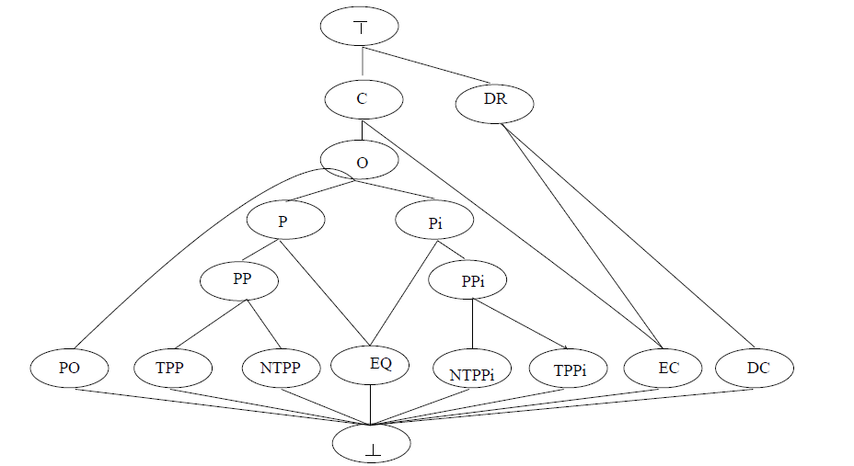

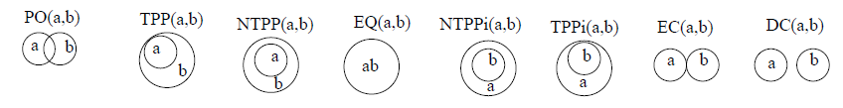

Fig: Lattice defining the subsumption hierarchy of dyadic relationship defined in terms of C.

Defined Relations:

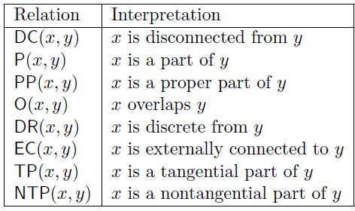

MOVEMENT PATTERN ANALYSIS USING QUALITATIVE SPATIAL CALCULAS

6.1.1 Qualitative Spatio Temporal Reasoning:

The connection between time and space has been a recurring topic, initially in geographic and most recently in computer science. Reasoning about space often involves reasoning about change in spatial configuration. Spatial change is spatio temporal. Spatio temporal is so common in our daily life that we rarely notice it is a particular concept of spatial analysis. When applied to computer information system, spatio temporal reasoning attempts to solve problems that deal with objects that occupy space and change over time.

1.2 Application Areas of QSTR:

There are three application domains which are often cited as the natural application areas of qualitative spatial reasoning and they are as follows—

1. Robot navigation.
2. Geographic Information System or GIS.
3. Computer Aided Design.

The main research topics in spatial reasoning in the past decade include the following-

1. Determining the complexity of reasoning over different spatial calculi.
2. Proving that formalism is decidableand if so, possibly identifying tractable or even maximal tractable subsets of spatial calculi.
3. Finding representations of qualitative spatial knowledge which allow for more efficient reasoning.
4. Developing efficient algorithms for spatial reasoning as well approximation methods and heuristics which lead to faster solutions in practice.
5. Developing methods for proving tractability.

MOVEMENT PATTERN ANALYSIS USING QUALITATIVE SPATIAL CALCULAS

1. Computing composition tables and verifying their correctness
2. Determining whether a qualitative spatial description is realizable that is whether a planar interpretation exits.

Continuity and Conceptual Neighbours:

Two relations drawn from a set of relations are conceptual neighboursif one can be transformed to other by a process of gradual continuous change without passage through a third relation. Here what seems as continuous at some level of granularity may be discontinuous at a finer level. Continuity may be thought of as the intuitive idea of a gradual variation with no abrupt jumps or gaps. Continuity has remained an implicitly assumed notion for construction of a conceptual neighbourhood for any qualitative spatial calculus.

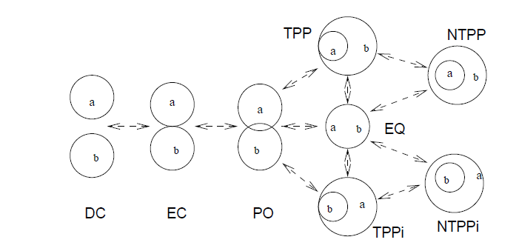

Fig: figure describing continuity and conceptual neighbours.

MOVEMENT PATTERN ANALYSIS USING QUALITATIVE SPATIAL CALCULAS

A possible counter-example that has been much discussed by the Region Connection . Calculus group is when a two-part scattered region x has one part inside y, and the other part outside y. If the inside part dwindles continuously to a point and then disappears, we have PO transformed into DC with no intervening instance of EC. The question is whether this kind of spatial change in which a component of a region disappears, is to count as continuous.

8. Qualitative Motion Representation:

Representation a course of motion qualitatively means abstracting from irrelevant details to get only the big directional changes which can be transformed in some qualitative categories for direction. So an observed course of motion should be simplified by some generalization algorithm.

9.1.1 Finding Efficient Reasoning Algorithm:

Large tractable subsets of spatial calculi are the most important part of efficient spatial reasoning. In order to find tractable subsets or even maximal tractable subsets several ingredients have to be provided-

1. One ingredient is a method for proving the complexity of a given subset or slightly weaker, a sound method for proving that a given subset is tractable.
2. The second ingredient is a way for finding subsets that might be tractable subsets and for which the method described above can be used. A set of n based relations contains 2n relations. It is impossible to test all subsets for tractability, so the number of candidate sets should be made as small as possible.
3. For a complete analysis of tractability it must be shown that the identified tractable subsets are maximal tractable subsets and that no

MOVEMENT PATTERN ANALYSIS USING QUALITATIVE SPATIAL CALCULAS

1. other subset which is not contained in one of the maximal tractable subsetsis tractable.

1.2 Generalization Algorithm:

Generalization algorithms are that algorithm that suppresses small zigzags and deviations and returns a course of motion that contains only the big directional changes and overall shape information.

Directional changes can be represented qualitatively as well as the distance between each directional changes. We can do this by mapping the numeric values for distance and angle into corresponding numerical values.

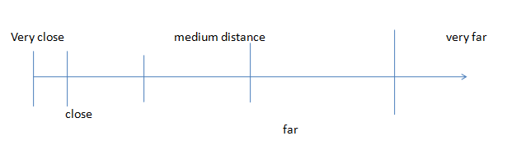

The qualitative values for distance can be e.g.. Named as------

a) Very close.

b) Close.

c) Medium close.

d) Far.

e) Very far.

The values for direction will be hence----

MOVEMENT PATTERN ANALYSIS USING QUALITATIVE SPATIAL CALCULAS

a) North.

b) East.

c) West.

d) South.

1.3 Speed of Object in Qualitative Motion:

The resulting qualitative representation of a course of motion is a sequence

ofqualitative motion vectors. Hence from this the speed of a particular object can be deducted as follows-----

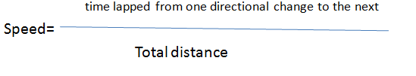

10.1.1 Interpreting Motion Events of Pairs of Moving Objects by Gottfried:

This interpretation aims at the investigation to identify possible patterns among moving objects. Instead of describing quantitatively the paths of objects, i.e. by lists of many precise positions, the main intention of our work is to identify qualitative features about how pairs of objects move relative to each other. Here, it is especially of importance to discover move in parallel or behind one another, either towards each other or whether they part or whether their paths cross, to maintain just some of the most obvious

MOVEMENT PATTERN ANALYSIS USING QUALITATIVE SPATIAL CALCULAS

relationships. Aiming at describing motion events in such a qualitative way, one of the main problems consists in identifying where to draw the line between different qualitative classes. This proposed method takes on the challenge by analysing how significant structures of different motion events look. In this way methods are provided that supplement localization technologies that are restricted to determine positions.

1.2 Relative Motion Descriptions:

Qualitative features should be recognisable independent of differences in position, orientation and size of entire motion events, i.e. we are interested in relative descriptions, which are translation-, rotation- and scale-invariant. There are several relative descriptions which have been proposed recently-

1. Relative positions and relative velocities are taken into account that set into relation a target objet with a reference object in order to describe the motion event of the former object with reference to later one.
2. Relative directions between objects are used in order to determine features of group of objects such as flock, leadership and convergence.
3. Oriented points are used in order to describe the relative direction between pair of objects. Changing distance among moving objects is considered.
4. Relative directions and relative positions between two oriented line segments are taken into account.

So which kinds of motion pattern can be distinguished when restricting the analysis to directional information?

There are several motivations for such restrictions.

* Direction is a basic spatial conception in GI science. Cardinal directions are used in order to locate object in geographic space. But taking cardinal direction alone it is generally not possible to unambiguously derive composite results. Then what about forming chains of motion pattern based solely on directional distinctions?

MOVEMENT PATTERN ANALYSIS USING QUALITATIVE SPATIAL CALCULAS

* One should be aware of the particular importance of directional information I the context of providing cognitive agents help in navigating. It has been motivated that orientation information is relevant for navigating agents.
* Investigating motion patterns of human and animal, who in a context might only be able to reliably distinguish directional information while metrical distinctions are hard or impossible to make.
* Using qualitative directions alone, in might, in particular, be of interest to analyse pairs of moving objects who adapt their directions with regard to other objects.
* While others also employ further dimensions such as velocity when investigating motion patterns, in order to better understand the influence of direction, it makes sense to analyse the dimension separately.
* Direction is the only dimension which does contribute to the shapes of trajectories distances and velocities do this only indirectly.

The result of these investigations will be that some qualitative features can indeed be derived using only directional information. While other features do need additionally the consideration of velocity or distance information. For the purpose of analysing directional information of motion events, we describe the possible changes in direction between pairs of objects and show how these types of changes combine. Such combinations can then be mappedto specific interpretations of the underlying motion events.

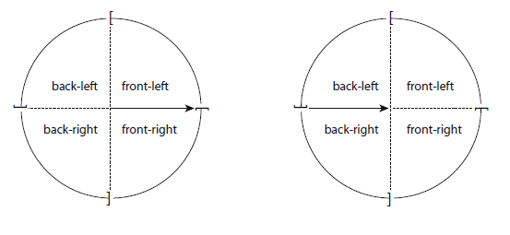

MOVEMENT PATTERN ANALYSIS USING QUALITATIVE SPATIAL CALCULAS

Fig: The quadripartite reference system is induced at the tail of the arrow (left) and at its head (right); the brackets are around the circles indicate that precisely font pertains to front-right, precisely right to back-right and so on.

1.3 Atomic Motion Patterns:

For two objects, O and P, the following distinctions are made:

– P moves towards O.

– P moves away from O.

– P moves left with respect to O.

– P moves right with respect to O.

Varying these four directions simultaneously for both O and P and combining them, we obtain 42 = 16 relations which is shown in the figure-----

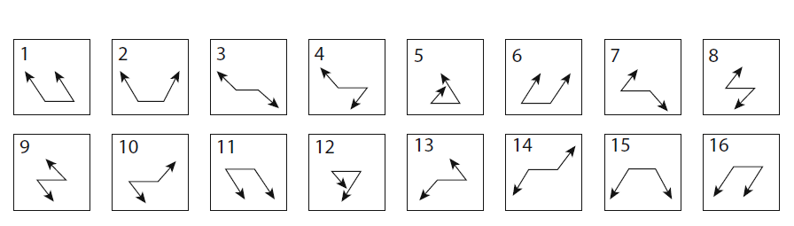

Fig: Sixteen classes of atomic motion patterns

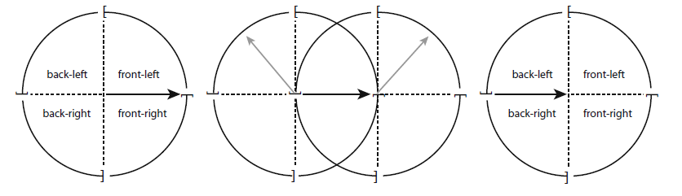

Fig: How a motion pattern (m2) is defined

MOVEMENT PATTERN ANALYSIS USING QUALITATIVE SPATIAL CALCULAS

These four possibilities derive from the four possible directions one can easily distinguish from both the egocentric view point and the bird’s eye view. The four directions define a single cross for each object separately, as shown for O on the left hand side of figure and for P on the right hand side; the arrow connects the positions of O and P. Verifying these four directions simultaneously for both objects O and P and combining them, we obtain four square which equals to 16 relations. Here each relation represents a bipartite motion pattern between to time point’s t0 and t1. The set of the sixteen atomic patterns is M = {m1, m2,… ,m16}; a relation algebra is defined on these patterns and they form the basis of diagrammatic representations as well.

Since O and P are always different, they always occupy different locations so that their positions never coincide; moreover, as far as them both move away from their initial positions, exactly one of the sixteen patterns holds. The sixteen atomic motion patterns have been introduced, which hold between two time points.

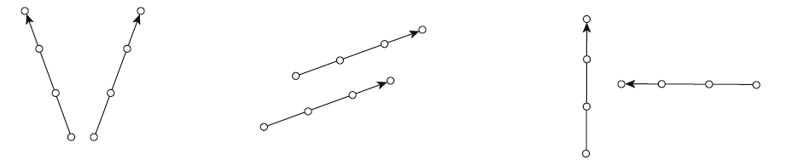

Fig: Two objects separating and moving in parallel and orthogonal to one another.

1.4 Changes in Motion Patterns:

Depending on the accuracy needed for the application at hand, it makes sense to break down motion events into a number of sections.

Let O and P be two different objects. Their relative locomotion during the time interval [t1,tn] is given through a list of atomic locomotion pattern {x1,x2,……….,xk}, xi belongs to M.

MOVEMENT PATTERN ANALYSIS USING QUALITATIVE SPATIAL CALCULAS

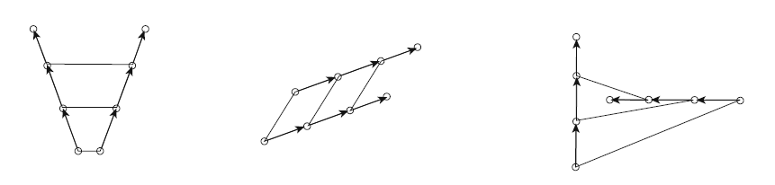

Fig: The motions events approximated by motion patterns.

Figure above shows how the straight trajectories are approximated by motion patterns. The list of patterns between the movements of objects are {m2, m2,m2}, {m1,m1,m1} and {m5,m5,m4}. The relations in these lists approximately describe how the two trajectories develop relative to each other. m2 to tells us that the trajectories fork, m2 tells us that they run in similar directions if not parallel and in the last example m5 says that they run towards each other before they diverged towards different but adjoining directions according to m4.

The complexity of these motion events is quite low. For the first two motion events single motion pattern suffice for accurately approximating them. For both motion events it holds that no object changes its direction nor do the relative directions between the objects change. The third example is slightly more sophisticated. Again neither of the two objects changes its direction of movement but now they move orthogonally to one another and there is a point in time at which their relative motion direction changes. This is the region why m4 takes the place of m5 in the third example.

MOVEMENT PATTERN ANALYSIS USING QUALITATIVE SPATIAL CALCULAS

1.5 Example of Different Motion Patterns:

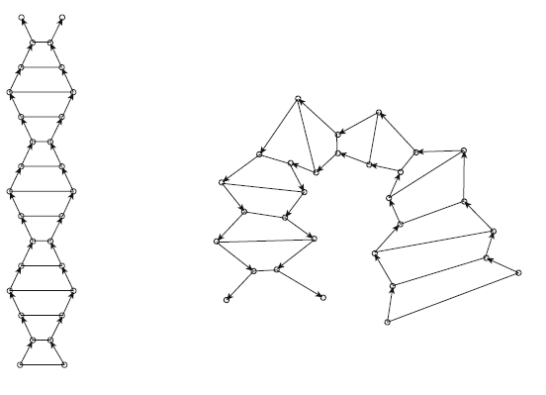

Fig: The motion patterns based on m2 and m5.

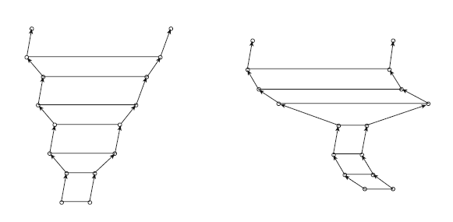

Fig: Motion patterns based on m1,m2 and m6.

1.6 Single Changes:

If only one of the two objects changes its direction of movement, the new relation which holds between that object and the other object can be read off the neighborhood graph. That is one of the four possible relations with which

MOVEMENT PATTERN ANALYSIS USING QUALITATIVE SPATIAL CALCULAS

each relation is connected in the neighborhood graph will hold after such a single change. For instance, if m1 holds and the first object changes towards front-length, then m5 holds and if the other object changes its direction of movement, either m2 or m4 follows.

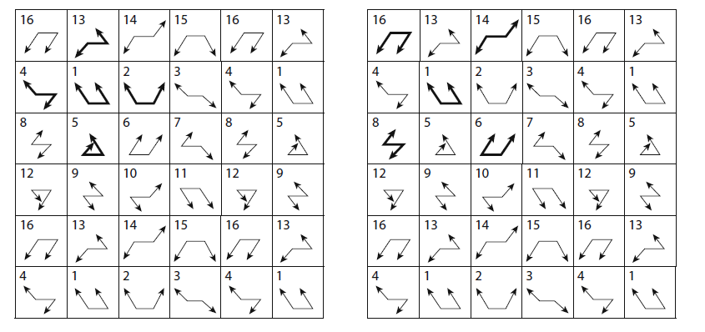

Fig: Left:If m1 holds, there are four possibility patterns (m2,m5,m4,m13) thatmight when one object changes its direction. Right: If both objects change their direction simultaneously than four possible patterns might follow (m6,m8,m14,m16).

1.7 Double Changes:

If both objects simultaneously change their directions, the new relation can also be read off the neighbourhood graph. But now a relation follows which is one of the next but one relation in the neighbourhood graph.

1.8 Abrupt changes:

Abrupt changes occur when an object suddenly moves backward. For example. In such a case the other object either might not change its direction it might change it by a single turn or it might change abruptly.

MOVEMENT PATTERN ANALYSIS USING QUALITATIVE SPATIAL CALCULAS

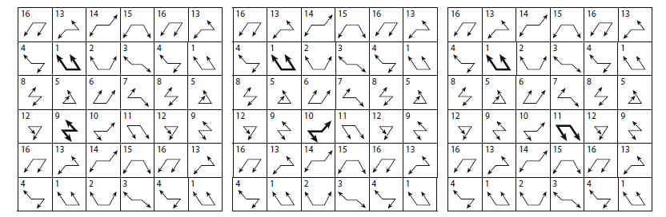

Fig: Left: One object abruptly changes its direction. Middle: The other object changes too, but only by a single turn. Right: Both objects abruptly change their directions.

1.9 No Changes:

In this situation neither of the two objects changes its direction. Instead it is crucial how the two trajectories develop relative to each other. That is, this case implies that the reference axis for the patterns will suddenly have another orientation. Therefore, this will be similar to the case that both objects change their directions because the relative direction will now determined with the new orientation of the reference segment for both objects simultaneously.

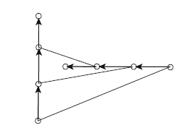

For example in this above diagram the motion patterns change from m4 to m5. Although neither of the two objects changes its direction they both move straight.

MOVEMENT PATTERN ANALYSIS USING QUALITATIVE SPATIAL CALCULAS

1.10 Locality of Changes:

Having analysesthe relative motion of objects, we should be aware of the fact that it is the relative development of the trajectories and not their overall shape that is dealt with here.

11. Constraints/Predicates for the Gottfried Movement Patterns:

Here we have applied the basic mathematical co-ordinate geometry to evaluate the predicates for the sixteen possible movement patterns as mentioned by Gottfried earlier.

m1: (x1/,y1/) (x2/,y2/)

l1l2

(x1,y1) (x2,y2)

For l1, slope m1 = (y1/-y1) / (x1/-x1) = negative.

For l2, slope m2= (y2/-y2) / (x2/-x2) = negative.

Here, m1= m2.

And also, y1/ >y1 and y2/>y2.

MOVEMENT PATTERN ANALYSIS USING QUALITATIVE SPATIAL CALCULAS

m2:

(x1/,y1/) (x2/,y2/)

l1 l2

(x1, y1) (x2, y2)

For l1, slope m1 = (y1/-y1) / (x1/-x1) = negative.

For l2, slope m2= (y2/-y2) / (x2/-x2) = positive.

Here, m1≠ m2.

And also, y1/ >y1 and y2/>y2.

m3: (x1/,y1/)

l1

(x2, y2)

(x1, y1) l2 (x2/ , y2/)

MOVEMENT PATTERN ANALYSIS USING QUALITATIVE SPATIAL CALCULAS

For l1, slope m1 = (y1/-y1) / (x1/-x1) = negative.

For l2, slope m2= (y2/-y2) / (x2/-x2) = negative.

Here, m1= m2.

And also, y1/ >y1 and y2/<y2.

m4: (x1/,y1/)

l1

(x1,y1) (x2,y2)

l2

(x2/,y2/)

For l1, slope m1 = (y1/-y1) / (x1/-x1) = negative.

For l2, slope m2= (y2/-y2) / (x2/-x2) = positive.

Here, m1≠ m2.

And also, y1/ >y1 and y2/<y2. (x2/, y2/)

m5: (x1/, y1/)

l1 l2

(x1, y1) (x2, y2)

For l1, slope m1 = (y1/-y1) / (x1/-x1) = positive.

For l2, slope m2= (y2/-y2) / (x2/-x2) = negative.

MOVEMENT PATTERN ANALYSIS USING QUALITATIVE SPATIAL CALCULAS

Here, m1≠ m2.

And also, y1/ >y1 and y2/>y2.

m6:(x1/, y1/)

(x2/, y2/)

l1l2

(x1, y1) (x2, y2)

For l1, slope m1 = (y1/-y1) / (x1/-x1) = positive.

For l2, slope m2= (y2/-y2) / (x2/-x2) = positive.

Here, m1= m2.

And also, y1/ >y1 and y2/>y2.

m7:(x1/, y1/)

l1

(x1, y1) (x2, y2)

L2

(x2/, y2/)

MOVEMENT PATTERN ANALYSIS USING QUALITATIVE SPATIAL CALCULAS

For l1, slope m1 = (y1/-y1) / (x1/-x1) = positive.

For l2, slope m2= (y2/-y2) / (x2/-x2) = negative.

Here, m1≠ m2.

And also, y1/ >y1 and y2/<y2.

m8:(x1/, y1/)

l1

(x2, y2)

(x1, y1)

L2

(x2/, y2/)

For l1, slope m1 = (y1/-y1) / (x1/-x1) = positive.

For l2, slope m2= (y2/-y2) / (x2/-x2) = positive.

Here, m1= m2.

And also, y1/ >y1 and y2/<y2.

MOVEMENT PATTERN ANALYSIS USING QUALITATIVE SPATIAL CALCULAS

m9:(x2/, y2/)

l2

(x1, y1)(x2, y2)

l1 (x1/, y1/)

For l1, slope m1 = (y1/-y1) / (x1/-x1) = negative.

For l2, slope m2= (y2/-y2) / (x2/-x2) = negative.

Here, m1= m2.

And also, y1/ <y1 and y2/>y2.

m10:(x2/, y2/)

l2

(x1, y1) (x2, y2)

l1

(x1/, y1/)

For l1, slope m1 = (y1/-y1) / (x1/-x1) = negative.

For l2, slope m2= (y2/-y2) / (x2/-x2) = positive.

MOVEMENT PATTERN ANALYSIS USING QUALITATIVE SPATIAL CALCULAS

Here, m1≠ m2.

And also, y1/ <y1 and y2/>y2.

m11: (x2, y2)

(x1, y1) l2

l1

(x1/, y1/) (x2/, y2/)

For l1, slope m1 = (y1/-y1) / (x1/-x1) = negative.

For l2, slope m2= (y2/-y2) / (x2/-x2) = negative.

Here, m1= m2.

And also, y1/ <y1 and y2/<y2.

m12:(x1, y1) (x2, y2)

l1 l2

(x1/, y1/)

(x2/, y2/)

For l1, slope m1 = (y1/-y1) / (x1/-x1) = negative.

For l2, slope m2= (y2/-y2) / (x2/-x2) = positive.

Here, m1≠ m2.

And also, y1/ <y1 and y2/<y2.

MOVEMENT PATTERN ANALYSIS USING QUALITATIVE SPATIAL CALCULAS

m13: (x2/, y2/)

(x1, y1) l2

(x2, y2)

l1

(x1/, y1/)

For l1, slope m1 = (y1/-y1) / (x1/-x1) = positive.

For l2, slope m2= (y2/-y2) / (x2/-x2) = negative.

Here, m1≠ m2.

And also, y1/ <y1 and y2/>y2.

m14: (x2/, y2/)

l2

(x1, y1) (x2, y2)

l1

(x1/, y1/)

For l1, slope m1 = (y1/-y1) / (x1/-x1) = positive.

For l2, slope m2= (y2/-y2) / (x2/-x2) = positive.

Here, m1= m2.

MOVEMENT PATTERN ANALYSIS USING QUALITATIVE SPATIAL CALCULAS

And also, y1/ <y1 and y2/>y2.

m15:(x1, y1) (x2, y2)

l1 l2

(x2/, y2/)

(x1/, y1/)

For l1, slope m1 = (y1/-y1) / (x1/-x1) = positive.

For l2, slope m2= (y2/-y2) / (x2/-x2) = negative.

Here, m1≠ m2.

And also, y1/ <y1 and y2/<y2.

m16: (x1, y1) (x2, y2)

l1 l2

(x2/, y2/)

(x1/, y1/)

For l1, slope m1 = (y1/-y1) / (x1/-x1) = positive.

For l2, slope m2= (y2/-y2) / (x2/-x2) = positive.

Here, m1= m2.

And also, y1/ <y1 and y2/<y2.

MOVEMENT PATTERN ANALYSIS USING QUALITATIVE SPATIAL CALCULAS

Implementation:

To implement the required objective of our project we have used the JAVA programming language. At first we tried it by taking some arbitary synthetic points. We created the programme in such a way that on clicking the mouse on the frame it will show dots on the place in which it has been clicked. For calculation purpose we store the values of each co-ordinate in arrays. Since we are working on two objects, so we have to take four arrays for them; two for each object's x and y co-ordinate. The limits of these arrays are taken as 100 as shown below.

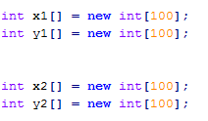

The interface will have one start and one stop button. For object one and object two (reference and the other object) there will be two more buttons named as Object1 and Object2. For clicking the dots for object1, user has to click the start button first and then the object1 button. Same will be applied for the object two also. The Stop button will delete all the point co-ordinates from the arrays in which they are stored. The interface will look as shown in below. There will be a textarea down there at the bottom of the interface in which the movement patterns for the two objects will be shown in the Regular Grammer format.

MOVEMENT PATTERN ANALYSIS USING QUALITATIVE SPATIAL CALCULAS



Also, we have seen three extra buttons at the right of the interface which are named as GetRelation, ReadFromFiles and StoreInFiles. After clicking the GetRelation button, all of the movement pattern relations between the two objects will appear on the textarea in a regular grammer formate as mentioned before. This synthetic idea is actually to see how well the idea of our codings will be able to implement when we will take a real time video in hand for two moving objects. So, since this coding implementation will be done on a video later on so we must have to create a way of storing the co-ordinates into a file and a way of retrieving those co-ordinate points again from that file. So, for storing purpose we have the StoreInFiles button and for retrieving purpose we have the button ReadFromFiles. The retrieved co- ordinate points will be actually stored in those arrays which were created before for each object's x and y co-ordinates.

MOVEMENT PATTERN ANALYSIS USING QUALITATIVE SPATIAL CALCULAS

Diagram showing gottfried constraint m2 in the interface is given below.

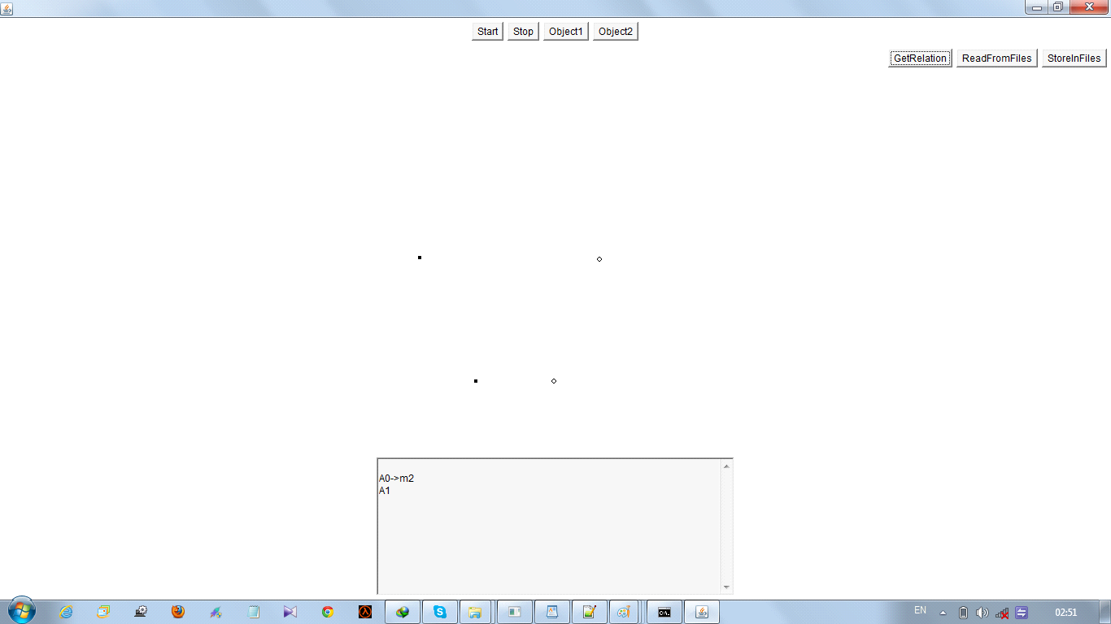

The black dot is for object one and white dot is for object two.

For multiple relations:

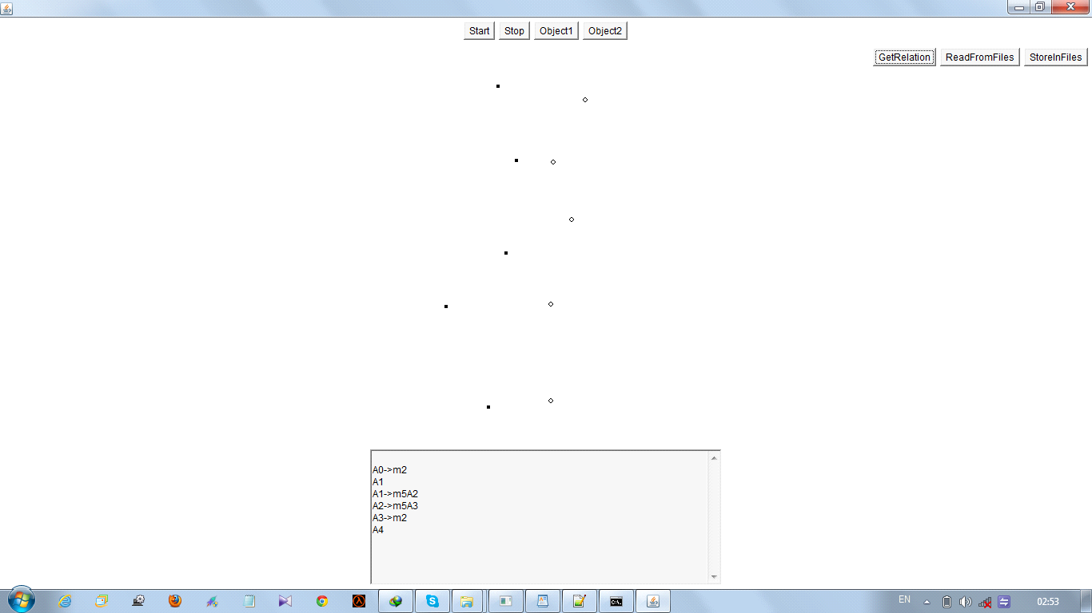

MOVEMENT PATTERN ANALYSIS USING QUALITATIVE SPATIAL CALCULAS

Here, the name of the file in which the co-ordinate points is to be stored is named as "data.txt" file. The co-ordinate values will be stored in the file as shown in the diagram below. The "#" in between each of the co-ordinate points is kept so that when we will try to retrieve those points to store in each specific array for each x and y co-ordinate for the two objects, then we can store those by just using the "StringTokenizer" format for "#".



MOVEMENT PATTERN ANALYSIS USING QUALITATIVE SPATIAL CALCULAS

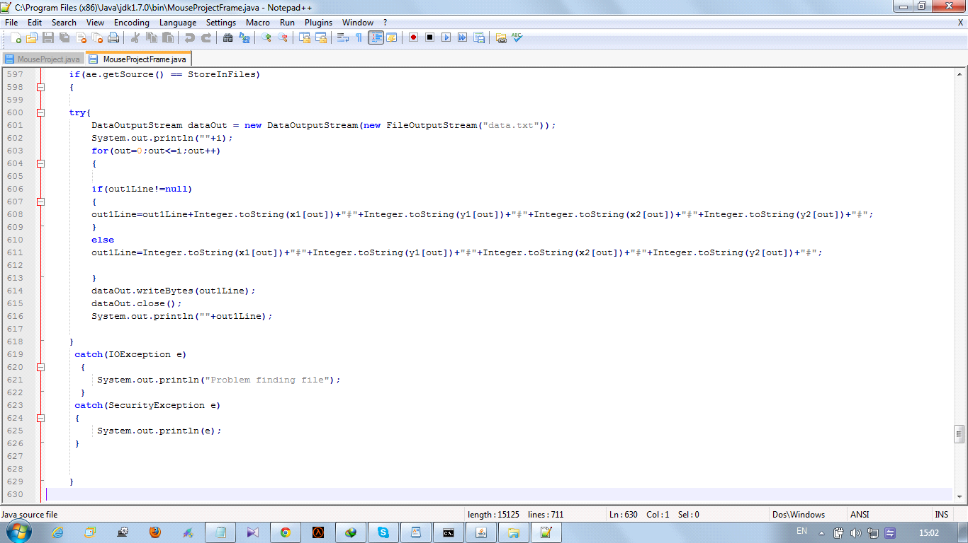

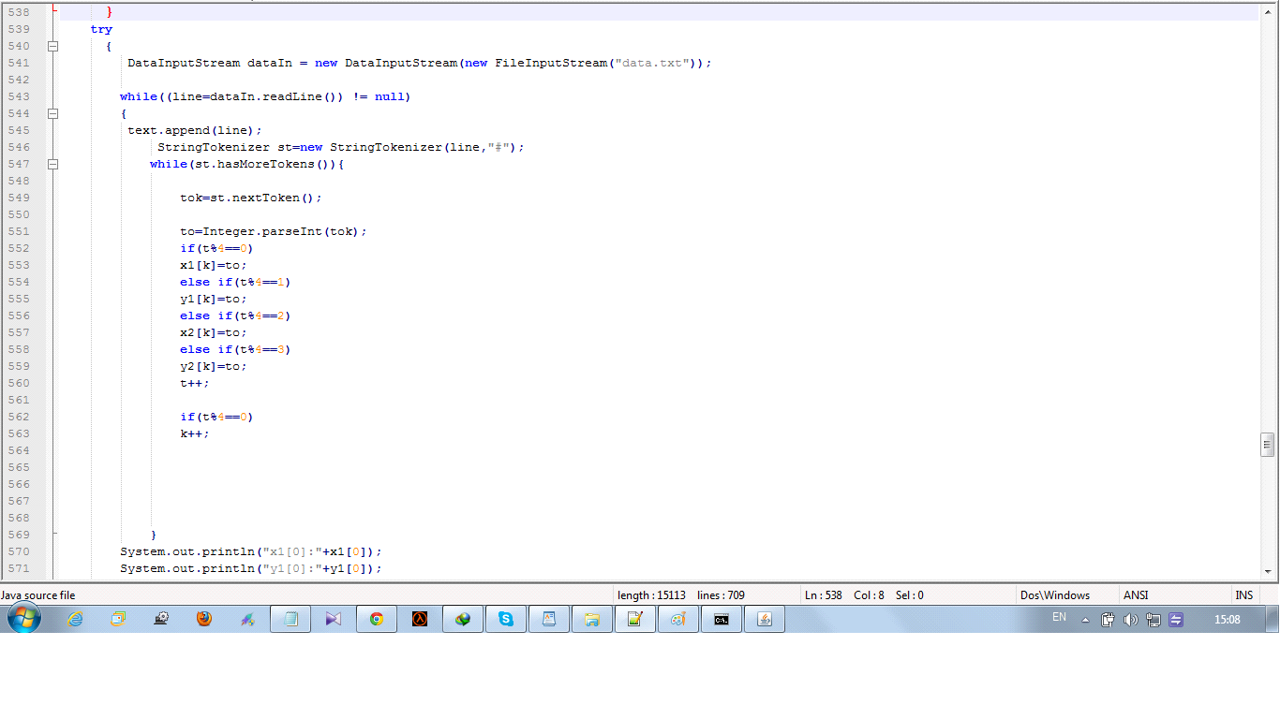

MOVEMENT PATTERN ANALYSIS USING QUALITATIVE SPATIAL CALCULAS

13. References:

-Qualitative Spatial Change : Space Time Histories and Continuity by Shyamanta M. Hazarika.

- Qualitative Spatial Reasoning by Christian Freska.

- Interpreting Motion Events of pairs of Moving Object by Bjorn Gottfried.

- Qualitative Calculus by Ligozat and Renz.

- Handbook of knowledge representation by Harmelen, Lifschitz and Porter.