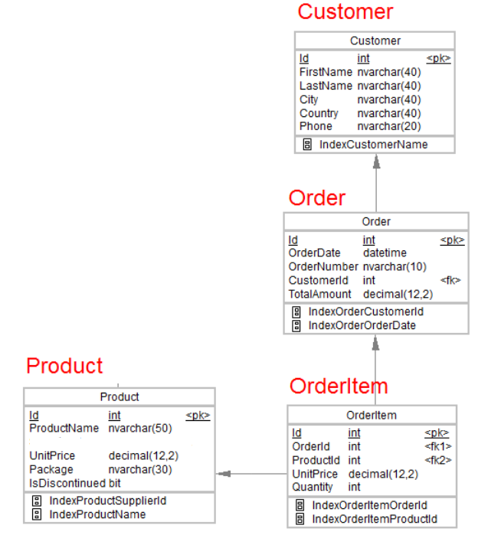

1.Desgin the above database with following table by applying Primary key and Foreign key

2.Insert Records in all tables

3.In Customer table FirstName Attribute should not accept null value

4.In Order table OrderDate should not accept null value

5.Display all customer details

6.write a query to display Country whose name starts with A or I

7 .write a query to display whose name of customer whose third character is i

CREATE TABLE Customer(id int PRIMARY KEY, FirstName nvarchar(40),LastName nvarchar(40),City nvarchar(40), Country nvarchar(40),Phone nvarchar(20));

CREATE TABLE Order1 (id int PRIMARY KEY, OrderDate DATETIME, OrderNumber nvarchar(10), CustomerId int, TotalAmount decimal(12,2))

CREATE TABLE Product(id int PRIMARY KEY, ProductName nvarchar(50), UnitPrice decimal(12,2), Package nvarchar(30), isDiscontinued bit);

CREATE TABLE OrderItem(id int PRIMARY KEY, OrderId int, ProductId int, UnitPrice decimal(12,2), Quantity int);

INSERT INTO Customer (id, FirstName, LastName, City, Country, Phone) VALUES (1, 'Rohit', Sharma, 'Mumbai', 'India', 9822109450)

INSERT INTO Customer (id, FirstName, LastName, City, Country, Phone) VALUES (2, 'Shyam', 'Sundar', 'Mumbai', 'India', '9020304050')

INSERT INTO Customer (id, FirstName, LastName, City, Country, Phone) VALUES (3, 'Rutuja', 'Kale', 'America', 'USA', '125478932')

INSERT INTO Customer (id, FirstName, LastName, City, Country, Phone) VALUES (4,'Rahul', 'Darekar', 'Bangalore', 'India', '741258930')

INSERT INTO Customer (id, FirstName, LastName, City, Country, Phone) VALUES (5,'Soham', 'Pathare', 'Kanpur', 'India', '012547896')

INSERT into Order1(id, OrderDate, OrderNumber, CustomerId, TotalAmount) VALUES(101, 12-03-2022, 'OD771', 1, 2200.00);

INSERT into Order1(id, OrderDate, OrderNumber, CustomerId, TotalAmount) VALUES(102, 12-04-2022, 'OD772', 2, 3500.00);

INSERT into Order1(id, OrderDate, OrderNumber, CustomerId, TotalAmount) VALUES(103, 12-02-2022, 'OD773', 3, 4785.00);

INSERT into Order1(id, OrderDate, OrderNumber, CustomerId, TotalAmount) VALUES(104, 12-01-2022, 'OD774', 4, 1452.00);

INSERT into Order1(id, OrderDate, OrderNumber, CustomerId, TotalAmount) VALUES(105, 12-02-2022, 'OD775', , 7458.00);

INSERT INTO PRODUCT(id, ProductName, UnitPrice, Package, isDiscontinued) VALUES(31, 'Bottle', 400.00, 'yes', 0);

INSERT INTO PRODUCT(id, ProductName, UnitPrice, Package, isDiscontinued) VALUES(32, 'Jug', 500.00, 'no', 1);

INSERT INTO PRODUCT(id, ProductName, UnitPrice, Package, isDiscontinued) VALUES(33, 'Table', 2000.00, 'no', 0);

INSERT INTO PRODUCT(id, ProductName, UnitPrice, Package, isDiscontinued) VALUES(34, 'Chair', 3500.00, 'yes', 1);

INSERT INTO PRODUCT(id, ProductName, UnitPrice, Package, isDiscontinued) VALUES(55, 'Mixer', 4500.00, 'yes', 0);

Insert into OrderItem(id, OrderId, ProductId, UnitPrice, Quantity) VALUES (301, 101, 50,000.00, 2);

Insert into OrderItem(id, OrderId, ProductId, UnitPrice, Quantity) VALUES (302, 102, 51,000.00, 4);

Insert into OrderItem(id, OrderId, ProductId, UnitPrice, Quantity) VALUES (303, 103, 53,3200.00, 8);

Insert into OrderItem(id, OrderId, ProductId, UnitPrice, Quantity) VALUES (304, 104, 54,000.00, 10);

Insert into OrderItem(id, OrderId, ProductId, UnitPrice, Quantity) VALUES (305, 105, 55,000.00, 5);

-------------------------------------------------------------

ALTER TABLE Orderitem

ADD FOREIGN KEY(ProductId) REFERENCES Product(id);

ALTER TABLE Orderitem

ADD FOREIGN KEY(ProductId) REFERENCES Product(id);

ALTER TABLE Order1

ADD FOREIGN KEY(CustomerId) REFERENCES Customer(id);

ALTER TABLE Customer

ALTER Column FirstName nvarchar(40) NOT NULL;

ALTER TABLE Orders

ALTER COLUMN OrderDate datetime NOT NULL;

Select * from Customer;

Select * from Customer WHERE Country LIKE 'i%' or Country LIKE 'a%'

Select * from Customer WHERE FirstName LIKE '__i%'