1st page <https://tejasya.com.np/>

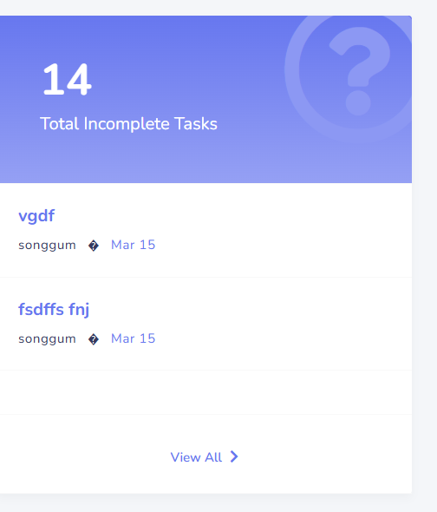

Yo chai vitra pending task haru aaauni, content chai jamma 2 ota aauxa ahile, 5 ota haru aauni ani scroll garna milni banau.

<https://tejasya.com.np/Common/Task?IsCaseRelated=false> yo page ko   
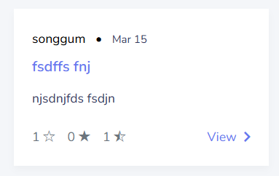  
yo info haru dekhanauni ho hai hai k k rakhna milxa . herana

2nd page : <https://tejasya.com.np/User/User>  
yesma chai , user ko profile ramro hai.

2 otai side ma. Ani page full content huna paryo hai.

3rd page : go to https://tejasya.com.np/Admin/User/UsersList.

then 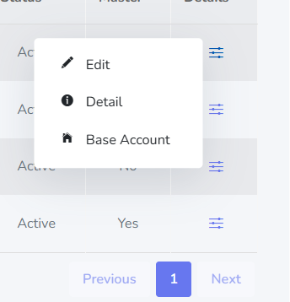

yo user ko detail page banauni hai. Popup model ma. Popup model kasto hunxa vane edit ko hera hai.

4th page : <https://tejasya.com.np/Admin/Company>  
same company ko ni details gape baauni. Ani content chai edit ko halni hai. Tyo ni popup model.

5th page: <https://tejasya.com.np/Vehicle/Navigation/SelectMenu/5>



yo page ramrod banuni hai, ani remarks chai textarea rakhni hai.

6th page:

yo ali k namile namileko jasto xa yo ramrod baunui hai.

7th page: <https://tejasya.com.np/Common/Memo/Index/1?forAll=True>

<https://tejasya.com.np/Common/Memo/Index/1?forAll=False>

Yo 2 ota milauni hai. Ramrod banuni.

Ani yesma forme or farall xa. Same ho, forall ma chai user ko detail hunxa . tyo milauni. Ani date ni rakhna xa hai kaile create ra last edit gareko vanera.

7th page: <https://tejasya.com.np/Vehicle/Sms/GetAll/1>

ANI Yesma ni ramrod banuni. Date rakhni yesma ni kaile create garekoa vanera. Ani username ni hunxa yesma.

Ani yo pani ramrod banauni hai.

Yo pani toogler garda ramrod dekni paryo. Ahile mileko xaina.

8th page: <https://tejasya.com.np/User/Insurance>, view click garesi

Yesma insuranc ko detail dekhanua paryo. Popup ma hoina, full page ma. Ani

Facebook ma jasgto cover photo ra profule photo huna oaryo. Insurance ko <https://tejasya.com.np/Admin/Insurance>

Yesma gara edit ko info haru dekhauna paryo. Admin ko insurance kod detail ra user ko insurance detail farak hunxa. Ani yesma chai form haru hunxa , form ko naam ko side ma , download button, ani whatsapp, viber, sms, email ko button huna paryo.

9th page: <https://tejasya.com.np/Vehicle/VehicleInfo/Upsert/5?identifier=OD&isUpdate=True>  
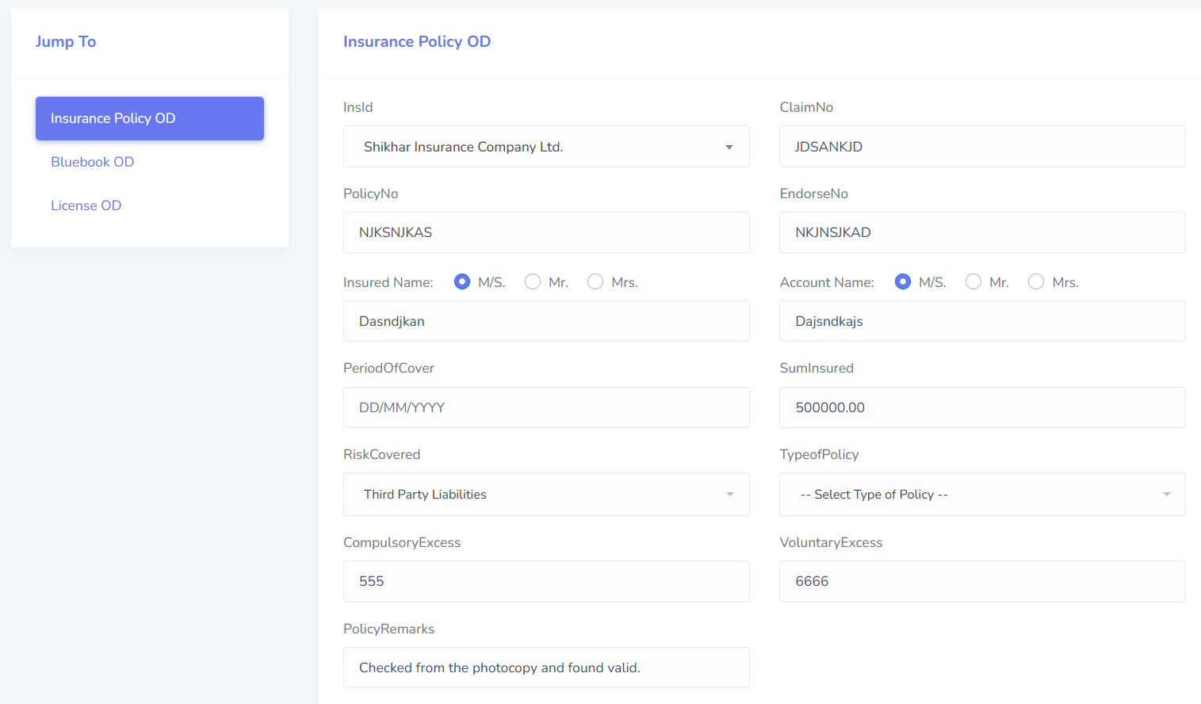  
yo k namilekos jasto dekhinye xa. Yo milauna paryo. Baru side ko menu wla tab lai mathi rakhna hunxa. Form vitra ko input haru change agrna parena, side ko menu lai mathi Rakha hunxa ki horizontalma. Ahile vertical ma xa ni.

10th page: <https://tejasya.com.np/Common/Pdf/GetAll/1>

Yesma detail haru vorna paryuo. Create gareko date, userko detail, ani create garda jun aauxa ni, name , pdfor, ty oni aauna paryo. Ani description chai optional ho. Tei vara, description vaye description ni dekhauna paryo. Ani yesma chai. Detail ko auta popup pani banuna paryo. Sabai dekhini.

11th page: https://tejasya.com.np/User/ReportStatus

yesma chai 6th page ko detail dekhanni ho, tara full page ma ramrod dekhni gari.

Ahile aada matra xa.

12th footer:

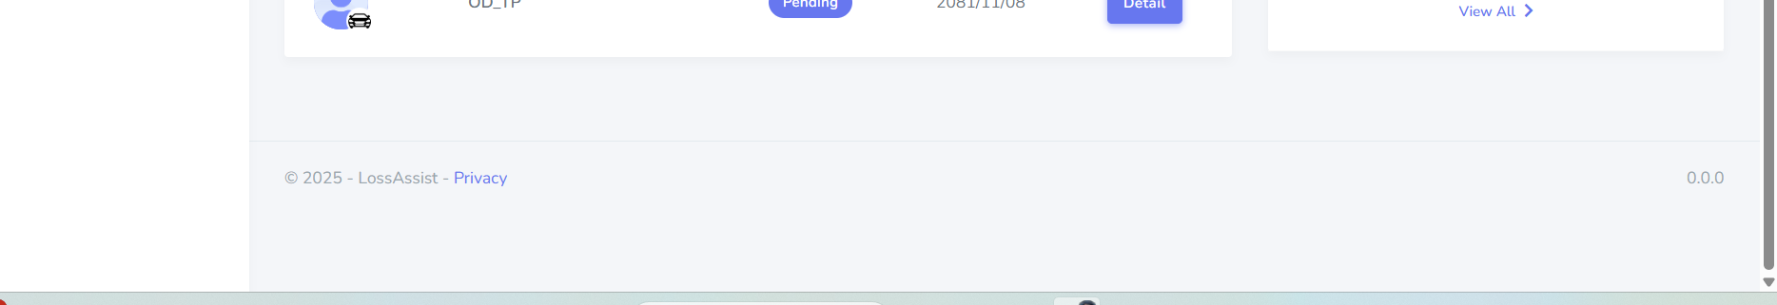

Footer thulo vako xa. Sano patalo banuni.. ani yesma content haru k k rakhan milxa, aru ni thapni. Herda ramrod.

13th page: <https://tejasya.com.np/Vehicle/Assessment/Upsert/5?identifier=TP2&IsVat=true>

Yesma chai, filter change garda, tyo row ko color change huna paryo. Kunai pani select gareko xaina vane, white. Natra aru xa vane, 5 ota different light color haru aauna paryo row ma. 5 ota items xa filter ma tei anusar aauna paryo.

Ani jun row select hunxa, tyo row chai aafnai row ko color ko dark colour huna paryo.

14th page: <https://tejasya.com.np/Vehicle/Assessment/CalculationTPs/5?identifier=TP2&isAssessSpecs=True>

Yo page ma chai

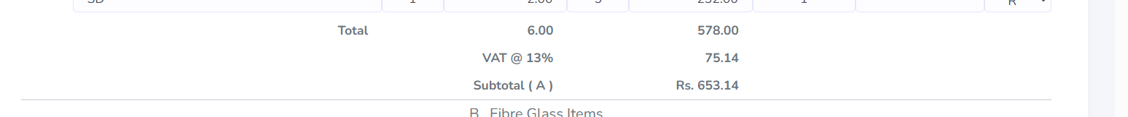

Yesma ali ramrod dekhina paryo.

.

Ani yesma chai different condition hunxa. Status report ma gara, repairs, total loss, cashloss change gardai test gara. Ani tax, vat ra both ni hunxa. Tyo ni hera hai. Overall page nai ramrod banauna na.