BEL

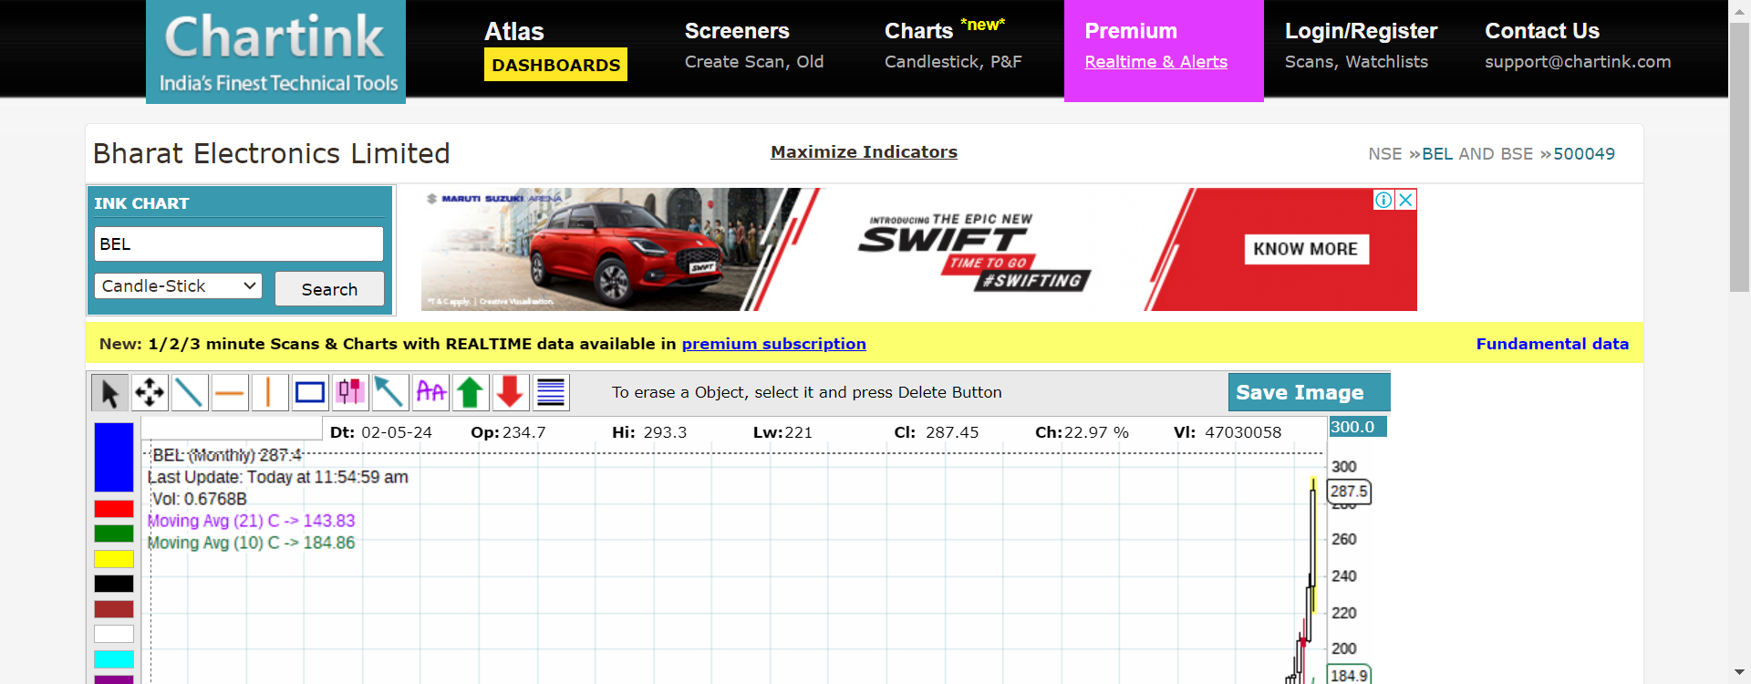

https://chartink.com/stocks/BEL.html

INFY

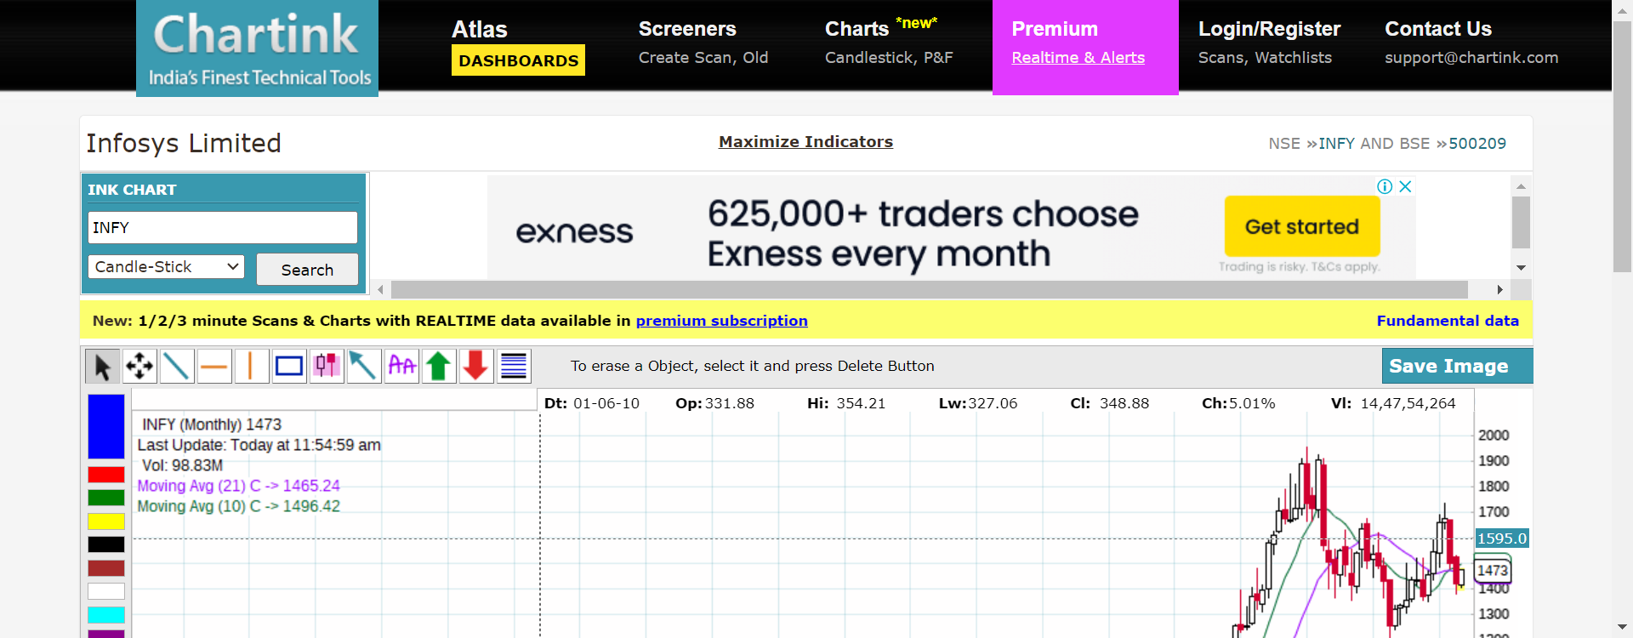

https://chartink.com/stocks/INFY.html