I’ve used same VM which one used for 1st Task

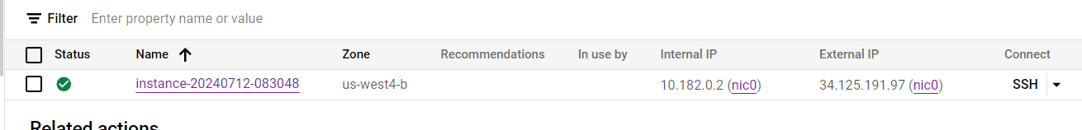

After that in /home/dhirajub1993/dhiru directory I’ve created main.tf

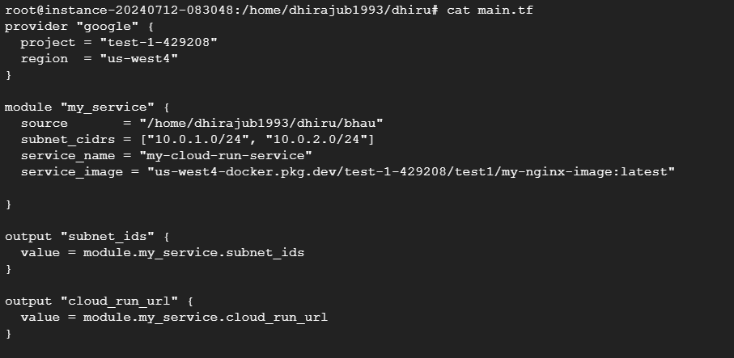

In dhiru directory I’ve created bhau directory to mention all terraform modules

Main.tf

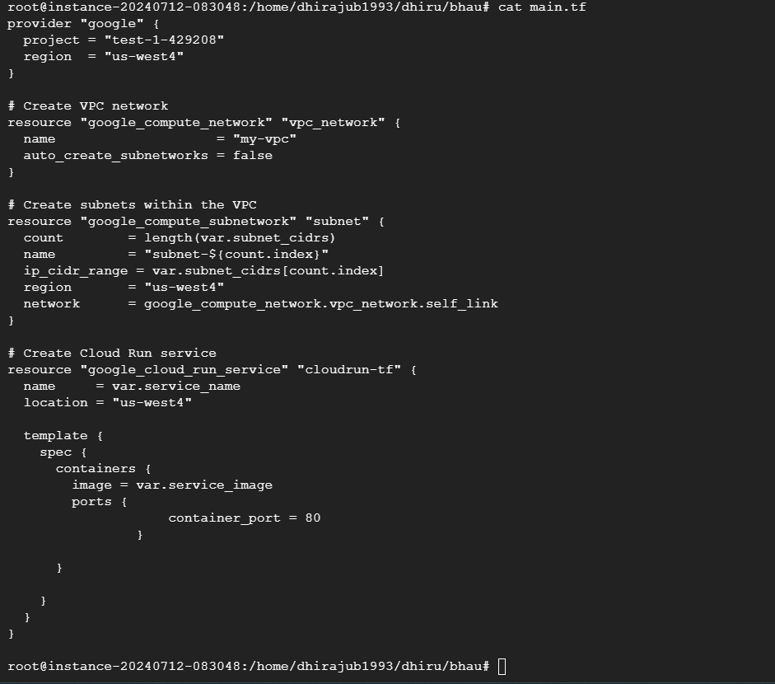

Variables.tf

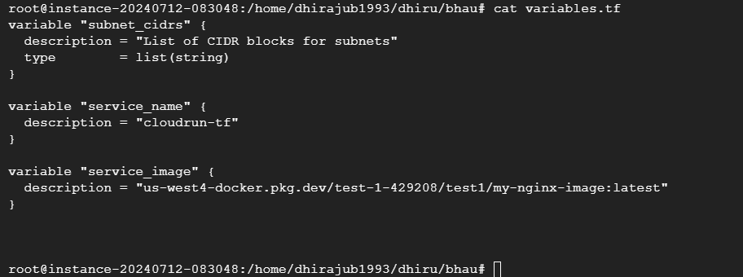

terraform.tf

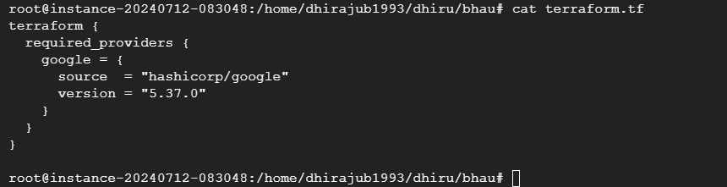

Output.tf

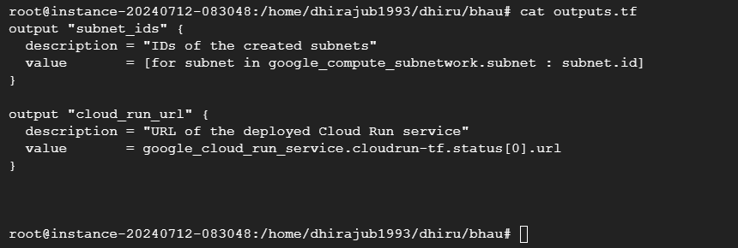

After that I’ve initialize terraform from dhiru directory

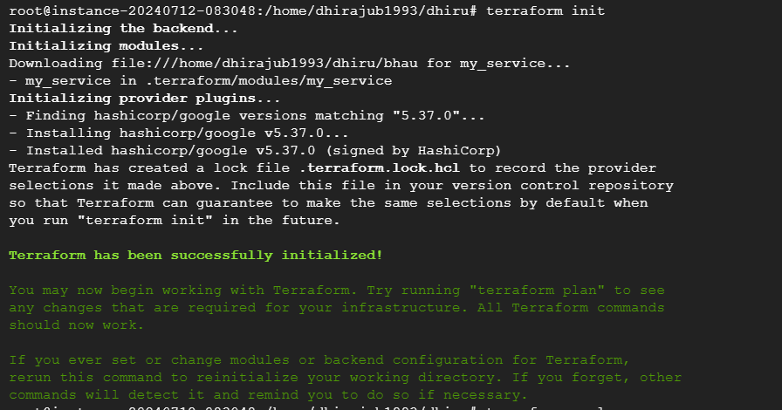

After init hit the apply command to deploy vpc, subnet and cloudrun service.

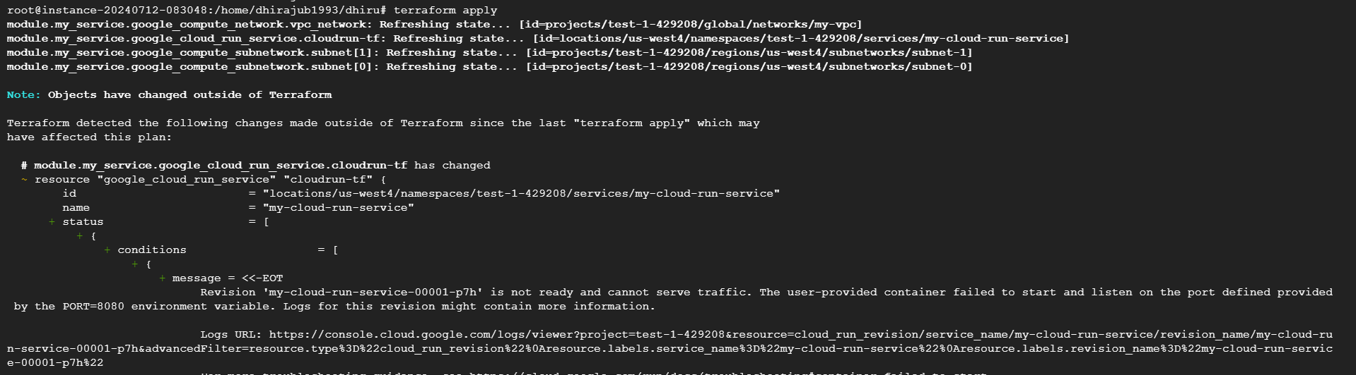

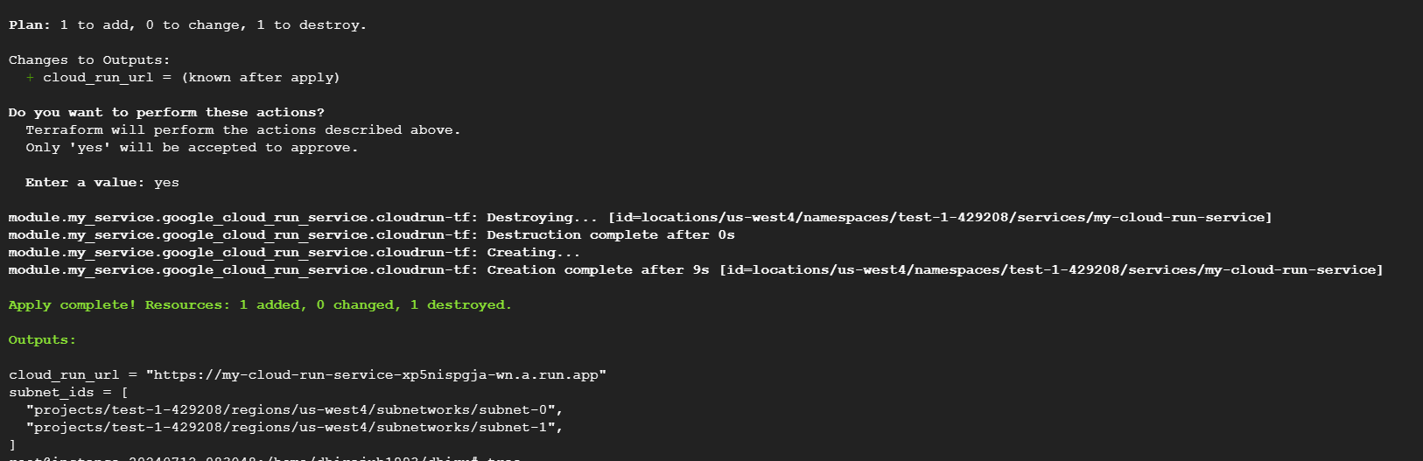

Find below tree command output

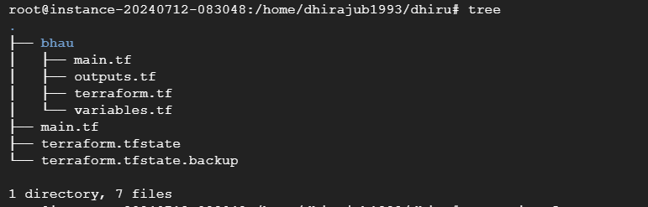

Below is the vpc created :-

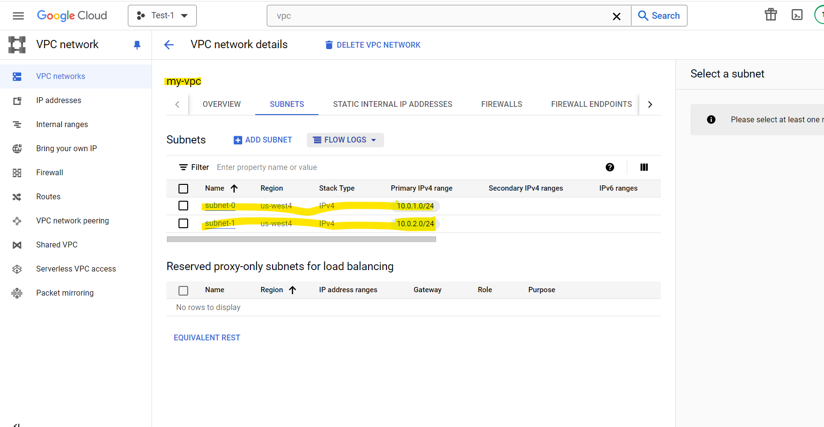

Below is the cloudrun service :-

