I’ve created new project first- Test1

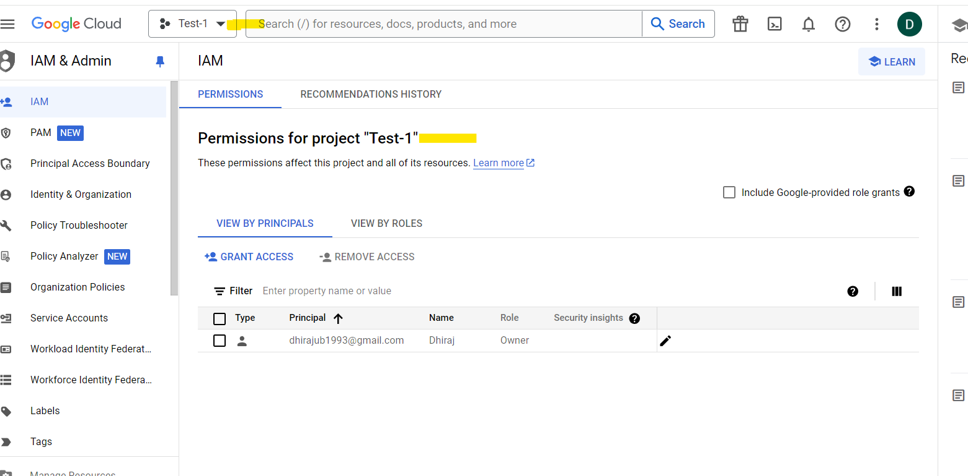

Creating a GCP VM to create docker file and push docket image to artifacts.

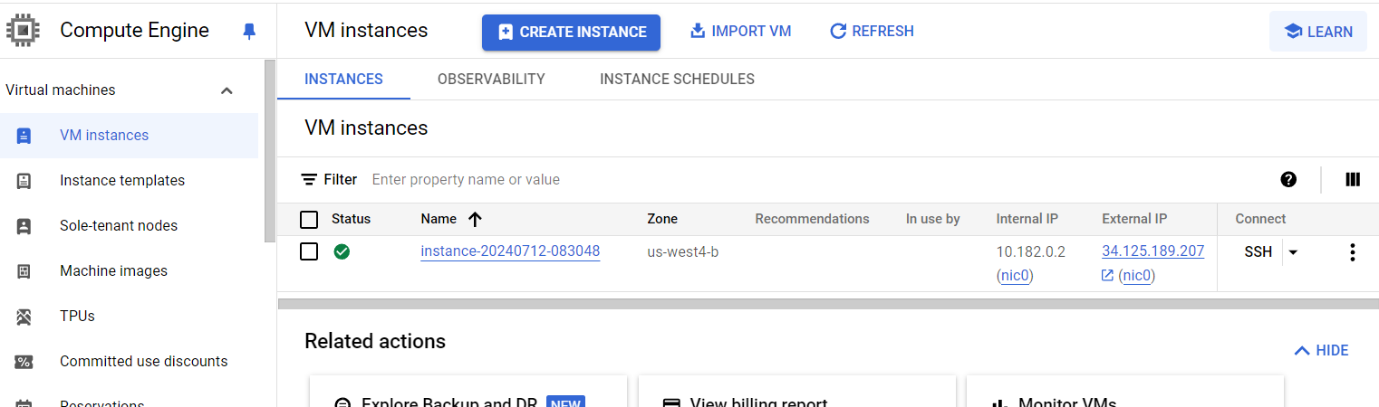

Installed Docker on the VM:

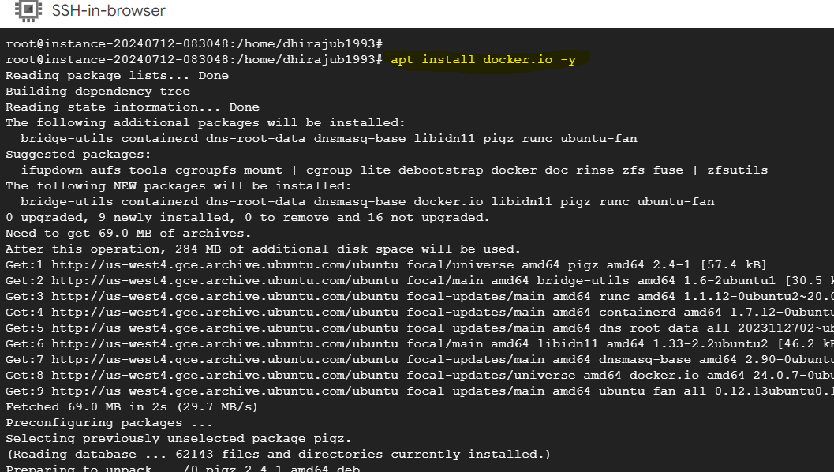

I’ve created docker file and push this image to artifact

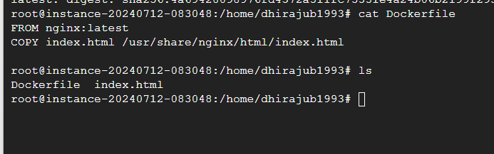



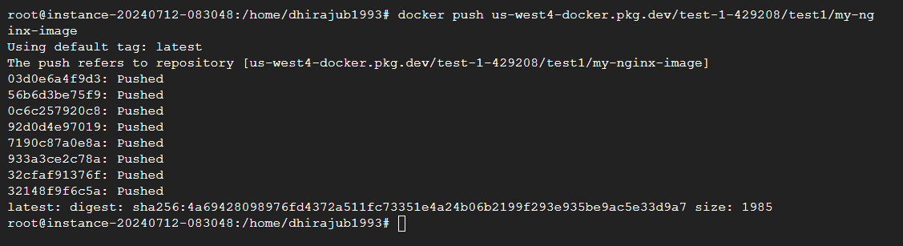

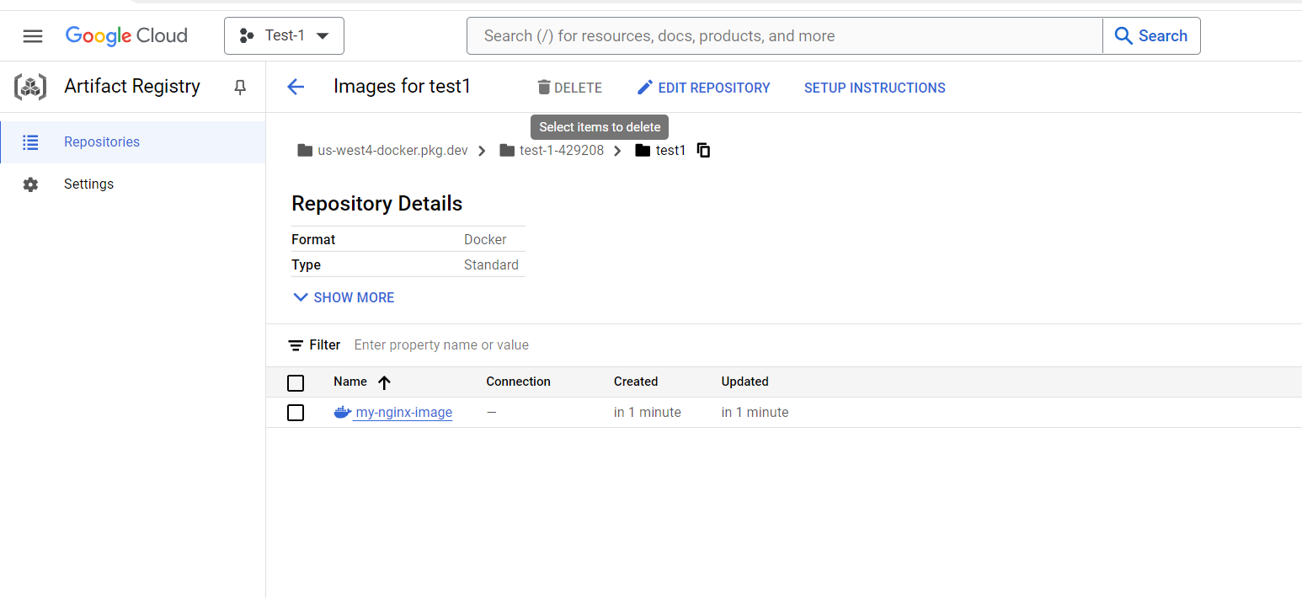

Then I’ve installed terraform

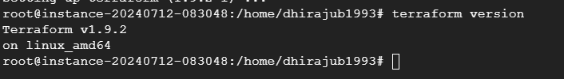

Created main.tf file to run cloud run service along with iam policy to access publicly

Before terraform apply we have to run terraform init to initialize

terraform {

required_providers {

google = {

source = "hashicorp/google"

version = "5.37.0"

}

}

}

provider "google" {

project = "test-1-429208"

region = "us-west4"

zone = "us-west4-b"

}

resource "google_cloud_run_service" "cloudrun-tf" {

name = "cloudrun-tf"

location = "us-west4"

template {

spec {

containers {

image = "us-west4-docker.pkg.dev/test-1-429208/test1/my-nginx-image"

ports {

container_port = 80

}

}

}

}

traffic {

percent = 100

latest_revision = true

}

}

resource "google_cloud_run_service_iam_policy" "pub1-access" {

location = google_cloud_run_service.cloudrun-tf.location

service = google_cloud_run_service.cloudrun-tf.name

policy_data = data.google_iam_policy.pub-1.policy_data

}

data "google_iam_policy" "pub-1" {

binding {

role = "roles/run.invoker"

members= ["allUsers"]

}

}

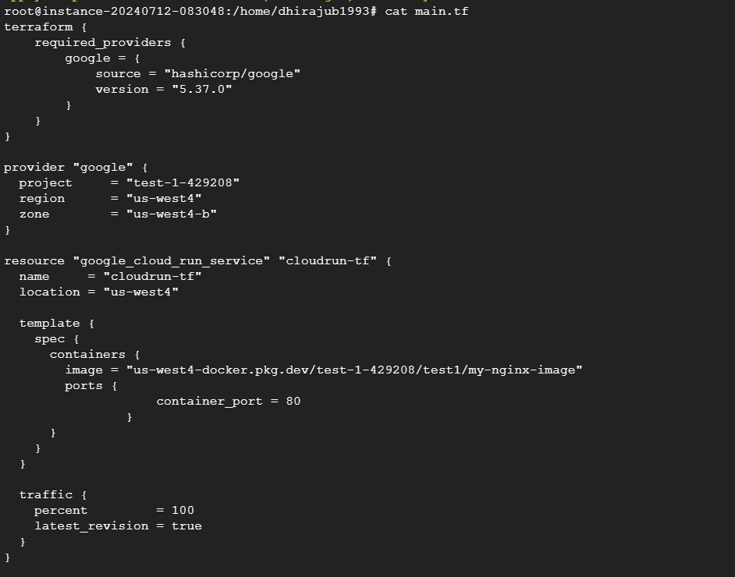

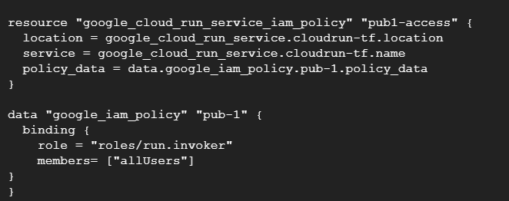

For authentication credentials I’ve put below command

#gcloud auth application-default login

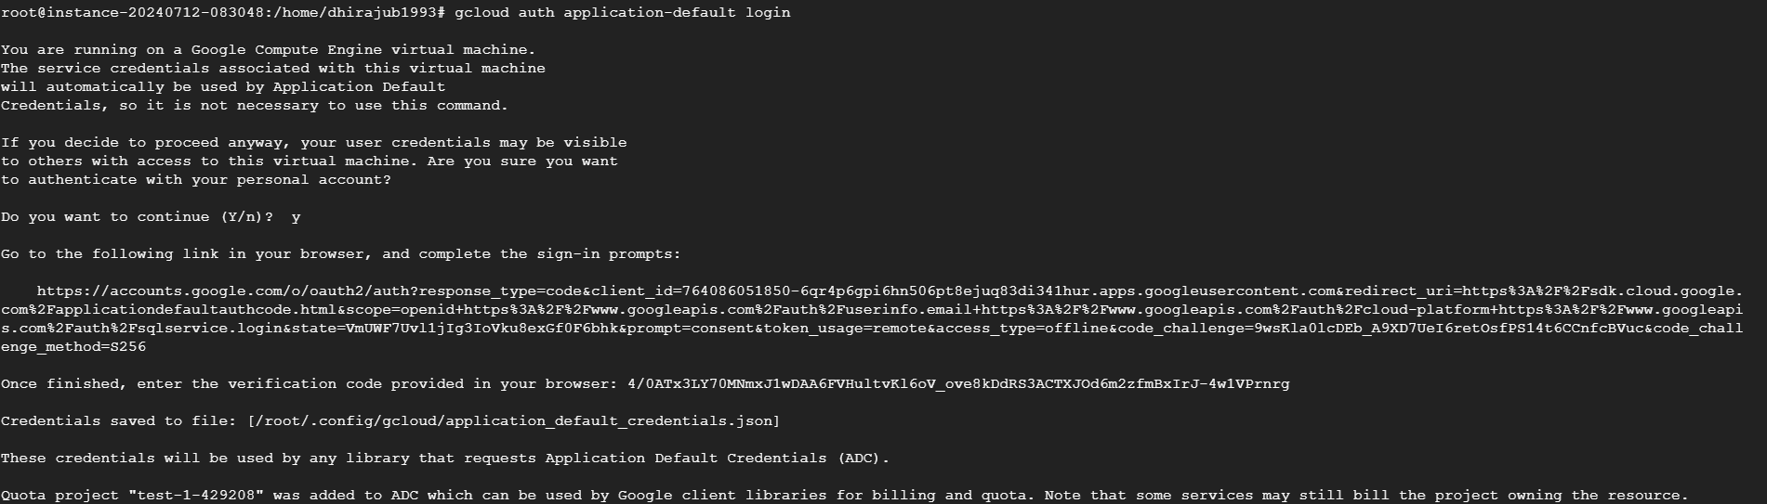

After that cloudrun service successfully created and its accessible publicly

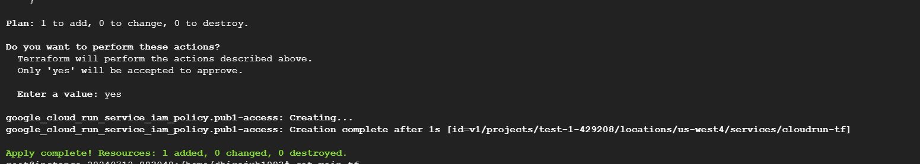

GCP console

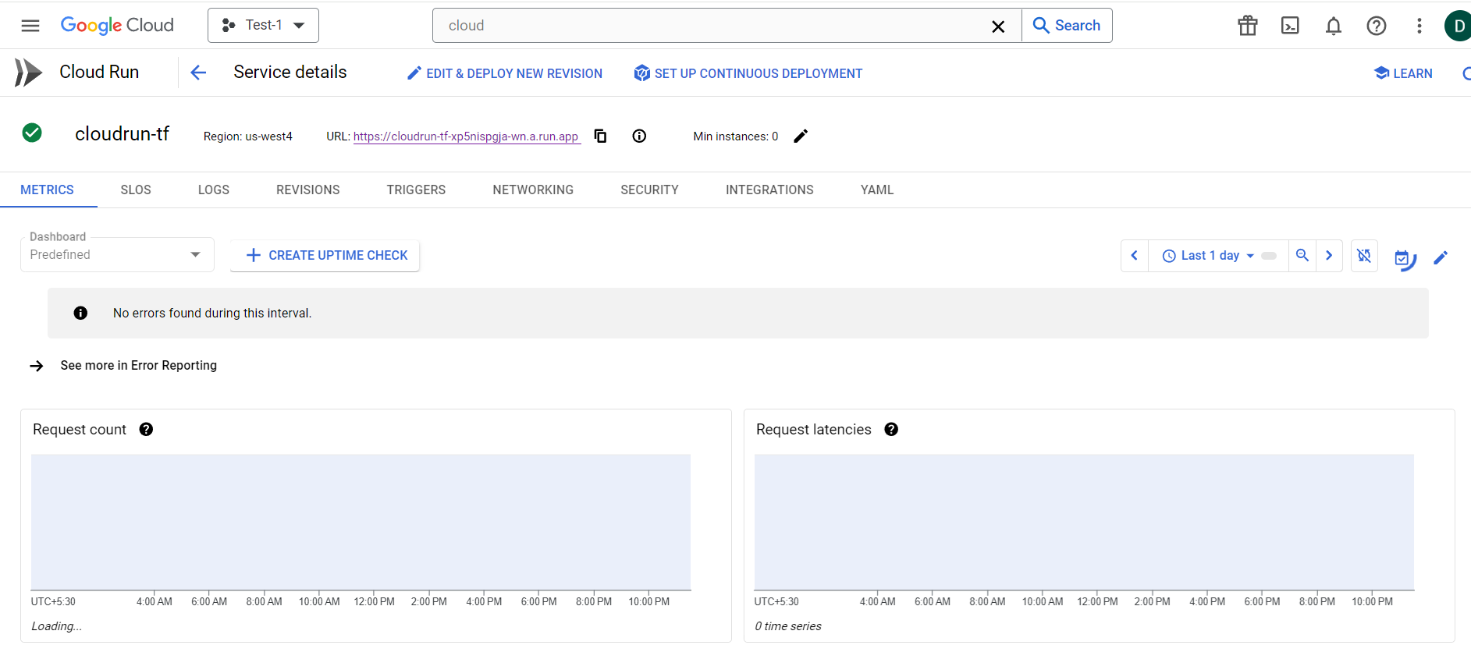

From browser

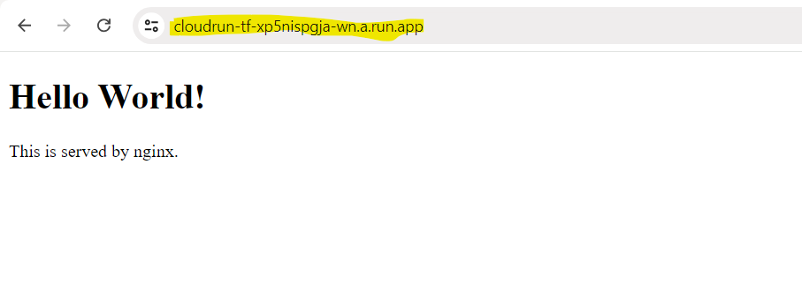

Below IAM policy I’ve created.

