Chapter 1 <TNR 18 B>
- First Chapter <TNR 18 B>
This is a sample chapter showing you the formatting styles. As soon as you float in (paste in) your actual report content, select the whole material, [using <CTRL>+A], and apply the style the items enclosed in the Red Colored Chevrons (or Angle Brackets “<”& “>”, represent the Style Names. They should be visible to you in the Home → Styles Menu. Initially MAIN_PARA (and some other styles employed here) may not be visible in the Styles gallery, but you can scroll the gallery up or down, and select the needed styles. Please note: YOU SHOULD NOT TYPE THESE STYLE NAMES. < TNR 12 line space 1.5, justify both sides and do not hyphenate>
  - About Styles <TNR 16 B>
A style is nothing but a collective group of properties applied to a whole paragraph of material. This includes the Font styles and its variations, the various spacing and alignments. The style also covers parameters like Bullets, Numbering, Indents, Auto-numbering, Borders/Shades, whether the hyphenation be allowed or disallowed, whether the particular style should start on a separate page, etc.
    - Home tab <TNR 14 B>
You can also format text directly by using the other controls on the Home tab. Most controls offer a choice of using the look from the current theme or using a format that you specify directly. To change the overall look of your document, choose new Theme elements on the Page Layout tab.
      - Selected Text <TNR 12 B>
From the Quick Styles gallery on the Home tab. You can also format text directly by using the other controls on the Home tab. Most controls offer a choice of using the look from the current theme or using a format that you specify directly. To change the overall look of your document, choose new Theme elements on the Page Layout tab. To change the looks available in the Quick Style gallery, use the Change Current Quick Style Set command.
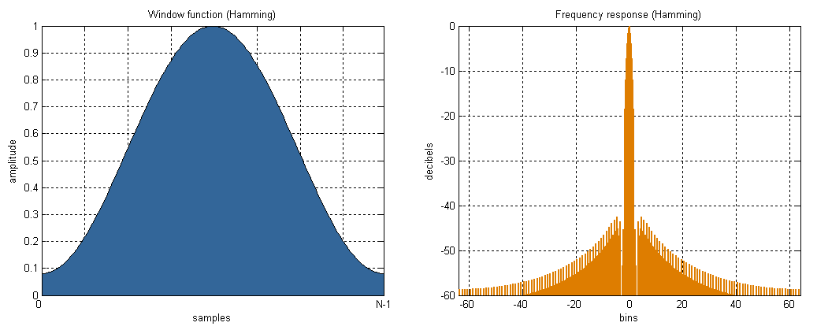
Fig. 1.1. A sample figure / illustration. <TNR 12 center justified>

Table 1.1. A sample table. <TNR 12 center justified>
Sl.No. | This is a | Sample | Table
1 | ITEM 1 | SAMPLE1 | SOMETHING
2 | ITEM2 | ANOTHER SAMPLE LINE SPREADING OVER | SOMETHING

On the Insert tab, the galleries include items that are designed to coordinate with the overall look of your document. To change the overall look of your document, choose new Theme elements on the Page Layout tab. To change the looks available in the Quick Style gallery, use the Change Current Quick Style Set command. You can use these galleries to insert tables, headers, footers, lists, cover pages, and other document building blocks. When you create pictures, charts, or diagrams, they also coordinate with your current document look.
A sample equation:
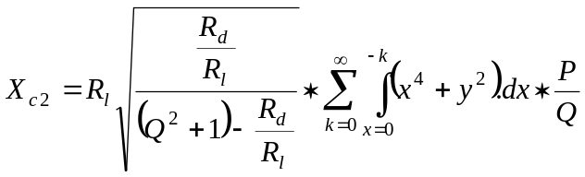 | (1.1)

