Assignment 6: Prolog Assignment – parent3.pl

* Dhiraj Bag, Roll: 33

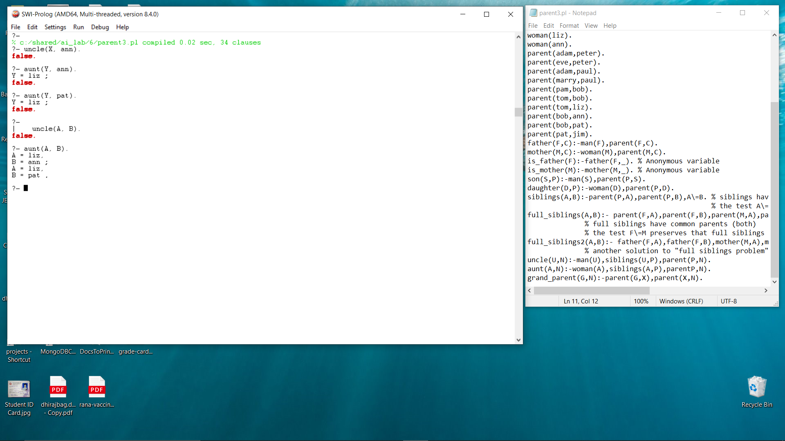Ran queries and received output as follows:

As per the knowledge base:

“Bob” has two children – “ann” and “pat”.

Both “bob” and “liz” have the same parent “tom” and “liz” is a woman.

Therefore, ”liz” is an aunt of both “ann” and “pat”.

They have no more a aunt or uncle.