Machine Learning, ICP – 2

Question 1:

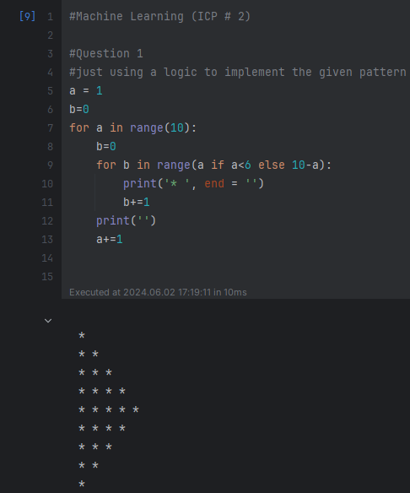

This code prints a pattern of stars that first increases to five stars and then decreases back to one star, making a diamond shape. I use two loops to control the number of stars on each line.

Question 2:

This code goes through the list and prints the numbers that are in the odd positions, like the 2nd, 4th, and so on. I did this by checking if the position number is odd.

Question 3:

This code takes a list with different types of items and makes a new list showing the type of each item, like numbers or words. Then, I print both lists.

Question 4:

I'm taking a list and making sure each number appears only once. I do this by converting the list into a set, as sets only keep unique elements. Then, I convert the set back into a list. Finally, I print out both the original list and the list with unique numbers.

Question 5:

This code counts how many uppercase and lowercase letters are in my given sentence. I go through each letter in the sentence and check if it's uppercase or lowercase. Then, I print out the counts of both uppercase and lowercase letters.

GITHUB LINK:

<https://github.com/dhirajbandiucm/ML>