# Week 1-2

Table of Contents

Week 1-2 1

1.2 Exercise 1

Using Tableau 1

Barchart 1

Pie chart 1

Staked bar chart 2

Donut chart 3

Using Python 3

Bar chart 3

Staked bar chart 4

Pie chart 5

Donut chart 6

Using R 7

Bar chart 7

Staked bar chart 8

Pie chart 9

Donut chart 10

# 1.2 Exercise

Hi Professor,

This week I started my assignment little late. I decided to use a tableau to generate the **bar charts, stacked bar charts, pie charts, and donut charts**. I really enjoyed plotting graphs it is just a drag and drop. It really generate lovely graphs. You must need to think about data visualization and how it can be self-explanatory.

## Using Tableau

### Barchart

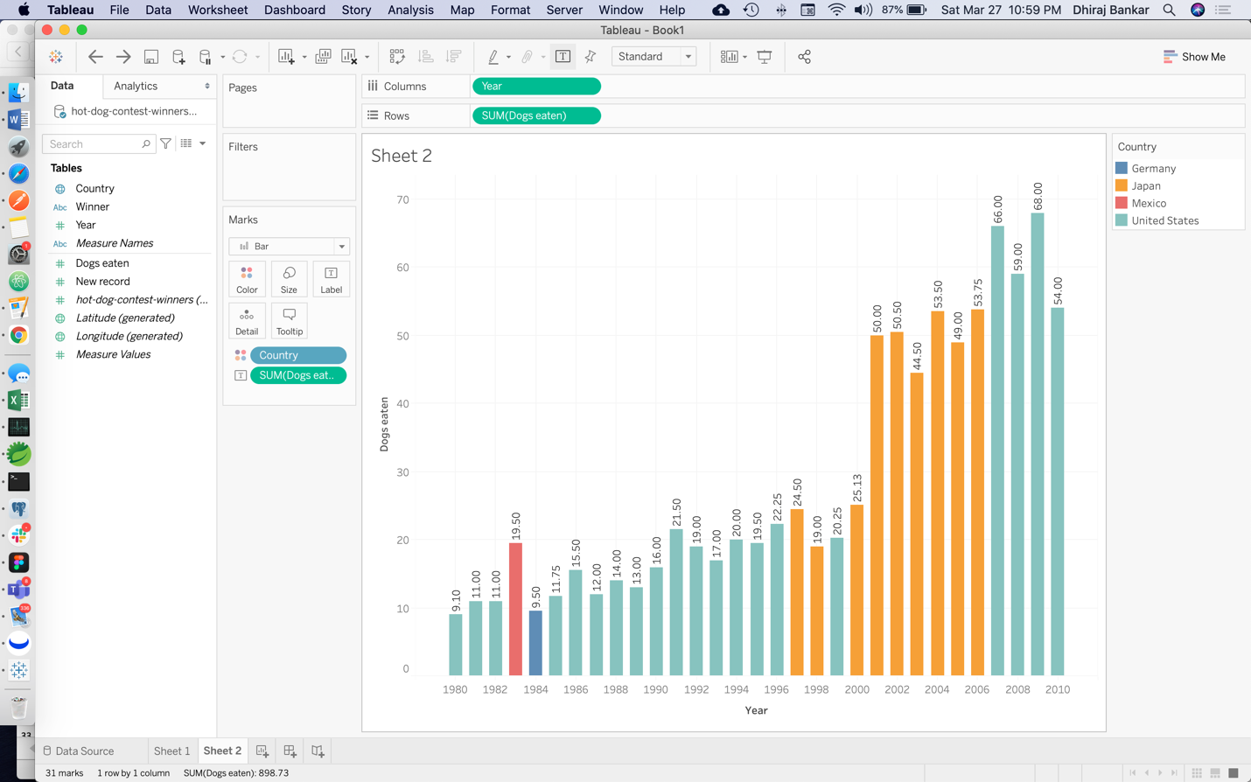

### Pie chart

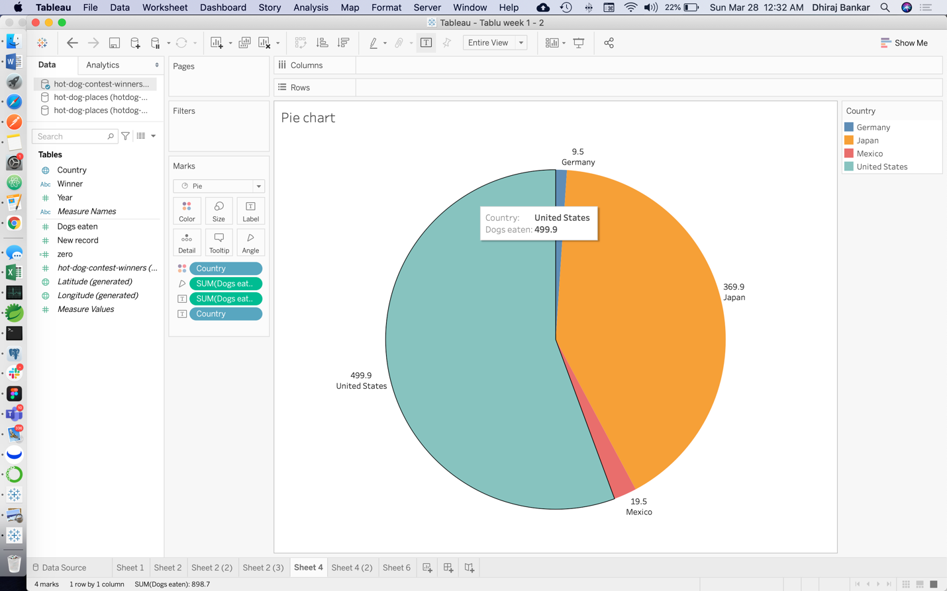

### Staked bar chart

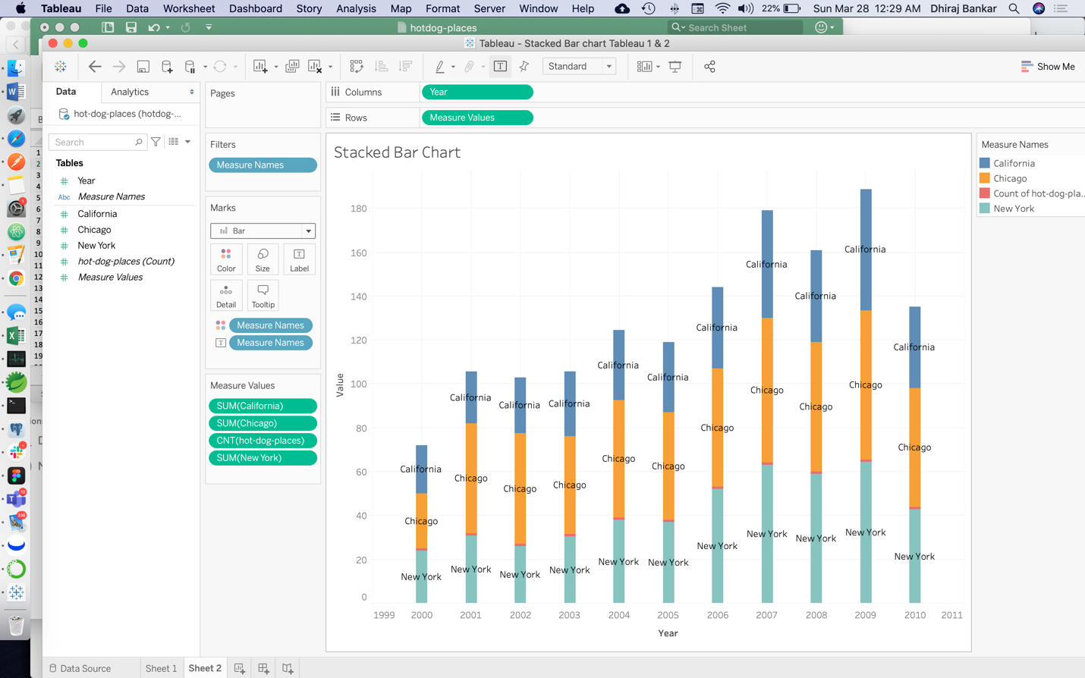

### Donut chart

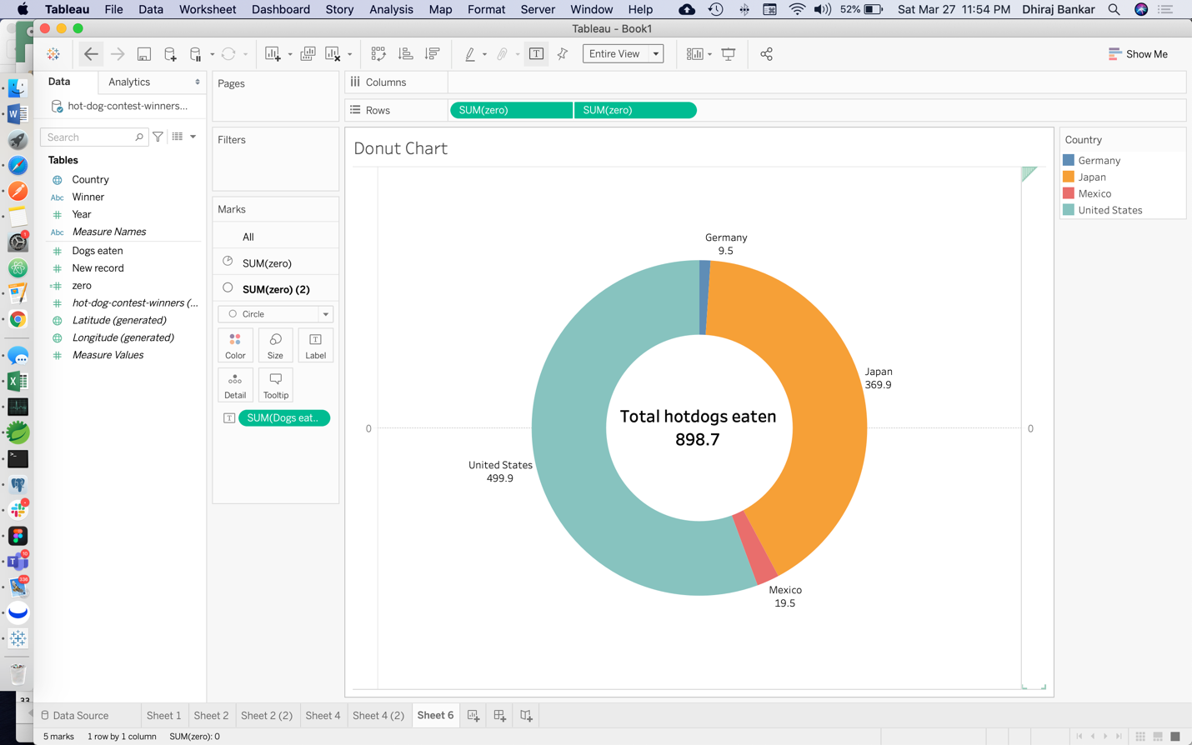

## Using Python

### Bar chart

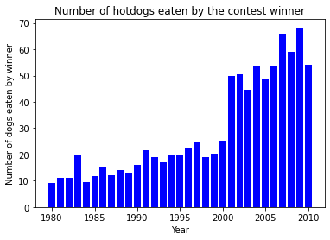

### Staked bar chart

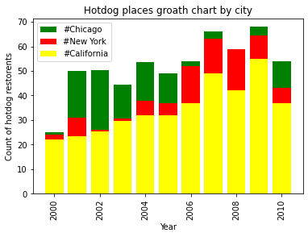

### Pie chart

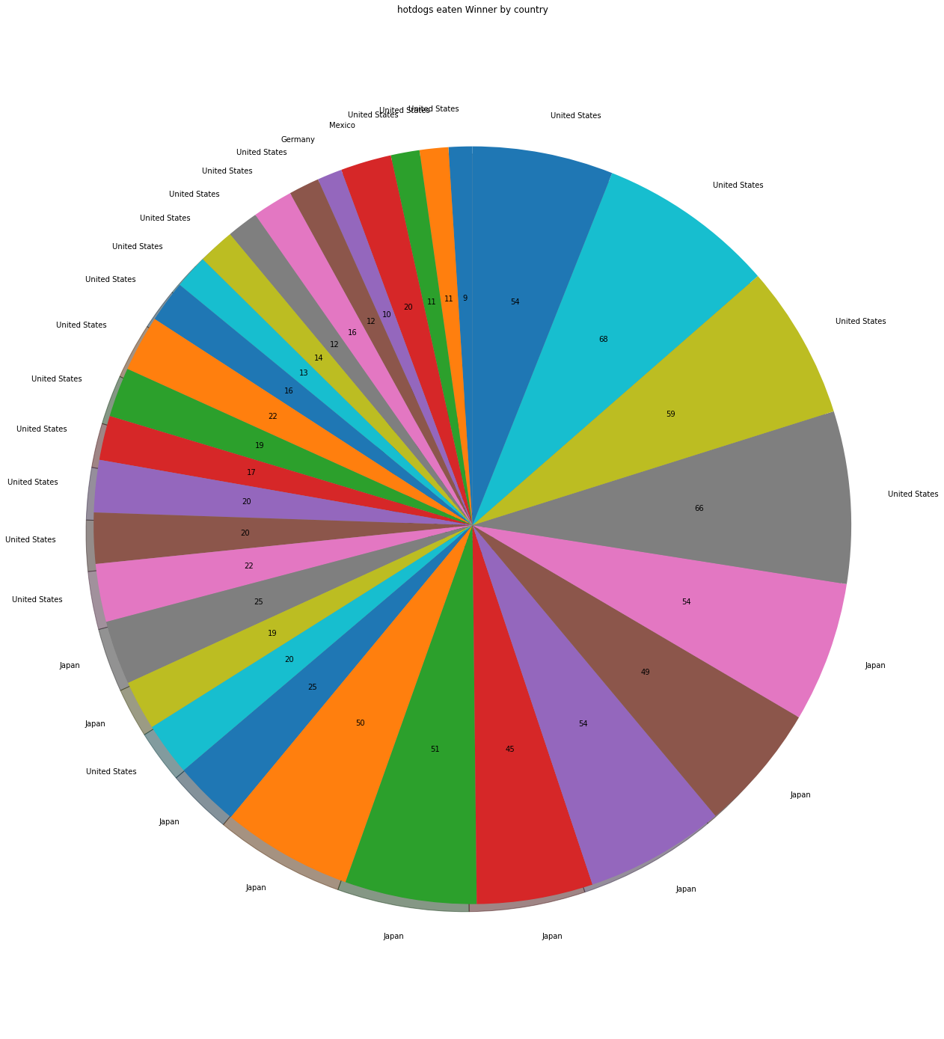

### Donut chart

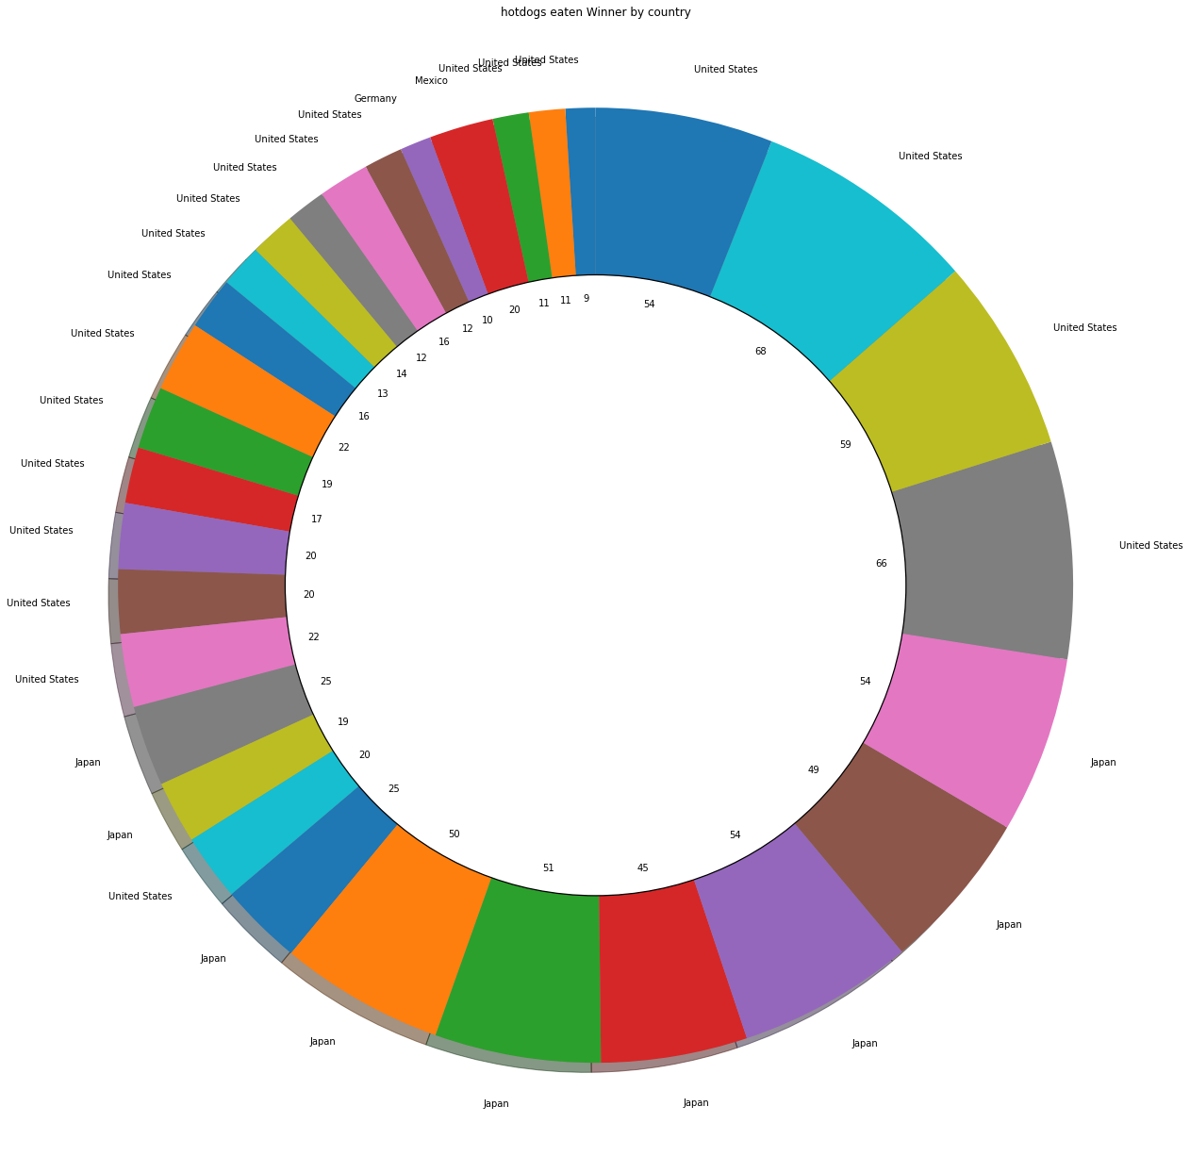

## Using R

### Bar chart

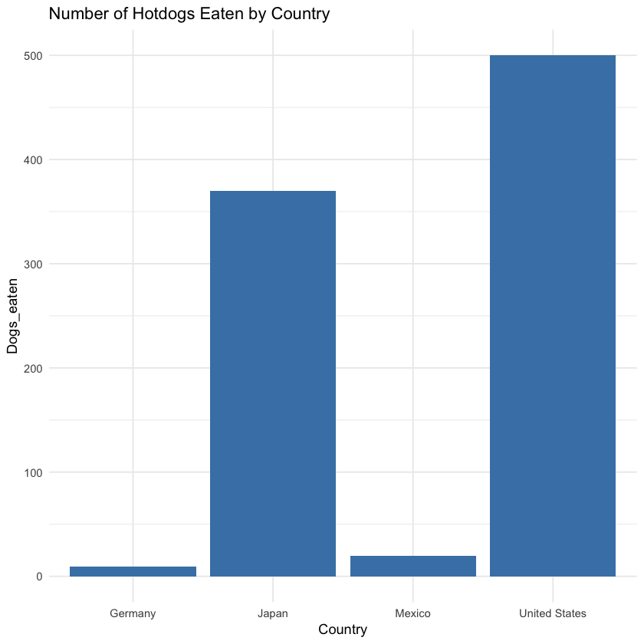

### Staked bar chart

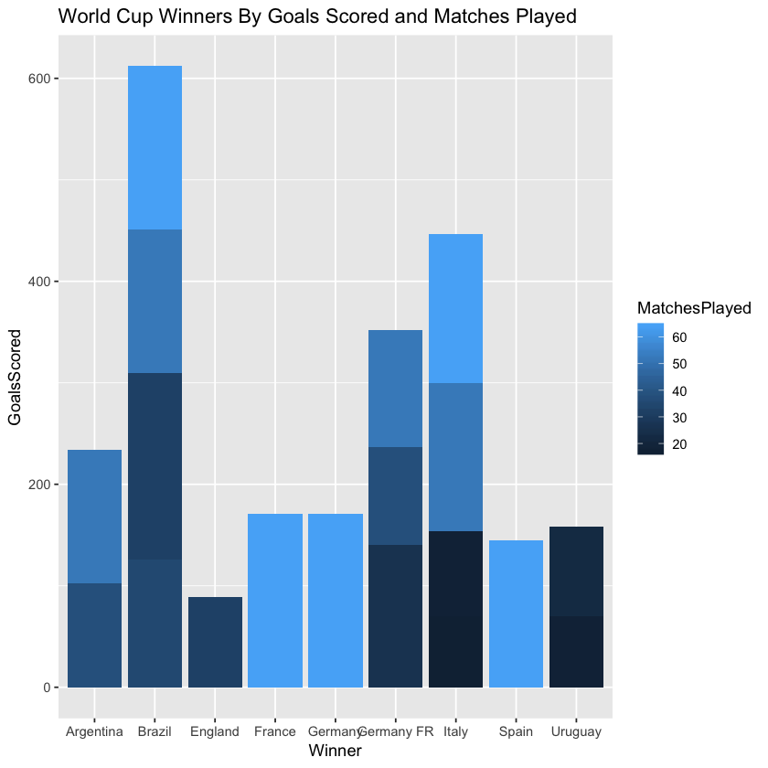

### Pie chart

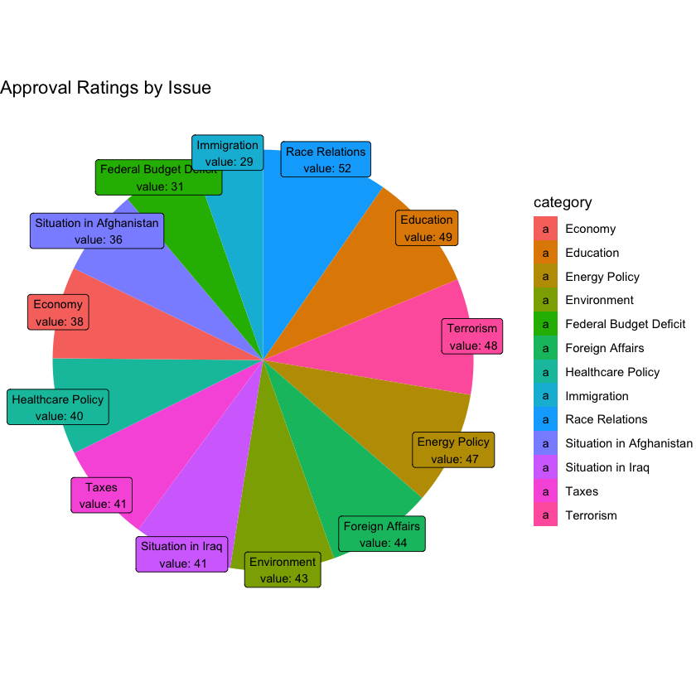

### Donut chart

