CURRICULM VITAE

Anil kumar
Gurgaon, Haryana - INDIA
Mobile: +91- 7408521927
E-Mail: anilvishwa1947@gmail.com

- One years of experience as JavaScript PHP/MySQL/JQuery, XML, HTML, API (Laravel Framwork)

Education Detail

- UG from University of Allahabad.

Other Experience:
- Dialysis Technician 1 Year + 6 Month practical.
- Computer Operator and Back office in SBI card (1 year).
- Technical support Executive in (JMU) Jamia Milia University. (outsourcing) (1 year)

Training's & Certifications:

- PHP Training (6 months) from Aptron technologies.
- C & C++ Training (6 month) from Ducat training center.
- Hardware & Networking (6 months) Hi-Tech training Institute
- Linux operating system
IT Experience:

- Aspire Innovation Pvt Ltd (PHP developer - 5 Month) 6th Apr 2022 – 1st Sep 2022.
- Prabhubhakti Ecommerce Company (PHP developer - 7 Month) 5th Sep 2022 on going
Work In House sales CRM portal.
Technical Skills:
- Cloud maintain IN degitalocean Hosting server
- Hostinger server
- Build In House CRM Admin Pannel
- Use Shiprocket API
- Use Ecom Express API
- LMS – Lead Management system
- Operating System: LINUX, Windows 10
- Tools & Technologies: VS Studio, Photoshop
- Databases: MySql
- Web Technologies: (HTML, Javascript, CSS, Bootstrap, JQuery)
- Laravel 9, PHP 8
- Webservices

Project:
Squareknot & prabhubhakti – 5 Sep 2022 till now
PHP DEVELOPER
www.https://prabhubhakti.in (Wordpress)
Prabhubhakti Store is a single window answer for all your pooja samagri needs. We assist you with advancing the underlying foundations of your familial customs by bringing you hand-picked pooja boxes, symbols, sanctuaries, things, and accessories.
Being a one-stop pooja samagri online store in India, Prabhubhakti Store overcomes any issues among devotees and dedication.
We have arranged all your reverential necessities by advancing a wide grouping of items by making it simpler for you purchase pooja things on the web. Hindu religion is a blend of conventions and services.

IN HOUSE CRM SALES PANNEL
- Cloud Hosting digital ocean
- Create multiple droplet
- Install linux os in digital ocean
- PHP Letest version 8.1.6
- Mysql version 5.2.0
- With Admin Pannel Login using session dynamic website.
- Used Ajax for every page for dynamically displaying the data without a page refresh.
- Worked with PHP, MySQL, CSS, javascript, ajax and HTML to build a full
- Used PHPMYADMIN to handle the administration of MySQL Worked on
- Create report analysis page in crm
- Integration with Courier shiprocket api for push order
- Integration with Courier bluddart api for push order
- Integration with Courier nimbuspost api for push order

- Get update status data using api.

Freelancer Project:
PHP Developer:
MissPretty https://www.misspretty.in/
- Developed, tested, and maintained current systems written in CMS.
- Responsible for installing, configuring.
- Used PHPMYADMIN to handle the administration of MySQL Worked on customizing modules and themes for web applications using WordPress.
- Used Photoshop For Image.
- Content management for the website.
- Basic SEO & Digital Marketing.
- Maintainance Of Many website.
- Theme installation and customization.
- Install Plugin.

https://lifecity.in/(wordpress)-E-commerce web

- Developed, tested, and maintained.
- Installation Theme And Listing Product.
- Ecommerce Project.

Aspire Innovation Pvt Ltd
PHP Developer:
https://digitalmarketing.lifecity.in/
- With Admin Pannel Login using session dynamic website.
- Used Ajax for every page for dynamically displaying the data without a page refresh.
- Used all aspects of MySQL/PHP programming (object-oriented PHP), in lamp and xampp environment.
- Worked with PHP, MySQL, CSS, javascript, ajax and HTML to build a full web 2. 0 compliant E-Commerce website.
- Used SMTP mail class of PHP for the users to send mail with suggestions.
- Used Payment Gateway Integration in PHP with Razorpay,
- Used PHPMYADMIN to handle the administration of MySQL Worked on customizing modules and themes for web applications using WordPress.
- Worked on HTML, CSS, javascript and their integration within a PHP environment.
- Login as admin
- 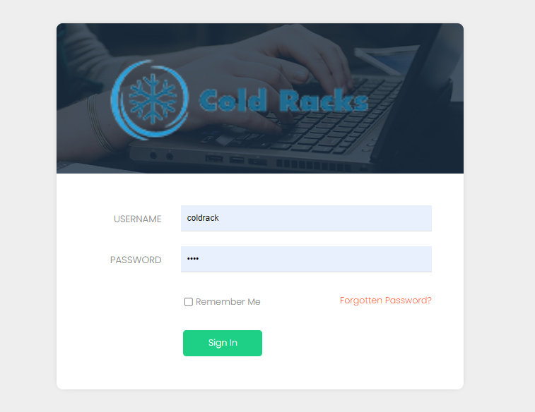
- Dashboard user interface
- 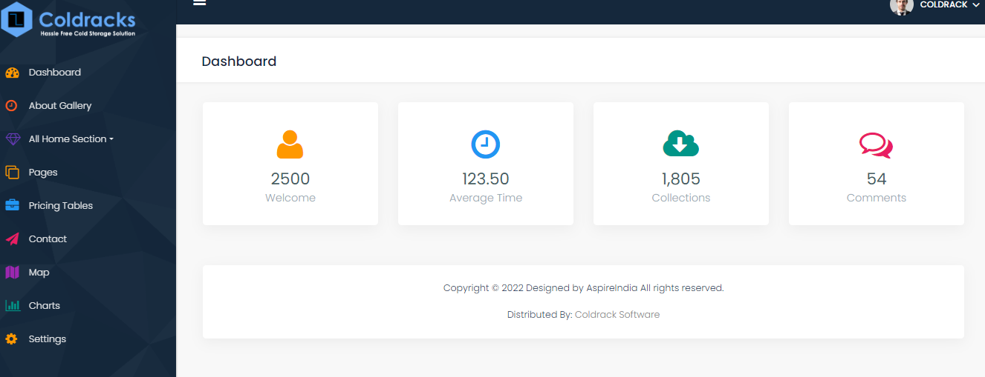
- Change content of about page and gallery section image download and remove
- 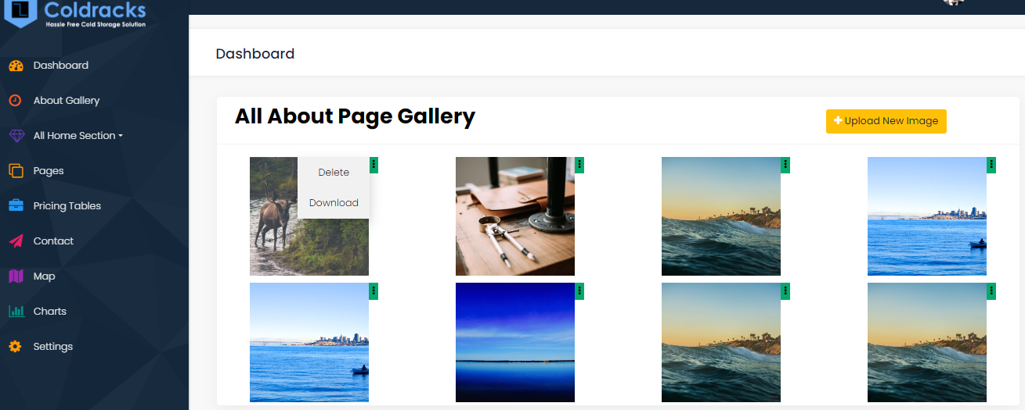
- All exist page of dynamic website
- 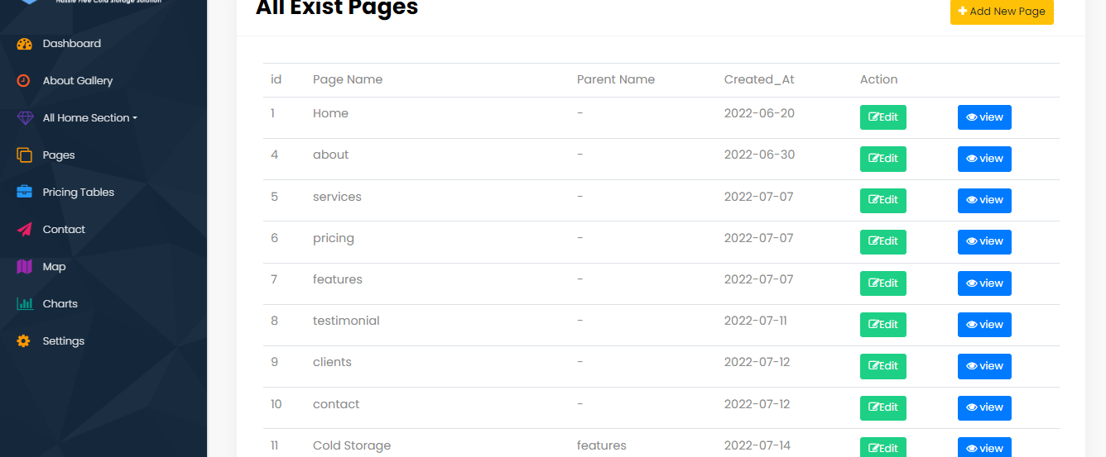
- Update home page section
- 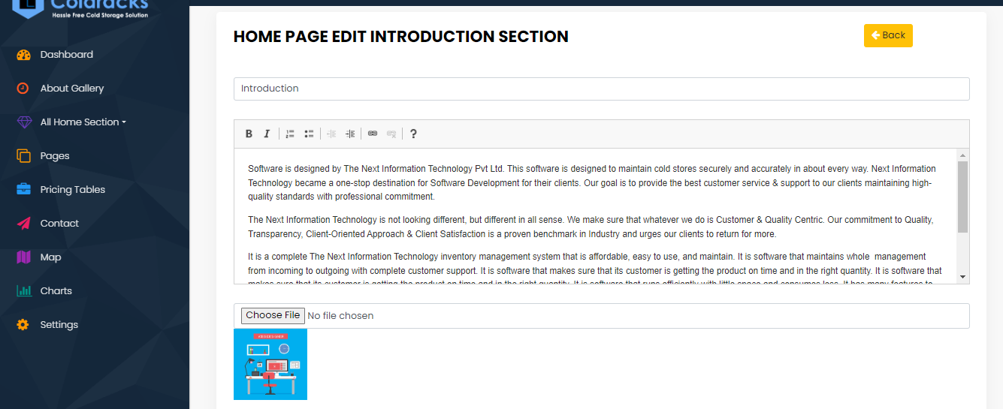
- Add new page from admin
- 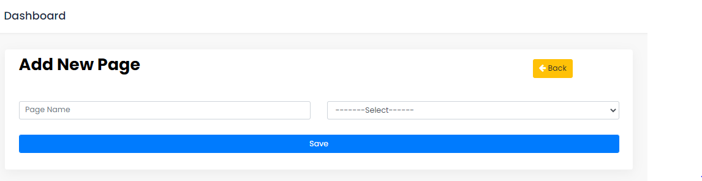
- Add faq section dynimic and also update and delete
- 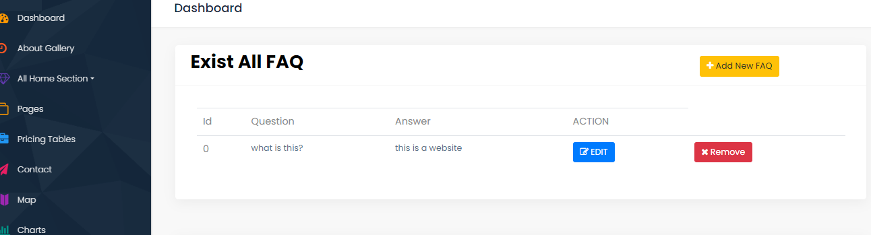
- Add banner section of home page update, add, delete
- 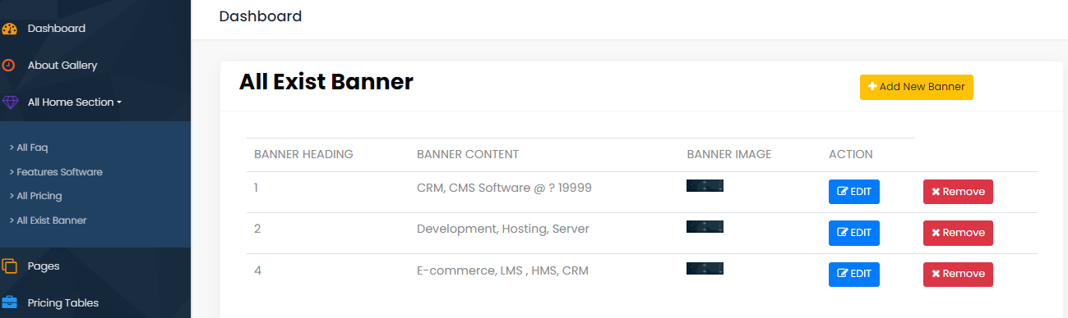

https://rojgar.lifecity.in/
- Used html CSS JS Jquery for every page for displaying the data without a page refresh.
Worked with PHP, MySQL, CSS, Javascript, Ajax and HTML to build a full web

Ecommerce website
- wordpress Installation and theme installation.
- Install Woocommerce plugin.
- Customize of thme.
- Listing products.

CRM Portal - https://portal.starbuy.in/
https://portal.starbuy.in/
- Cloud Hosting In Hostinger
- Create multiple subdomain project
- php letest version 8.1.6
- mysql version 5.2.0
- With Admin Pannel Login using session dynamic website.
- Used Ajax for every page for dynamically displaying the data without a page refresh.
- Worked with PHP, MySQL, CSS, javascript, ajax and HTML to build a full
- Used PHPMYADMIN to handle the administration of MySQL Worked on
- Ui of inhouse srm portal login
- 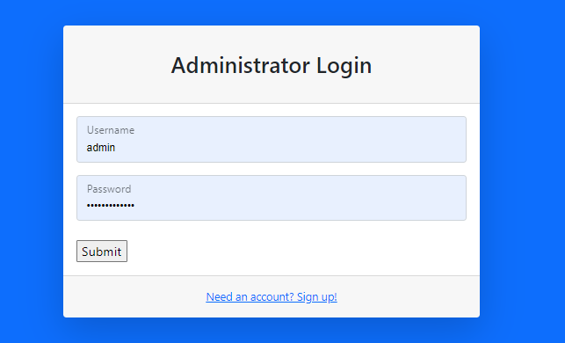
- Dashboard after login using session
- 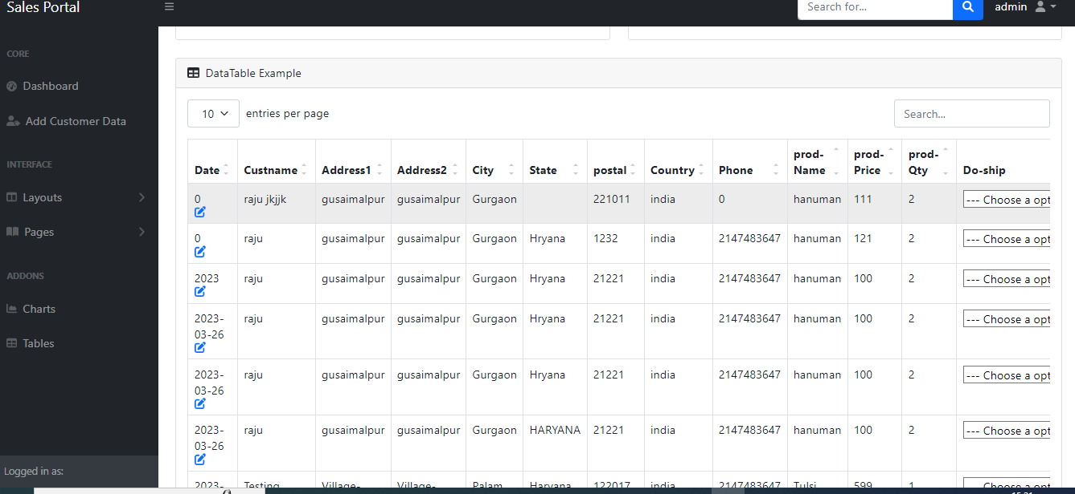
- Edit and update data
- 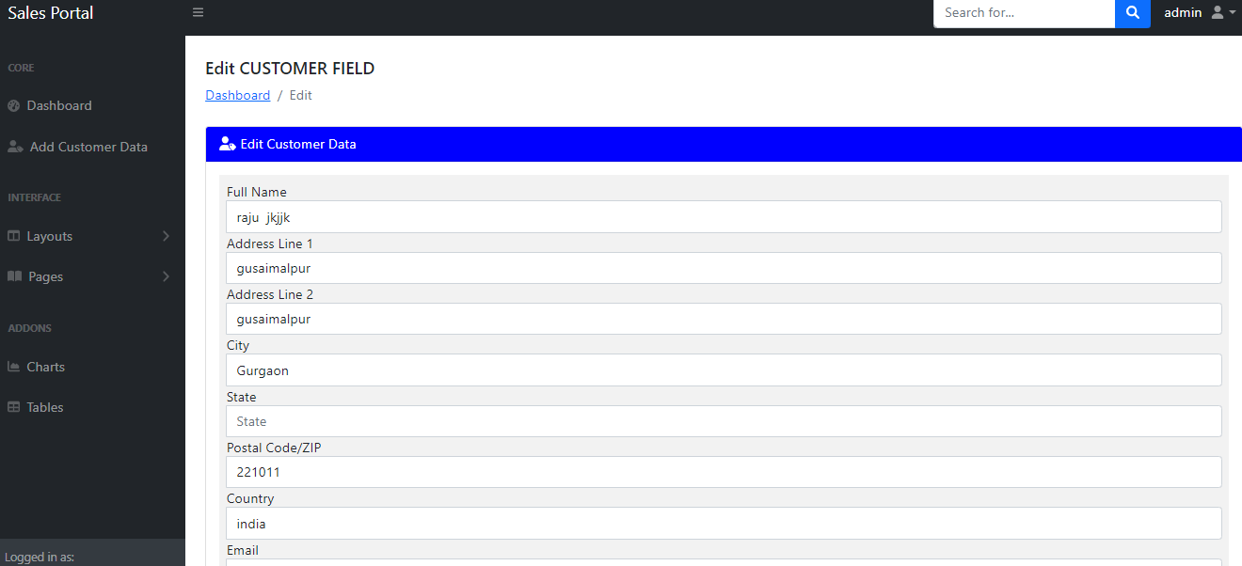
- Add new sales data
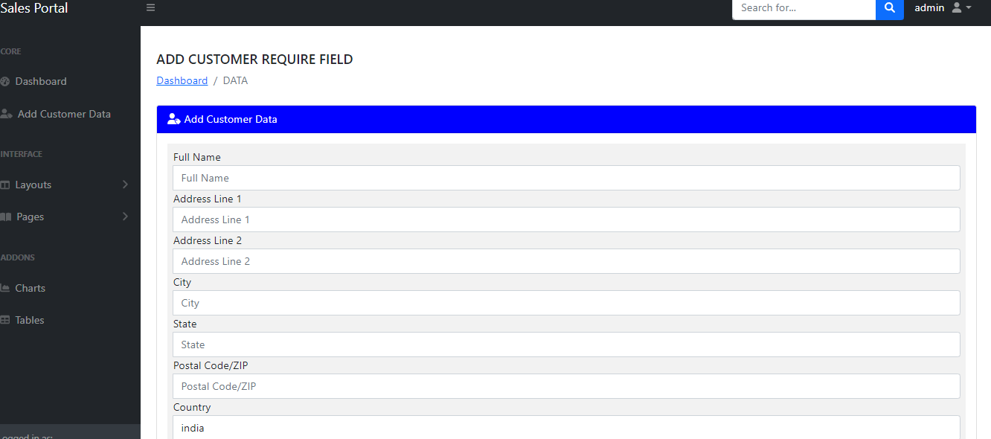

Laravel project details:-

LOGIN ADMIN PANNEL --

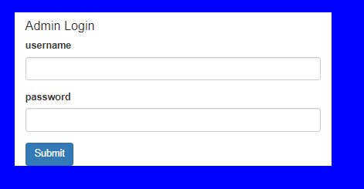

Add banner -

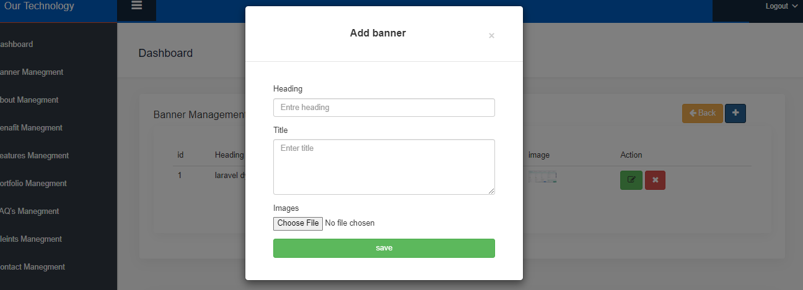

Update section –
EDIT, UPDATE, REMOVE

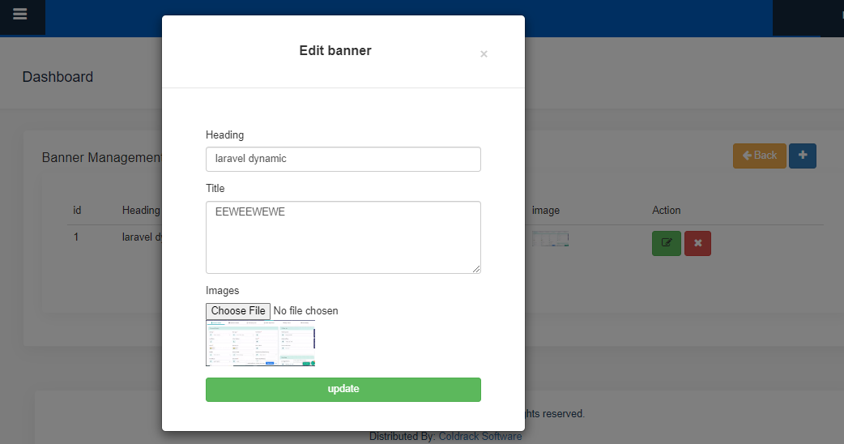

Personal Details:

Hobbies : Reading books, Music
Interests : Information Technology and Leadership
Languages Known : English, Hindi

I hereby declare that the information given above is true to my knowledge.

Yours faithfully,
(Anil Vishwakarma)

