CURRICULAM VITAE
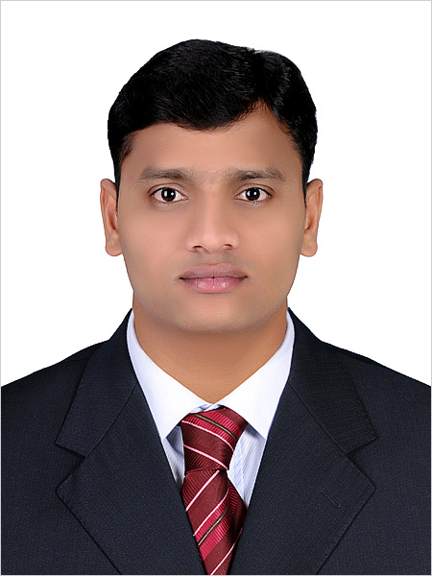

AMALADOSS.M
Al Hamra Palace Hotel By Warwick, Riyadh, Saudi Arabia
Mob : 0966-566183235 0966-561878229
Email : mailtoamal.pc@gmail.com, mariyasusaiamal@gmail.com

OBJECTIVE

Am committed to meeting our goal of being the preferred Company and fully dedicated to ensuring that products and services are been constantly delivered to meet our customer’s requirements and my key objective will be Customer Satisfactions, which will be measured, monitored and improved continually.

PROFESSIONAL EXPERIENCE:

- Working as a Housekeeping Manager Al hamra Palace Hotel By Warwick, Riyadh, Saudi Arabia, from March-2022 – Till Date,

- Worked as a Housekeeping Manager + Camp Boss in Al Sawadi Beach Resort & Spa, Muscat, Oman, from July 2019 - July 2020,

PH
- Worked as a senior Housekeeping supervisor in Radisson Blu Hotel, Doha, Qatar, from March- 2014 – Nov 2018,

- Worked as a Housekeeping Supervisor + coordinator Le Meriden Al Aqah Beach Resort, Fujairah U.A.E from Sep 2008 – Jan 2014,

- Worked as a Senior Room Attendant in The Park Hotel Chennai, Tamilnadu, India, from Jan 2005 – Nov – 2006 and May 2007 – Sep 2008,

- Worked as a Front office Assistant Hotel Singaar International Kanyakumari, Tamilnadu, India from May 2004 - Jan 2005,

- Professional Training in Front Office & Housekeeping in Hotel Marina New Delhi, India, from Nov 2003 - Jan 2004.
.

TRAINING & SEMINARS ATTENDED

- Successfully completed Fire and Safety Procedures.
- Food Hygiene.
- First Aid training.
- Blood borne Pathogen training
- Chemical training from Johnson Diversity & Ecolab.
- Service culture training program-2008.
- Supervisory skill Builders training Program-2009.
- Customer service workshop-2009.
- Microsoft Office 2007-2010.
- Emotional connection with customers-2010.
- Great customer service training-2011.
- Leadership training -2012.
- Work Stress & Time management training-2012.
- People management training-2013.
- Responsible business training-2014.
- Stress Management training-2015.
- On job skills training ( Train the Trainer) - 2016

PROFESIONAL ACHIEVEMENTS

- Towel Animal Competition Winner-2010.
- Bed Making Competition Winner-2010.
- Nominated for the Best Employee for the month of February 2011.
- Nominated for the Best Employee for the month of March 2013.
- Special Appreciation Letter Received from the Human resource manager from Le Meriden Al Aqah, Beach Resort for the hard work and efforts contributed to the Hotel.
- Special Appreciation Letter Received from the Executive Housekeeper from Le Meridien Al Aqah, Beach Resort for uniform cost and categorization.
- Appreciation Letter from the Training Consultant for Towel Animal.
- Task force in soft opening hotel St.Regis Abu Dhabi.

SKILLS:

- Expert management, Stress management and Motivational, Recruitment, Managing budget and Accounts, Abilities to deal with guest, Good communication, Good trainer and effective training, Excellent time management, Expert leader and a team player, Ability to take initiative, Expert decision-making abilities, Interpersonal Skills, Flexible, Attention to Detail, Reliable, disciplined, Ambitious, outgoing and have solid work ethic.

ACADEMIC QUALIFICATIONS:

- State Institute of hotel management & catering technology, Thuvakkudi, Tamilnadu, India,
Front office Housekeeping and Book keeping (First class) 2003 to 2004.

PERSONAL DETAILS

Permanent Address : Mariyasusai Amaladoss
Naduvalur (post)
Ariyalur (Dist)
Pincode-612904
Tamilnadu, India

Date of Birth : 21/12/1985

Sex : Male

Marital Status : Married

Nationality : Indian

Languages Known : Tamil, English, Hindi, Telugu, and Malayalam

Passport Number : M 3966202

Place of issue : Doha

Date of Issue : 31/01/2015

Date of Expiry : 30/01/2025

Declaration:

I hereby declare that the above-furnished details are true to the best of my knowledge.

Your Sincerely

(Amaladoss Mariyasusai)

