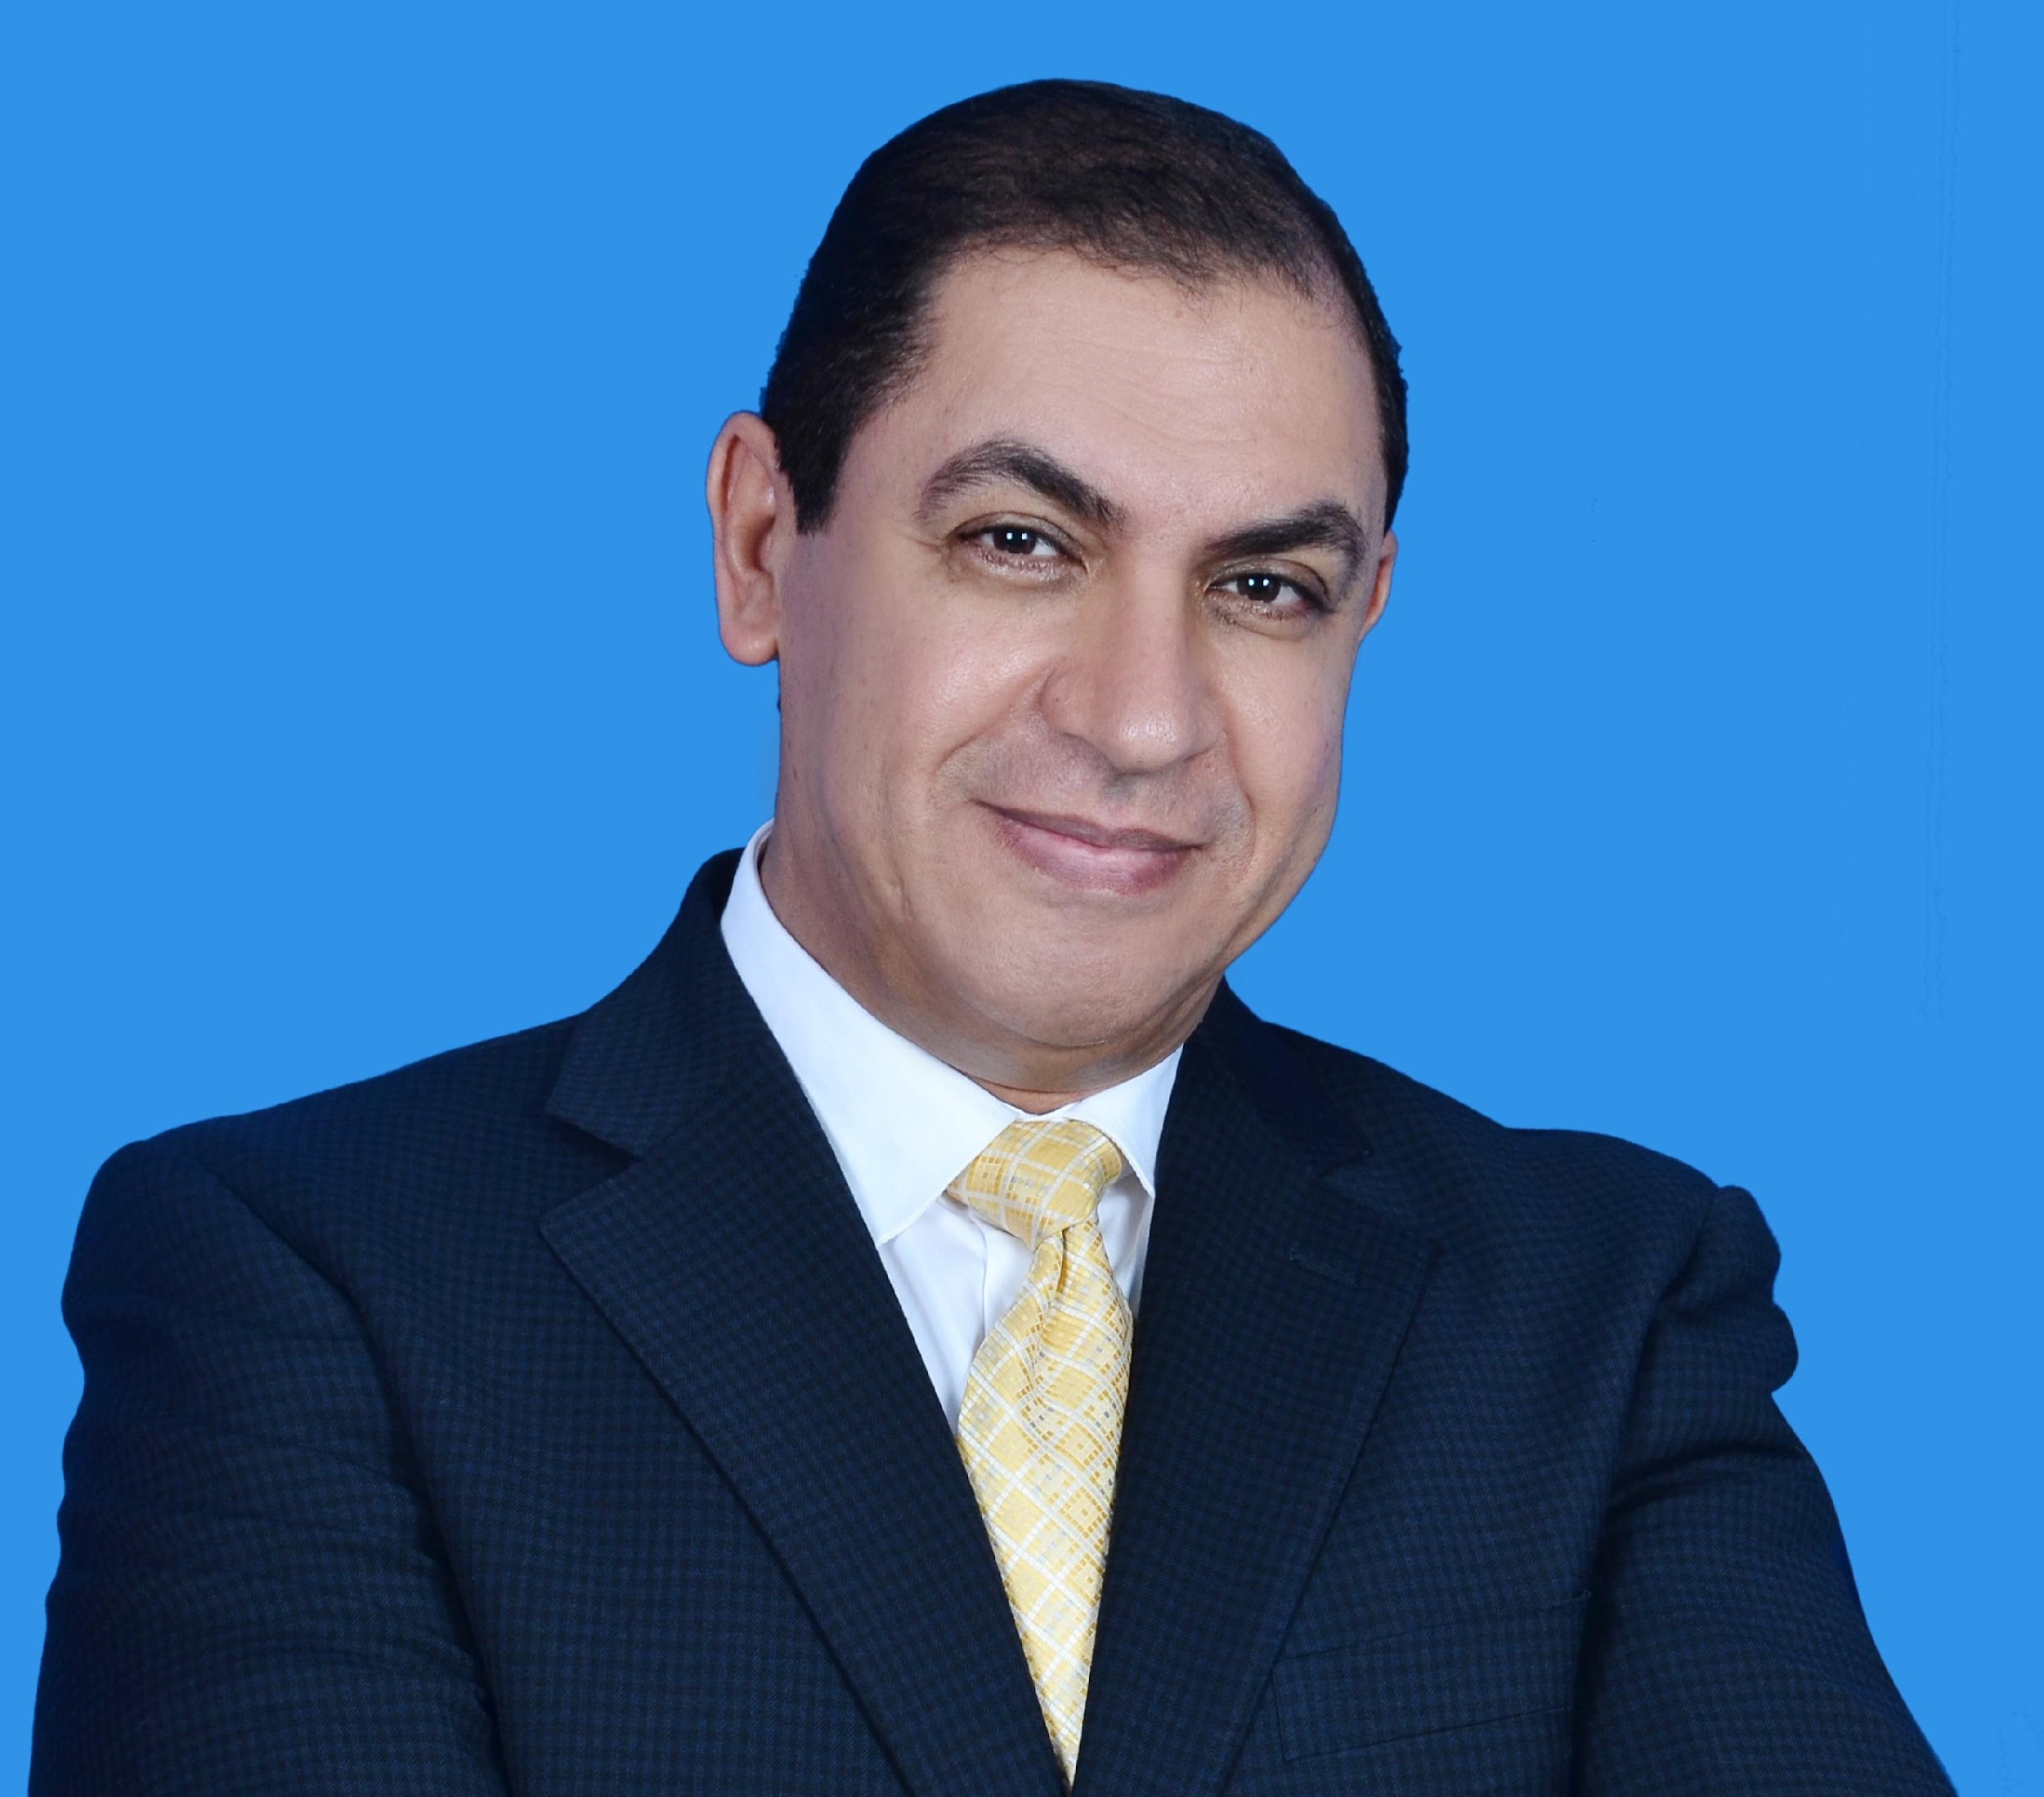

Hesham Dawoud
14 Zahraa el Maady St., El Maady, Cairo Egypt
Hdawoud2000@yahoo.com
002 01000044413

Summary of Qualifications:

Over 34 years of experience encompassing Marriott Hotels & Resorts (Domestic USA & International), Ritz Carlton and Marriott Conference Centers, In addition to Ramada International and Tia Heights (Le Meridian Hotel). Most recently; CEO General Manager of Dhofar Tourism Company in Oman. Key contributions include Strategic Planning to maximize sales and revenue, excellence in building great Owner Relations and Profit Improvements and operation execution with high standards. Putting a total master plan and defining companies’ business model by suggesting buying new properties or merging to another company to the benefit of the owners.
A dynamic hands–on and inspiring leader; result-oriented with ability to align the leadership team around challenges; creative in problem resolution. Passionate about customer service and building positive associate relationships. Have new hotels opening experience in Cairo, USA and Gulf area.

Dhofar Tourism Company, Oman
CEO/General Manager August 2016 – April 2021

CEO is the face of The company , responsible for the overall leadership and strategic planning. Selected by the Board of Directors the CEO has the responsibility to carry out the mission and is responsible for the overall management and operation of all aspects of the Dhofar Tourism Company. The General Manager/CEO focuses on long-range goals, strategies, plans and policies routinely exercising discretion and independent judgment in the performance of job duties. The General Manager/CEO is accountable for the overall programmatic and fiscal integrity of the organization.
In this role: I was

- Looking after almost $ 3 billion in total projects in the master plan of the company
- The land mass is about 2 million sq. meters
- I worked with Engineering Team and owners to develop the “Master Plan” encompasses; multiple hotels properties, commercial and residential buildings, golf course, shopping mall, touristic aqua park, marina, amusement park and local market. Dividing the whole Master Plan to five phases.
- I did the opening of Mirbat Marriott hotel which is a part of (1st phase) and I did work on starting both 5th and 3rd phases same time of the Master Plan.
- I did overlook the audit and assets of the Marriott, as well as Dhofar Tourism company assets
- Facilitating merging with a major German touristic company and buy off other members shares.
- Created a website to promote the company and solicit more investors
- Developed new market (Iranian and Russian ) including visas program
- First time to show a budget with net profits to owner since opening on 1993

Reef Oasis hotels and Resorts (Sharm el Sheikh) Egypt
Multi-Hotels Manager June 2015 to August 2016

Main responsible is to establish “Standard Operating Procedures” for three operating Hotels (Two five stars and one four stars) to support the growth and profitability of the company while enhancing the quality of service and Improving the ranking of Guest satisfactions (on Trip Advisors). Directed and implement training and systems that support Company initiatives, business strategies and Core Values. Supervised and led the performance and development of department Leaders in all departments of the hotels. Partnered with Sales Leaders to maximize revenue.

- Established a process for operation excellence and execution for all hotels
- Wrote/review standards of operations to all departments (SOP)
- Focused on guest satisfaction to be in the top ten of the area (currently number ten and 9 instead of 16 out of 228 hotels in Sharm El Sheikh)
- Came up with unique process for arrival and departure experience
- Innovative ideas for increasing revenue and improve the food quality and quantities
- Implemented process of quarterly assts inventory to protect owner’s values.
- Involved in hiring the high ranking executives.
- Challenged the marketing team to increase market share and diversify hotel guests.

Tia Heights Hotels & Resorts (Le Meridian) ( Three hotels a total of 1450 rooms, two five-stars hotels and one four stars) Egypt
Area General Manager October 2012 to November 2013

As an Area General Manager; I did oversee all operational aspects of all three hotels from customer management, personnel training and development, financial control, budgeting and forecasting, utility management, maintenance and engineering, energy conservation and food services. I created a check and balance system (I.e. Establishing five Goals and check them against performance) holding the General managers responsible and accountable for operations and results. I also unified internal departmental systems to unify reporting (in accounting, Food & Beverage and Front Desk operations).

- Restructured the leadership team to redefine roles and responsibilities
- Hired a Hygiene Doctor to bring F&B operation to improve standard
- Established a “Make Ready team” with Housekeeping and Engineering departments to improve room product overall
- Championed training and hired training Manager to improve level of service and execution
- Improved ranking in “Tripadvisor” from 16 position to number 11out of 19 hotels and “Holiday Check” from 68% to 81%
- Created new restaurant as an additional option for West Europeans as well as Entertainment area “El Tekya” with huge opportunity to sell to all-inclusive guests (New revenue generated center)
- Improved Sales process by deploying each sales manager to specific market and assigning goals as well as introduced E-commerce manager concept which brought additional 18 % of sales and improved overall Revpar by 30%
- Led the budget process and trained leadership on creating a vision and mission to hotels as well as understanding “what is business positioning” mean.
- Lead the team to finish about 490 rooms’ renovation in less than 6 month and helped in designing and constructing a 5000 seated tent for conferencing and entertainment.
- Created new opportunity to sell the hotel (football field, basketball court) for local and international teams to practice and play.

Ramada Plaza International, Sharm El Sheikh (CHI) (254 Rooms) Egypt
General Manager (opening Hotel) November 2011 to May 2012

- Number one mission was to improve the total hotel image and ranking on tripadvisor site. Therefore, with the focus on customer service and feedback as well as corresponding with them I did succeed to move the ranking from 156/211 to 134/211. In addition, I reorganized the leadership team to have positive impact on total hotel improvement and positively affecting financial statement.
- Redesigned the Lounge bar, Arabic Shisha corner as well as the Piano Bar to increase the potential of additional sales from the all-inclusive customers.
- Renegotiated all contracts with the travel agencies to have consistency in positioning the hotel in the market.
- Worked on improving the hotel building appearance from the street by adding special light effects and redesigning the hardsacpe as well as the landscape in front of the building
- Improved the beach and swimming pools setting capacity and creatively added more space for guests to enjoy.
- Did the grand opening with the team and owner with great success; with the focusing on Marketing team, the media and local communities to start with great “big bang”

Sharm El Sheikhs Marriott Resort (520 Rooms) Egypt
Director of Operations/ Acting General Manager January 2009 November 2011

- Acted as GM in the absence of the GM, specially from June 2012 to November 2012
- Focused on guest satisfaction and training managers and hourly staff on hospitality and technical skills to bring the standards to higher level with improvement of 17-point % in total satisfaction from previous year.
- Re-instated procedures and standards at the front desk to optimize operation and maximize productivity.
- Streamlined the F&B operation to improve overall profit of the department from 46% to 54%
- Enforced the total hotel standard audit to pass for the second consecutive year
- Participated in renovating the Japanese restaurant to increase the capacity and revenue
- Successfully created an entertainment program to improve sales on the beach, thus creating new outlet (i.e. Lebanese Restaurant, fresh juice Bar and Italian Restaurant).
Built great relationship with the owners and kept Marriott priorities in mind.

Salalah OMAN
Director of Operations (opening Hotel ) (Task force from November 2009- April 2010)

As an opening manager; I had the experience and the skill set to manage and built all (IT systems) from start to end with the help of company expertise. I was personally responsible for the following :

* Successfully prepared and received the tools and equipments for the total hotel (5SU)
- Trained all F&B team as well as the front desk/housekeeping teams on Bob Brown techniques to improve service and increase revenue
- Created all Restaurants Menus and inputted them on the POS system
- Established Housekeeping/Front Desk operation SOP and systems.
- Worked with the IT team to install front of the house/Back of the house systems according to Marriott international standards
- Strategically structured all the operation team and cross-utilized different departments to manage with the minimum staffing level.
- Build great relationship with owners and owners representative
- Earned the respect of the local community and the Omani associates as a result of respecting their culture
- Celebrated the opening of the hotel with the minister of Tourism and the governor of Salalah.

Philadelphia Airport Marriott (419 rooms) USA
Hotel Manager April 2006 to January 2009

- Managing six department heads and nineteen managers with a total of 230 hourly associates
- Total hotel revenue $33 millions with 87% average occupancy in 2007
- The hotel was awarded the “Best Financial Performance” in 2006
- Exceeded budgeted profit margin in 2007 by 2 points
- Implemented “Perfect Guest Arrival Program” which helped move GSS scores for the last half of the year by 3 points (from 80 % in the first half to 83% in the second half)
- Proactively reduced the number of managers to the point of optimization
- Improved food cost from 33.9 % to 27.3% and Beverage cost from 29.3% to 22.8%
- Created new menus reflecting food/market trends to maximize sales and profit.
- Improved food and beverage profit margin from 26% in early 2006 to a current 31.8%
- Achieved 20 point improvement in AOS in 2007 by strategically working with the team on associate engagement
- Challenged revenue management team to increase room rates both corporate and weekend.
- Acted as General Manager in the absence of GM

Key Bridge Marriott (582 rooms) USA
Senior Director of Food and Beverage (special task)/ September 2003 to April 2006

- Awarded “Best in Class” hotel in all categories for 2005
- Improved food and beverage profit margin from 17 to 19%
- Redesigned the food and beverage operation to achieve 25% profit margin
- Improved breakfast GSS score by focusing on the concierge lounge breakfast (from 74% to 77%)
- Worked with the food and beverage team to develop new concept for the Allie’s American Grill which improved the total average check and sales overall by 8%
- Completed detailed analysis/business plan to convince the owner to convert the top floor restaurant to a banquet ballroom
- Best AOS results for two consecutive years in our cluster

University of Maryland Conference Center, Adelphi, MD (356 rooms) USA
Director of Operations/ November 1999 to September 2003

- Directed all aspects of the Hotel operations including F&B and Rooms, with a team of five department heads , 11 Managers, 9 Supervisors and 160 hourly associates
- Managed total hotel room renovation.
- Suggested and managed an addition of 126 rooms to the existing building.
- Was awarded best overall operation (Balance Score Card; Sales, Profit, guest satisfaction and employees satisfaction) in the Mid-Atlantic Region in 2000

University of Maryland Conference Center, Adelphi, MD (356 rooms) USA
Director of Food and Beverage/ August 1997 to November 1999

- Challenged the team to increased F&B sales from $3.5 million to $4.5 million by redesigning and pricing menus and banquet packages.
- Increased profit from 29% to 36% by implementing all standards of operation in purchasing and labor control.
- Awarded the Best AOS results in the F&B area in the Mid Atlantic Region

Crystal City Marriott, Arlington, VA, USA
Executive Chef/1995 to 1997
Key Bridge Marriott, Arlington, VA, USA
Catering Sales Manager, 1994 to 1995
Ritz Carlton, Tyson’s Corner, VA, Opened hotel USA
Senior Banquet Captain while working at Key Bridge USA
Key Bridge Marriott, Arlington, VA, USA
Restaurant & Bar Manager, 1991 to 1994
Crystal City Marriott, Arlington, VA, USA
Restaurant Operations Manager, 1990 to 1991
Riyadh Marriott, Riyadh, Saudi Arabia
Director of Restaurants, 1989 to 1990
Room Service Manger, 1987 to 1989
Restaurant Operations Manager, 1985 to 1987
Cairo, Egypt, Restaurant Supervisor, 1982 to 1985

Education:
1982–1985, Cairo University, Cairo, Egypt, Master in Science -Tissue Analysis
1978-1982, Cairo University, Cairo, BS in Microbiology
June 2000, Attended National Leadership Institute Program (University of Maryland, USA)

Personal Accomplishments and Awards:
- Awarded “Best Brunch & Best Romantic Dinner” in the area by the Washington Post and Washingtonian Magazine (Key Bridge Marriott)
- Best QA Audit, at Key Bridge, Crystal City, University of Maryland and Philadelphia Airport Marriott
- Best AOS results, at Key Bridge Marriott & best improved AOS at University of Maryland and best improved AOS at Philadelphia Airport Marriott.
- Awarded “Manager of the Quarter” numerous times.
- Successfully opened the JW Steakhouse at Key Bridge (Pilot Restaurant) which gave me great opportunity to “Task-force “ opening all of JW ‘s in Philadelphia Marriott, Williamsburg Marriott , and Crystal City Marriott hotels
Interests:
- Teaching - Professor at University of District of Colombia; taught Hotel Management for two years.
- Co-chaired the Diversity Council of the Mid Atlantic Region and helped to develop training topics
- Very involved in the community (President of Home owner association), and active in planning and zoning of Fairfax County and Springfield’s District, Virginia.
- Active and well-respected member of project “ZEN” in Marriott “Eastern Region” helping other hotels identify opportunities to increase sales, improve profit margin and overall performance. (I did the evaluation for Westfield Marriott, Long Warf Marriott, Boston Copley Marriott and Key Bridge Marriott).
Special Skills:
- Have opened four Hotels successfully and was assigned task force in Rooms and food and beverage operations
- Have opened and changed the concepts in different food and beverage outlets.
- I have managed multiple complex renovations at the same time including adding a complete building to the existing hotel.
- Excellent trainer and facilitator. Have championed “Service Excellence training” in the Washington D.C area.
- Great in implementing and creating operation standards/diagnostics.
Personal information:
- Birth day: November 18 1960
- Citizenship: Egyptian /American

