Transport Department Government of Delhi
Licence to Drive Vehicles Throughout India
Licence No . Name  S/W/D |  | DL-0420110149646 (P) N  ANURAG BREJA  BODH RAJ BREJA  DOB: 09/02/1976 BG : U Address :  HNO-178 A2/B MIG FLATS PASCHIM VIHAR,DELHI 110063 | 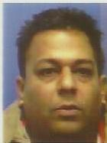
Authorisation to Drive Date of Issue
INVCRG 01/03/2011
(Holder's Signature)
Issuing Authority (WZI
Issue Date | : | 01/03/2011
Validity | : | 08/02/2026
Inv Carr No | : | NA

