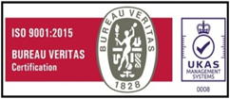

M S S C E T

Date: «date»

**BONAFIDE CERTIFICATE**

This is to certify that, Mr/Miss. **«name» (USN: «usn»)** S/o / D/o **«father»** is a bonafide student of this college studying in «sem» semester, Bachelor of Engineering («branch» Branch) during the year 2021-22.

His/her date of birth as per records is: «dob»

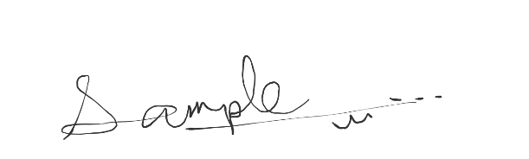

**PRINCIPAL**