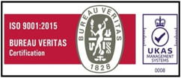

M S S C E T

Date: «date»

**STUDY CERTIFICATE**

This is to certify that, Mr/Miss. **«name» (USN: «usn»)**  S/o / D/o **«father»** has studied Bachelor of Engineering («branch» Branch) in our institution from 2019 to 2023 academic years.

The above details are true and correct to the best of my knowledge.

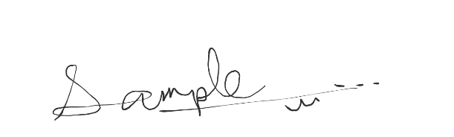

**PRINCIPAL**