<http://localhost:8080/SpringBootRestApiSecurity/counter-api/top/5>

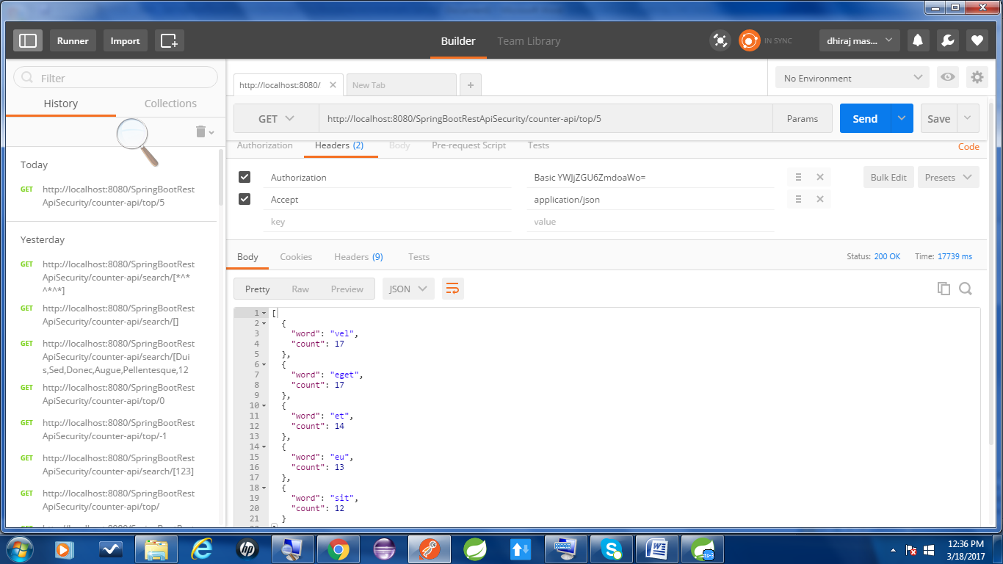

[http://localhost:8080/SpringBootRestApiSecurity/counter-api/search/[Duis,Sed,Donec,Augue,Pellentesque,123](http://localhost:8080/SpringBootRestApiSecurity/counter-api/search/%5bDuis,Sed,Donec,Augue,Pellentesque,123)]

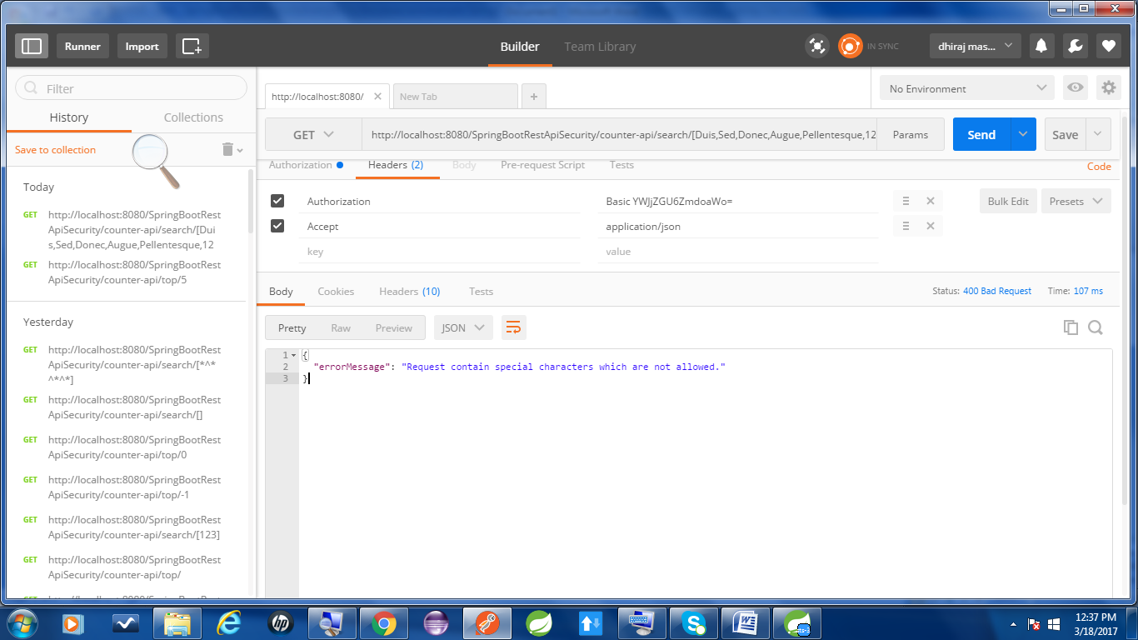

[http://localhost:8080/SpringBootRestApiSecurity/counter-api/search/[*^*^*^*](http://localhost:8080/SpringBootRestApiSecurity/counter-api/search/%5b*%5e*%5e*%5e*)]

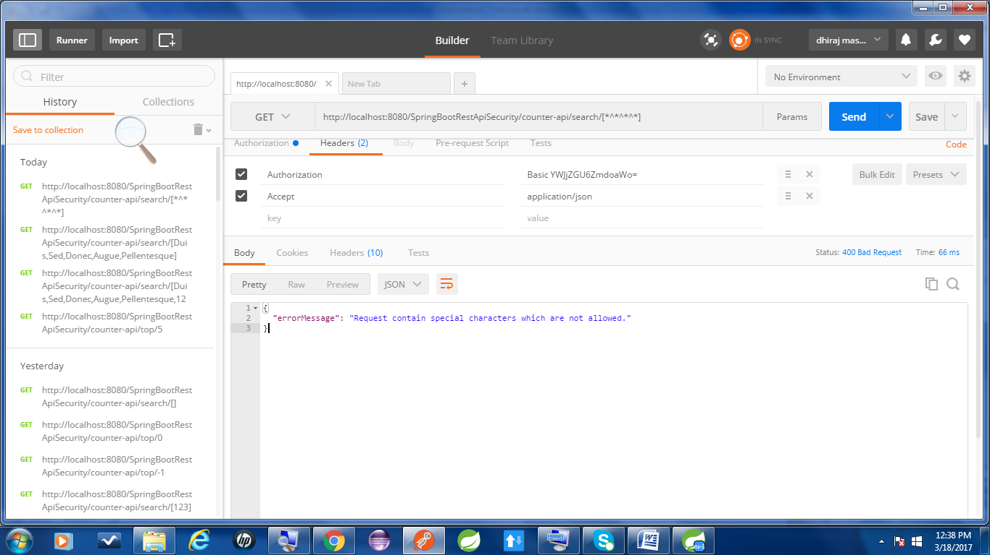

[http://localhost:8080/SpringBootRestApiSecurity/counter-api/search/[Duis,Sed,Donec,Augue,Pellentesque](http://localhost:8080/SpringBootRestApiSecurity/counter-api/search/%5bDuis,Sed,Donec,Augue,Pellentesque)]

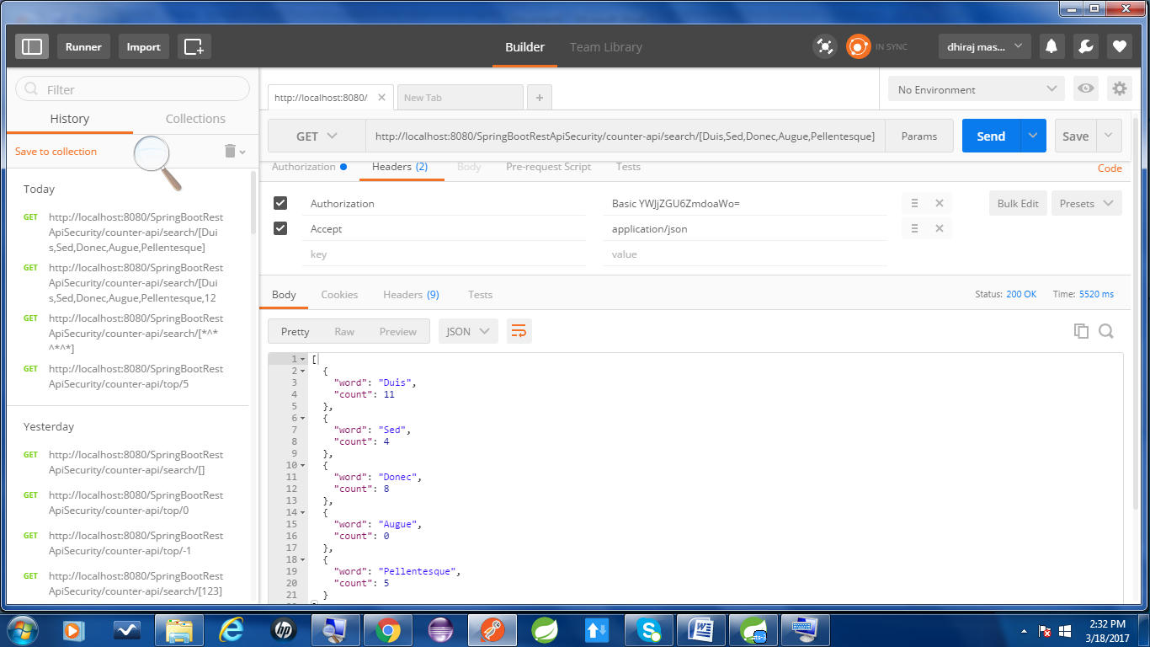

[http://localhost:8080/SpringBootRestApiSecurity/counter-api/search/[Duis,Sed,Donec,Augue,Pellentesque,123](http://localhost:8080/SpringBootRestApiSecurity/counter-api/search/%5bDuis,Sed,Donec,Augue,Pellentesque,123)]

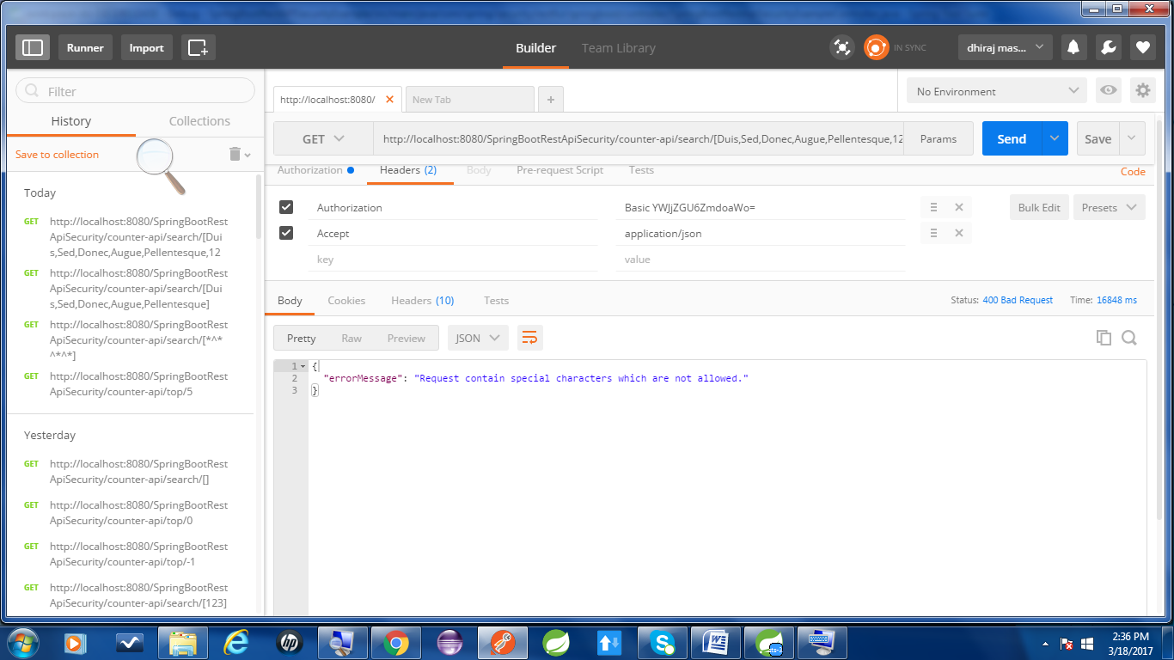

<http://localhost:8080/SpringBootRestApiSecurity/counter-api/top/-1>

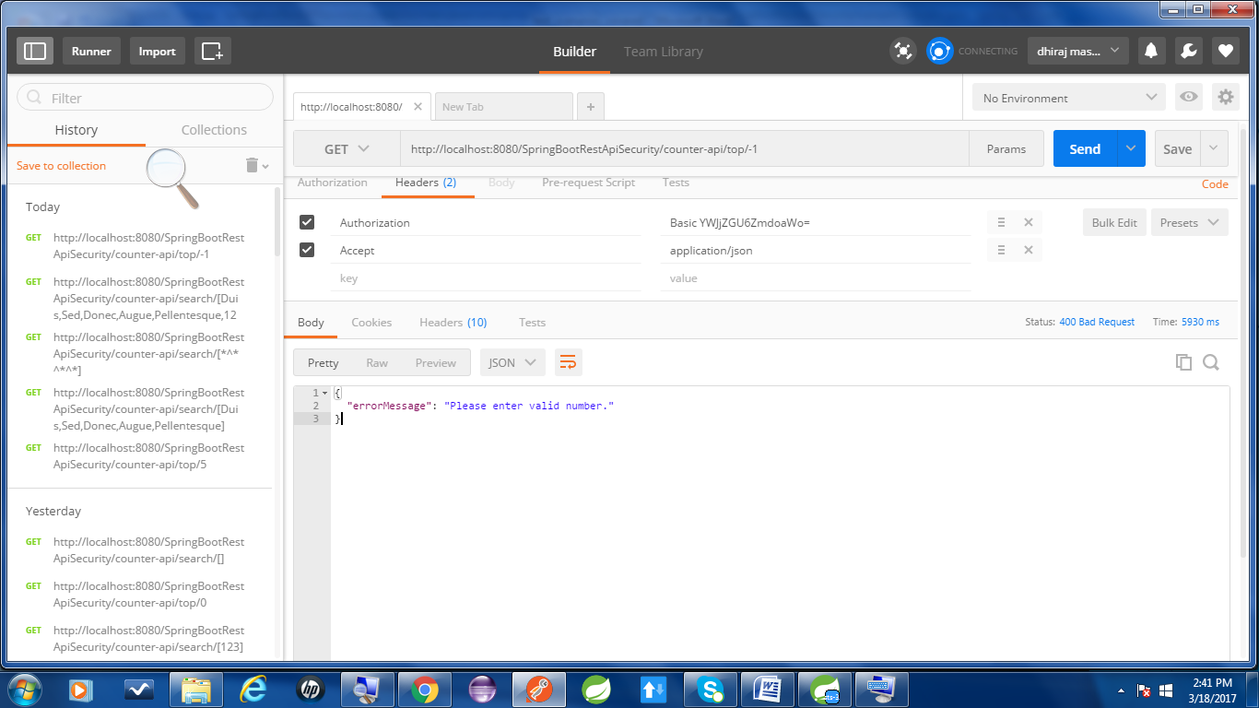

<http://localhost:8080/SpringBootRestApiSecurity/counter-api/top/5>

