1. We need ad space on top of the game 300 x 250 pls suggest what you are using.
2. Icon consistency one is circle and once is square. Maintain overall. Give the highest resolution. Buttons are pixelating
3. The overall screen is stretched. Need to be square not rectangle
4. The button style keep it simple should look like a button. Since the score and the timer has plain background the submit button also looks like a info box
5. Shape, height has to be maintained
6. Remove shadow from the Timer and the score text. In the lighter Theme the timer and score colour also needs to be changed.
7. Can the theme change( Lighter and darker tone) be a button instead of having as inside settings?

Please refer the game Wordle! On ios app store <https://apps.apple.com/in/app/wordle/id1095569891>

1. Popup should move down to the keyboard section and the keyboard should disappear in the background. Eg

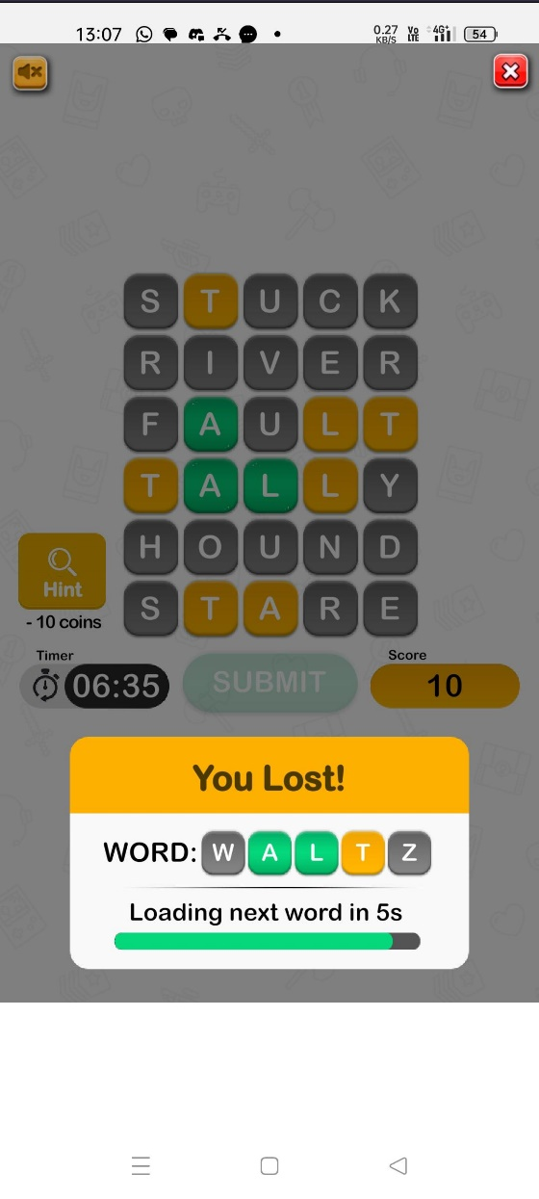

Please do not use pink or blue. Just copy the above option share a colour option

Please find the colour option not for the text just the colour suggestion

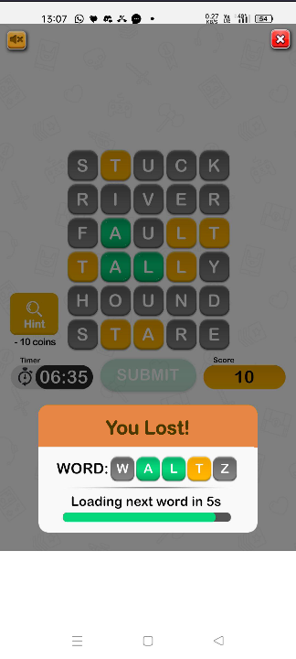

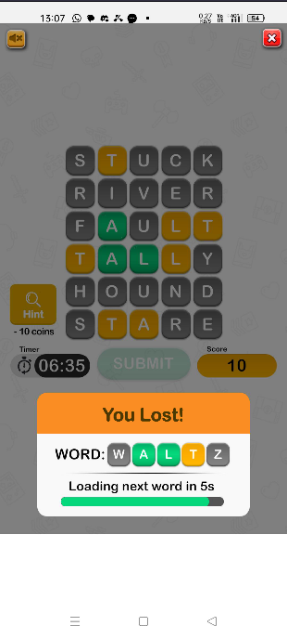

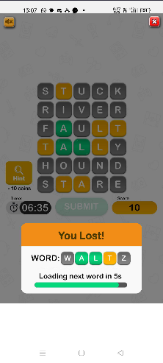  
9) Reference for the button

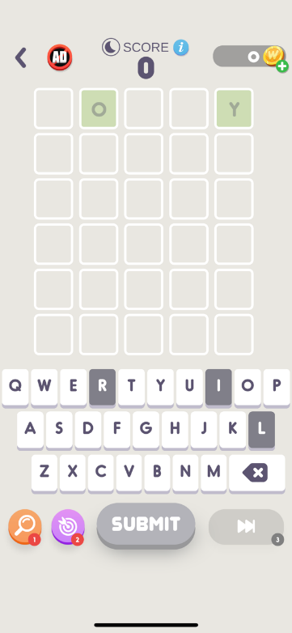

1. If the alphabet can flip like a coin
2. Music should start the moment the game starts
3. Add the dictionary link shared
4. Plural dictionary can be added later once you share the final dictionary at your end.
5. Help screen is too cluttered and small. Can we have a scroll and readable text