ML Assignment No. 4
R (2) | C (4) | V (2) | T (2) | Total (10) | Dated Sign

4.1 Title

Assignment based on k-mean Clustering

4.2 Problem Definition:


We have given a collection of 8 points. P1=[0.1,0.6] P2=[0.15,0.71] P3=[0.08,0.9] P4=[0.16,0.85] P5=[0.2,0.3] P6=[0.25,0.5] P7=[0.24,0.1] P8=[0.3,0.2]. Perform the k-mean clustering with initial centroids as m1=P1 =Cluster#1=C1 and m2=P8=cluster#2=C2. Answer the following
1] Which cluster does P6 belongs to?
2] What is the population of cluster around m2?
3] What is updated value of m1 and m2?

4.3 Prerequisite:

Basic of Python, Data Mining Algorithm, Concept of K-mean Clustering

4.4 Software Requirements:

Anaconda with Python 3.7

4.5 Hardware Requirement:

PIV, 2GB RAM, 500 GB HDD, Lenovo A13-4089Model.

4.6 Learning Objectives:

Learn How to Apply Kmean Clustering for given datapoints

4.7 Outcomes:

After completion of this assignment students are able Implement code for the k-mean clustering with initial centroids

4.8 Theory Concepts:

    - Motivation

A Hospital Care chain wants to open a series of Emergency-Care wards within a region. We assume that the hospital knows the location of all the maximum accident-prone areas in the region. They have to decide the number of the Emergency Units to be opened and the location of these Emergency Units, so that all the accident-prone areas are covered in the vicinity of these Emergency Units.
The challenge is to decide the location of these Emergency Units so that the whole region is covered. Here is when K-means Clustering comes to rescue!
A cluster refers to a small group of objects. Clustering is grouping those objects into clusters. In order to learn clustering, it is important to understand the scenarios that lead to cluster different objects. Let us identify a few of them.

What is Clustering?
Clustering is dividing data points into homogeneous classes or clusters:
Points in the same group are as similar as possible
Points in different group are as dissimilar as possible
When a collection of objects is given, we put objects into group based on similarity.
Application of Clustering:
Clustering is used in almost all the fields. You can infer some ideas from Example 1 to come up with lot of clustering applications that you would have come across.
Listed here are few more applications, which would add to what you have learnt.
- Clustering helps marketers improve their customer base and work on the target areas. It helps group people (according to different criteria’s such as willingness, purchasing power etc.) based on their similarity in many ways related to the product under consideration.
- Clustering helps in identification of groups of houses on the basis of their value, type and geographical locations.
- Clustering is used to study earth-quake. Based on the areas hit by an earthquake in a region, clustering can help analyse the next probable location where earthquake can occur.
Clustering Algorithms:
A Clustering Algorithm tries to analyse natural groups of data on the basis of some similarity. It locates the centroid of the group of data points. To carry out effective clustering, the algorithm evaluates the distance between each point from the centroid of the cluster.
The goal of clustering is to determine the intrinsic grouping in a set of unlabelled data.
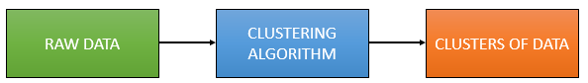
What is K-means Clustering?
K-means (Macqueen, 1967) is one of the simplest unsupervised learning algorithms that solve the well-known clustering problem. K-means clustering is a method of vector quantization, originally from signal processing, that is popular for cluster analysis in data mining.

K-means Clustering – Example 1:
A pizza chain wants to open its delivery centres across a city. What do you think would be the possible challenges?
- They need to analyse the areas from where the pizza is being ordered frequently.
- They need to understand as to how many pizza stores has to be opened to cover delivery in the area.
- They need to figure out the locations for the pizza stores within all these areas in order to keep the distance between the store and delivery points minimum.
Resolving these challenges includes a lot of analysis and mathematics. We would now learn about how clustering can provide a meaningful and easy method of sorting out such real life challenges. Before that let’s see what clustering is.
K-means Clustering Method:
If k is given, the K-means algorithm can be executed in the following steps:
- Partition of objects into k non-empty subsets
- Identifying the cluster centroids (mean point) of the current partition.
- Assigning each point to a specific cluster
- Compute the distances from each point and allot points to the cluster where the distance from the centroid is minimum.
- After re-allotting the points, find the centroid of the new cluster formed.
The step by step process:
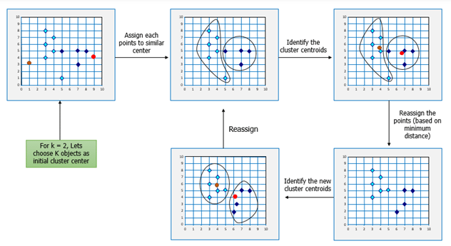
Now, let’s consider the problem in Example 1 and see how we can help the pizza chain to come up with centres based on K-means algorithm.

Similarly, for opening Hospital Care Wards:
K-means Clustering will group these locations of maximum prone areas into clusters and define a cluster center for each cluster, which will be the locations where the Emergency Units will open. These Clusters centers are the centroids of each cluster and are at a minimum distance from all the points of a particular cluster, henceforth, the Emergency Units will be at minimum distance from all the accident prone areas within a cluster.
Here is another example for you, try and come up with the solution based on your understanding of K-means clustering.

K-means Clustering – Example 2:
Let’s consider the data on drug-related crimes in Canada. The data consists of crimes due to various drugs that include, Heroin, Cocaine to prescription drugs, especially by underage people. The crimes resulted due to these substance abuse can be brought down by starting de-addiction centres in areas most afflicted by this kind of crime. With the available data, different objectives can be set. They are:
- Classify the crimes based on the abuse substance to detect prominent cause.
- Classify the crimes based on age groups.
- Analyze the data to determine what kinds of de-addiction centre is required.
- Find out how many de-addiction centres need to be setup to reduce drug related crime rate.
The K-means algorithm can be used to determine any of the above scenarios by analyzing the available data.
Following the K-means Clustering method used in the previous example, we can start off with a given k, following by the execution of the K-means algorithm.

Mathematical Formulation for K-means Algorithm:
K-Means clustering intends to partition n objects into k clusters in which each object belongs to the cluster with the nearest mean. This method produces exactly k different clusters of greatest possible distinction. The best number of clusters k leading to the greatest separation (distance) is not known as a priori and must be computed from the data. The objective of K-Means clustering is to minimize total intra-cluster variance, or, the squared error function:
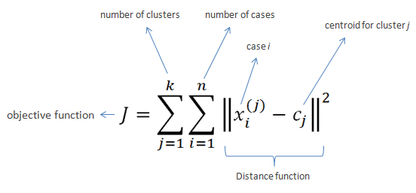

4.9 Algorithm

Import the Required Packages

Create dataset using DataFrame

Find centroid points

plot the given points

for i in centroids():

plot given elements with centroid elements

import KMeans class and create object of it

using labels find population around centroid

Find new centroids

4.10 Conclusion

In this way we learn Kmean Clustering Algorithm.

4.11 Assignment Questions

Why does k-means clustering algorithm use only Euclidean distance metric?

How to decide on the correct number of clusters?
- What are the Different Application of K Mean Clustering?
- What is K-medoids?
- What is k-medians clustering?

References:-

- https://www.saedsayad.com/k_nearest_neighbors.htm
- https://www.edureka.co/blog/k-means-clustering/

