BIRLA INSTITUTE OF TECHNOLOGY & SCIENCE, PILANI
WORK INTEGRATED LEARNING PROGRAMMES (WILP) DIVISION
VIDYA VIHAR, PILANI, RAJASTHAN – 333031
DISSERTATION OUTLINE
Second Semester, Academic Year 2025–2026
Demand Forecasting & Inventory Optimization
A probabilistic deep-learning forecasting pipeline integrated with stochastic inventory policy on the M5 retail dataset
Student ID | 2024DA04376
Name of the Student | Ms. Prithvi Uday Amonkar
Student's Email | 2024da04376@wilp.bits-pilani.ac.in
Course No. / Title | S2-25_DSECLZG628T / Dissertation
Degree Program | M.Tech. in Data Science and Data Engineering
Research Area | Logistics & Supply Chain Management
Broad Academic Area | Applied Deep Learning for Retail Demand Forecasting & Inventory Optimization
Employing Organization | Dassault Systèmes, Infotech Park, MIDC Phase-1, Hinjewadi, Pune – 411057, India
Supervisor | Mr. Ramkrishna Tayade (Data Engineer Manager, Dassault Systèmes)
Supervisor's Email | Ramkrishna.TAYADE@3ds.com
Additional Examiner | Mr. Prashant Shimpi (Data Engineer Manager, Dassault Systèmes)
Additional Examiner's Email | Prashant.SHIMPI@3ds.com

Contents
1. Concrete Problem Statement (Deficiency → Solution)
2. Elevator Pitch
3. Broad Area of Work
4. Background & Motivation
5. Objectives
6. Scope of Work
7. Technologies & Tools (with role of each)
8. System Architecture
9. Plan of Work — Measurable, Demo-able Milestones
10. Integration into a Larger Environment (not a standalone notebook)
11. Evaluation Methodology
12. Literature References
13. Particulars of the Supervisor and Examiner
14. Remarks of the Supervisor

1. Concrete Problem Statement (Deficiency → Solution)
Deficiency identified: Most retail inventory systems still treat demand forecasts as deterministic point estimates (a single number per SKU per day). This ignores the variance around that estimate, which is precisely what determines whether a retailer over-stocks (carrying cost, waste) or stocks-out (lost revenue, customer churn). Classical methods like ARIMA produce point forecasts; even when modern deep-learning models are applied, their probabilistic outputs are rarely integrated into the downstream inventory policy.
Proposed solution: I will build an end-to-end pipeline that produces probabilistic demand forecasts (point forecast + quantile bands at P10 / P50 / P90) using LSTM and Transformer-based models trained on the M5 Forecasting Competition dataset, and then feed those quantile bands directly into a stochastic inventory-optimization layer (dynamic safety-stock, reorder-point, and EOQ adjusted by forecast uncertainty). I will benchmark the deep-learning models against an ARIMA / ETS statistical baseline on two classes of metrics: (i) forecast accuracy (RMSE, MAPE, pinball loss) and (ii) operational cost (simulated holding cost, stockout rate, achieved service level). The hypothesis I am testing is concrete and falsifiable: propagating predictive uncertainty into the inventory policy reduces total operational cost by a measurable margin compared to using a point forecast plus a static safety-stock rule.

2. Elevator Pitch
Stores often end up with too much of one product and too little of another because they decide how much to stock based on a single guess of tomorrow's sales. This project builds a system that doesn't just predict “we'll sell 100 units” — it predicts “we'll sell between 80 and 130 units, most likely 100” — and then uses that range to decide exactly how much to keep on the shelf. The result is fewer empty shelves and less wasted inventory, measured directly in money saved per simulated week.

3. Broad Area of Work
The project sits at the intersection of four domains: Data Science, Deep Learning, Time-Series Analysis, and Supply Chain Management. Specifically, it bridges three sub-areas:
- Probabilistic time-series forecasting using neural architectures (LSTM, Transformer, DeepAR-style models).
- Stochastic inventory optimization under demand uncertainty (EOQ, dynamic safety stock, reorder-point policies).
- End-to-end ML system design (training pipeline, model registry, REST API, dashboard, containerization).
The work is comparative and application-driven rather than a pursuit of algorithmic novelty: the contribution is in measuring how forecast uncertainty translates into operational cost across a realistic retail dataset.

4. Background & Motivation
Accurate demand forecasting is a core driver of efficiency in retail and supply-chain systems. Poor forecasting leads to overstocking (high holding costs, perishable waste) or stockouts (lost sales, brand damage). Classical methods such as ARIMA and exponential smoothing are well understood but struggle with non-linear seasonality, promotional effects, and the long-tail of slow-moving SKUs.
Recent advances in deep learning — in particular LSTM and Transformer-based models — capture these complex patterns better and naturally support probabilistic outputs (e.g., via quantile regression or DeepAR-style negative binomial heads). However, in practice, forecasting research and inventory research are usually carried out in silos: forecasting is evaluated on RMSE/MAPE while inventory is evaluated on cost. The question of whether a better forecast actually produces better inventory decisions is rarely measured end-to-end.
This dissertation closes that loop. Using the M5 Forecasting Competition dataset (42K hierarchical Walmart time series), it benchmarks statistical, ML, and deep-learning forecasters and — critically — simulates a downstream inventory policy on each, scoring it in dollars rather than only in RMSE.
Relevance to the employing organization (Dassault Systèmes): the host team works on data engineering for industrial / supply-chain customers. A reproducible probabilistic-forecast → inventory-decision template is directly applicable to retail and manufacturing customer use-cases.

5. Objectives
The objectives are deliberately consolidated into a small, mutually exclusive set so that each one can be pointed at a measurable deliverable and a demo. Bloat and overlap from earlier drafts have been removed.

5.1 Primary Objectives
- O1. Build a baseline statistical forecaster (ARIMA / ETS) on the M5 dataset and lock its accuracy numbers as the improvement target.
- O2. Train deep-learning forecasters (LSTM and a Transformer-based model) that produce probabilistic outputs (P10 / P50 / P90 quantile bands) on the same dataset.
- O3. Implement an inventory-decision layer (EOQ + reorder point + uncertainty-driven dynamic safety stock) that consumes the quantile forecasts.
- O4. Run a closed-loop simulation that scores each forecaster on operational cost, not just statistical error, and quantify the cost saving from using probabilistic vs. point forecasts.

5.2 Secondary Objectives
- O5. Wrap the trained system as a containerized FastAPI service with a Streamlit dashboard so the project is demoable as a running application, not a notebook.
- O6. Track all experiments in MLflow so model lineage and metric comparisons are reproducible.

6. Scope of Work

6.1 In Scope
- Data ingestion, cleaning, and feature engineering on the public M5 Forecasting Competition dataset (Walmart, 42K series, 5 years of daily history).
- Statistical baselines: ARIMA and ETS via statsmodels.
- Deep-learning forecasters: LSTM with quantile loss and a Transformer / DeepAR-style probabilistic model in PyTorch.
- Inventory layer: EOQ, reorder point, and uncertainty-adjusted dynamic safety stock derived from quantile forecasts.
- Simulation harness that replays forecast → order → demand realization → cost, per SKU per store.
- Deployment artifacts: Dockerized FastAPI service exposing /forecast and /inventory endpoints, Streamlit dashboard, MLflow experiment tracking, GitHub Actions CI.

6.2 Out of Scope
- Live deployment into Dassault Systèmes production systems or a real customer ERP.
- Multi-echelon supply-chain optimization (transport, warehouse routing) — this work stops at the SKU/store decision.
- Architectures that demand training resources beyond a single GPU / 3-month timeline (e.g., very large foundation models for time series).

7. Technologies & Tools (with role of each)
The evaluator's feedback specifically asked for a list of tools paired with the role each plays. The table below is organized by architectural layer so the mapping to the system diagram (Section 8) is unambiguous.
Layer | Tool / Technology | Role in the project
Language | Python 3.11 | Primary implementation language
Data | pandas, NumPy | Cleaning, joins (calendar/promo/price), feature engineering
Statistical baseline | statsmodels, pmdarima | ARIMA and ETS — fixed accuracy target the DL models must beat
Deep-learning forecasting | PyTorch, PyTorch Forecasting | LSTM (quantile loss) and Transformer / DeepAR probabilistic models
Experiment tracking | MLflow | Logging metrics (RMSE, pinball loss, holding cost), versioning models
Storage | PostgreSQL (or SQLite for local) | Forecast outputs (point + quantiles) and inventory state per SKU/store
Inventory simulation | SimPy / custom NumPy harness | Replays demand against ordering policy to compute cost & service level
Serving | FastAPI + Uvicorn, Docker | REST endpoints for /forecast and /inventory; container makes it deployable, not a notebook
Dashboard | Streamlit (with Plotly) | Visualizes forecasts, uncertainty bands, simulated cost-savings; serves as the live demo surface
DevOps | GitHub + GitHub Actions | Source control, CI: lint + unit tests + build container on every push

8. System Architecture
The diagram below shows how data flows from the M5 dataset, through preprocessing and the three forecasting models, into the forecast store, the inventory optimizer, and finally the FastAPI service and Streamlit dashboard. The dashed arrow is the evaluation loop that feeds operational cost back into model selection.
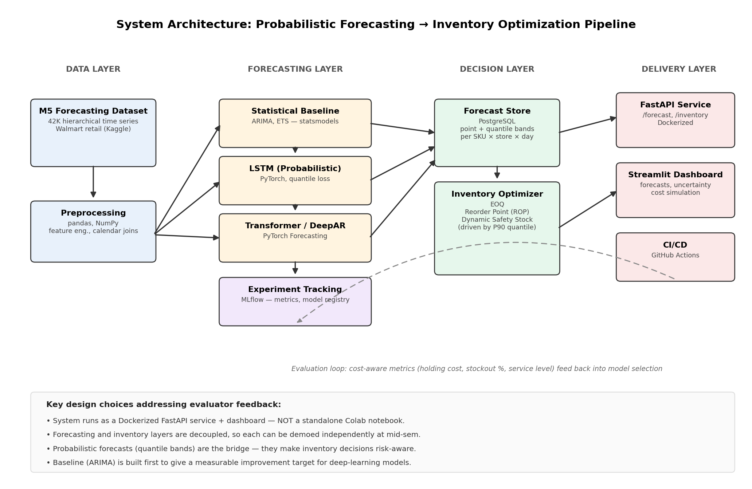
Figure 1. End-to-end architecture of the forecasting + inventory optimization pipeline.

9. Plan of Work — Measurable, Demo-able Milestones
Generic project-management timelines (“abstract submission → development complete → testing”) have been replaced by phase-wise deliverables, each tied to (a) a concrete artifact in the repository and (b) something that can be demoed live, not just talked about.
Mid-semester checkpoint: the highlighted row marks the mid-sem demo. By that point the data pipeline, statistical baseline, and LSTM probabilistic forecaster will all be runnable end-to-end on a held-out test slice — roughly 50% of the full scope, demonstrable as code.
Final viva: the full system (data → three forecasters → inventory layer → API → dashboard) runs from a fresh repo checkout via docker compose up, and the report quantifies the cost saving from probabilistic forecasts vs. the point-forecast baseline.
Phase | Weeks | Deliverable | What the demo shows
Setup & EDA | Week 1–2 | M5 dataset ingested into project repo; reproducible preprocessing scripts; exploratory notebooks committed. | Run the preprocessing CLI on raw M5 files → see cleaned, joined dataset and EDA dashboards (sales by category, seasonality, promo lift).
Baseline forecaster | Week 3–4 | ARIMA + ETS baselines on a representative slice of SKUs; RMSE / MAPE locked as the target. | Show MLflow run comparing ARIMA and ETS; produce a forecast plot + a metrics table that subsequent models must beat.
LSTM probabilistic | Week 5–6 | LSTM with quantile loss producing P10 / P50 / P90 forecasts; RMSE and pinball loss vs. baseline. | Forecast plot with uncertainty band; side-by-side metrics table vs. ARIMA in MLflow UI.
MID-SEMESTER REVIEW | End Week 6 | Mid-semester checkpoint: items above are demoable end-to-end on a held-out test split. | Live walk-through: data pipeline → ARIMA baseline → LSTM quantile forecasts → MLflow metrics. ~50% of total scope complete.
Transformer / DeepAR | Week 7–8 | Transformer-based probabilistic forecaster trained; full three-way model comparison. | Three-model comparison plot and metrics; Transformer wins or loses on a measurable margin — either result is a real result.
Inventory optimization layer | Week 9–10 | EOQ + reorder-point + uncertainty-driven dynamic safety stock; simulation harness scoring each forecaster on holding cost and stockout rate. | Run the simulator on top of each forecaster; show the dollar-cost table that quantifies the value of probabilistic forecasting.
Service + dashboard | Week 11 | FastAPI service in Docker; Streamlit dashboard pulling forecasts and inventory recommendations from the API. | docker compose up → hit the dashboard URL → select a SKU → see live forecast, recommended order quantity, and projected cost.
Final evaluation & documentation | Week 12–13 | End-to-end report, full results, ablations, README, reproducible run instructions, recorded demo. | Final viva: full system runs on a fresh checkout; results section answers the central hypothesis with numbers.

10. Integration into a Larger Environment
The evaluator's note explicitly cautioned against projects that ship as a single Colab notebook. This project is designed from day one to be a small but real system, not a lab exercise:
- The forecasting models are accessed through a FastAPI service, not via a notebook cell. Any client (the dashboard, a curl request, a future downstream service) hits the same /forecast endpoint.
- The whole stack ships as a docker-compose application with three services: api (FastAPI + model artifacts), db (PostgreSQL), and ui (Streamlit). docker compose up brings up the running system.
- Forecasts are persisted to PostgreSQL, not just printed inline. The inventory optimizer reads from this store, exactly as a downstream production component would.
- Models are versioned in MLflow's model registry; the API loads a specific named version, so swapping the served model is a config change, not a code change.
- A GitHub Actions pipeline runs lint + unit tests + a Docker build on every push, so the project is continuously verified to be runnable, not just “works on my laptop”.
In short, the demo at viva will be: open the dashboard URL, pick a SKU, see the forecast and the recommended order quantity — served by a real API backed by a real database — and toggle between forecaster versions to compare cost outcomes.

11. Evaluation Methodology
Each model is evaluated on three layers of metrics. The headline number — the one the dissertation reports as its main result — is the bottom row.
Metric family | Specific metrics | Why it matters
Forecast accuracy (point) | RMSE, MAE, MAPE | Standard sanity check; comparable to M5 leaderboard.
Forecast accuracy (probabilistic) | Pinball loss at P10/P50/P90, coverage of the 80% interval | Tells us whether the uncertainty estimates are calibrated, not just whether the median is good.
Inventory operational metrics | Total holding cost, stockout rate, achieved service level, fill rate | These are the metrics a retailer actually cares about; they are what the project ultimately optimizes.
End-to-end metric | Cost-saving (%) of probabilistic-forecast policy vs. point-forecast policy at matched service level | This is the headline number that answers the project's central hypothesis.

12. Literature References
Books
- Hyndman, R. J. & Athanasopoulos, G. (2021). Forecasting: Principles and Practice (3rd ed.), OTexts.
- Chopra, S. & Meindl, P. (2016). Supply Chain Management: Strategy, Planning, and Operation, Pearson.
- Goodfellow, I., Bengio, Y. & Courville, A. (2016). Deep Learning, MIT Press.
Foundational papers
- Hochreiter, S. & Schmidhuber, J. (1997). Long Short-Term Memory. Neural Computation, 9(8), 1735–1780.
- Salinas, D., Flunkert, V., Gasthaus, J. & Januschowski, T. (2020). DeepAR: Probabilistic forecasting with autoregressive recurrent networks. International Journal of Forecasting, 36(3).
- Lim, B., Arik, S. O., Loeff, N. & Pfister, T. (2021). Temporal Fusion Transformers for interpretable multi-horizon time series forecasting. International Journal of Forecasting, 37(4).
Recent surveys & applied work
- “Machine Learning and Deep Learning Models for Demand Forecasting in Supply Chain Management: A Critical Review” (2024).
- “Deep Learning Techniques for Demand Forecasting” (2022).
- “A Cross-Temporal Hierarchical Framework using LSTM for Supply Chain Forecasting” (2020).
- “Predictive Analytics for Demand Forecasting: A Deep Learning-Based Decision Support System” (2024).
Dataset
- Makridakis, S., Spiliotis, E. & Assimakopoulos, V. (2022). The M5 Accuracy competition: results, findings, and conclusions. International Journal of Forecasting, 38(4).

13. Particulars of the Supervisor and Examiner
 | Supervisor | Additional Examiner
Name | Mr. Ramkrishna Tayade | Mr. Prashant Shimpi
Qualification | M.Tech. / equivalent | M.Sc. Computer Science
Designation | Data Engineer Manager | Data Engineer Manager
Employing Organization | Dassault Systèmes, Pune, Maharashtra – 411057, India | Dassault Systèmes, Pune, Maharashtra – 411057, India
Email | Ramkrishna.TAYADE@3ds.com | Prashant.SHIMPI@3ds.com

14. Remarks of the Supervisor
The proposed study is timely and substantive. The student has covered the relevant literature on probabilistic forecasting and inventory optimization, and has framed the problem as an end-to-end measurable hypothesis rather than an open-ended literature survey. The scope is appropriate for a Master's-level dissertation and aligned with current research directions in applied data science for supply-chain decision support.
The architecture and milestone plan demonstrate that the project is intended as a deployable system rather than an isolated notebook, which is essential for meaningful evaluation. The student has prior demonstrated commitment and the technical skills required to execute the experiments in a standard research paradigm. There is a reasonable prospect of a publishable result given the comparative evaluation framework. I approve the project as the supervisor.

Signature of Student  _______________________  Name: Prithvi Amonkar | Signature of Supervisor  _______________________  Name: Ramkrishna Tayade | Signature of Additional Examiner  _______________________  Name: Prashant Shimpi

