NOTE: In production environment, to make a Kubernetes Cluster Highly Available, its recommended that we should always have an odd (like 3 or 5 or 7) number of Master Nodes. But here we are not using this cluster to run any production grade application, we have decided to proceed with 2 Master Nodes and 4 worker nodes.

**Pre-Requisites:**

1. 6 Raspberry Pi 4 boards with 8 GB Memory
2. SD Card – 32 GB
3. 8 Port Ethernet Switch
4. Power Supply
5. Ethernet Cables – 7 (1 for each board and 1 for up linking)
6. HDMI to micro-USB Cables
7. Keyboard
8. Display

HDMI – microUSB, Keyboard, Display you can use as per your convenience and availability.

**Making SD Card Ready and Booting up Boards:**

1. Download Raspbian Lite using this [link](https://www.raspberrypi.org/software/operating-systems/).

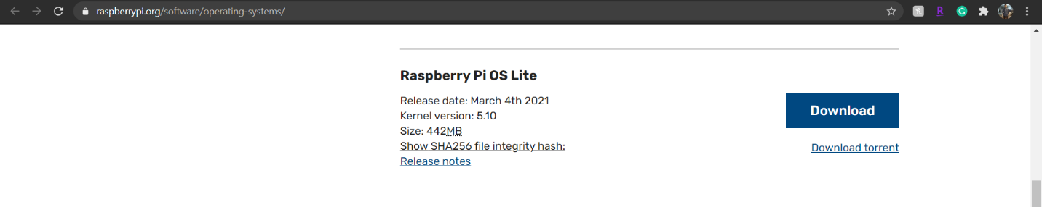

1. Download Balena Etcher to flash SD Card using this [link](https://www.balena.io/etcher/).

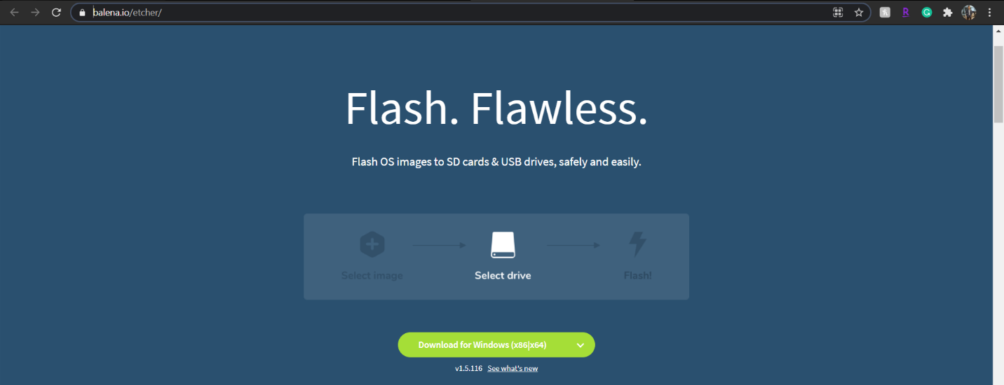

1. Once SD card is ready, then mount it to your Laptop and create a blank file named “ssh” in “/boot” partition.

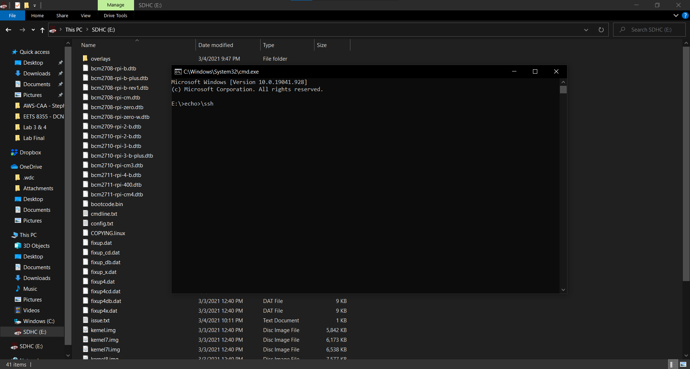

1. Once all 6 cards are ready, then insert them in all Raspberry Pi 4 boards.
2. Connect Ethernet Cables, HDMI-mircoHDMI cables (for display), Keyboards and Displays.
3. And then at last, Power On your all boards. Let the boards power on completely, usually it takes 25ms. However, depends on many other components like storage, Application etc.
4. Once all boards are up and running, login using default credentials:

Username: pi

Password: raspberry

****************************