Skills of entrepreneur should be good. He will do good work. He has to make sure good money. Good product is also important, but not as important because product evolves. Also, I think the product is very important, but we should get money. If I money, then I give product. If you go market, then people know pay money. We don't give product. Because only with money you get product. More money you give.

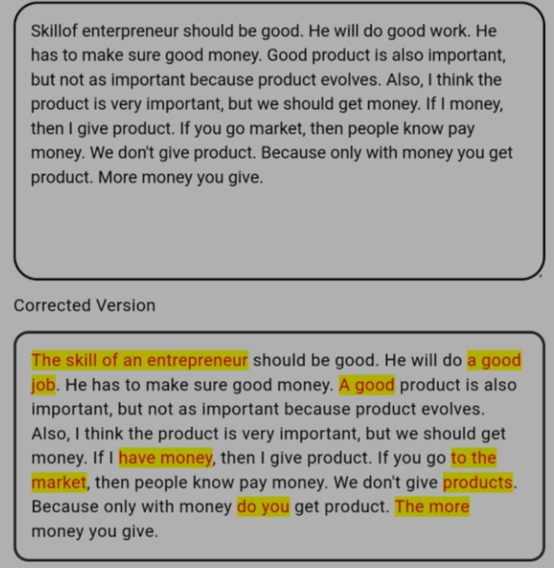

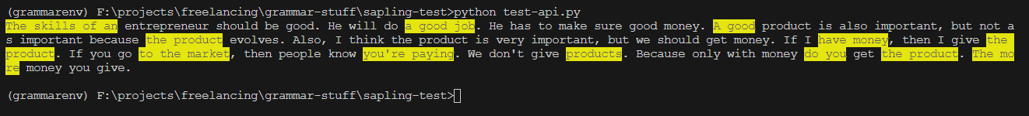

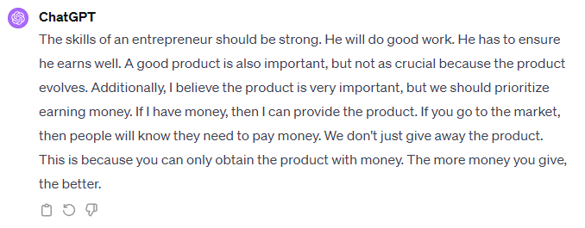

I studing nursing. My dream is to become a surgeon. I excited about the app I attended anatomy class and back home I meet my therapist who learnt medicine and skills and experience is great.he is a dedicated consultant.

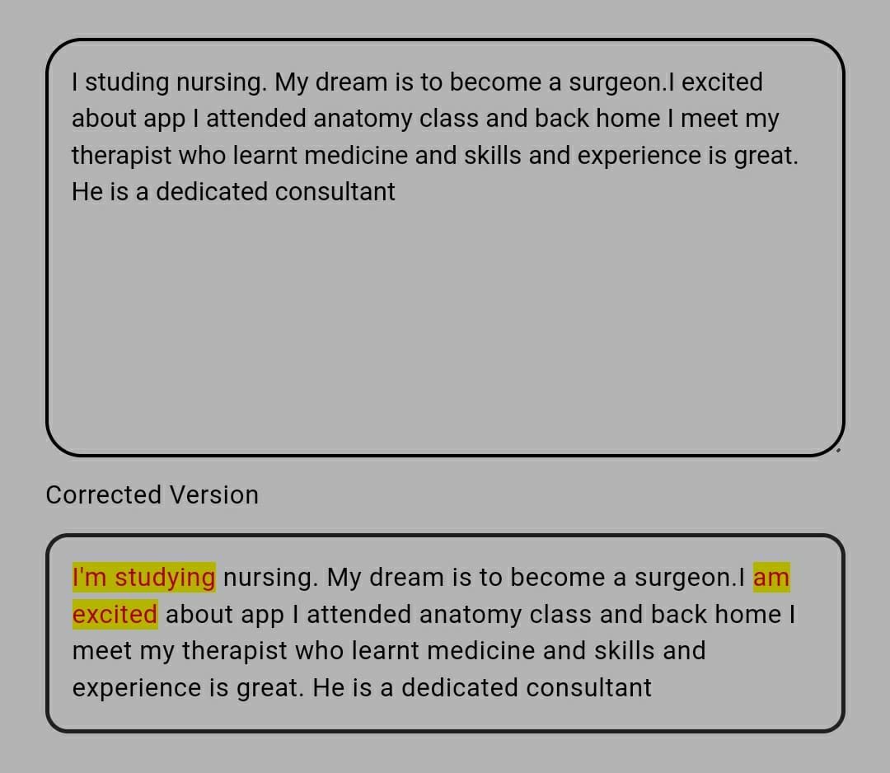





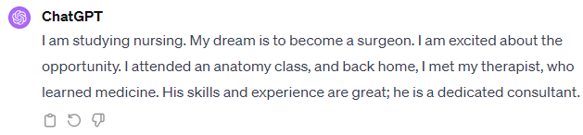

What you talking I doesn't know. What I talking you doesn't know. Anyways, let us see how it is working. It is not seem to be working. Let me see the text. What you do is your name Sarita. Are she also coming with us? Who doesn't you know? Why doesn't you know? These are also, they are also coming. He is also coming. I can't able to because I doesn't know. How you doesn't know you are not or you can't able to. We have to think all these things. You are understanding what I am saying. My English is the good or the bad. I doesn't know. Are she coming with us? These coming. Is it the good or the better? Or does it just more better?





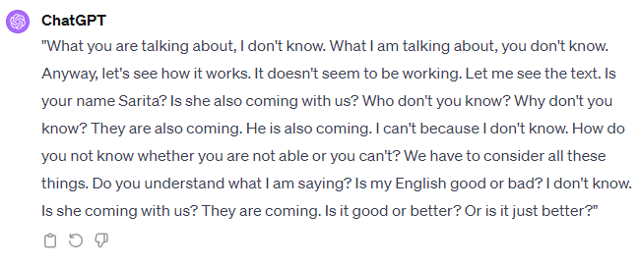

Breakfast when I work. As always I have to grab a few tots, some spinach and they had all of the ingredients again, half to grab that, some soy chorizo scrambled, some bacon. I went back for a chicken patty and some scrambled cakes. Some toasted toast and they also have a waffle maker but I'm always too lazy to wait for the waffle to be done so maybe next time. Guys that is Thai tea whipped cream. I loved Thai tea but what is Thai tea whipped cream? Okay what should I do for breakfast today? Soap obviously but I'm going to skip on coke and get spiked today. They also had ham and cheese croissant so I had to grab one, catch up for my eggs, grabbing utensils and anapkin. I feel like sitting outside for breakfast today. Okay taste test. Cresson was pretty good. Toast is toasty. I'll opinion it was spicy. Chicken sausage patty, not too bad. Tater tot, it's crispy. Spinach, healthy and sprite was delicious. I have some dill. Look at that spicy fried chicken stir fry. Oh my goodness the chicken, the sauce, it's all amazing. We are making dragon chicken. Dragon chicken. Cool name but what is it? So it's actually an indoor Chinese dish and by that I mean it...

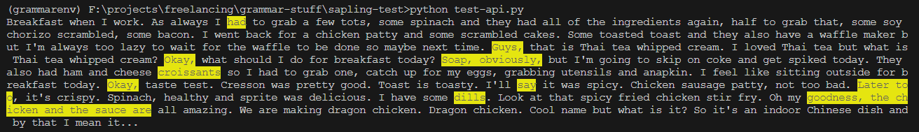

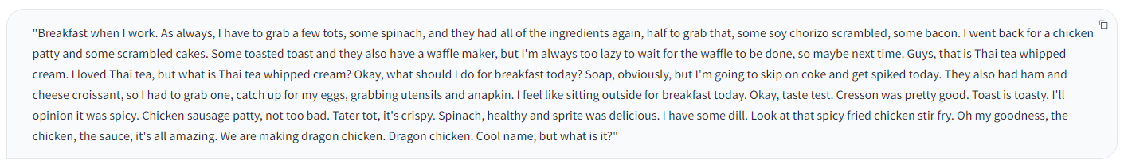

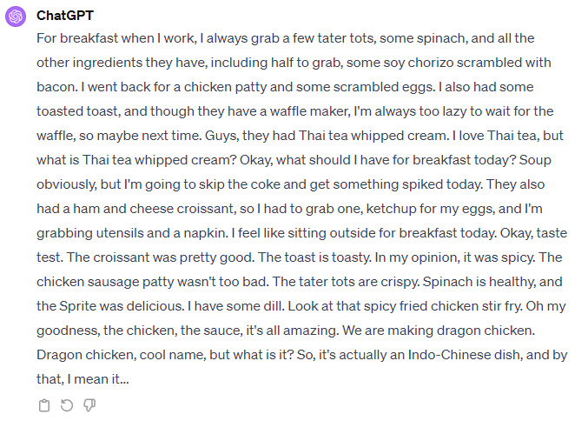

What do I like to do in my free time? I like to do many things in my free time. I like to eat, drink, dance, fight, many other things also I like to do. Some TV we were watching but I don't know, it's not my thing but I see a necklace. It was different, it's a red roll. So they are doing all these old songs. I might have got a tight dance and all those things. And it is how it is, I don't know but it looks like it is good only not bad only.



