Demo Session Under-the-Hood Walkthrough
Enterprise Diagnostics GraphRAG Platform — Document 09
This document explains everything that happened in your live Streamlit demo session (washer spin failure, two-turn conversation, CRM enrichment, warranty gate, 94% vs 47% confidence, escalation, and CCaaS case creation) and maps each UI element to the tech stack, Neo4j graph, LangGraph workflow, and enterprise ETL pipelines.

1. What You Saw — Executive Summary
UI indicator | Value | What it means
Neo4j Connected | Yes | Knowledge graph loaded and Cypher queries succeeded
Mode Enterprise | Yes | USE_MOCK_ENTERPRISE_APIS=true — CRM/PIM/FSM/Claims on :8090
Mock APIs Online | Yes | simulation/mock_enterprise_apps.py serving fixture data
Open Escalations | 3 | Cases in data/escalations.json from should_escalate=true diagnoses

Your session had two customer turns on the same washer asset (AST-WM-4421). Turn 1 resolved automatically at 94% confidence. Turn 2 added a second symptom, diluting confidence to 47%, triggering escalation and simulated case management handoff.

2. System Context & Module Map
Figure 1 shows where the demo platform sits relative to enterprise systems and operators.
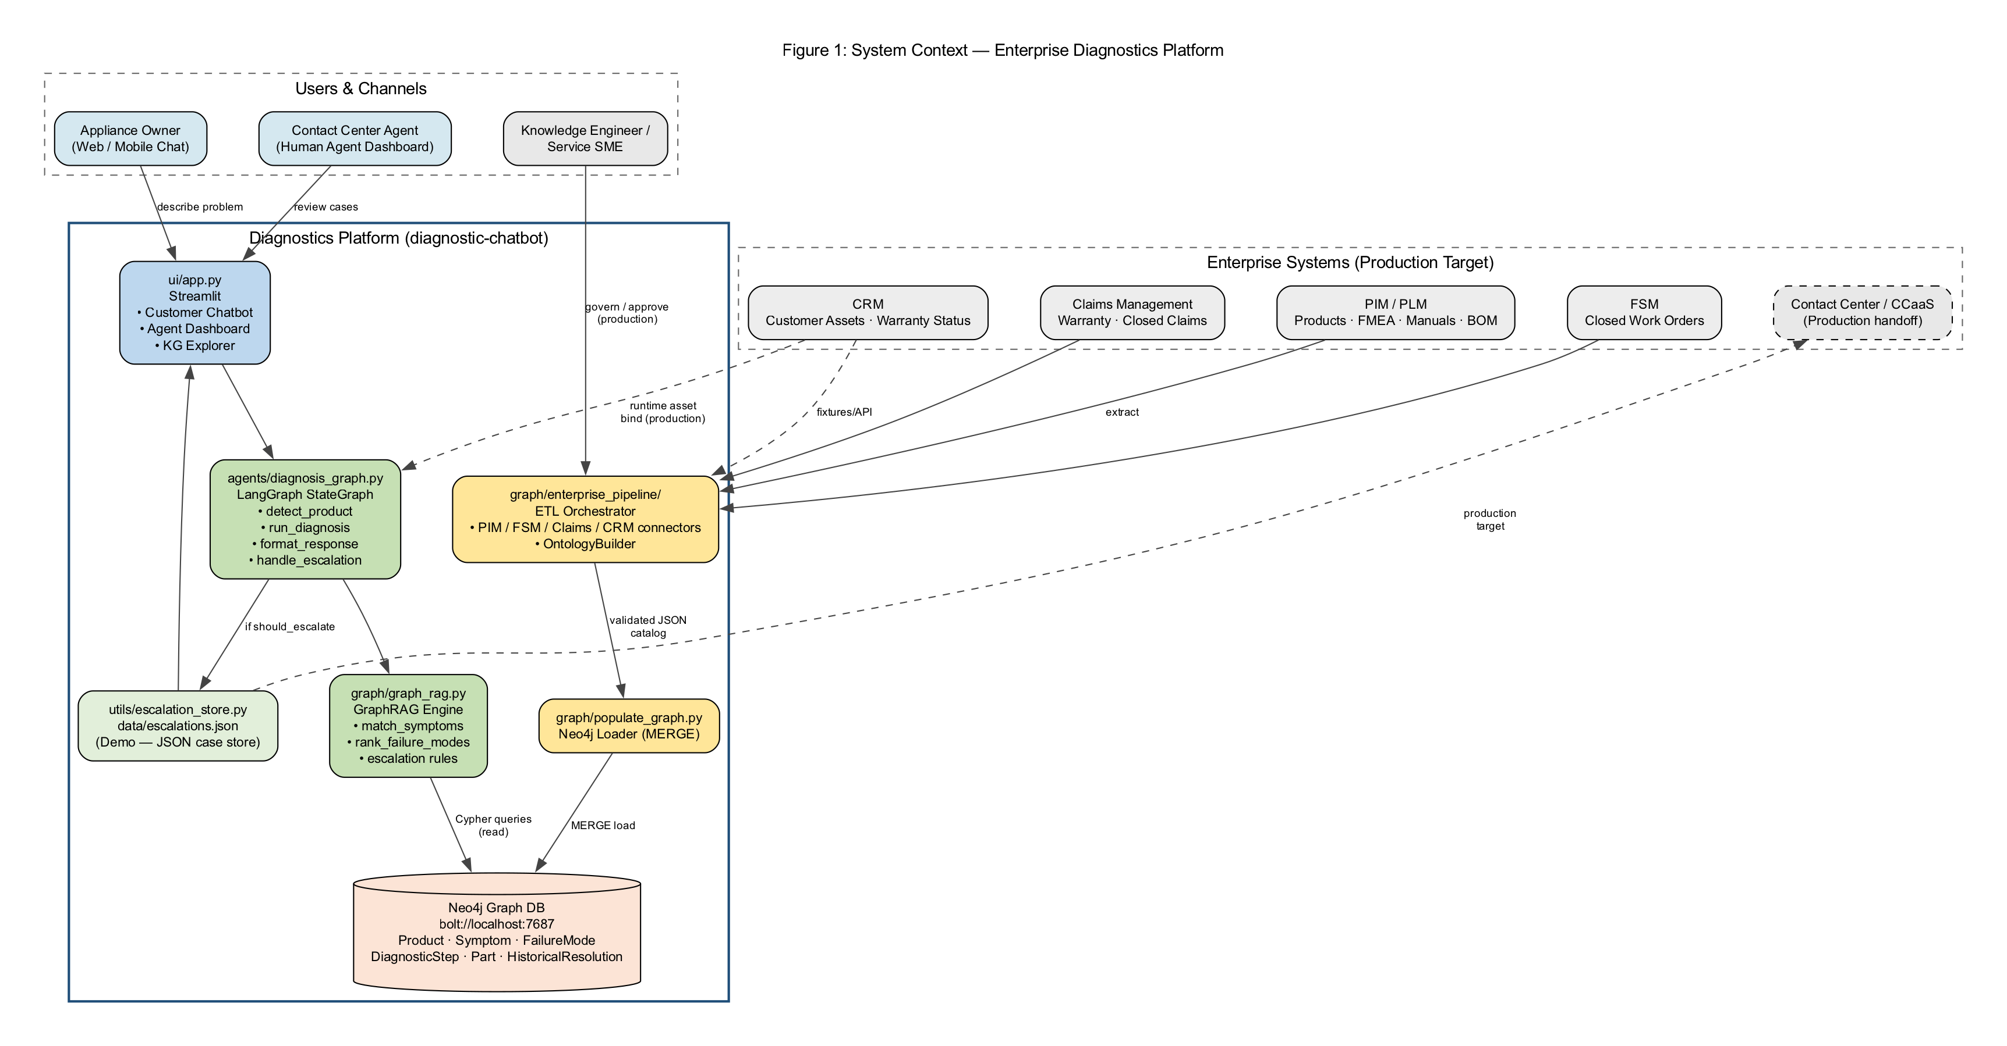
Figure 1: Enterprise system context (C4-style)
Figure 2 maps Python modules to functional responsibilities.
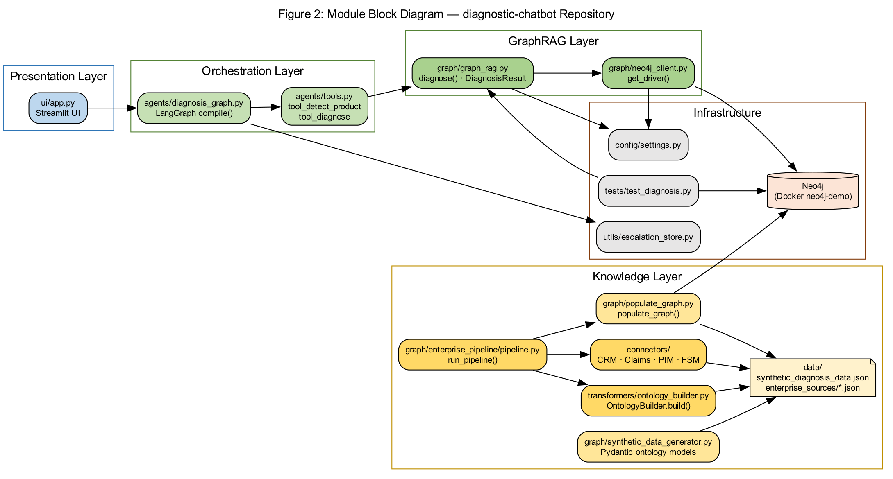
Figure 2: Module block diagram

Tech stack mapping
Layer | Technology | File(s) | Role in your demo
Presentation | Streamlit | ui/app.py | Chat UI, CRM selectors, 4 tabs
Orchestration | LangGraph | agents/diagnosis_graph.py | 4-node state machine per message
GraphRAG | Neo4j + Python | graph/graph_rag.py | Cypher queries + symptom matching
Knowledge store | Neo4j 5.x | graph/neo4j_client.py | Product wm-001 graph
Enterprise APIs | FastAPI mock | simulation/mock_enterprise_apps.py | CRM asset lookup
Integrations | Python | integrations/*.py | CRM, warranty, case management
ETL | Python pipelines | graph/enterprise_pipeline/ | Loaded graph before demo
Audit | JSONL | utils/lineage_store.py | ETL batch lineage in Enterprise tab

3. Enterprise ETL — How the Graph Got There
Before your chat session, the orchestrator ran three pipelines to build the Neo4j knowledge graph.
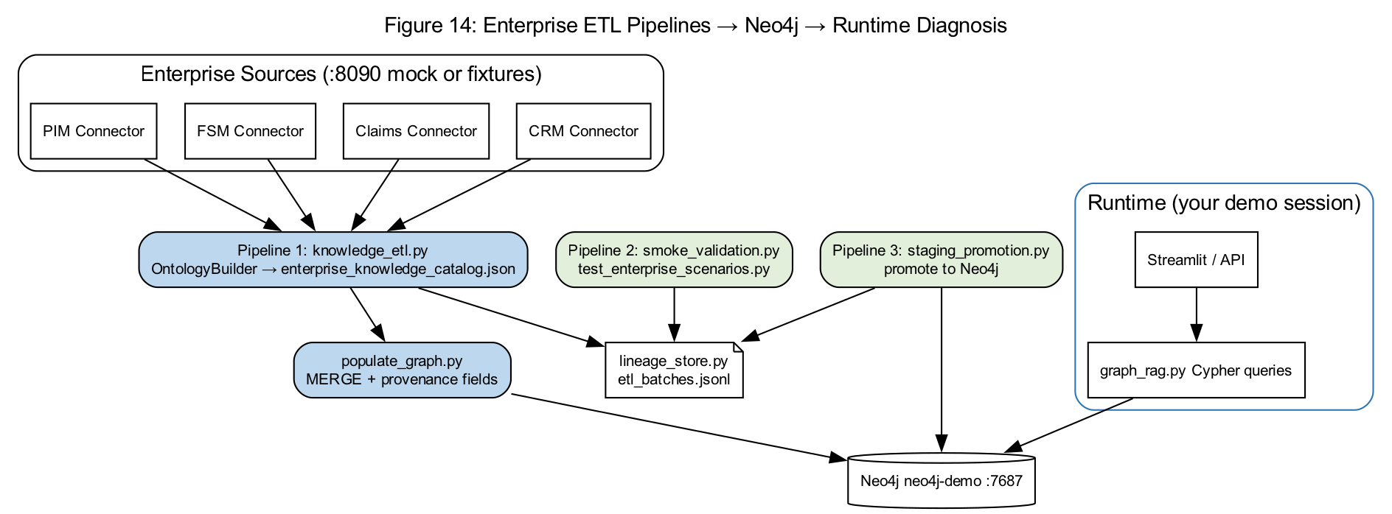
Figure 14: ETL pipelines to runtime diagnosis
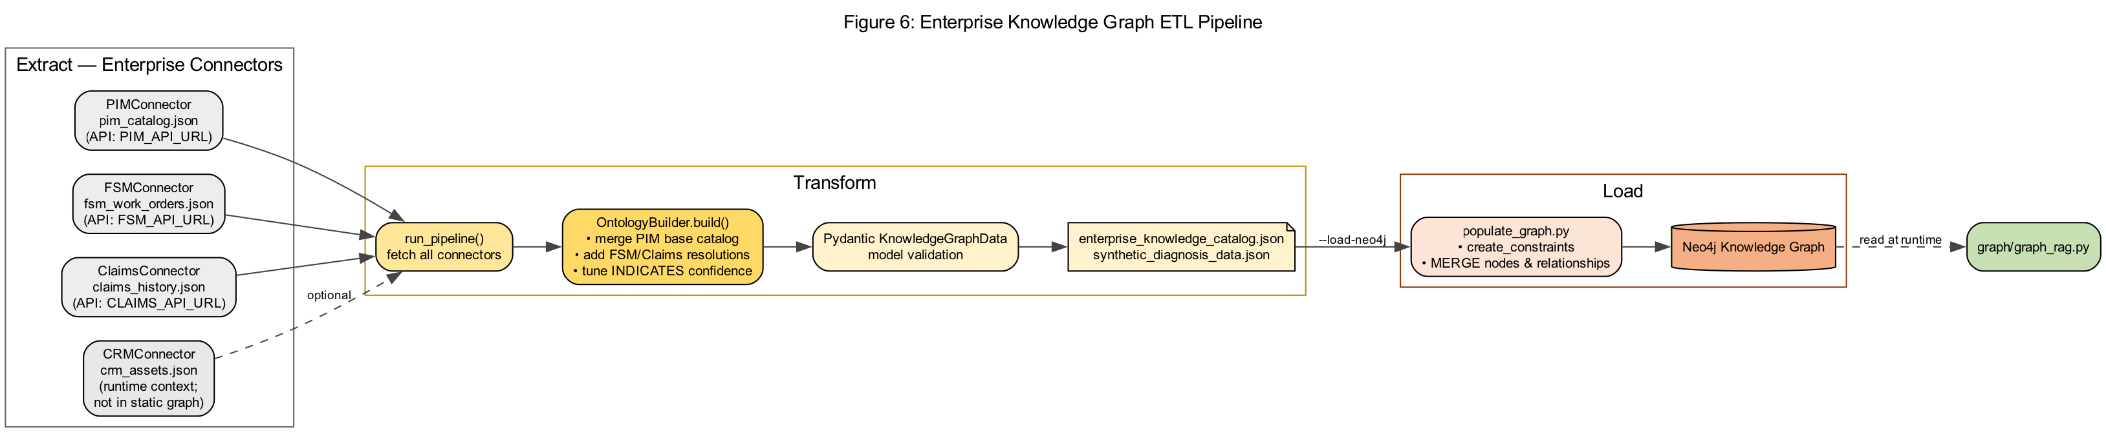
Figure 6: Knowledge ETL pipeline detail
- Pipeline 1 knowledge_etl — PIM + FSM + Claims + CRM connectors → OntologyBuilder → JSON catalog
- populate_graph.py — MERGE nodes with source_system, source_record_id provenance
- Pipeline 2 smoke_validation — regression scenarios gate promotion
- Pipeline 3 staging_promotion — load validated catalog to Neo4j
- lineage_store.py — each step logged to data/lineage/etl_batches.jsonl

4. Neo4j Ontology Used in Your Demo
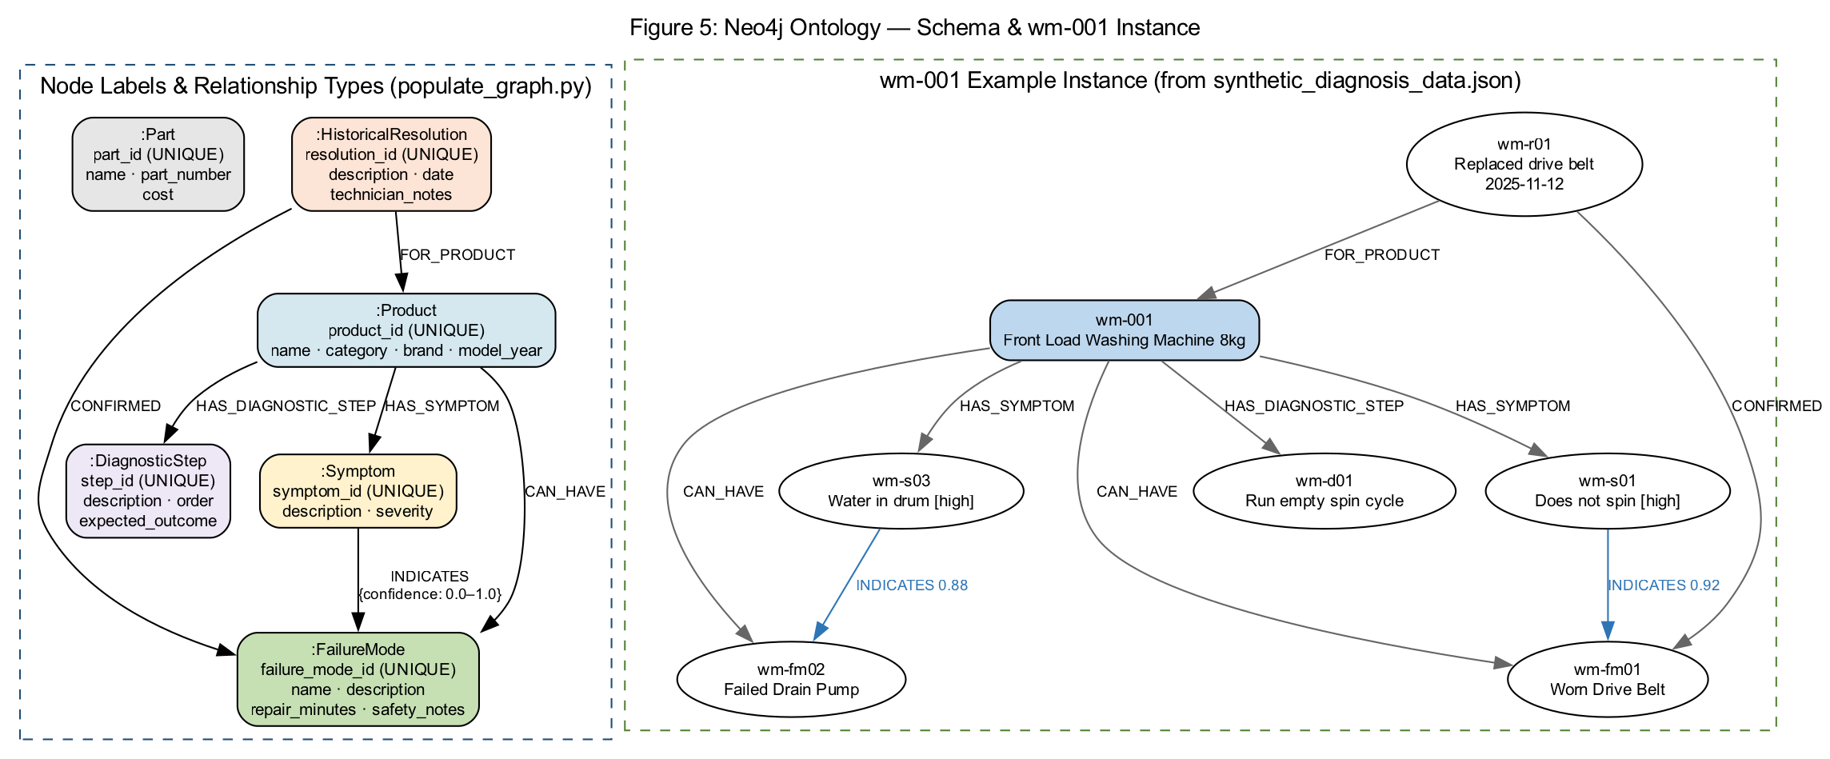
Figure 5: Neo4j ontology (nodes and relationships)
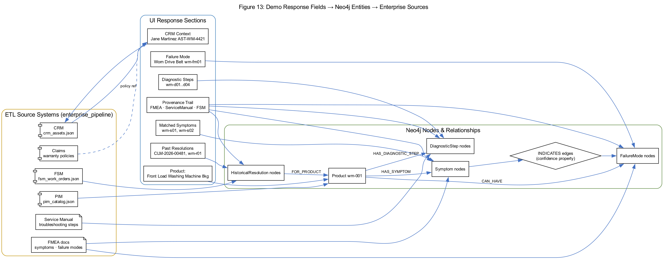
Figure 13: Response fields → graph entities → source systems
Every field in your diagnosis response maps to a graph entity that was ETL'd from an enterprise source:
Response section | Neo4j entity | Source system | Example from demo
Product name | Product wm-001 | PIM | Front Load Washing Machine 8kg
Matched Symptoms | Symptom wm-s01, wm-s02 | FMEA | manuals/wm-001/symptoms.pdf
Failure Mode | FailureMode wm-fm01 | FMEA | fmea/wm-001/wm-fm01.pdf
Diagnostic Steps | DiagnosticStep wm-d01..d04 | ServiceManual | troubleshooting.pdf#step=N
Past Resolutions | HistoricalResolution | FSM | CLM-2026-00481, WO-FSM-88104
Parts | JSON catalog | PIM | Drive Belt Assembly AH-DB-8842
CRM Context | Runtime only | CRM mock | Jane Martinez, AST-WM-4421
Warranty | Runtime only | CRM + Claims | WP-STANDARD-24M

5. CRM & Warranty — Before Diagnosis Runs
Note: You selected Robert Chen in the Customer dropdown but asset AST-WM-4421. Asset ID takes priority in enrichment.
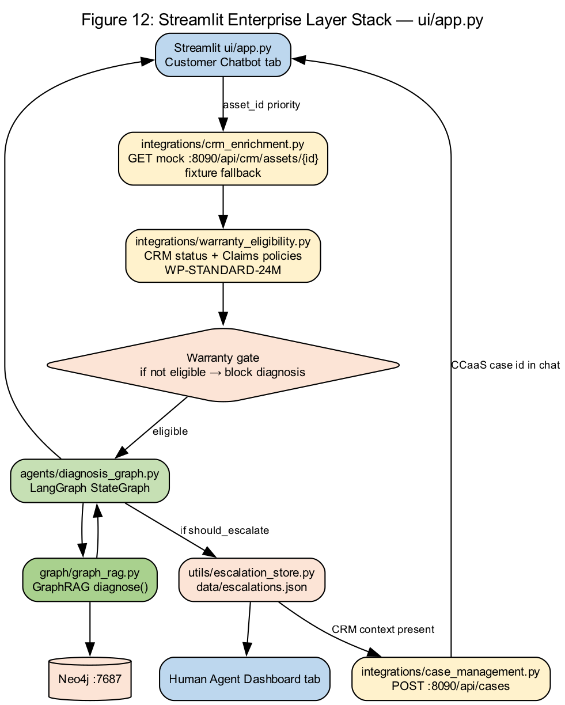
Figure 12: Streamlit enterprise layer stack
- ui/app.py calls enrich_session_from_crm(asset_id=AST-WM-4421)
- integrations/crm_enrichment.py GETs http://localhost:8090/api/crm/assets/AST-WM-4421
- Returns Jane Martinez (actual asset owner), product wm-001, warranty active until 2027-06-15
- integrations/warranty_eligibility.py checks status + Claims policies → eligible=true
- product_id passed to run_diagnosis() — skips keyword auto-detect
product_id = CRM asset product OR appliance dropdown OR detect_product(message)

6. LangGraph Workflow — Per Message
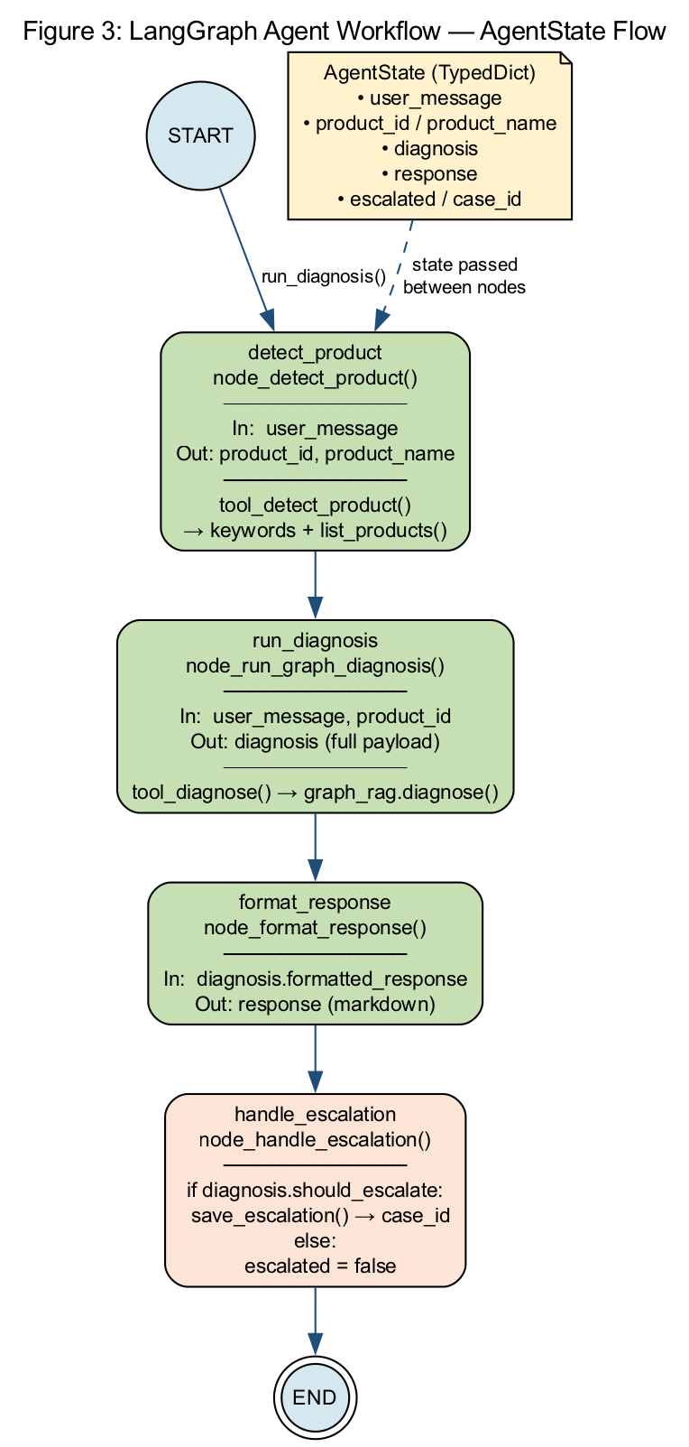
Figure 3: LangGraph diagnosis workflow
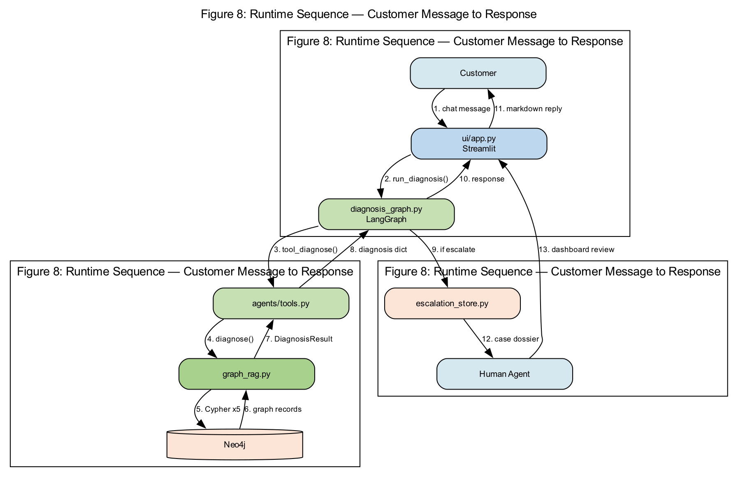
Figure 8: Runtime request sequence
Node | File | Action in your demo
detect_product | agents/diagnosis_graph.py | Kept wm-001 from CRM (message already product-specific)
run_diagnosis | agents/tools.py → graph_rag.py | Executed full GraphRAG Cypher pipeline
format_response | graph_rag.py format_diagnosis_response() | Built markdown with evidence + provenance
handle_escalation | utils/escalation_store.py | Turn 2 only: saved case 231311d2

7. GraphRAG — Turn-by-Turn Diagnosis Logic
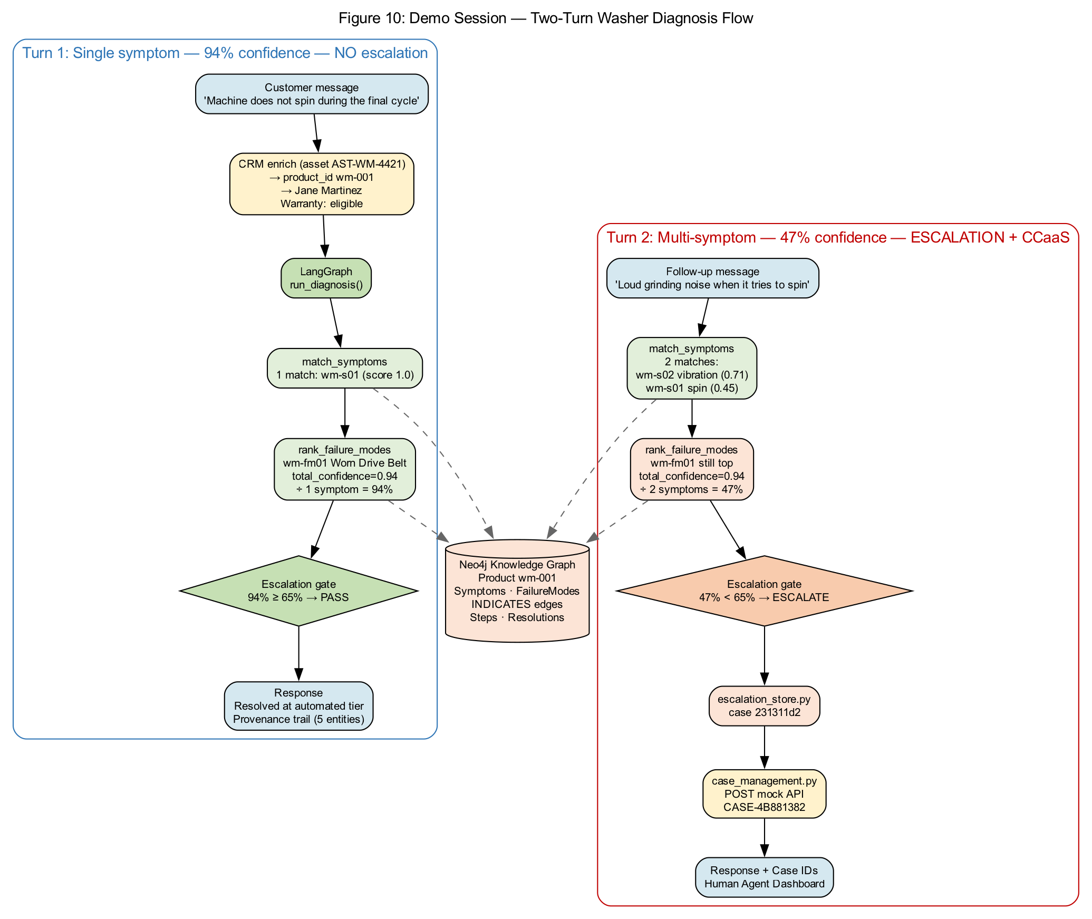
Figure 10: Demo session two-turn flow
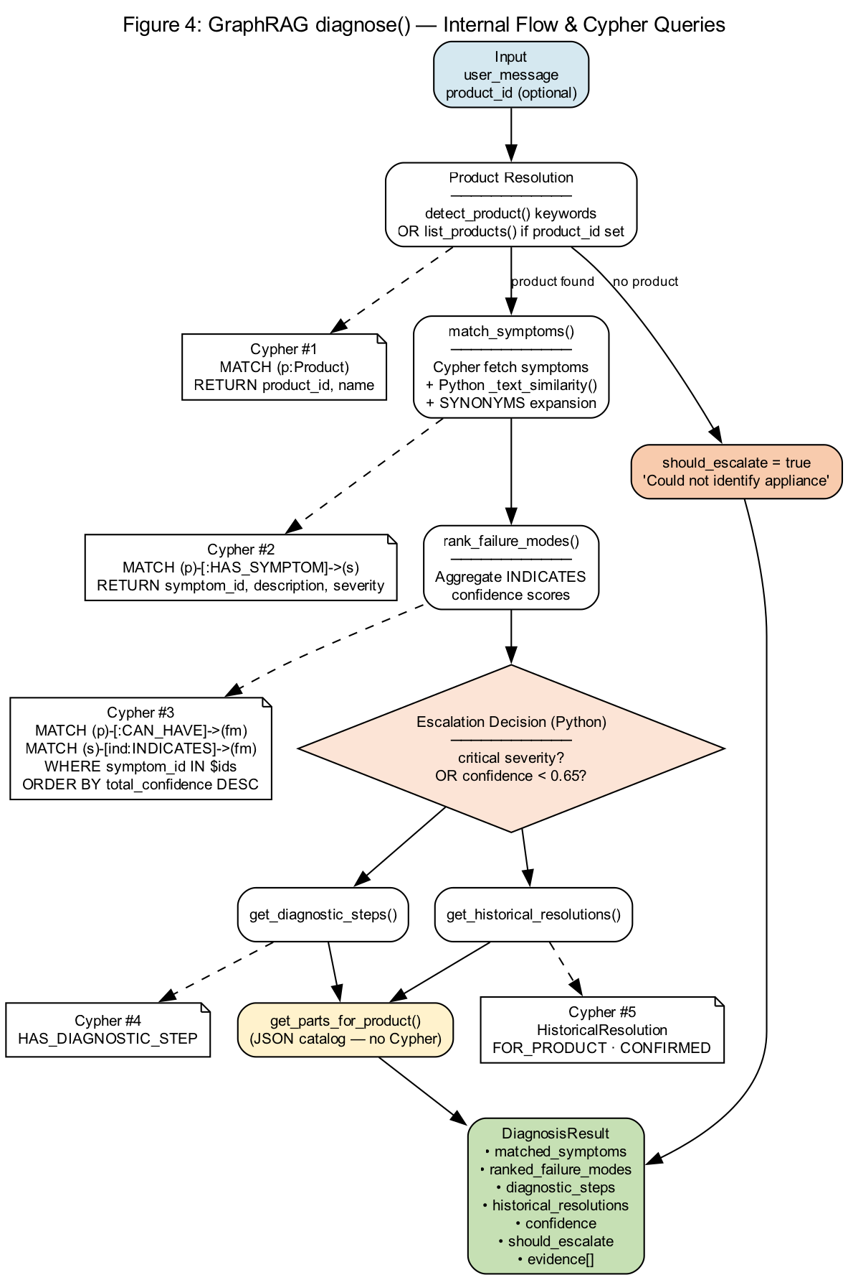
Figure 4: GraphRAG diagnose() internal flow

Turn 1: Machine does not spin during the final cycle
- match_symptoms: 1 match — wm-s01 (Machine does not spin…) score 1.0
- rank_failure_modes: wm-fm01 Worn Drive Belt, INDICATES confidence 0.94
- aggregate_confidence = 0.94 ÷ 1 symptom = 94%
- Escalation gate: 94% ≥ 65% threshold, no critical symptoms → should_escalate=false
- Status: Resolved at automated tier
- provenance_trail: 5 entries (Symptom, FailureMode, 2 Steps, 1 Resolution)

Turn 2: It also makes a loud grinding noise when it tries to spin
- match_symptoms: 2 matches — wm-s02 vibration (0.71) + wm-s01 spin (0.45)
- rank_failure_modes: wm-fm01 still #1 (total_confidence 0.94 from wm-s01 link only)
- aggregate_confidence = 0.94 ÷ 2 symptoms = 47%
- Escalation gate: 47% < 65% → should_escalate=true
- escalation_store saved case 231311d2 → Open Escalations count increased
- case_management POST → CCaaS case CASE-4B881382 in simulated_cases.json

Why confidence dropped from 94% to 47%
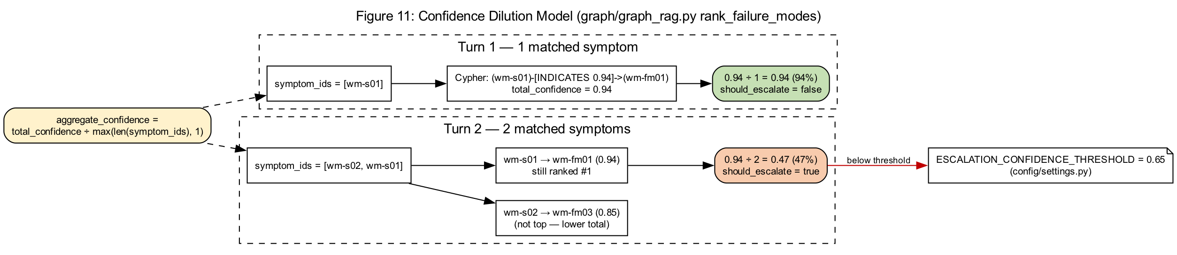
Figure 11: Confidence dilution model
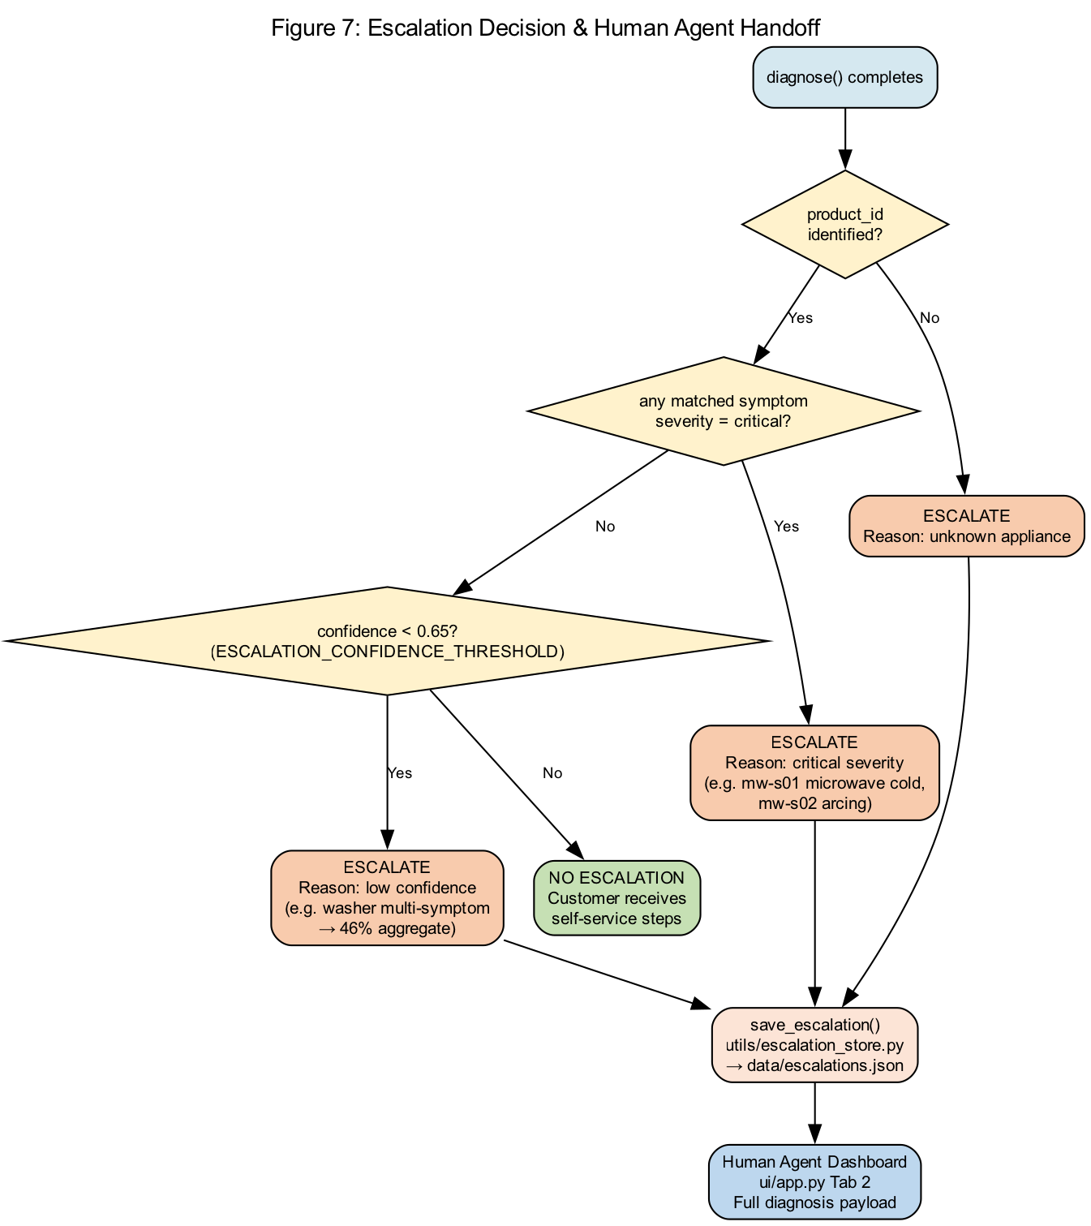
Figure 7: Escalation decision logic
aggregate_confidence = total_confidence / max(len(symptom_ids), 1) # graph/graph_rag.py
The top failure mode did not change — Worn Drive Belt remained #1. What changed was the denominator: adding a second matched symptom divides the same graph evidence across more symptoms, lowering aggregate confidence below the 0.65 ESCALATION_CONFIDENCE_THRESHOLD in config/settings.py.

8. Response Payload — Field-by-Field Explanation

Matched Symptoms
Neo4j query HAS_SYMPTOM + Python _text_similarity() with SYNONYMS expansion. Turn 2 added wm-s02 (medium severity).

Ranked Failure Modes
Cypher aggregates INDICATES edge confidence per failure mode. wm-fm03 also linked to wm-s02 (0.85) but ranked lower overall.

Diagnostic Steps
HAS_DIAGNOSTIC_STEP relationship — ordered troubleshooting from service manual ETL.

Historical Resolutions
FSM closed work orders and claims merged at ETL. WO-FSM-88104 and wm-r01 confirm past belt replacements.

Provenance Trail
graph/provenance.py builds audit lines when ENABLE_PROVENANCE=true. Shown in UI expander and Source Traceability section.

CRM Context JSON
Runtime enrichment only — not stored in Neo4j. Binds session to registered asset and warranty metadata.

9. Escalation & Case Management Outcomes
Artifact | Storage | Your demo value
Local escalation case | data/escalations.json | 231311d2 — Human Agent Dashboard
CCaaS simulated case | data/simulated_cases.json | CASE-4B881382 — Enterprise Systems tab
Open Escalations metric | ui/app.py count | 3 open cases across session
Escalation triggers (any one fires):
- Product unknown (not in your session)
- Any matched symptom severity = critical (not in washer turns)
- aggregate_confidence < 0.65 (Turn 2 — this fired)

10. End-to-End Architecture (Production View)
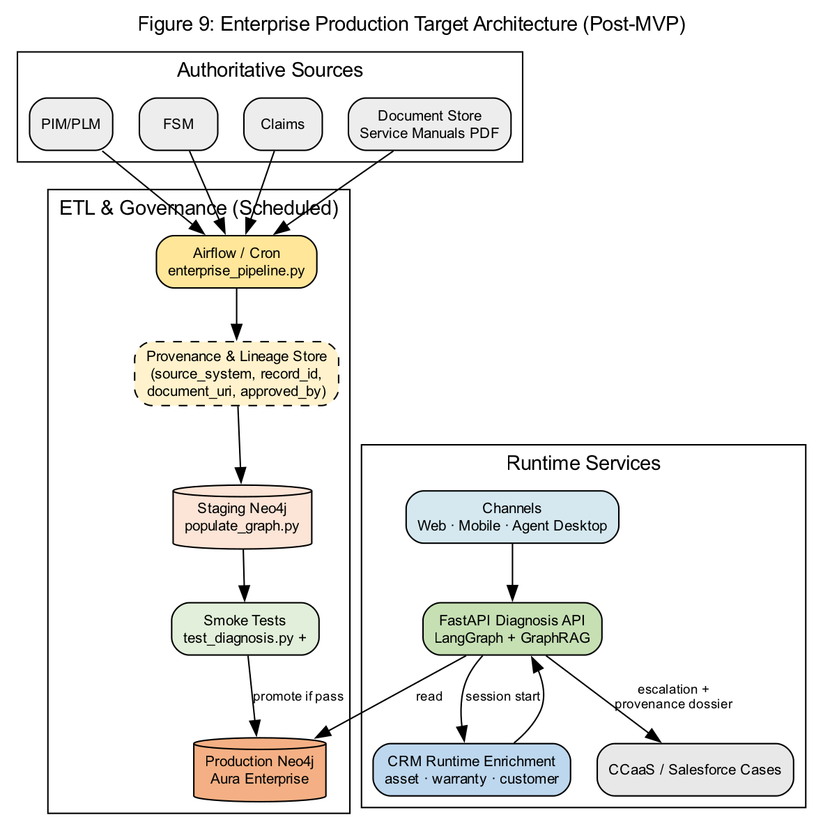
Figure 9: Enterprise production deployment pattern

11. Module & Port Reference
Component | Port / path | Your session
Streamlit UI | localhost:8501 | Customer Chatbot tab
Diagnostics API | localhost:8080 | Same logic as UI (optional)
Mock Enterprise | localhost:8090 | CRM asset + CCaaS POST
Neo4j Bolt | localhost:7687 | All GraphRAG Cypher
Neo4j Browser | localhost:7474 | Visual graph inspection
ETL lineage | data/lineage/etl_batches.jsonl | Enterprise Systems tab

12. Graphviz Source Files
All diagrams are version-controlled in docs/graphviz/*.dot. Render with:
bash docs/graphviz/render_all.sh

Graphviz: 10-demo-session-turn-flow.dot
// Figure 10: Demo session — two-turn washer flow (Streamlit → LangGraph → GraphRAG → Neo4j)
digraph DemoSessionTurnFlow {
graph [
rankdir=TB
label="Figure 10: Demo Session — Two-Turn Washer Diagnosis Flow"
labelloc=t
fontsize=14
fontname="Arial"
bgcolor="white"
nodesep=0.35
]
node [fontname="Arial", fontsize=10]
edge [fontname="Arial", fontsize=9]
subgraph cluster_turn1 {
label="Turn 1: Single symptom — 94% confidence — NO escalation"
style=rounded
color="#2E75B6"
fontcolor="#2E75B6"
T1_IN [label="Customer message\n'Machine does not spin during the final cycle'", shape=box, style="rounded,filled", fillcolor="#D5E8F0"]
T1_CRM [label="CRM enrich (asset AST-WM-4421)\n→ product_id wm-001\n→ Jane Martinez\nWarranty: eligible", shape=box, style="rounded,filled", fillcolor="#FFF2CC"]
T1_LG [label="LangGraph\nrun_diagnosis()",
// ...

Graphviz: 11-confidence-dilution-model.dot
// Figure 11: Confidence dilution — why 94% becomes 47% with two symptoms
digraph ConfidenceDilution {
graph [
rankdir=LR
label="Figure 11: Confidence Dilution Model (graph/graph_rag.py rank_failure_modes)"
labelloc=t
fontsize=14
fontname="Arial"
bgcolor="white"
]
node [fontname="Arial", fontsize=10]
edge [fontname="Arial", fontsize=9]
Formula [label="aggregate_confidence =\ntotal_confidence ÷ max(len(symptom_ids), 1)", shape=box, style="rounded,filled", fillcolor="#FFF2CC"]
subgraph cluster_t1 {
label="Turn 1 — 1 matched symptom"
style=dashed
S1 [label="symptom_ids = [wm-s01]", shape=box, fillcolor="#E2EFDA"]
E1 [label="Cypher: (wm-s01)-[INDICATES 0.94]->(wm-fm01)\ntotal_confidence = 0.94", shape=box, fillcolor="#E2EFDA"]
R1 [label="0.94 ÷ 1 = 0.94 (94%)\nshould_escalate = false", shape=box, style="rounded,filled", fillcolor="#C6
// ...

Graphviz: 12-streamlit-enterprise-layers.dot
// Figure 12: Streamlit UI enterprise layer stack (ui/app.py)
digraph StreamlitEnterpriseLayers {
graph [
rankdir=TB
label="Figure 12: Streamlit Enterprise Layer Stack — ui/app.py"
labelloc=t
fontsize=14
fontname="Arial"
bgcolor="white"
]
node [shape=box, style="rounded,filled", fontname="Arial", fontsize=10]
edge [fontname="Arial", fontsize=9]
UI [label="Streamlit ui/app.py\nCustomer Chatbot tab", fillcolor="#BDD7EE"]
CRM [label="integrations/crm_enrichment.py\nGET mock :8090/api/crm/assets/{id}\nfixture fallback", fillcolor="#FFF2CC"]
WAR [label="integrations/warranty_eligibility.py\nCRM status + Claims policies\nWP-STANDARD-24M", fillcolor="#FFF2CC"]
GATE [label="Warranty gate\nif not eligible → block diagnosis", shape=diamond, fillcolor="#FCE4D6"]
LG [label="agents/diagnosis_graph.py\nLangGraph StateGraph", fillcolor="#C6E0B4"]
GR [label
// ...

Graphviz: 13-demo-response-field-map.dot
// Figure 13: Demo response fields mapped to knowledge graph entities and source systems
digraph DemoResponseFieldMap {
graph [
rankdir=LR
label="Figure 13: Demo Response Fields → Neo4j Entities → Enterprise Sources"
labelloc=t
fontsize=14
fontname="Arial"
bgcolor="white"
]
node [fontname="Arial", fontsize=10]
edge [fontname="Arial", fontsize=9, color="#4472C4"]
subgraph cluster_ui {
label="UI Response Sections"
style=rounded
color="#2E75B6"
R_PROD [label="Product:\nFront Load Washing Machine 8kg", shape=box, fillcolor="#D5E8F0"]
R_SYM [label="Matched Symptoms\nwm-s01, wm-s02", shape=box, fillcolor="#D5E8F0"]
R_FM [label="Failure Mode\nWorn Drive Belt wm-fm01", shape=box, fillcolor="#D5E8F0"]
R_STEP [label="Diagnostic Steps\nwm-d01..d04", shape=box, fillcolor="#D5E8F0"]
R_RES [label="Past Resolutions\nCLM-2026-00481, wm-r
// ...

Graphviz: 14-etl-to-runtime.dot
// Figure 14: ETL pipelines to runtime diagnosis (batch load → live query)
digraph ETLToRuntime {
graph [
rankdir=TB
label="Figure 14: Enterprise ETL Pipelines → Neo4j → Runtime Diagnosis"
labelloc=t
fontsize=14
fontname="Arial"
bgcolor="white"
]
node [fontname="Arial", fontsize=10]
edge [fontname="Arial", fontsize=9]
subgraph cluster_sources {
label="Enterprise Sources (:8090 mock or fixtures)"
style=rounded
PIM [label="PIM Connector", shape=box, fillcolor="#FFF2CC"]
FSM [label="FSM Connector", shape=box, fillcolor="#FFF2CC"]
CLM [label="Claims Connector", shape=box, fillcolor="#FFF2CC"]
CRM [label="CRM Connector", shape=box, fillcolor="#FFF2CC"]
}
P1 [label="Pipeline 1: knowledge_etl.py\nOntologyBuilder → enterprise_knowledge_catalog.json", shape=box, style="rounded,filled", fillcolor="#BDD7EE"]
POP [label="populate_grap
// ...

