Live Diagnostic Session — Technical Walkthrough
Enterprise Diagnostics GraphRAG Platform — Document 09
This document explains a live customer diagnostic session on the pilot platform (washer spin failure, two-turn conversation, CRM enrichment, warranty gate, 94% vs 47% confidence, escalation, and Service Cloud case handoff) and maps each outcome to the solution architecture, Neo4j knowledge graph, LangGraph workflow, and enterprise knowledge-engineering pipelines.

1. Executive Summary
Platform indicator | Value | Business meaning
Neo4j Connected | Yes | Authoritative knowledge graph available for GraphRAG queries
Mode Enterprise | Yes | Full enterprise integration path enabled (CRM · PIM · FSM · Claims)
Integration Services Online | Yes | Enterprise Integration Layer (sandbox) serving representative APIs
Open Escalations | 3 | Cases requiring human agent review with full graph context

The live session comprised two customer turns on registered asset AST-WM-4421. Turn 1 achieved automated resolution at 94% confidence. Turn 2 introduced a second symptom, reducing aggregate confidence to 47% and triggering governed escalation with case-management handoff.

2. Current State vs Future State (Swimlanes)
Figure 15 shows the POC / pilot architecture with an Enterprise Integration Layer (sandbox) connecting representative enterprise services to the diagnostics platform.
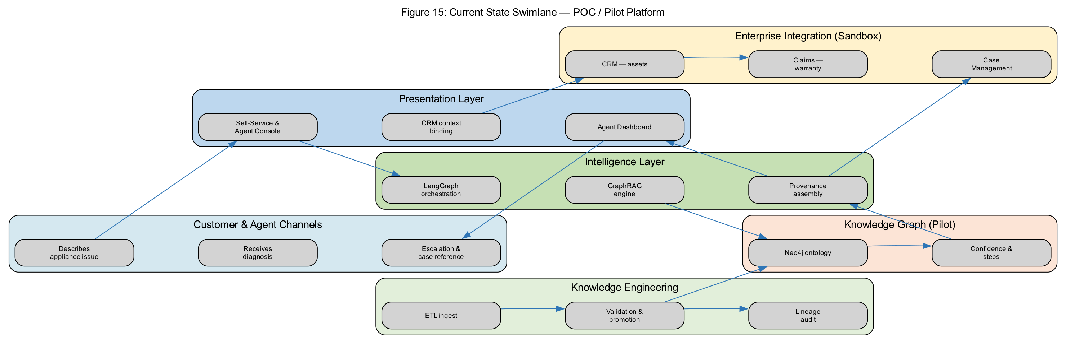
Figure 15: Current state swimlane — POC / pilot platform
Figure 16 shows the target production architecture with authoritative systems, governed ETL, and production Neo4j.
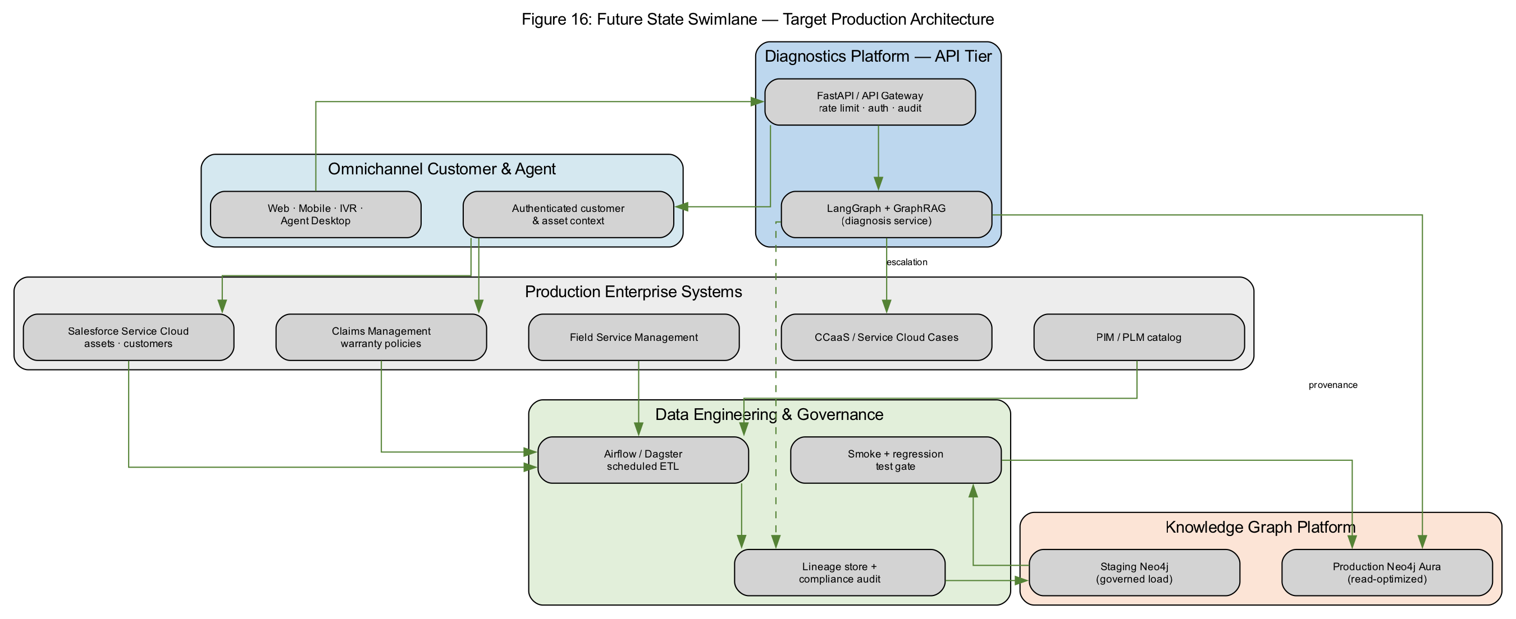
Figure 16: Future state swimlane — target production
Figure 17 traces your live washer session across functional swimlanes — customer, CRM, platform, knowledge graph, and agent operations.
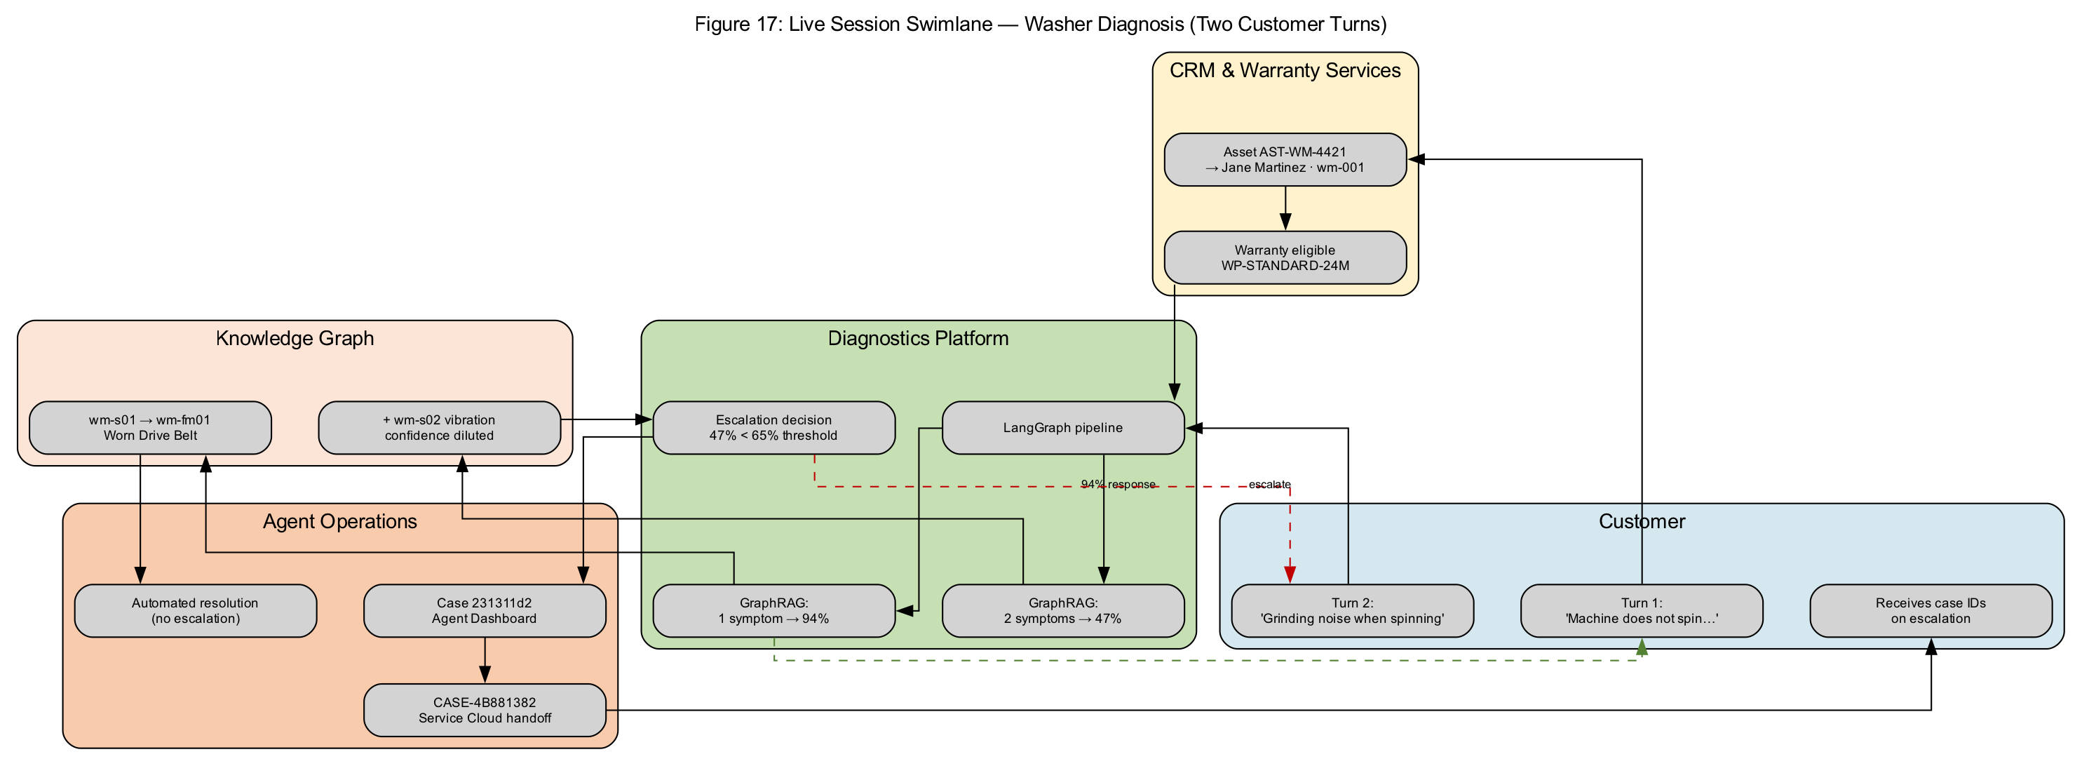
Figure 17: Live session swimlane — two customer turns
Figure 18 separates batch knowledge engineering from runtime diagnosis — the operational boundary stakeholders care about for SLA and governance.
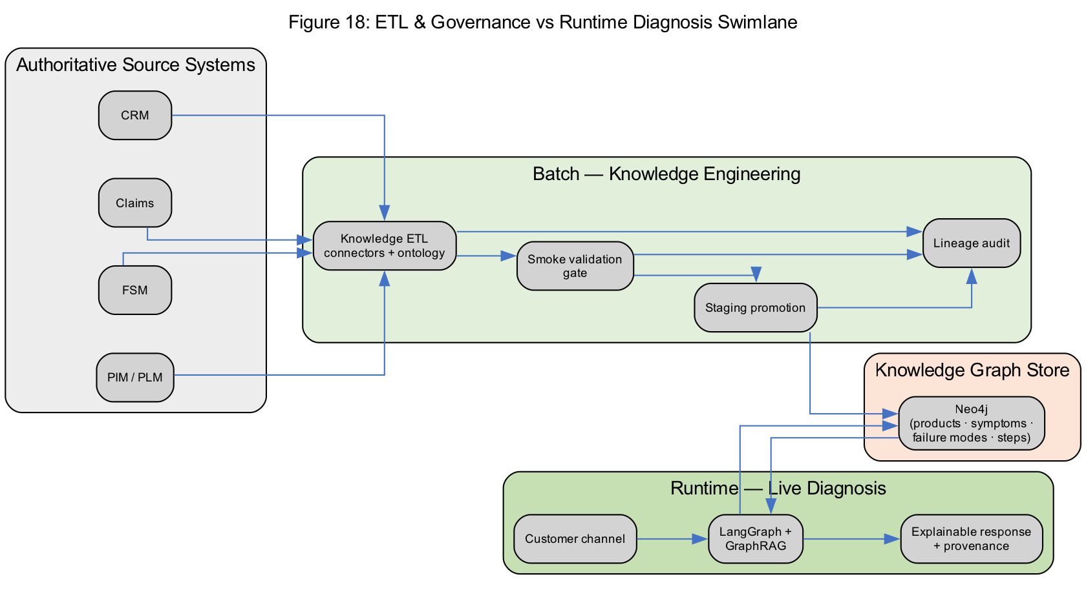
Figure 18: ETL & governance vs runtime diagnosis swimlane

3. System Context & Module Map
Figure 1 shows where the diagnostics platform sits relative to enterprise systems and operators.
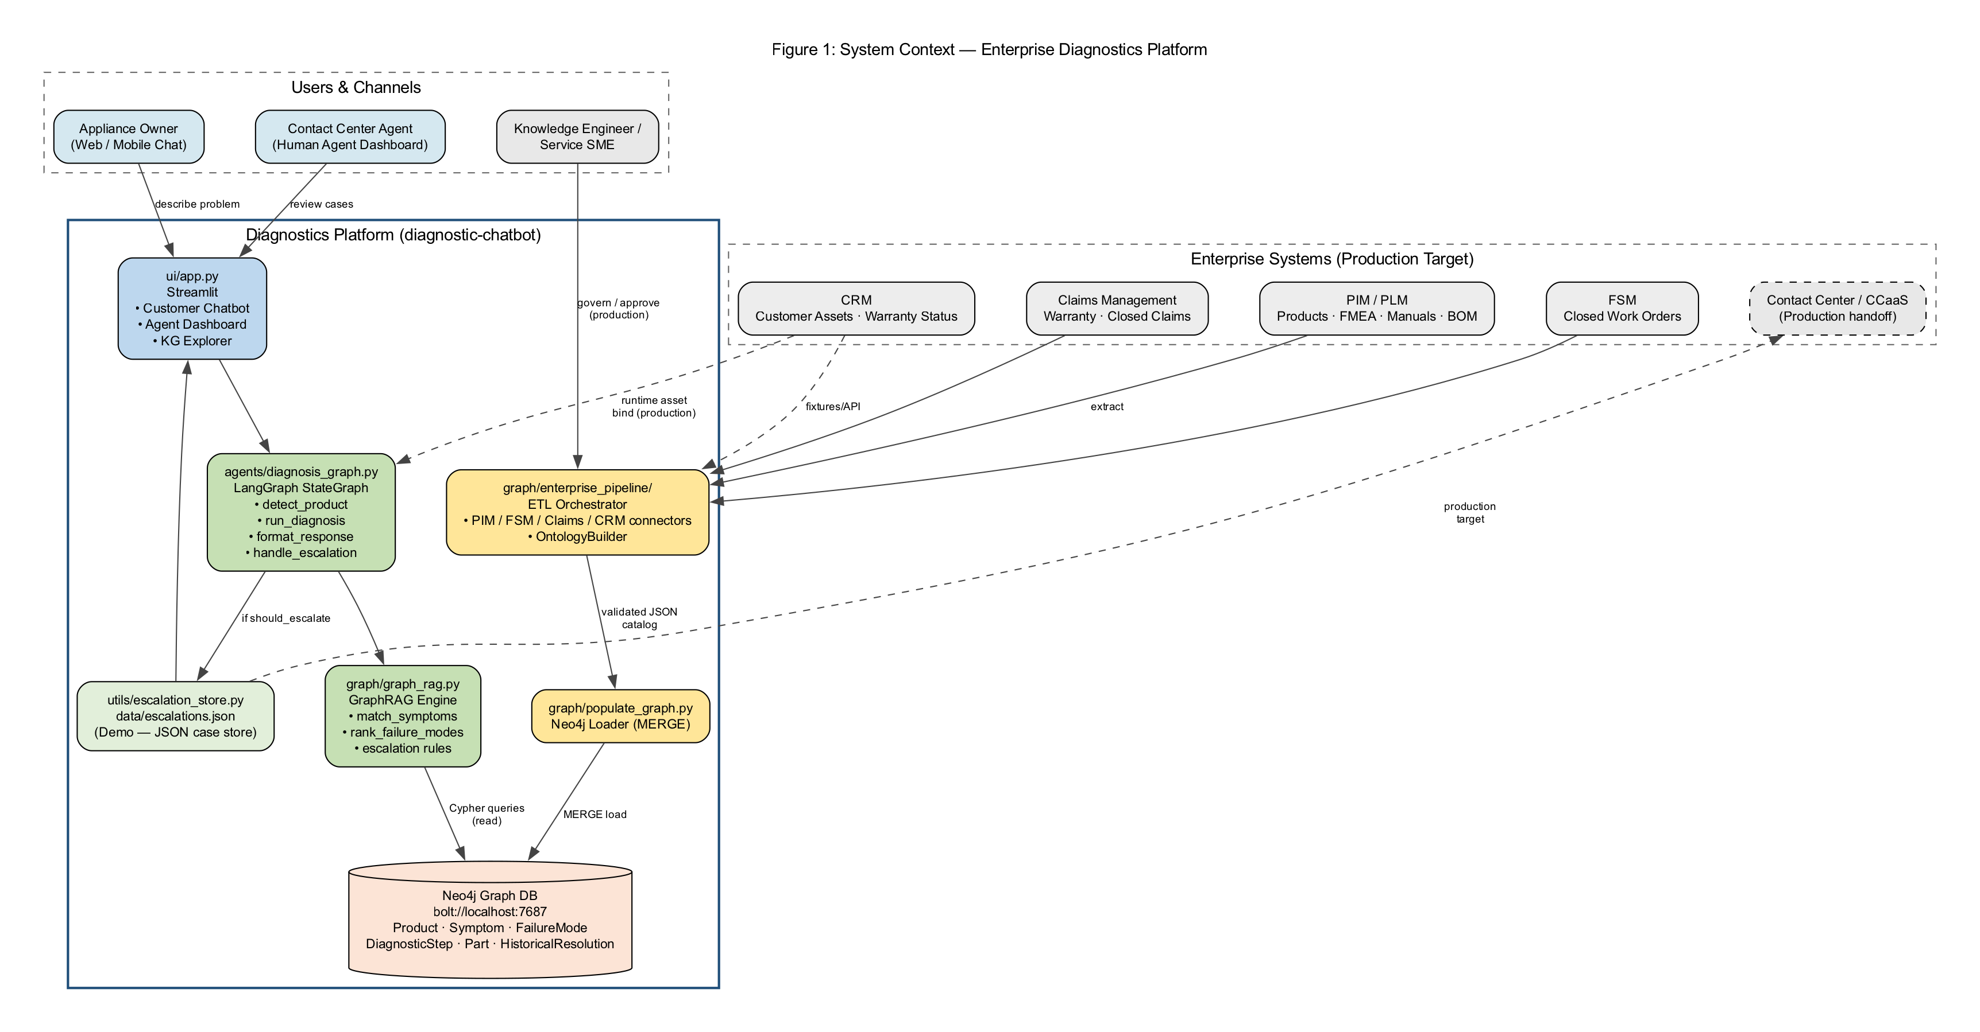
Figure 1: Enterprise system context (C4-style)
Figure 2 maps Python modules to functional responsibilities.
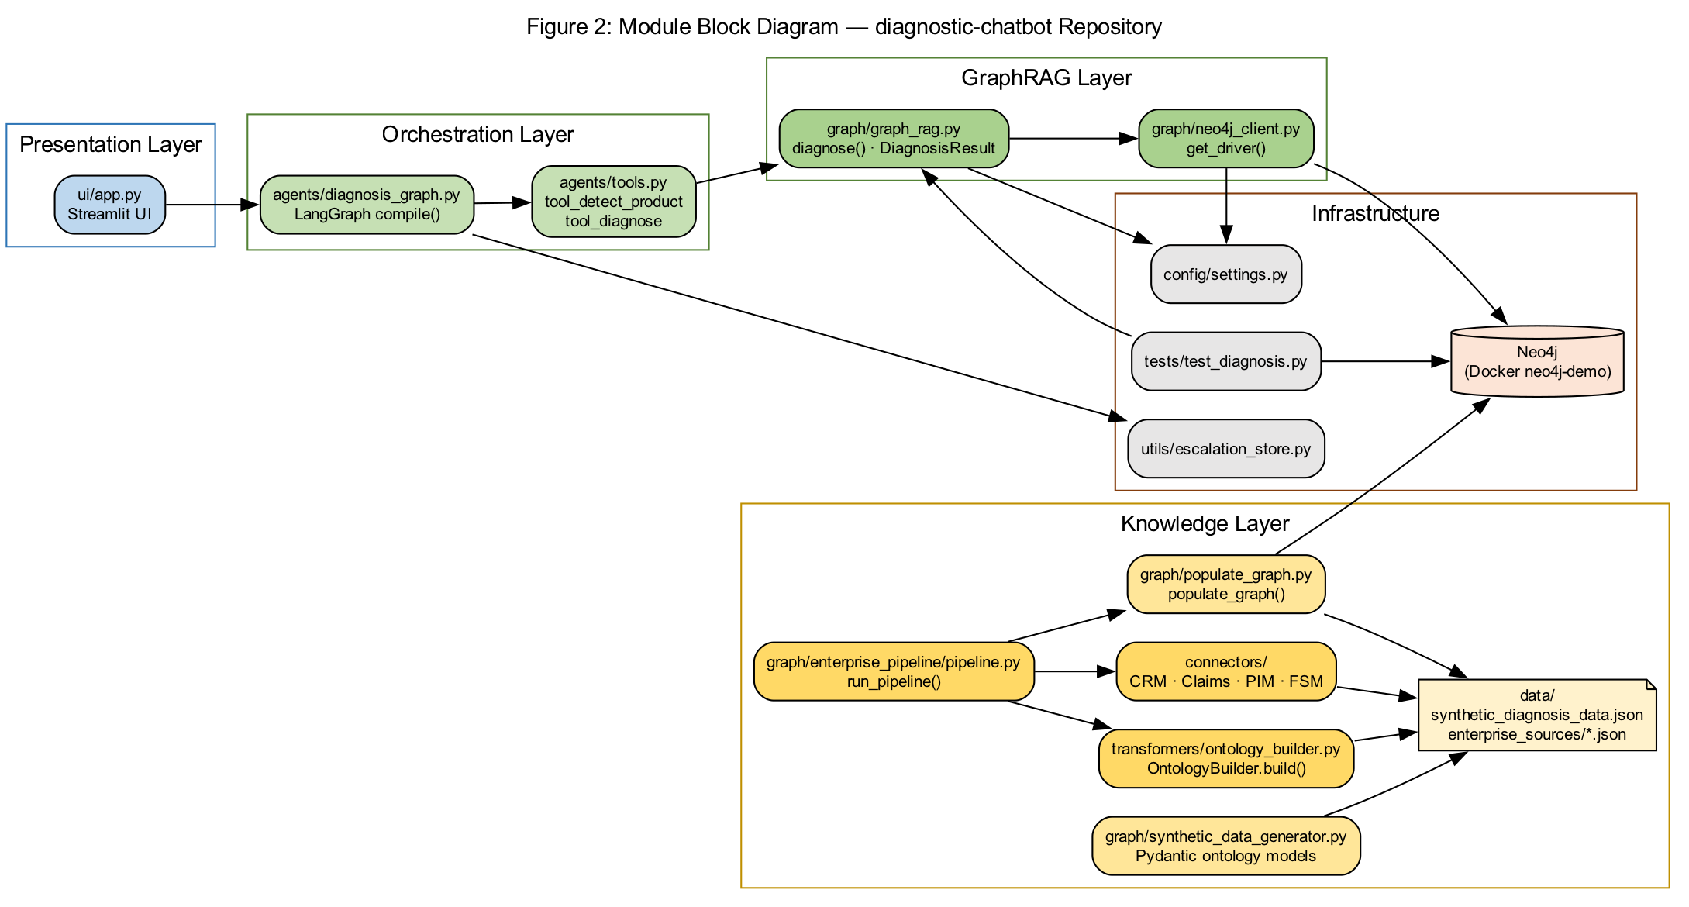
Figure 2: Module block diagram

Technology stack mapping
Layer | Technology | Module | Role in live session
Presentation | Streamlit | ui/app.py | Self-service channel, CRM binding, agent console
Orchestration | LangGraph | agents/diagnosis_graph.py | Governed diagnosis workflow per message
GraphRAG | Neo4j + Python | graph/graph_rag.py | Evidence-based Cypher retrieval
Knowledge store | Neo4j 5.x | graph/neo4j_client.py | Product wm-001 ontology
Integration layer | FastAPI sandbox | simulation/mock_enterprise_apps.py | Representative CRM / Claims / CCaaS APIs
Integrations | Python | integrations/*.py | CRM enrichment, warranty gate, case handoff
Knowledge engineering | Python pipelines | graph/enterprise_pipeline/ | Batch load before runtime
Audit | JSONL lineage | utils/lineage_store.py | ETL governance trail

4. Knowledge Engineering — How the Graph Was Built
Before your chat session, the orchestrator ran three pipelines to build the Neo4j knowledge graph.
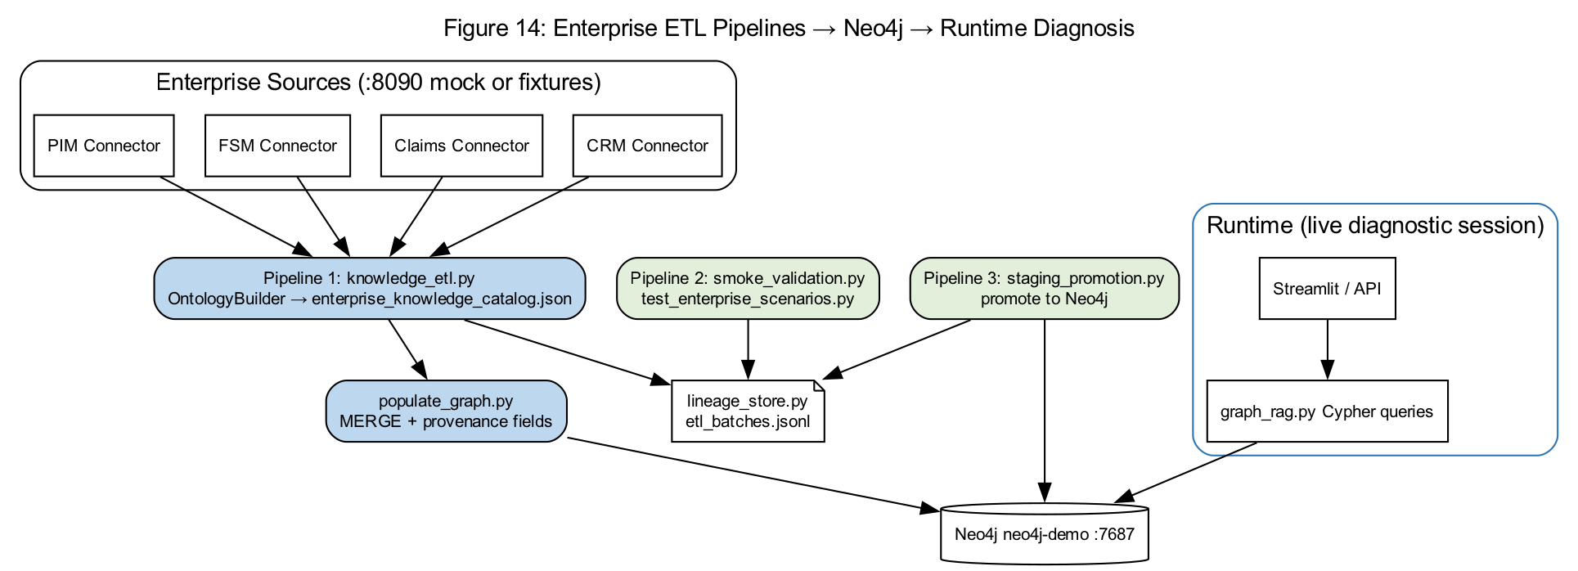
Figure 14: ETL pipelines to runtime diagnosis
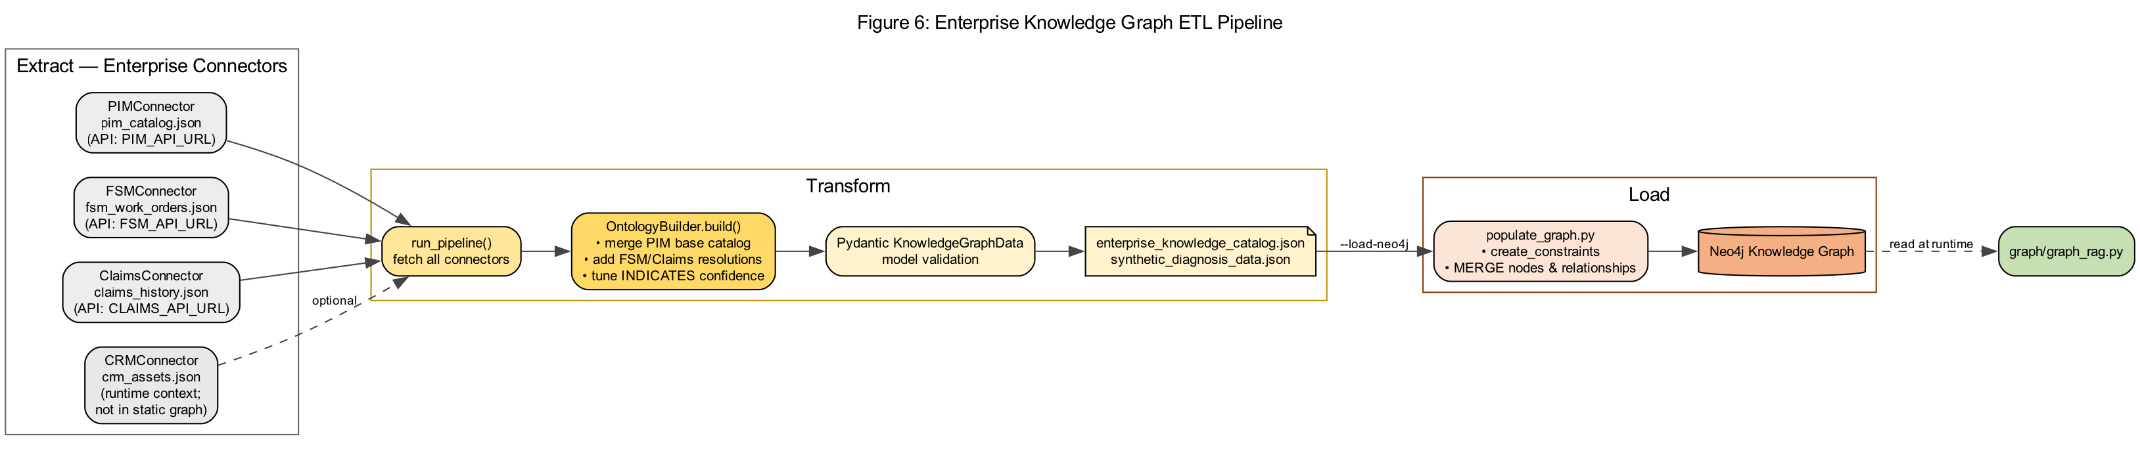
Figure 6: Knowledge ETL pipeline detail
- Pipeline 1 knowledge_etl — PIM + FSM + Claims + CRM connectors → OntologyBuilder → JSON catalog
- populate_graph.py — MERGE nodes with source_system, source_record_id provenance
- Pipeline 2 smoke_validation — regression scenarios gate promotion
- Pipeline 3 staging_promotion — load validated catalog to Neo4j
- lineage_store.py — each step logged to data/lineage/etl_batches.jsonl

5. Neo4j Ontology — Live Session Data Model
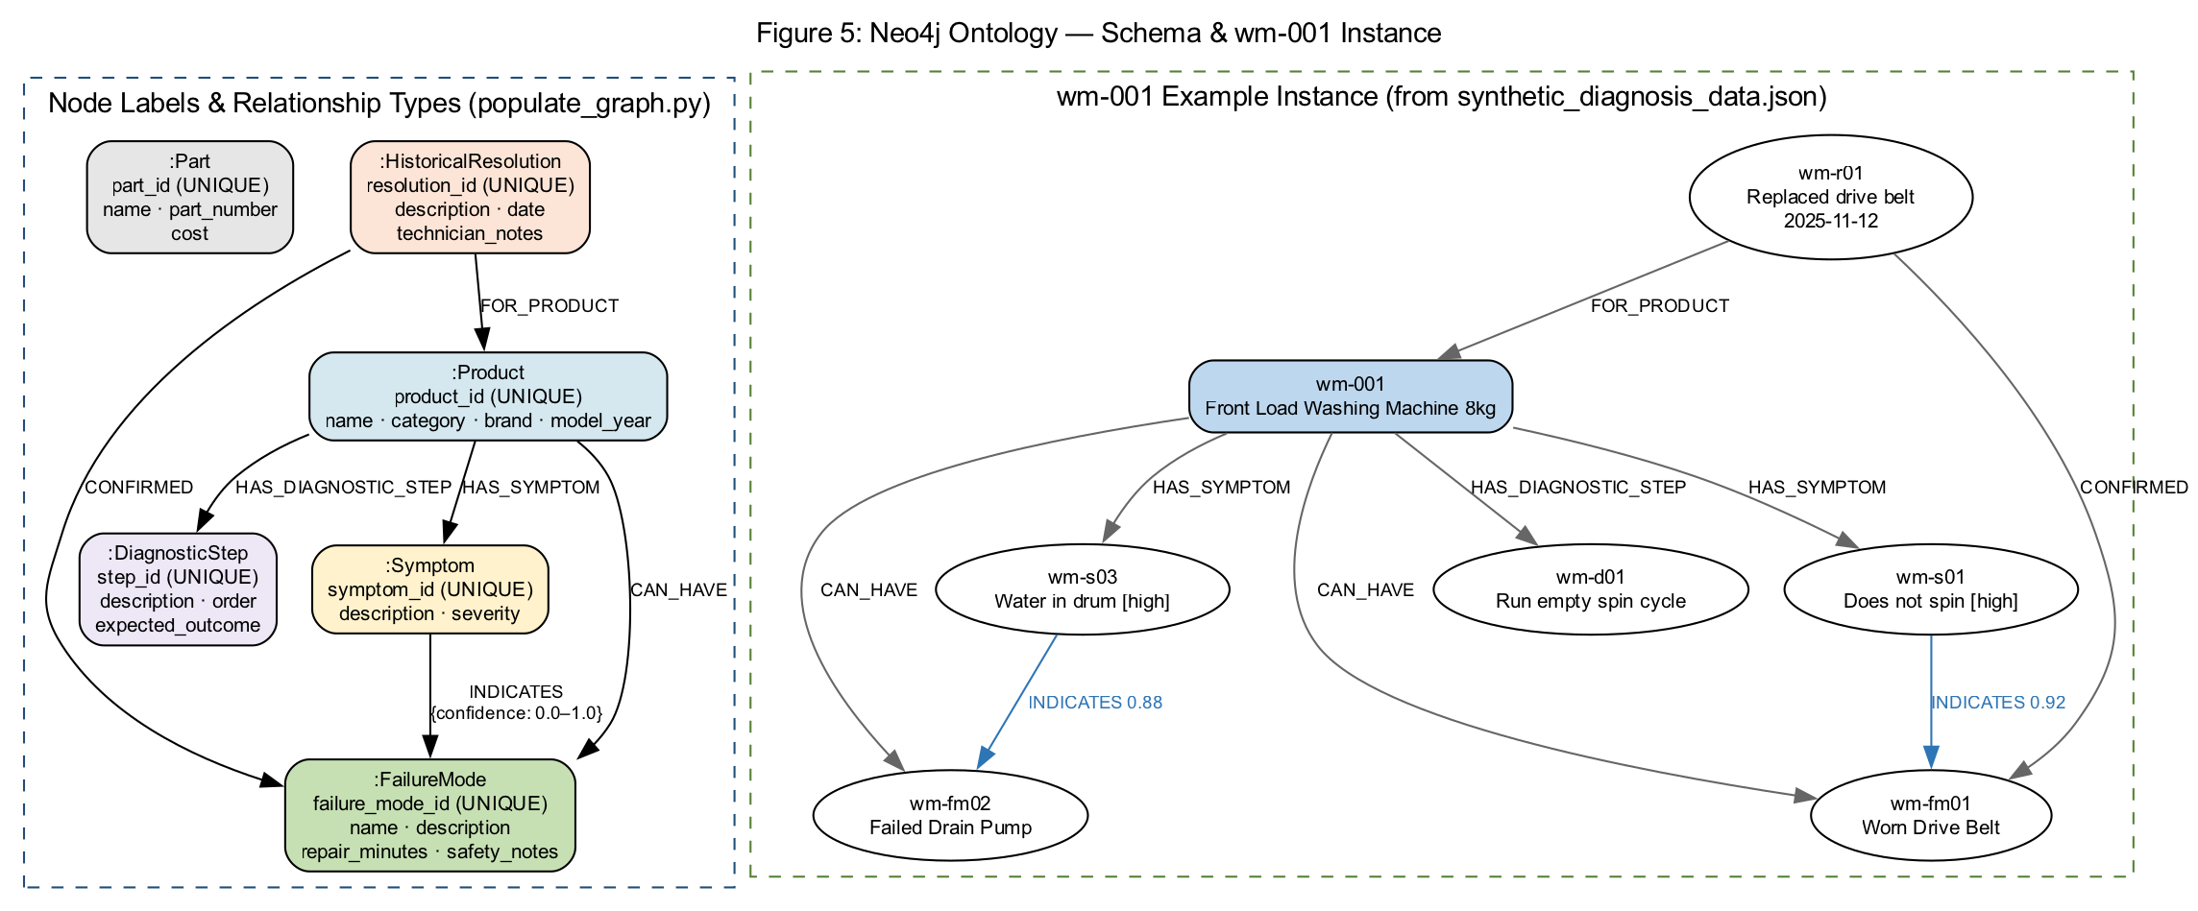
Figure 5: Neo4j ontology (nodes and relationships)
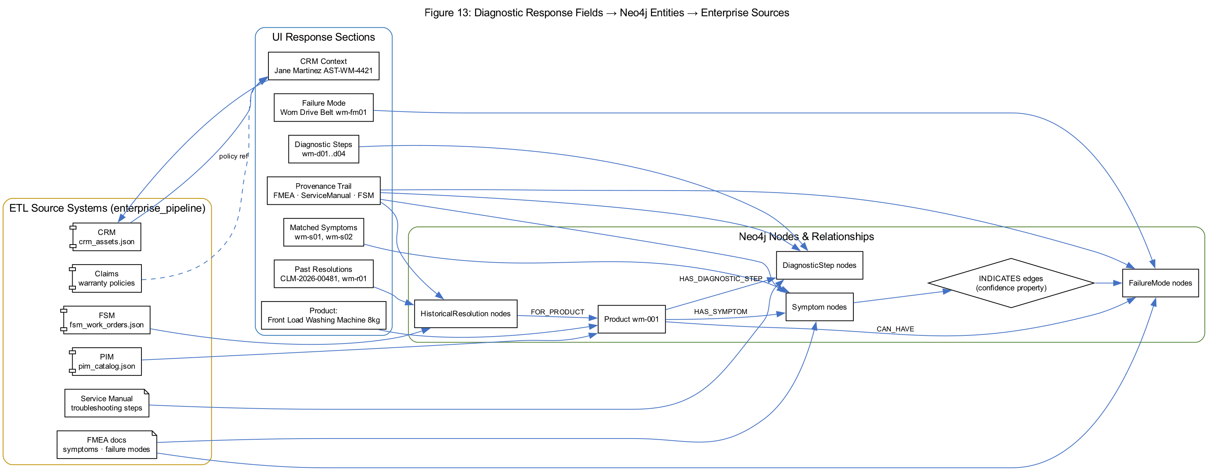
Figure 13: Response fields → graph entities → enterprise sources
Every field in the diagnostic response maps to a governed graph entity ingested from an authoritative source:
Response section | Neo4j entity | Source system | Live session example
Product name | Product wm-001 | PIM | Front Load Washing Machine 8kg
Matched Symptoms | Symptom wm-s01, wm-s02 | FMEA | manuals/wm-001/symptoms.pdf
Failure Mode | FailureMode wm-fm01 | FMEA | fmea/wm-001/wm-fm01.pdf
Diagnostic Steps | DiagnosticStep wm-d01..d04 | ServiceManual | troubleshooting.pdf#step=N
Past Resolutions | HistoricalResolution | FSM | CLM-2026-00481, WO-FSM-88104
Parts | JSON catalog | PIM | Drive Belt Assembly AH-DB-8842
CRM Context | Runtime enrichment | CRM (sandbox) | Jane Martinez, AST-WM-4421
Warranty | Runtime only | CRM + Claims | WP-STANDARD-24M

6. CRM & Warranty — Pre-Diagnosis Enrichment
Note: Customer dropdown showed Robert Chen while asset AST-WM-4421 was selected. Asset ID takes priority — the platform correctly resolved Jane Martinez as the registered owner.
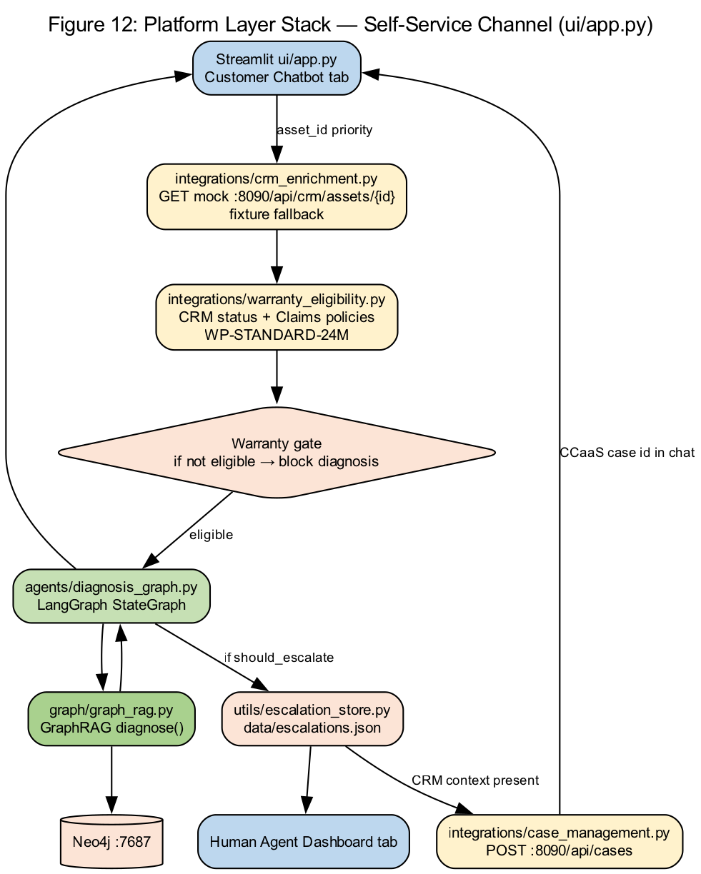
Figure 12: Platform layer stack — self-service channel
- ui/app.py invokes enrich_session_from_crm(asset_id=AST-WM-4421)
- integrations/crm_enrichment.py queries Enterprise Integration Layer — CRM assets endpoint
- Returns Jane Martinez (actual asset owner), product wm-001, warranty active until 2027-06-15
- integrations/warranty_eligibility.py checks status + Claims policies → eligible=true
- product_id passed to run_diagnosis() — skips keyword auto-detect
product_id = CRM asset product OR appliance dropdown OR detect_product(message)

7. LangGraph Workflow — Per Customer Message
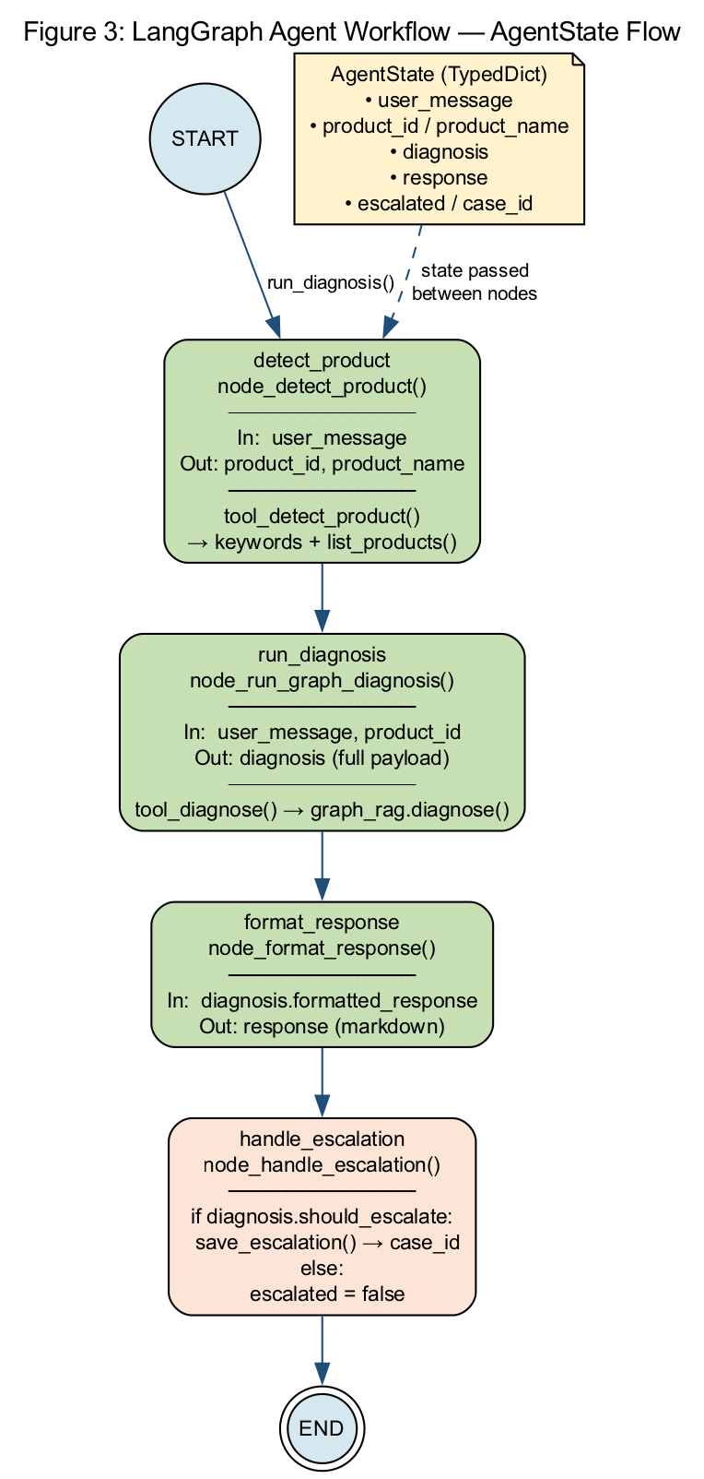
Figure 3: LangGraph diagnosis workflow
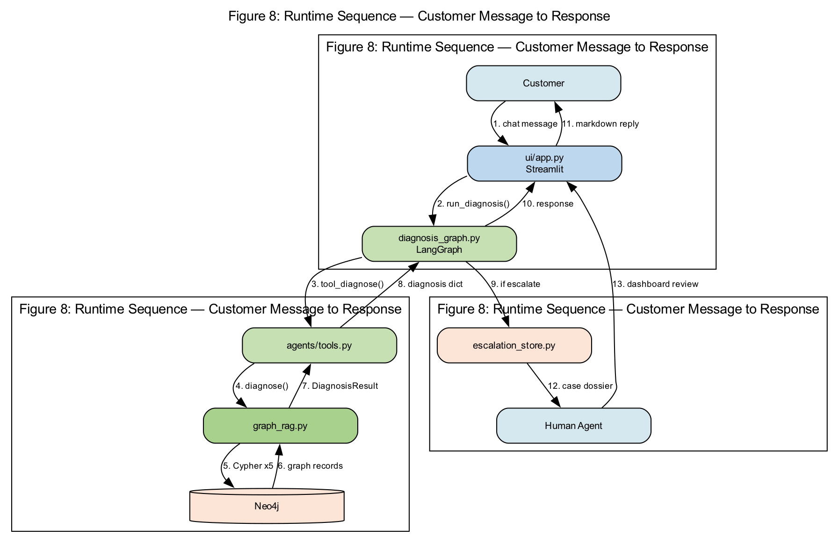
Figure 8: Runtime request sequence
Node | Module | Action in live session
detect_product | agents/diagnosis_graph.py | Kept wm-001 from CRM (message already product-specific)
run_diagnosis | agents/tools.py → graph_rag.py | Executed full GraphRAG Cypher pipeline
format_response | graph_rag.py format_diagnosis_response() | Built markdown with evidence + provenance
handle_escalation | utils/escalation_store.py | Turn 2 only: saved case 231311d2

8. GraphRAG — Turn-by-Turn Diagnosis Logic
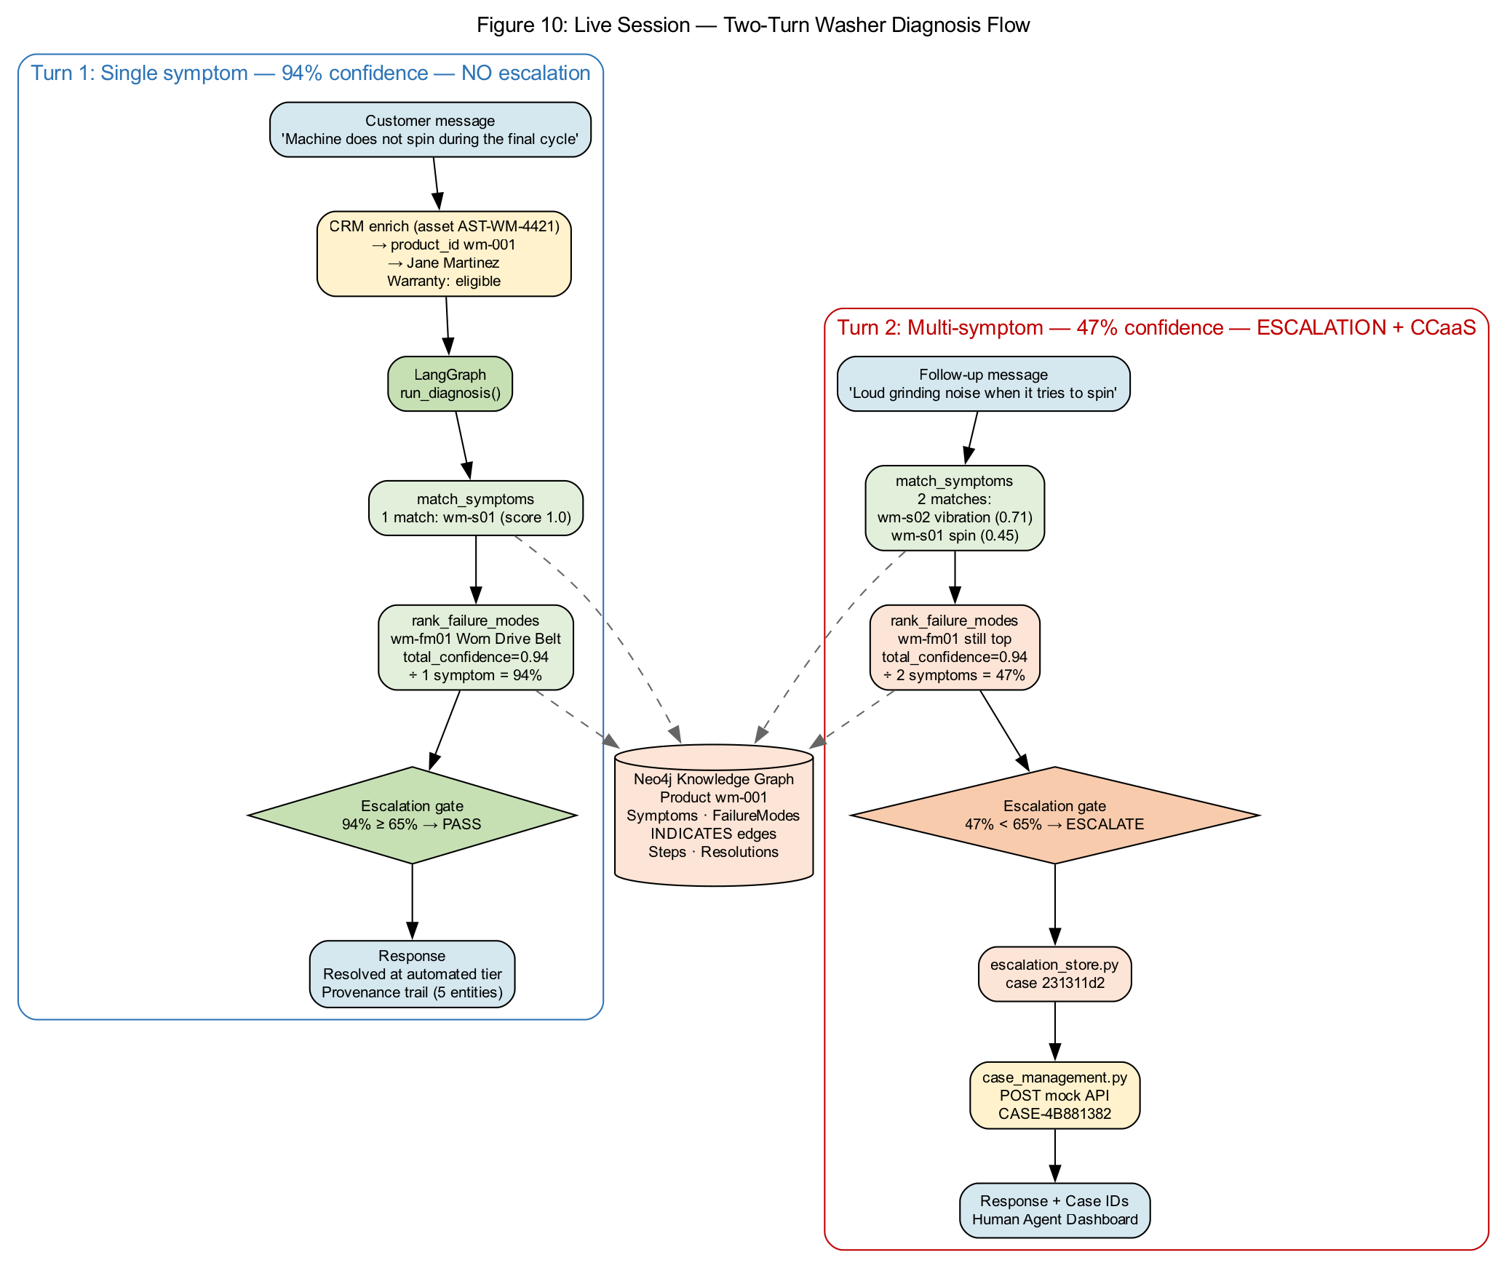
Figure 10: Live session two-turn diagnosis flow
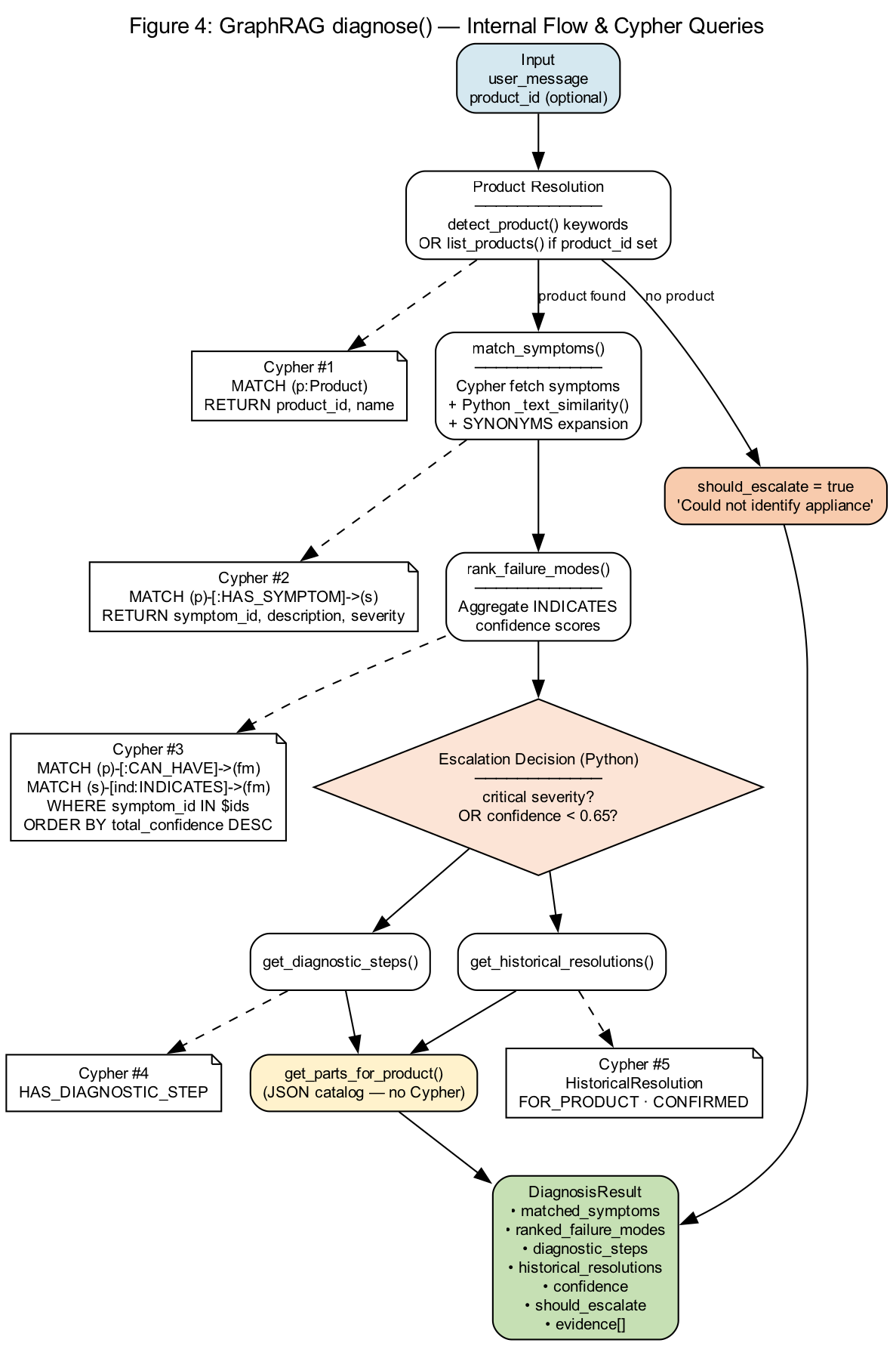
Figure 4: GraphRAG diagnose() internal flow

Turn 1: Machine does not spin during the final cycle
- match_symptoms: 1 match — wm-s01 (Machine does not spin…) score 1.0
- rank_failure_modes: wm-fm01 Worn Drive Belt, INDICATES confidence 0.94
- aggregate_confidence = 0.94 ÷ 1 symptom = 94%
- Escalation gate: 94% ≥ 65% threshold, no critical symptoms → should_escalate=false
- Status: Resolved at automated tier
- provenance_trail: 5 entries (Symptom, FailureMode, 2 Steps, 1 Resolution)

Turn 2: It also makes a loud grinding noise when it tries to spin
- match_symptoms: 2 matches — wm-s02 vibration (0.71) + wm-s01 spin (0.45)
- rank_failure_modes: wm-fm01 still #1 (total_confidence 0.94 from wm-s01 link only)
- aggregate_confidence = 0.94 ÷ 2 symptoms = 47%
- Escalation gate: 47% < 65% → should_escalate=true
- escalation_store saved case 231311d2 → Open Escalations count increased
- case_management POST → Service Cloud case CASE-4B881382 (integration sandbox)

Why confidence dropped from 94% to 47%
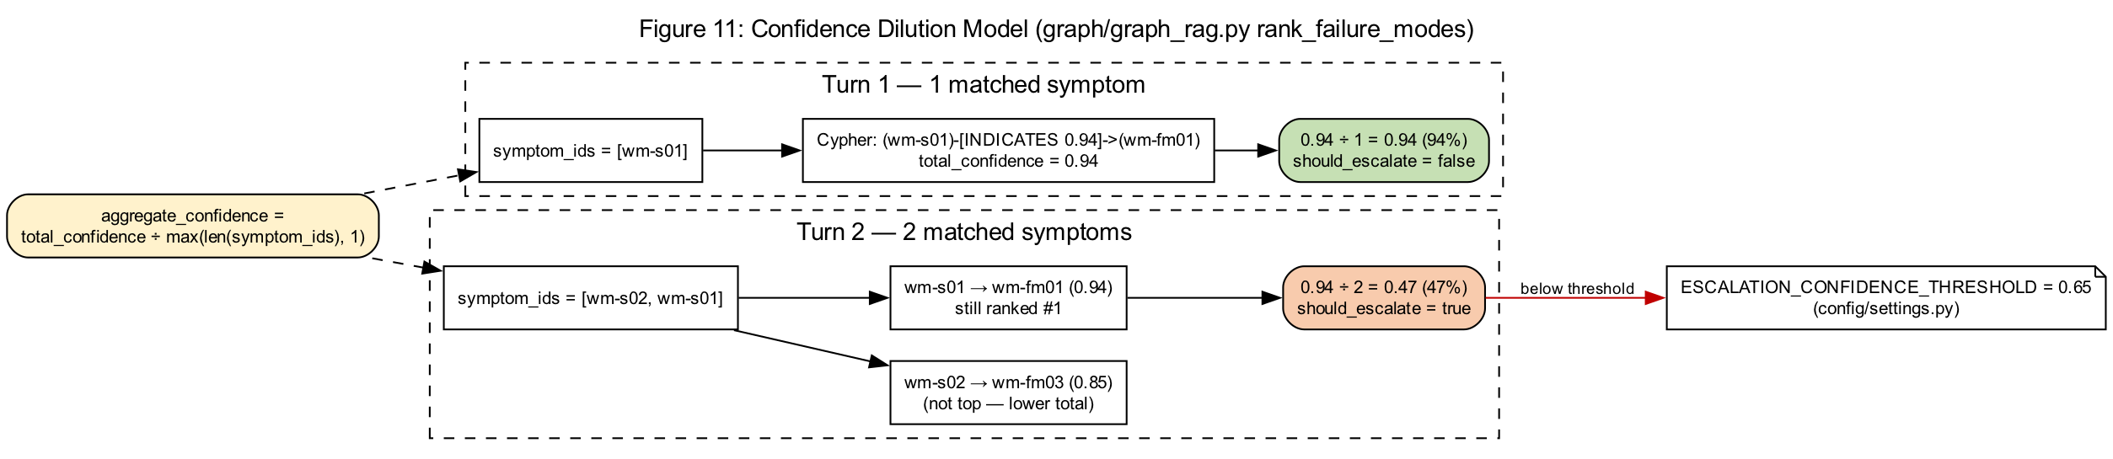
Figure 11: Confidence dilution model
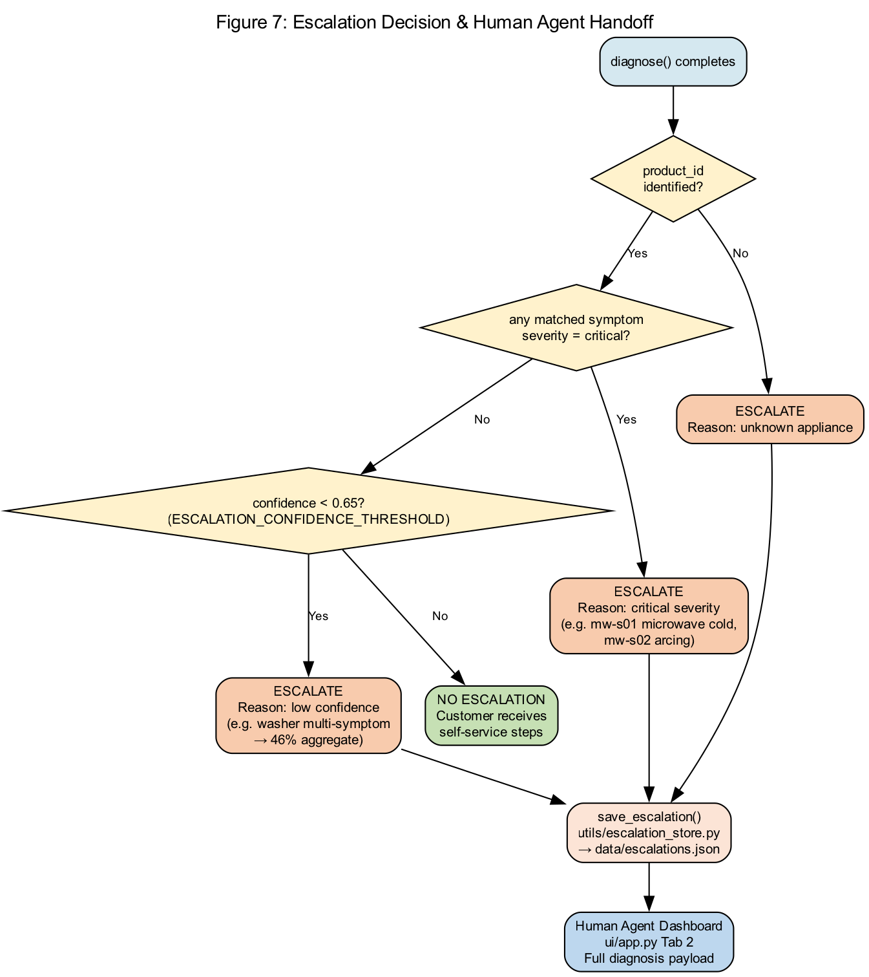
Figure 7: Escalation decision logic
aggregate_confidence = total_confidence / max(len(symptom_ids), 1) # graph/graph_rag.py
The top failure mode did not change — Worn Drive Belt remained #1. What changed was the denominator: adding a second matched symptom divides the same graph evidence across more symptoms, lowering aggregate confidence below the 0.65 ESCALATION_CONFIDENCE_THRESHOLD in config/settings.py.

9. Response Payload — Field-by-Field Explanation

Matched Symptoms
Neo4j query HAS_SYMPTOM + Python _text_similarity() with SYNONYMS expansion. Turn 2 added wm-s02 (medium severity).

Ranked Failure Modes
Cypher aggregates INDICATES edge confidence per failure mode. wm-fm03 also linked to wm-s02 (0.85) but ranked lower overall.

Diagnostic Steps
HAS_DIAGNOSTIC_STEP relationship — ordered troubleshooting from service manual ETL.

Historical Resolutions
FSM closed work orders and claims merged at ETL. WO-FSM-88104 and wm-r01 confirm past belt replacements.

Provenance Trail
graph/provenance.py builds audit lines when ENABLE_PROVENANCE=true. Shown in UI expander and Source Traceability section.

CRM Context JSON
Runtime enrichment only — not stored in Neo4j. Binds session to registered asset and warranty metadata.

10. Escalation & Case Management Outcomes
Artifact | Storage | Operational value
Agent escalation dossier | data/escalations.json | 231311d2 — Human Agent Dashboard
Service Cloud case record | data/simulated_cases.json | CASE-4B881382 — Case Management view
Open Escalations metric | ui/app.py | Real-time agent workload indicator
Escalation triggers (any one fires):
- Product unknown (not in your session)
- Any matched symptom severity = critical (not in washer turns)
- aggregate_confidence < 0.65 (Turn 2 — this fired)

11. Target Production Architecture
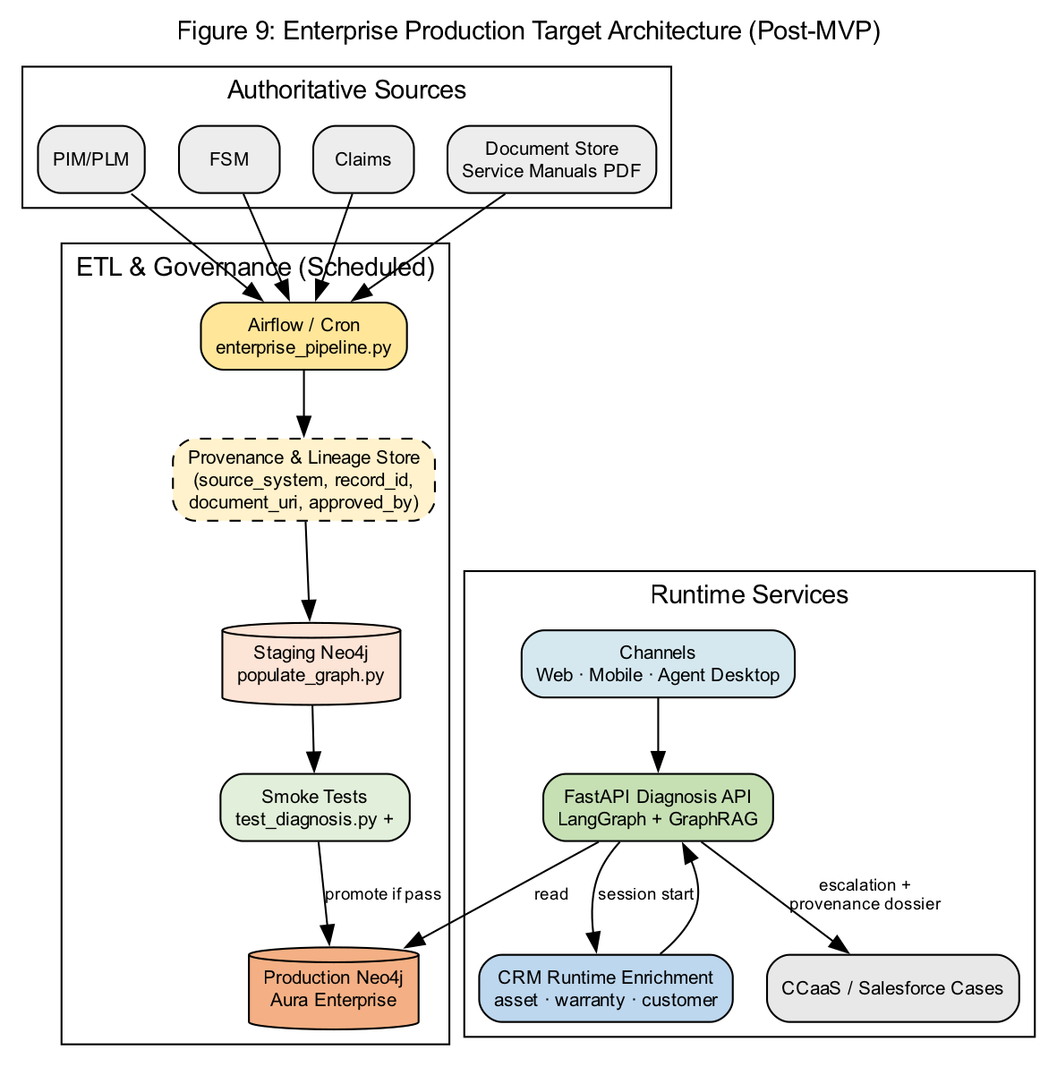
Figure 9: Target production deployment pattern

12. Platform Endpoint Reference
Component | Endpoint | Purpose
Self-Service Channel | localhost:8501 | Customer & agent console
Diagnostics API | localhost:8080 | Omnichannel integration surface
Enterprise Integration Layer | localhost:8090 | CRM · Claims · Case Management (sandbox)
Neo4j Bolt | localhost:7687 | All GraphRAG Cypher
Neo4j Browser | localhost:7474 | Visual graph inspection
ETL lineage | data/lineage/etl_batches.jsonl | Enterprise Systems tab

13. Graphviz Source Files

Graphviz: 15-current-state-swimlane.dot
// Figure 15: Current State — POC / Pilot Architecture (swimlanes)
digraph CurrentStateSwimlane {
graph [
rankdir=LR
splines=line
nodesep=0.35
ranksep=1.2
label="Figure 15: Current State Swimlane — POC / Pilot Platform"
labelloc=t
fontsize=14
fontname="Arial"
bgcolor="white"
]
node [shape=box, style="rounded,filled", fontname="Arial", fontsize=9, width=2.2]
edge [fontname="Arial", fontsize=8, color="#2E75B6"]
subgraph cluster_ch {
label="Customer & Agent Channels"
bgcolor="#D5E8F0"
style="filled,rounded"
CH1 [label="Describes\nappliance issue"]
CH2 [label="Receives\ndiagnosis"]
CH3 [label="Escalation &\ncase reference"]
CH1 -> CH2 -> CH3 [style=invis]
}
subgraph cluster_ui {
label="Presentation Layer"
bgcolor="#BDD7EE"
style="filled,rounded"
UI1 [label="Self-Service &\nAgent Console"]
UI2
// ...

Graphviz: 16-future-state-swimlane.dot
// Figure 16: Future State — Target Production Architecture (swimlanes)
digraph FutureStateSwimlane {
graph [
rankdir=TB
splines=ortho
nodesep=0.5
ranksep=0.45
label="Figure 16: Future State Swimlane — Target Production Architecture"
labelloc=t
fontsize=14
fontname="Arial"
bgcolor="white"
]
node [shape=box, style="rounded,filled", fontname="Arial", fontsize=9, width=2.5, height=0.55]
edge [fontname="Arial", fontsize=8, color="#548235"]
subgraph cluster_ch {
label="Omnichannel Customer & Agent"
bgcolor="#D5E8F0"
style="filled,rounded"
CH1 [label="Web · Mobile · IVR ·\nAgent Desktop"]
CH2 [label="Authenticated customer\n& asset context"]
}
subgraph cluster_api {
label="Diagnostics Platform — API Tier"
bgcolor="#BDD7EE"
style="filled,rounded"
API1 [label="FastAPI / API Gateway\nrate limit · auth · audit"
// ...

Graphviz: 17-live-session-swimlane.dot
// Figure 17: Live washer session — cross-functional swimlane (two customer turns)
digraph LiveSessionSwimlane {
graph [
rankdir=TB
splines=ortho
nodesep=0.45
ranksep=0.4
label="Figure 17: Live Session Swimlane — Washer Diagnosis (Two Customer Turns)"
labelloc=t
fontsize=14
fontname="Arial"
bgcolor="white"
]
node [shape=box, style="rounded,filled", fontname="Arial", fontsize=9, width=2.3, height=0.5]
edge [fontname="Arial", fontsize=8]
subgraph cluster_cust {
label="Customer"
bgcolor="#D5E8F0"
style="filled,rounded"
T1 [label="Turn 1:\n'Machine does not spin…'"]
T2 [label="Turn 2:\n'Grinding noise when spinning'"]
T3 [label="Receives case IDs\non escalation"]
}
subgraph cluster_crm {
label="CRM & Warranty Services"
bgcolor="#FFF2CC"
style="filled,rounded"
CRM1 [label="Asset AST-WM-4421\n→ Jane Mar
// ...

Graphviz: 18-etl-runtime-swimlane.dot
// Figure 18: Batch knowledge engineering vs runtime diagnosis (swimlanes)
digraph ETLRuntimeSwimlane {
graph [
rankdir=LR
splines=ortho
nodesep=0.4
ranksep=0.6
label="Figure 18: ETL & Governance vs Runtime Diagnosis Swimlane"
labelloc=t
fontsize=14
fontname="Arial"
bgcolor="white"
]
node [shape=box, style="rounded,filled", fontname="Arial", fontsize=9]
edge [fontname="Arial", fontsize=8, color="#4472C4"]
subgraph cluster_src {
label="Authoritative Source Systems"
bgcolor="#EDEDED"
style="filled,rounded"
PIM [label="PIM / PLM"]
FSM [label="FSM"]
CLM [label="Claims"]
CRM [label="CRM"]
}
subgraph cluster_batch {
label="Batch — Knowledge Engineering"
bgcolor="#E2EFDA"
style="filled,rounded"
ETL [label="Knowledge ETL\nconnectors + ontology"]
VAL [label="Smoke validation\ngate"]
PROM [label
// ...
All diagrams are version-controlled in docs/graphviz/*.dot. Render with:
bash docs/graphviz/render_all.sh

Graphviz: 10-demo-session-turn-flow.dot
// Figure 10: Demo session — two-turn washer flow (Streamlit → LangGraph → GraphRAG → Neo4j)
digraph DemoSessionTurnFlow {
graph [
rankdir=TB
label="Figure 10: Live Session — Two-Turn Washer Diagnosis Flow"
labelloc=t
fontsize=14
fontname="Arial"
bgcolor="white"
nodesep=0.35
]
node [fontname="Arial", fontsize=10]
edge [fontname="Arial", fontsize=9]
subgraph cluster_turn1 {
label="Turn 1: Single symptom — 94% confidence — NO escalation"
style=rounded
color="#2E75B6"
fontcolor="#2E75B6"
T1_IN [label="Customer message\n'Machine does not spin during the final cycle'", shape=box, style="rounded,filled", fillcolor="#D5E8F0"]
T1_CRM [label="CRM enrich (asset AST-WM-4421)\n→ product_id wm-001\n→ Jane Martinez\nWarranty: eligible", shape=box, style="rounded,filled", fillcolor="#FFF2CC"]
T1_LG [label="LangGraph\nrun_diagnosis()",
// ...

Graphviz: 11-confidence-dilution-model.dot
// Figure 11: Confidence dilution — why 94% becomes 47% with two symptoms
digraph ConfidenceDilution {
graph [
rankdir=LR
label="Figure 11: Confidence Dilution Model (graph/graph_rag.py rank_failure_modes)"
labelloc=t
fontsize=14
fontname="Arial"
bgcolor="white"
]
node [fontname="Arial", fontsize=10]
edge [fontname="Arial", fontsize=9]
Formula [label="aggregate_confidence =\ntotal_confidence ÷ max(len(symptom_ids), 1)", shape=box, style="rounded,filled", fillcolor="#FFF2CC"]
subgraph cluster_t1 {
label="Turn 1 — 1 matched symptom"
style=dashed
S1 [label="symptom_ids = [wm-s01]", shape=box, fillcolor="#E2EFDA"]
E1 [label="Cypher: (wm-s01)-[INDICATES 0.94]->(wm-fm01)\ntotal_confidence = 0.94", shape=box, fillcolor="#E2EFDA"]
R1 [label="0.94 ÷ 1 = 0.94 (94%)\nshould_escalate = false", shape=box, style="rounded,filled", fillcolor="#C6
// ...

Graphviz: 12-streamlit-enterprise-layers.dot
// Figure 12: Streamlit UI enterprise layer stack (ui/app.py)
digraph StreamlitEnterpriseLayers {
graph [
rankdir=TB
label="Figure 12: Platform Layer Stack — Self-Service Channel (ui/app.py)"
labelloc=t
fontsize=14
fontname="Arial"
bgcolor="white"
]
node [shape=box, style="rounded,filled", fontname="Arial", fontsize=10]
edge [fontname="Arial", fontsize=9]
UI [label="Streamlit ui/app.py\nCustomer Chatbot tab", fillcolor="#BDD7EE"]
CRM [label="integrations/crm_enrichment.py\nGET mock :8090/api/crm/assets/{id}\nfixture fallback", fillcolor="#FFF2CC"]
WAR [label="integrations/warranty_eligibility.py\nCRM status + Claims policies\nWP-STANDARD-24M", fillcolor="#FFF2CC"]
GATE [label="Warranty gate\nif not eligible → block diagnosis", shape=diamond, fillcolor="#FCE4D6"]
LG [label="agents/diagnosis_graph.py\nLangGraph StateGraph", fillcolor="#C6E0B4"]
// ...

Graphviz: 13-demo-response-field-map.dot
// Figure 13: Demo response fields mapped to knowledge graph entities and source systems
digraph DemoResponseFieldMap {
graph [
rankdir=LR
label="Figure 13: Diagnostic Response Fields → Neo4j Entities → Enterprise Sources"
labelloc=t
fontsize=14
fontname="Arial"
bgcolor="white"
]
node [fontname="Arial", fontsize=10]
edge [fontname="Arial", fontsize=9, color="#4472C4"]
subgraph cluster_ui {
label="UI Response Sections"
style=rounded
color="#2E75B6"
R_PROD [label="Product:\nFront Load Washing Machine 8kg", shape=box, fillcolor="#D5E8F0"]
R_SYM [label="Matched Symptoms\nwm-s01, wm-s02", shape=box, fillcolor="#D5E8F0"]
R_FM [label="Failure Mode\nWorn Drive Belt wm-fm01", shape=box, fillcolor="#D5E8F0"]
R_STEP [label="Diagnostic Steps\nwm-d01..d04", shape=box, fillcolor="#D5E8F0"]
R_RES [label="Past Resolutions\nCLM-2026-00481
// ...

Graphviz: 14-etl-to-runtime.dot
// Figure 14: ETL pipelines to runtime diagnosis (batch load → live query)
digraph ETLToRuntime {
graph [
rankdir=TB
label="Figure 14: Enterprise ETL Pipelines → Neo4j → Runtime Diagnosis"
labelloc=t
fontsize=14
fontname="Arial"
bgcolor="white"
]
node [fontname="Arial", fontsize=10]
edge [fontname="Arial", fontsize=9]
subgraph cluster_sources {
label="Enterprise Sources (:8090 mock or fixtures)"
style=rounded
PIM [label="PIM Connector", shape=box, fillcolor="#FFF2CC"]
FSM [label="FSM Connector", shape=box, fillcolor="#FFF2CC"]
CLM [label="Claims Connector", shape=box, fillcolor="#FFF2CC"]
CRM [label="CRM Connector", shape=box, fillcolor="#FFF2CC"]
}
P1 [label="Pipeline 1: knowledge_etl.py\nOntologyBuilder → enterprise_knowledge_catalog.json", shape=box, style="rounded,filled", fillcolor="#BDD7EE"]
POP [label="populate_grap
// ...

