Cypher & Query Walkthrough
From Customer Message to Diagnosis — With Neo4j Diagrams
Enterprise Diagnostics Chatbot
Document Version: 1.0
Date: June 25, 2026

1. What This Document Covers
This document walks through one real customer message step by step. For each step it shows: which code runs, whether Cypher is used, the exact query sent to Neo4j, what Neo4j returns, and how the final diagnosis and escalation decision are made. Three diagrams are included showing the full knowledge graph, the matched path for this message, and the query execution flow.

2. The Customer Message
"My washing machine won't spin and water stays in the drum"
This message enters the LangGraph agent via the Streamlit chat UI (ui/app.py), which calls run_diagnosis() in agents/diagnosis_graph.py.

3. Agent Workflow Overview
Four LangGraph nodes run in sequence:
Order | Node | File | Uses Cypher?
1 | detect_product | agents/diagnosis_graph.py | Yes — Query #1
2 | run_diagnosis | graph/graph_rag.py → diagnose() | Yes — Queries #2–#5
3 | format_response | graph/graph_rag.py | No — Python templates
4 | handle_escalation | utils/escalation_store.py | No — saves JSON case

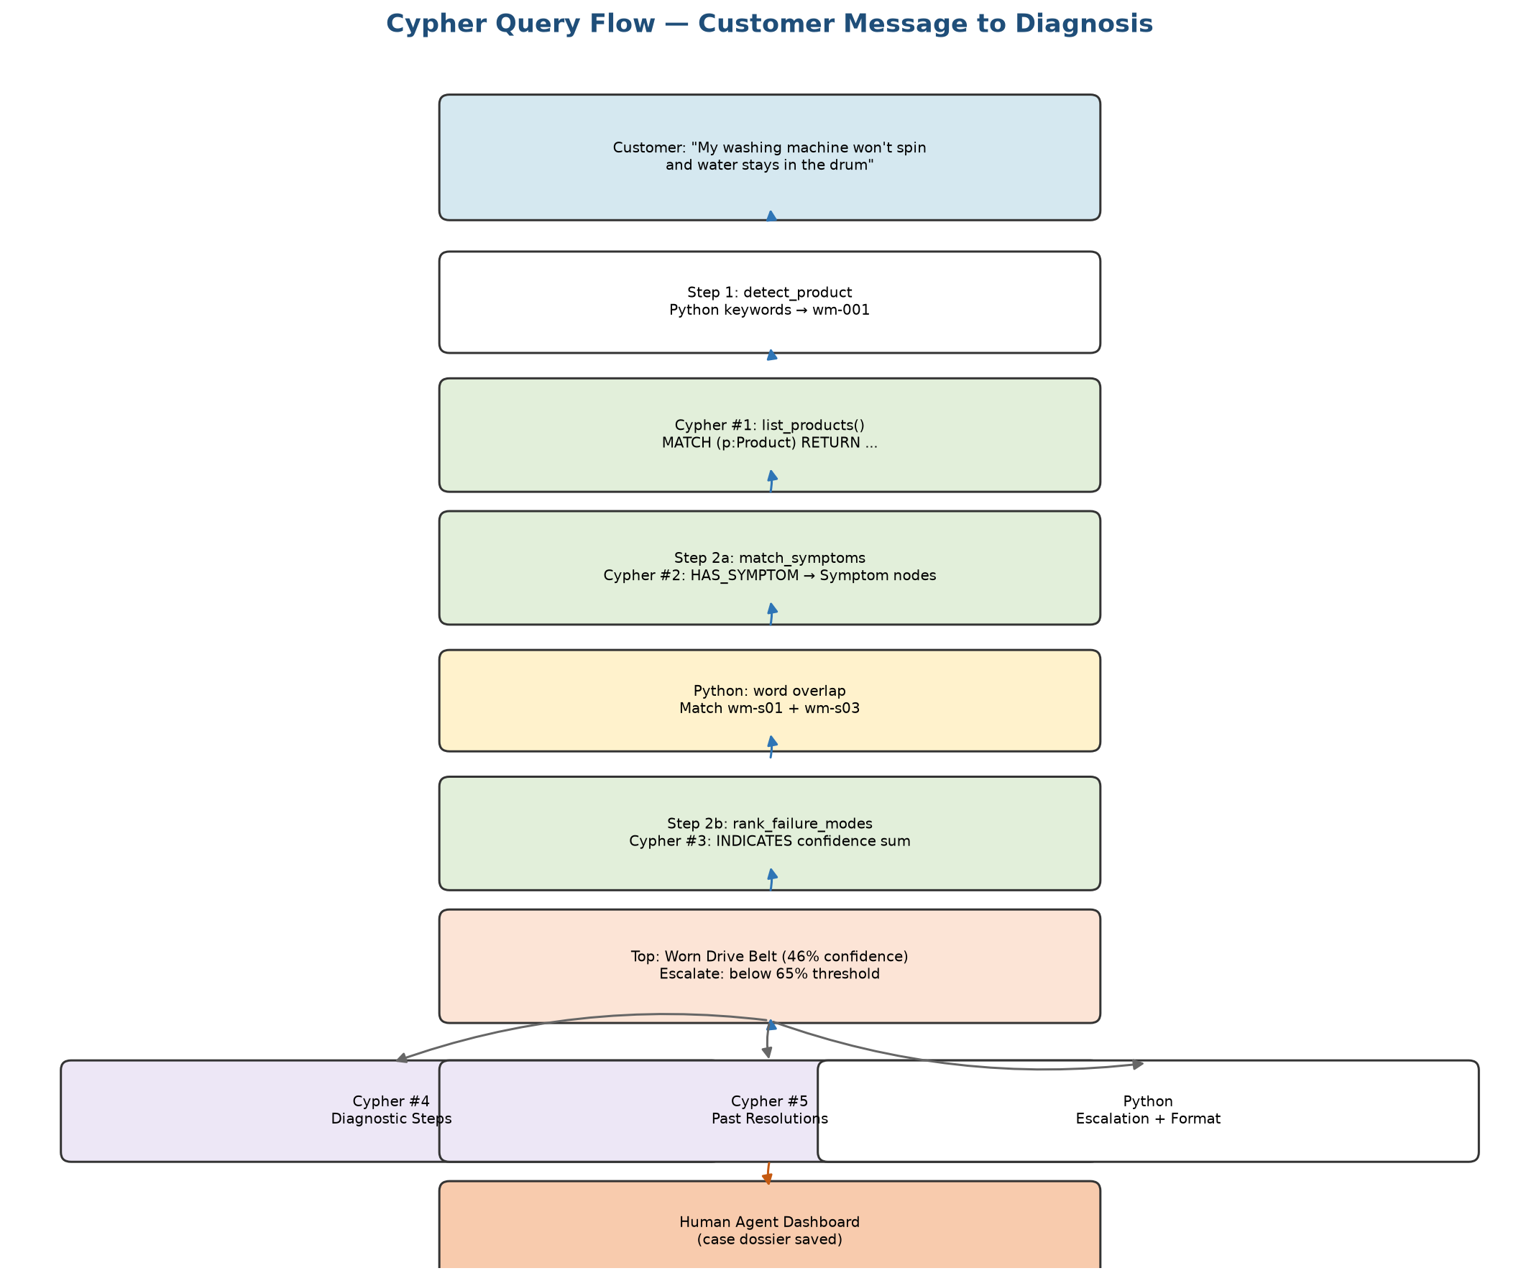
Figure 1: End-to-end Cypher query flow for this customer message

4. Step 1 — detect_product

4.1 Python Keyword Scoring
The message is lowercased and scored against appliance keyword lists:
Product ID | Keywords Checked | Hits in Message | Score
wm-001 | washing, washer, laundry, spin, drum | washing, spin, drum | 3
dw-001 | dishwasher, dish, dishes, rinse | none | 0
mw-001 | microwave, convection, magnetron, arcing, spark | none | 0

Winner: wm-001 (washing machine). To attach the full product name, the app queries Neo4j.

4.2 Cypher Query #1 — list_products()
File: graph/graph_rag.py — function list_products()
MATCH (p:Product)
RETURN p.product_id AS product_id, p.name AS name,
p.category AS category, p.brand AS brand
ORDER BY p.name
Plain English: Return every Product node in the database.
Key result used:
product_id = 'wm-001'
product_name = 'Front Load Washing Machine 8kg'

5. Step 2 — run_diagnosis (GraphRAG Core)
The run_diagnosis node calls diagnose() in graph/graph_rag.py. This executes up to five graph lookups plus Python text matching.

5.1 Sub-step A — match_symptoms()

Cypher Query #2 — fetch symptoms for product
MATCH (p:Product {product_id: 'wm-001'})-[:HAS_SYMPTOM]->(s:Symptom)
RETURN s.symptom_id AS symptom_id, s.description AS description,
s.severity AS severity
Plain English: Follow HAS_SYMPTOM arrows from the washing machine to all its known symptoms.
symptom_id | description | severity | Matched?
wm-s01 | Machine does not spin during final cycle | high | YES — 'won't spin'
wm-s02 | Excessive vibration and banging noise | medium | No
wm-s03 | Water remains in drum after cycle completes | high | YES — 'water...drum'
wm-s04 | Error code E21 displayed on panel | medium | No

After Cypher returns the symptom list, Python (_text_similarity in graph/graph_rag.py) compares the customer message to each description using token overlap and synonyms (spin/spinning, drum/tub, water/drain). Symptoms scoring >= 0.15 are kept.
Result: symptom_ids = ['wm-s01', 'wm-s03']

5.2 Sub-step B — rank_failure_modes()

Cypher Query #3 — the most important query in the app
MATCH (p:Product {product_id: 'wm-001'})-[:CAN_HAVE]->(fm:FailureMode)
OPTIONAL MATCH (s:Symptom)-[ind:INDICATES]->(fm)
WHERE s.symptom_id IN ['wm-s01', 'wm-s03']
WITH fm,
collect(DISTINCT {symptom_id: s.symptom_id, confidence: ind.confidence}) AS indications,
sum(CASE WHEN ind.confidence IS NULL THEN 0 ELSE ind.confidence END) AS total_confidence,
count(ind) AS link_count
RETURN fm.failure_mode_id, fm.name, fm.description,
fm.estimated_repair_time_minutes AS repair_minutes,
fm.safety_notes, indications, total_confidence, link_count
ORDER BY total_confidence DESC, link_count DESC
Plain English:
- Find all failure modes this product can have (CAN_HAVE)
- For each failure mode, check if matched symptoms INDICATES it
- Sum the confidence scores on those INDICATES relationships
- Return ranked list — highest score first
Failure Mode | INDICATES From | total_confidence | aggregate*
Worn Drive Belt (wm-fm01) | wm-s01 → 0.92 | 0.92 | 0.46
Failed Drain Pump (wm-fm02) | wm-s03 → 0.88 | 0.88 | 0.44
Unbalanced Load Sensor (wm-fm03) | none | 0 | 0.0

*aggregate_confidence = total_confidence ÷ number of matched symptoms (2). Computed in Python after the query returns.
Top failure mode: Worn Drive Belt. Overall confidence: 46%.
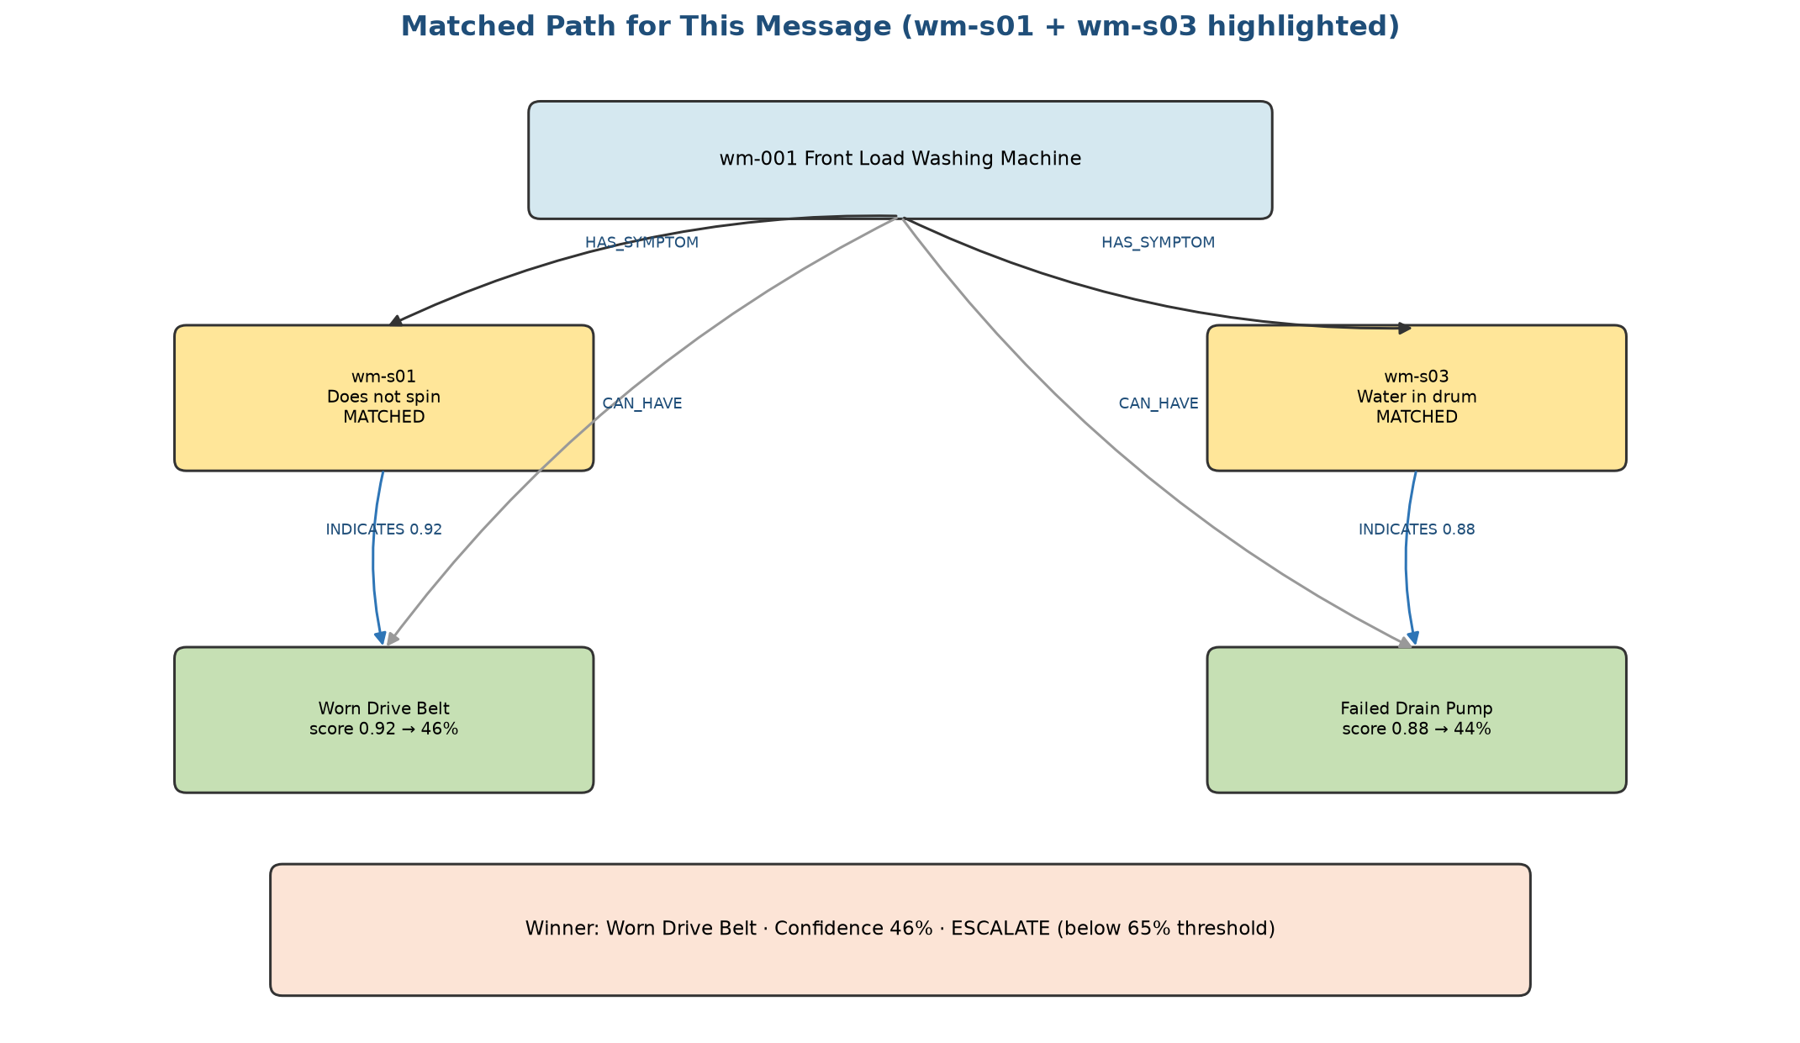
Figure 2: Matched symptoms and INDICATES paths for this specific message

5.3 Sub-step C — get_diagnostic_steps()

Cypher Query #4
MATCH (p:Product {product_id: 'wm-001'})-[:HAS_DIAGNOSTIC_STEP]->(ds:DiagnosticStep)
RETURN ds.step_id, ds.description, ds.order AS step_order,
ds.expected_outcome AS expected_outcome
ORDER BY ds.order
Returns four ordered troubleshooting steps shown to the customer.

5.4 Sub-step D — get_historical_resolutions()

Cypher Query #5
MATCH (r:HistoricalResolution)-[:FOR_PRODUCT]->(p:Product {product_id: 'wm-001'})
OPTIONAL MATCH (r)-[:CONFIRMED]->(fm:FailureMode)
WHERE fm.failure_mode_id = 'wm-fm01'
RETURN r.resolution_id, r.description, r.resolution_date,
r.technician_notes, fm.name AS failure_mode_name
ORDER BY r.resolution_date DESC
Returns: 'Replaced worn drive belt; spin restored.' (2025-11-12)

5.5 Parts — JSON file, not Cypher
get_parts_for_product() reads from data/synthetic_diagnosis_data.json — Drive Belt, Drain Pump, Shock Absorber Kit.

5.6 Escalation Decision — Python logic
confidence = 0.46
critical = any(symptom.severity == 'critical' for symptom in matched) → False
threshold = 0.65 (from config/settings.py)
should_escalate = (0.46 < 0.65) → True
Important: even though Worn Drive Belt is the clear winner, confidence is only 46% because the formula divides by two matched symptoms that point to different failure modes. This case escalates to a human agent.

6. Full Neo4j Knowledge Graph Diagram
The diagram below shows the complete wm-001 subgraph stored in Neo4j: all symptoms, failure modes, INDICATES confidence weights, diagnostic steps, and a historical resolution.
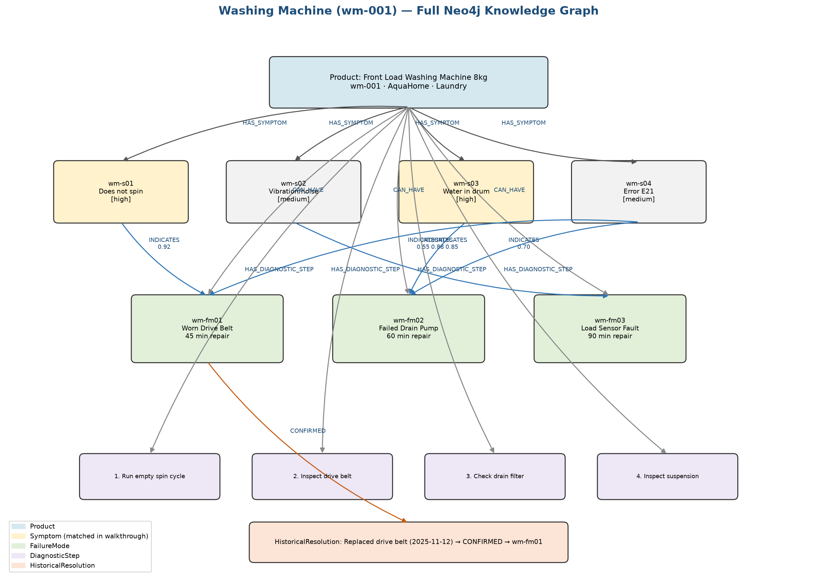
Figure 3: Complete washing machine knowledge graph in Neo4j

7. Step 3 — format_response
No Cypher. Python builds markdown from the DiagnosisResult:
**Product:** Front Load Washing Machine 8kg
**Matched Symptoms:**
- Machine does not spin during final cycle (severity: high)
- Water remains in drum after cycle completes (severity: high)
**Most Likely Failure Mode:** Worn Drive Belt
- Confidence: 46%
**Recommended Diagnostic Steps:**
1. Run empty spin cycle...
2. Inspect drive belt...
**Escalation:** Confidence (46%) below threshold — escalating to human agent.

8. Step 4 — handle_escalation
No Cypher. Because should_escalate = True, save_escalation() writes a case to data/escalations.json:
{
"case_id": "<uuid>",
"user_message": "My washing machine won't spin and water stays in the drum",
"diagnosis": { full payload with symptoms, failure modes, steps, evidence }
}
The Human Agent Dashboard tab in Streamlit displays this dossier so the agent starts with full context.

9. Complete Query Summary
# | Function | Cypher Purpose | When It Runs
1 | list_products() | List all Product nodes | Product detection
2 | match_symptoms() | HAS_SYMPTOM → get symptom catalog | Symptom matching
3 | rank_failure_modes() | INDICATES confidence aggregation | Root cause ranking
4 | get_diagnostic_steps() | HAS_DIAGNOSTIC_STEP → procedures | Troubleshooting steps
5 | get_historical_resolutions() | HistoricalResolution → CONFIRMED | Past repair evidence

10. Contrast — Microwave Message (Different Escalation Reason)
Message: 'Microwave runs but food stays cold, arcing inside'
- Same 5 Cypher query pattern, product_id = mw-001
- Matches mw-s01 (critical) and mw-s02 (critical)
- Query #3 ranks Magnetron Failure and Damaged Waveguide Cover
- Escalates because severity = critical — NOT because of low confidence
- Safety notes ('HIGH VOLTAGE') come from FailureMode properties in Query #3 results

11. Try It Yourself in Neo4j Browser
Open http://localhost:7474 (login: neo4j / password) and run:
// See all symptom-failure links
MATCH (s:Symptom)-[r:INDICATES]->(fm:FailureMode)
RETURN s.description, fm.name, r.confidence
ORDER BY r.confidence DESC
// Simulate Query #3 for this message
MATCH (p:Product {product_id: 'wm-001'})-[:CAN_HAVE]->(fm:FailureMode)
OPTIONAL MATCH (s:Symptom)-[ind:INDICATES]->(fm)
WHERE s.symptom_id IN ['wm-s01', 'wm-s03']
RETURN fm.name, sum(ind.confidence) AS score
ORDER BY score DESC

12. Key Takeaway
Cypher is the language for asking Neo4j structured questions. A query is one specific question. This app runs up to five queries per diagnosis to go from a customer complaint → matched symptoms → ranked failure mode → troubleshooting steps → past repairs → escalate or resolve. The diagrams in this document show the graph those queries traverse.

