Architecture Diagrams
Graphviz & Block Diagrams — Enterprise Diagnostics Chatbot
Accurate diagrams grounded in diagnostic-chatbot codebase
Document Version: 1.0 | Date: June 25, 2026
This document contains nine architecture diagrams rendered from Graphviz DOT source files in docs/graphviz/. Each diagram maps to actual modules, functions, and data flows in the repository. SVG and PNG renders are in docs/graphviz/rendered/.

How to Regenerate
bash docs/graphviz/render_all.sh
node docs/scripts/generate_architecture_diagrams_doc.js

Diagram Index
- Figure 1: Enterprise System Context — 01-system-context.dot
- Figure 2: Repository Module Block Diagram — 02-module-block.dot
- Figure 3: LangGraph Agent Workflow — 03-langgraph-workflow.dot
- Figure 4: GraphRAG diagnose() Flow — 04-graphrag-diagnosis.dot
- Figure 5: Neo4j Ontology & wm-001 Instance — 05-neo4j-ontology.dot
- Figure 6: Enterprise ETL Pipeline — 06-etl-pipeline.dot
- Figure 7: Escalation Decision Logic — 07-escalation-decision.dot
- Figure 8: Runtime Request Sequence — 08-runtime-sequence.dot
- Figure 9: Enterprise Production Target — 09-enterprise-production.dot

1. Diagram Gallery

Figure 1: Enterprise System Context
C4-style context diagram showing appliance owners, contact center agents, the diagnostics platform modules (ui/app.py, LangGraph, GraphRAG, ETL, populate_graph, Neo4j), and upstream enterprise systems (PIM, FSM, Claims, CRM). Dashed lines indicate production targets not fully wired in the demo.
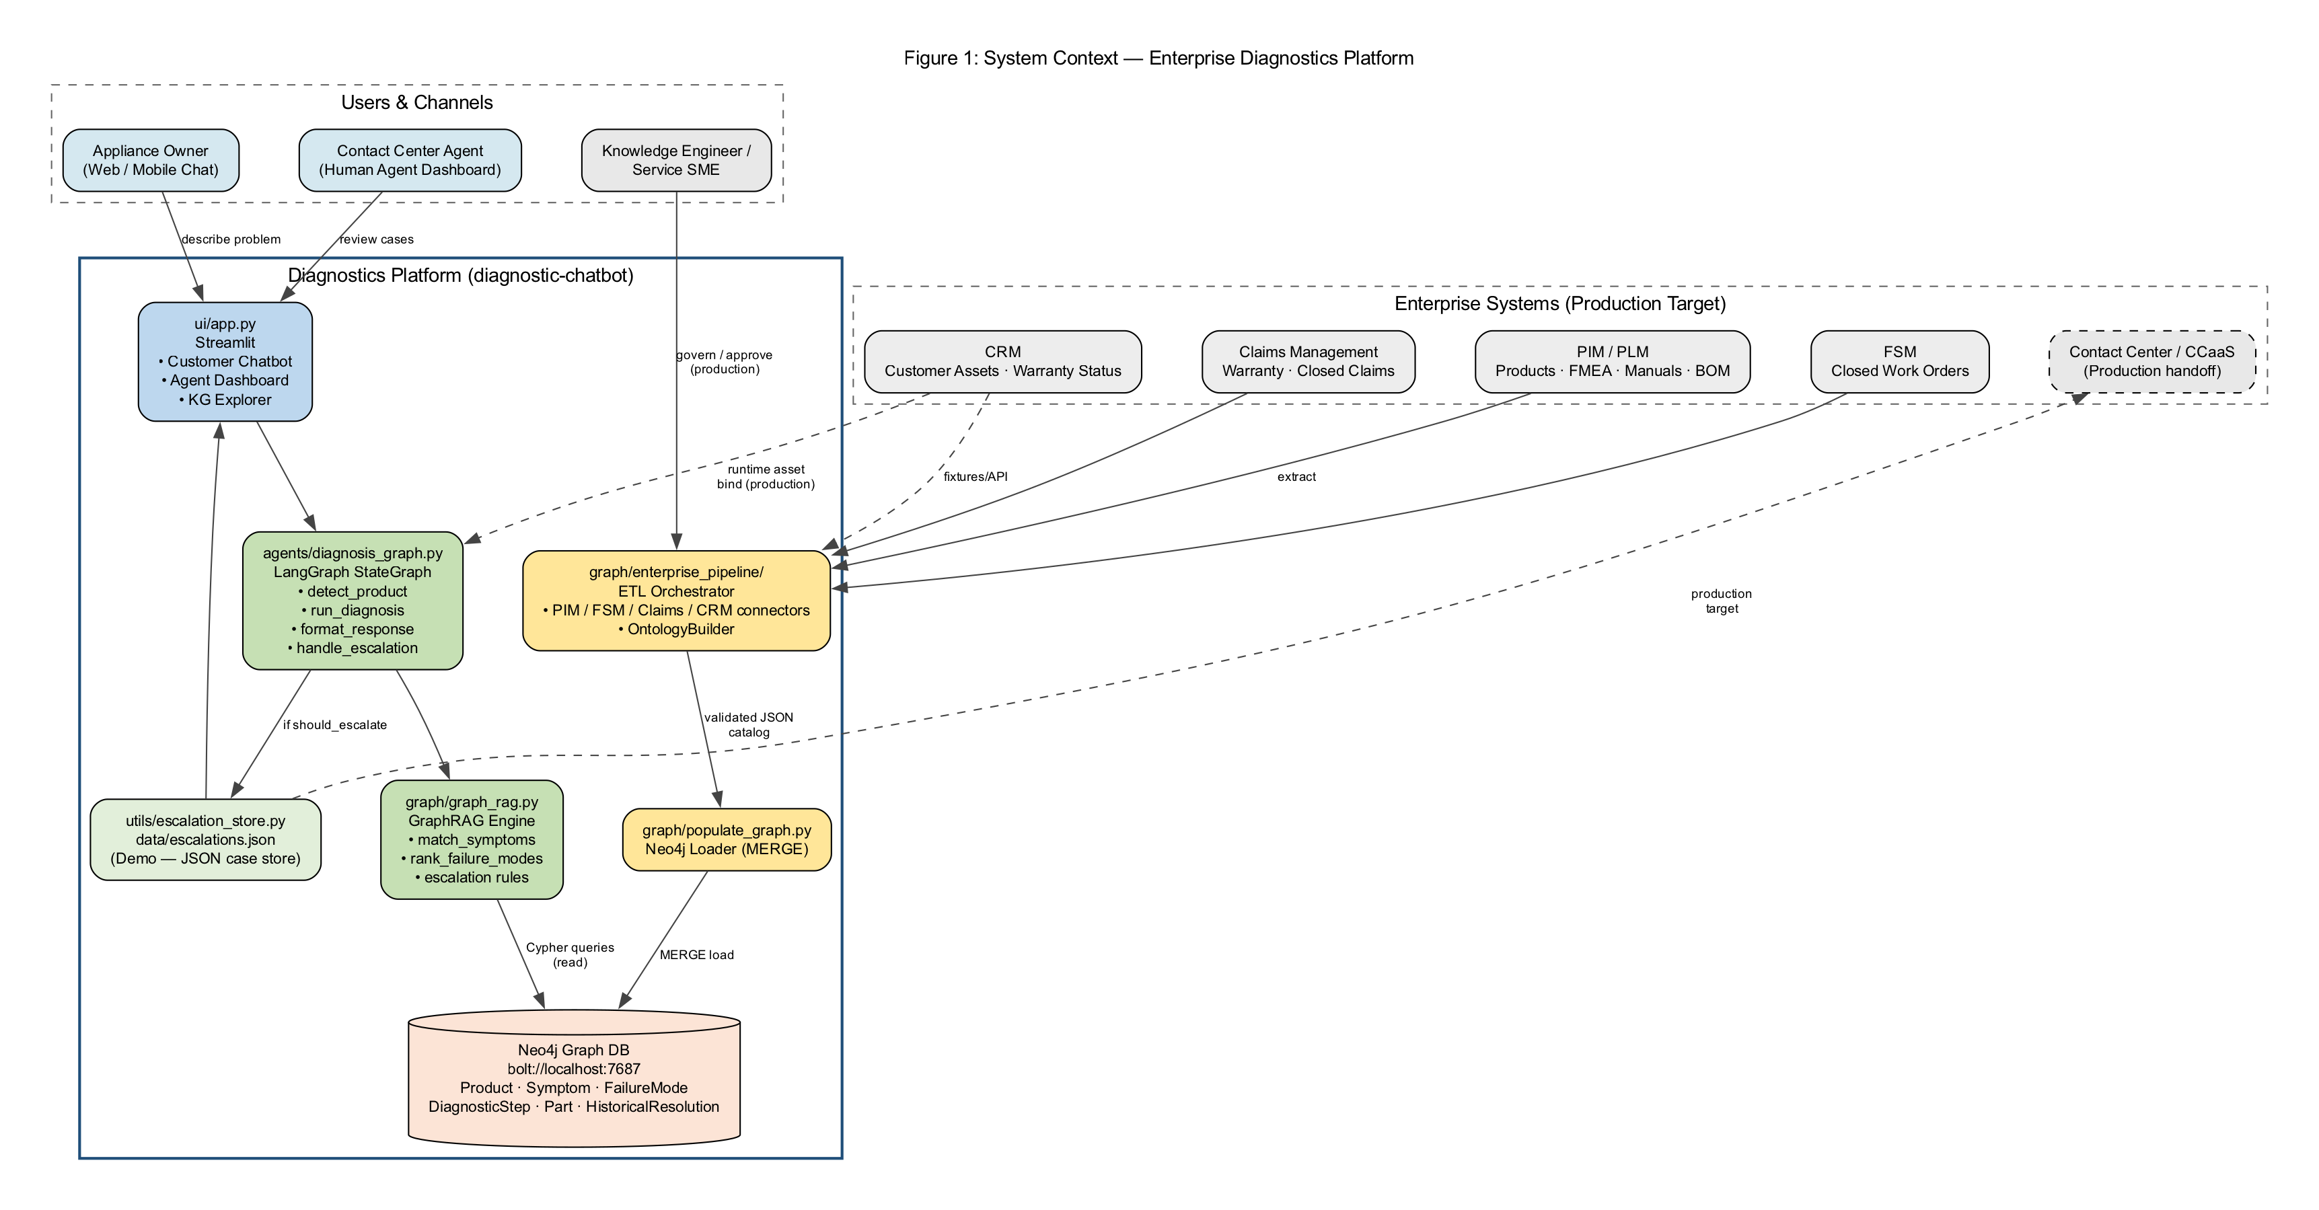
Figure 1: Enterprise System Context

Graphviz Source: 01-system-context.dot
// Figure 1: Enterprise System Context (C4 Level 1)
digraph SystemContext {
graph [
rankdir=TB
label="Figure 1: System Context — Enterprise Diagnostics Platform"
labelloc=t
fontsize=14
fontname="Arial"
bgcolor="white"
pad=0.4
nodesep=0.6
ranksep=0.8
]
node [shape=box, style="rounded,filled", fontname="Arial", fontsize=11, margin="0.2,0.12"]
edge [fontname="Arial", fontsize=9, color="#444444"]
subgraph cluster_users {
label="Users & Channels"
style=dashed
color="#666666"
Customer [label="Appliance Owner\n(Web / Mobile Chat)", fillcolor="#D5E8F0"]
Agent [label="Contact Center Agent\n(Human Agent Dashboard)", fillcolor="#D5E8F0"]
SME [label="Knowledge Engineer /\nService SME", fillcolor="#E8E8E8"]
}
subgraph cluster_platform {
label="Diagnostics Platform (diagnostic-chatbot)"
style=bold
color="#1F4E79"
fillcolor="#F7FAFC"
UI [label="ui/app.py\nStreamlit\n• Customer Chatbot\n• Agent Dashboard\n• KG Explorer", fillcolor="#BDD7EE"]
AgentOrch [label="agents/diagnosis_graph.py\nLangGraph StateGraph\n• detect_product\n• run_diagnosis\n• format_response\n• handle_escalation", fillcolor="#C6E0
// ... (see docs/graphviz/01-system-context.dot)

Figure 2: Repository Module Block Diagram
Block diagram of all major Python modules and data files in diagnostic-chatbot, grouped by presentation, orchestration, GraphRAG, knowledge, and infrastructure layers. Arrows show compile-time/runtime dependencies.
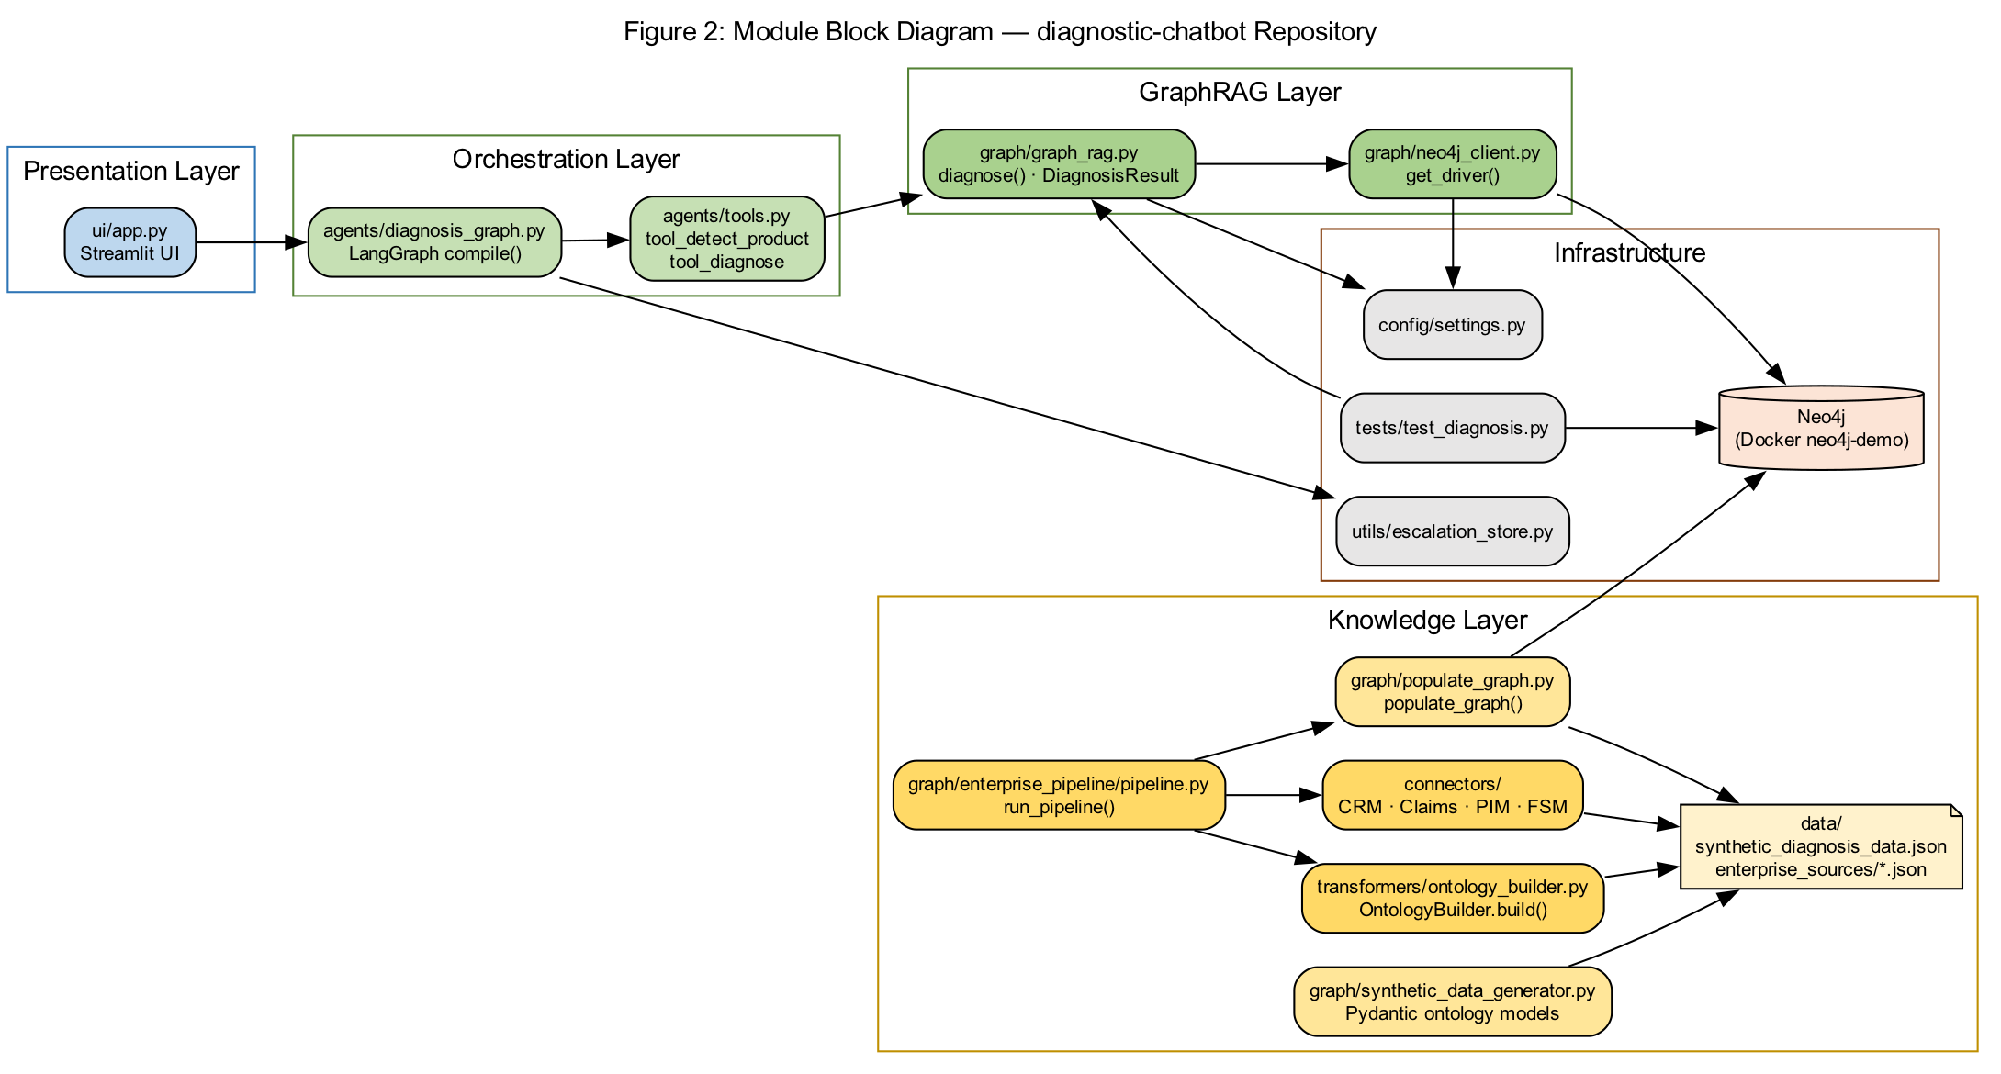
Figure 2: Repository Module Block Diagram

Graphviz Source: 02-module-block.dot
// Figure 2: Application Module Block Diagram (repository structure)
digraph ModuleBlock {
graph [
rankdir=LR
label="Figure 2: Module Block Diagram — diagnostic-chatbot Repository"
labelloc=t
fontsize=14
fontname="Arial"
bgcolor="white"
]
node [shape=box, style="rounded,filled", fontname="Arial", fontsize=10]
edge [fontname="Arial", fontsize=9]
subgraph cluster_presentation {
label="Presentation Layer"
color="#2E75B6"
UI [label="ui/app.py\nStreamlit UI", fillcolor="#BDD7EE"]
}
subgraph cluster_orchestration {
label="Orchestration Layer"
color="#548235"
DG [label="agents/diagnosis_graph.py\nLangGraph compile()", fillcolor="#C6E0B4"]
Tools [label="agents/tools.py\ntool_detect_product\ntool_diagnose", fillcolor="#C6E0B4"]
}
subgraph cluster_reasoning {
label="GraphRAG Layer"
color="#548235"
GR [label="graph/graph_rag.py\ndiagnose() · DiagnosisResult", fillcolor="#A9D18E"]
NC [label="graph/neo4j_client.py\nget_driver()", fillcolor="#A9D18E"]
}
subgraph cluster_knowledge {
label="Knowledge Layer"
color="#BF8F00"
PG [label="graph/populate_graph.py\npopulate_graph()", fillcolor="#FFE6
// ... (see docs/graphviz/02-module-block.dot)

Figure 3: LangGraph Agent Workflow
Exact workflow from agents/diagnosis_graph.py: linear StateGraph with four nodes (detect_product → run_diagnosis → format_response → handle_escalation) and AgentState fields passed between nodes.
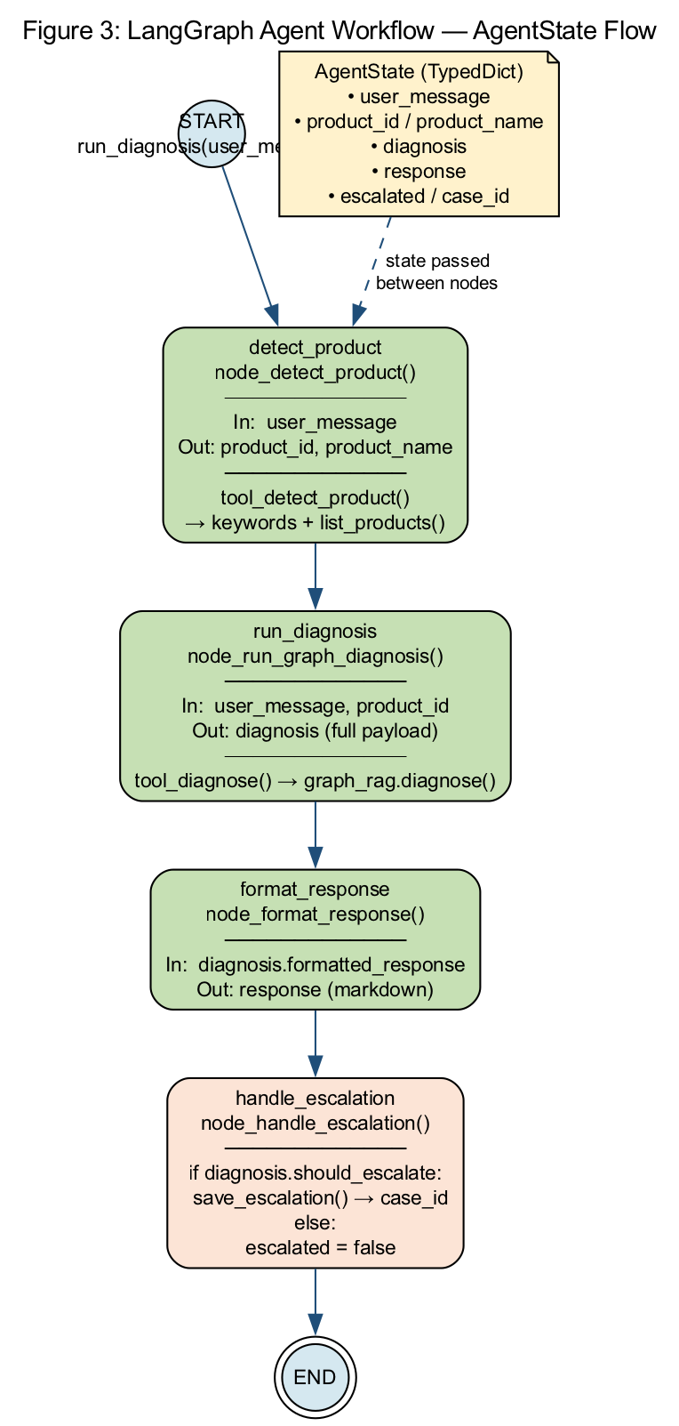
Figure 3: LangGraph Agent Workflow

Graphviz Source: 03-langgraph-workflow.dot
// Figure 3: LangGraph Agent Workflow (agents/diagnosis_graph.py)
digraph LangGraphWorkflow {
graph [
rankdir=TB
label="Figure 3: LangGraph Agent Workflow — AgentState Flow"
labelloc=t
fontsize=14
fontname="Arial"
bgcolor="white"
]
node [shape=box, style="rounded,filled", fontname="Arial", fontsize=11]
edge [fontname="Arial", fontsize=10, color="#1F4E79"]
Start [label="START\nrun_diagnosis(user_message)", shape=circle, fillcolor="#D5E8F0", width=0.5, fixedsize=true]
N1 [label="detect_product\nnode_detect_product()\n─────────────\nIn: user_message\nOut: product_id, product_name\n─────────────\ntool_detect_product()\n→ keywords + list_products()", fillcolor="#C6E0B4"]
N2 [label="run_diagnosis\nnode_run_graph_diagnosis()\n─────────────\nIn: user_message, product_id\nOut: diagnosis (full payload)\n─────────────\ntool_diagnose() → graph_rag.diagnose()", fillcolor="#C6E0B4"]
N3 [label="format_response\nnode_format_response()\n─────────────\nIn: diagnosis.formatted_response\nOut: response (markdown)", fillcolor="#C6E0B4"]
N4 [label="handle_escalation\nnode_handle_escalation()\n─────────────\nif diagnosis.should_escalate:\n save_escalation
// ... (see docs/graphviz/03-langgraph-workflow.dot)

Figure 4: GraphRAG diagnose() Flow
Internal flow of graph/graph_rag.py diagnose() function showing all five Cypher queries, Python-only steps (symptom matching, escalation decision, parts from JSON), and DiagnosisResult output.
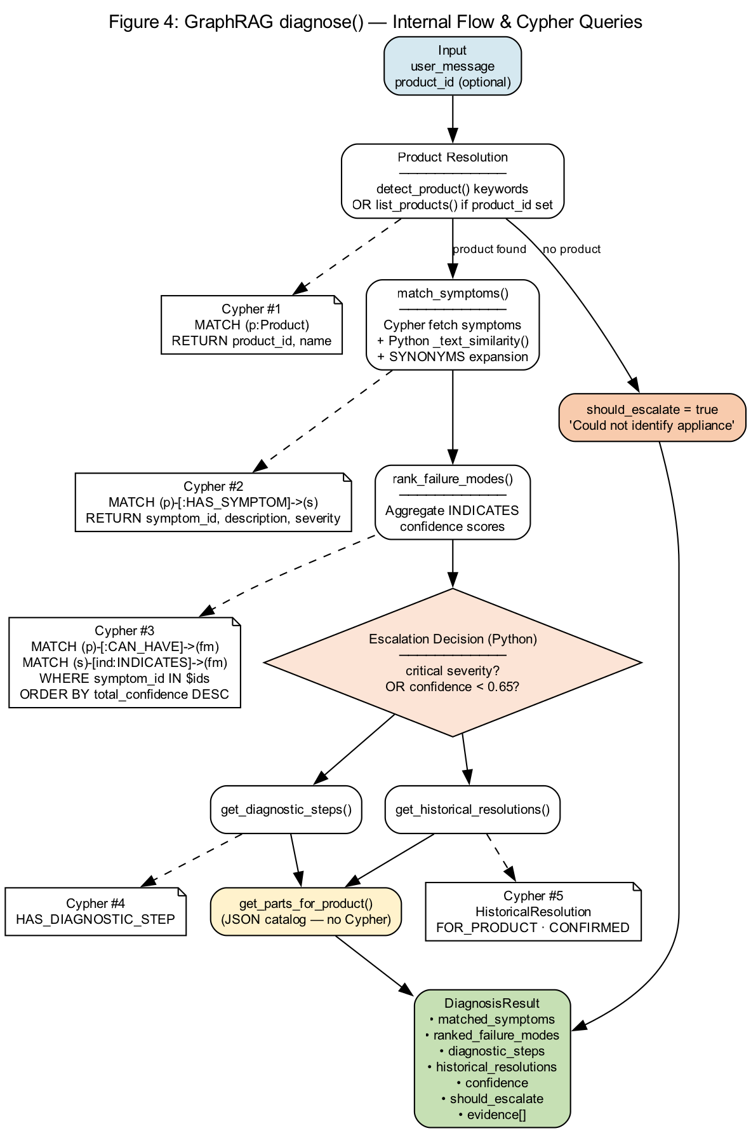
Figure 4: GraphRAG diagnose() Flow

Graphviz Source: 04-graphrag-diagnosis.dot
// Figure 4: GraphRAG diagnose() internal flow (graph/graph_rag.py)
digraph GraphRAGDiagnosis {
graph [
rankdir=TB
label="Figure 4: GraphRAG diagnose() — Internal Flow & Cypher Queries"
labelloc=t
fontsize=14
fontname="Arial"
bgcolor="white"
]
node [fontname="Arial", fontsize=10]
edge [fontname="Arial", fontsize=9]
Input [label="Input\nuser_message\nproduct_id (optional)", shape=box, style="rounded,filled", fillcolor="#D5E8F0"]
P1 [label="Product Resolution\n────────────\ndetect_product() keywords\nOR list_products() if product_id set", shape=box, style="rounded,filled", fillcolor="#FFFFFF"]
C1 [label="Cypher #1\nMATCH (p:Product)\nRETURN product_id, name", shape=note, fillcolor="#E2EFDA"]
P2 [label="match_symptoms()\n────────────\nCypher fetch symptoms\n+ Python _text_similarity()\n+ SYNONYMS expansion", shape=box, style="rounded,filled", fillcolor="#FFFFFF"]
C2 [label="Cypher #2\nMATCH (p)-[:HAS_SYMPTOM]->(s)\nRETURN symptom_id, description, severity", shape=note, fillcolor="#E2EFDA"]
P3 [label="rank_failure_modes()\n────────────\nAggregate INDICATES\nconfidence scores", shape=box, style="rounded,filled", fillcolor="#FFFFFF"]
C3 [
// ... (see docs/graphviz/04-graphrag-diagnosis.dot)

Figure 5: Neo4j Ontology & wm-001 Instance
Knowledge graph schema (node labels, relationship types, unique constraints from populate_graph.py) plus concrete wm-001 instance with INDICATES confidence weights from data/synthetic_diagnosis_data.json.
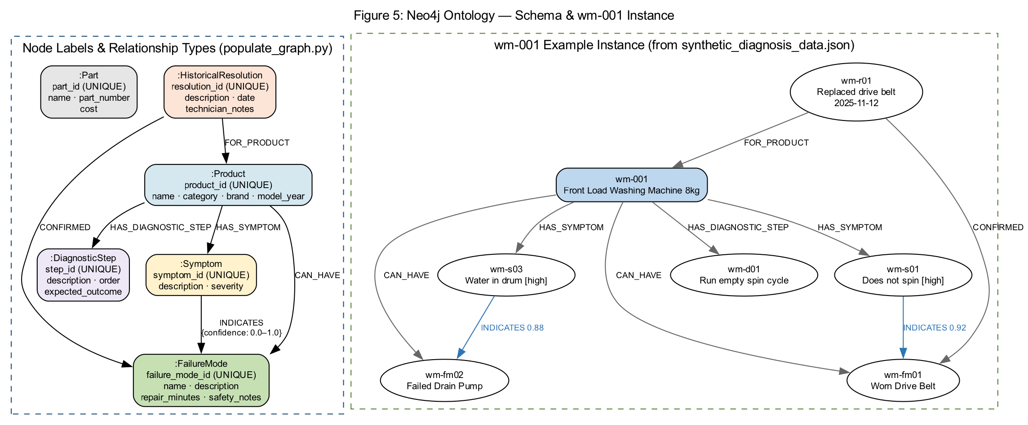
Figure 5: Neo4j Ontology & wm-001 Instance

Graphviz Source: 05-neo4j-ontology.dot
// Figure 5: Neo4j Knowledge Graph Ontology (schema + wm-001 instance)
digraph Neo4jOntology {
graph [
rankdir=TB
label="Figure 5: Neo4j Ontology — Schema & wm-001 Instance"
labelloc=t
fontsize=14
fontname="Arial"
bgcolor="white"
splines=true
]
node [fontname="Arial", fontsize=10]
edge [fontname="Arial", fontsize=9]
subgraph cluster_schema {
label="Node Labels & Relationship Types (populate_graph.py)"
style=dashed
color="#1F4E79"
Product [label=":Product\nproduct_id (UNIQUE)\nname · category · brand · model_year", shape=box, style="rounded,filled", fillcolor="#D5E8F0"]
Symptom [label=":Symptom\nsymptom_id (UNIQUE)\ndescription · severity", shape=box, style="rounded,filled", fillcolor="#FFF2CC"]
FailureMode [label=":FailureMode\nfailure_mode_id (UNIQUE)\nname · description\nrepair_minutes · safety_notes", shape=box, style="rounded,filled", fillcolor="#C6E0B4"]
DiagStep [label=":DiagnosticStep\nstep_id (UNIQUE)\ndescription · order\nexpected_outcome", shape=box, style="rounded,filled", fillcolor="#EDE7F6"]
Part [label=":Part\npart_id (UNIQUE)\nname · part_number\ncost", shape=box, style="rounded,filled", fillcolo
// ... (see docs/graphviz/05-neo4j-ontology.dot)

Figure 6: Enterprise ETL Pipeline
Extract-Transform-Load flow from graph/enterprise_pipeline/pipeline.py: four connectors → OntologyBuilder → validated JSON → populate_graph.py → Neo4j.
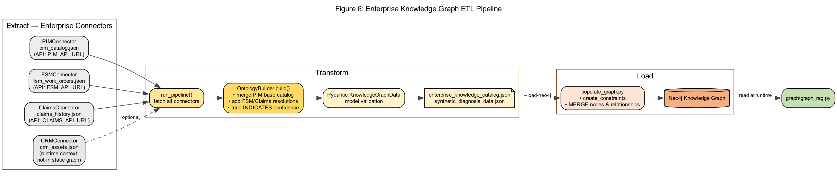
Figure 6: Enterprise ETL Pipeline

Graphviz Source: 06-etl-pipeline.dot
// Figure 6: Enterprise ETL Pipeline (graph/enterprise_pipeline/pipeline.py)
digraph ETLPipeline {
graph [
rankdir=LR
label="Figure 6: Enterprise Knowledge Graph ETL Pipeline"
labelloc=t
fontsize=14
fontname="Arial"
bgcolor="white"
]
node [shape=box, style="rounded,filled", fontname="Arial", fontsize=10]
edge [fontname="Arial", fontsize=9, color="#444444"]
subgraph cluster_sources {
label="Extract — Enterprise Connectors"
color="#666666"
PIM [label="PIMConnector\npim_catalog.json\n(API: PIM_API_URL)", fillcolor="#EDEDED"]
FSM [label="FSMConnector\nfsm_work_orders.json\n(API: FSM_API_URL)", fillcolor="#EDEDED"]
Claims [label="ClaimsConnector\nclaims_history.json\n(API: CLAIMS_API_URL)", fillcolor="#EDEDED"]
CRM [label="CRMConnector\ncrm_assets.json\n(runtime context;\nnot in static graph)", fillcolor="#E8E8E8"]
}
subgraph cluster_transform {
label="Transform"
color="#BF8F00"
Fetch [label="run_pipeline()\nfetch all connectors", fillcolor="#FFE699"]
Build [label="OntologyBuilder.build()\n• merge PIM base catalog\n• add FSM/Claims resolutions\n• tune INDICATES confidence", fillcolor="#FFD966"]
Validate
// ... (see docs/graphviz/06-etl-pipeline.dot)

Figure 7: Escalation Decision Logic
Decision diamond flow from graph/graph_rag.py: escalate if product unknown, any critical symptom, or confidence below 0.65 (config/settings.py). Escalated cases saved via utils/escalation_store.py to Human Agent Dashboard.
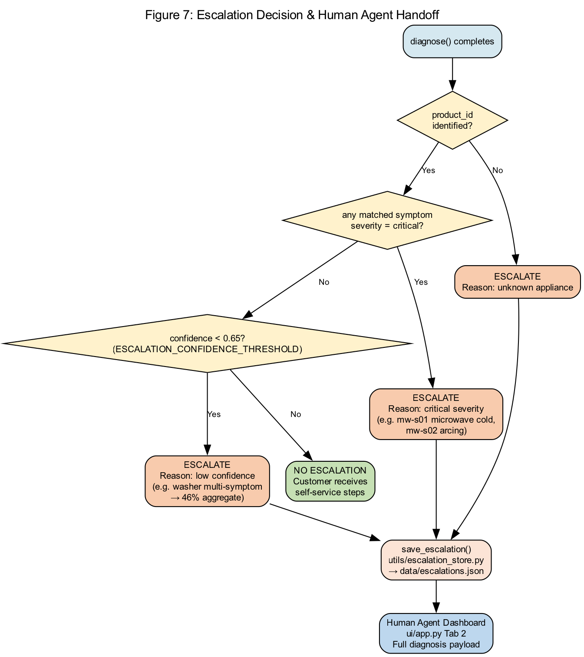
Figure 7: Escalation Decision Logic

Graphviz Source: 07-escalation-decision.dot
// Figure 7: Escalation Decision Logic (graph/graph_rag.py + escalation_store.py)
digraph EscalationDecision {
graph [
rankdir=TB
label="Figure 7: Escalation Decision & Human Agent Handoff"
labelloc=t
fontsize=14
fontname="Arial"
bgcolor="white"
]
node [fontname="Arial", fontsize=10]
edge [fontname="Arial", fontsize=9]
Start [label="diagnose() completes", shape=box, style="rounded,filled", fillcolor="#D5E8F0"]
Q1 [label="product_id\nidentified?", shape=diamond, style=filled, fillcolor="#FFF2CC"]
Q2 [label="any matched symptom\nseverity = critical?", shape=diamond, style=filled, fillcolor="#FFF2CC"]
Q3 [label="confidence < 0.65?\n(ESCALATION_CONFIDENCE_THRESHOLD)", shape=diamond, style=filled, fillcolor="#FFF2CC"]
Esc1 [label="ESCALATE\nReason: unknown appliance", shape=box, style="rounded,filled", fillcolor="#F8CBAD"]
Esc2 [label="ESCALATE\nReason: critical severity\n(e.g. mw-s01 microwave cold,\nmw-s02 arcing)", shape=box, style="rounded,filled", fillcolor="#F8CBAD"]
Esc3 [label="ESCALATE\nReason: low confidence\n(e.g. washer multi-symptom\n→ 46% aggregate)", shape=box, style="rounded,filled", fillcolor="#F8CBAD"]
Resolve [label="
// ... (see docs/graphviz/07-escalation-decision.dot)

Figure 8: Runtime Request Sequence
Thirteen-step runtime sequence from customer chat message through Streamlit, LangGraph, tools, GraphRAG, Neo4j, optional escalation, and agent dashboard review.
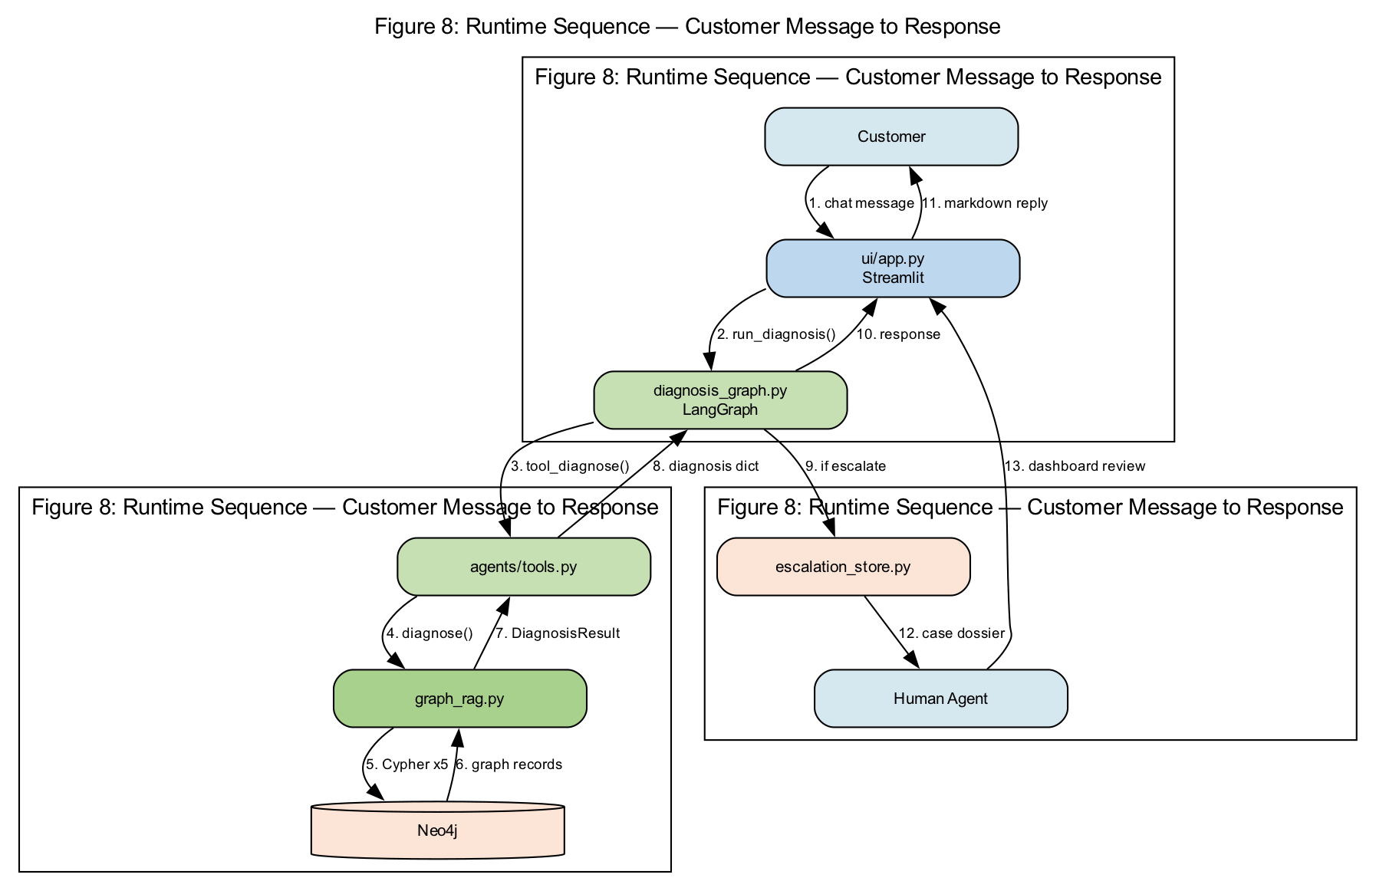
Figure 8: Runtime Request Sequence

Graphviz Source: 08-runtime-sequence.dot
// Figure 8: Runtime Request Sequence (customer message → response)
digraph RuntimeSequence {
graph [
rankdir=TB
label="Figure 8: Runtime Sequence — Customer Message to Response"
labelloc=t
fontsize=14
fontname="Arial"
bgcolor="white"
nodesep=0.4
]
node [shape=box, style="rounded,filled", fontname="Arial", fontsize=10, width=2.2]
edge [fontname="Arial", fontsize=9]
subgraph cluster_row1 {
rank=same
C [label="Customer", fillcolor="#D5E8F0"]
UI [label="ui/app.py\nStreamlit", fillcolor="#BDD7EE"]
LG [label="diagnosis_graph.py\nLangGraph", fillcolor="#C6E0B4"]
}
subgraph cluster_row2 {
rank=same
Tools [label="agents/tools.py", fillcolor="#C6E0B4"]
GR [label="graph_rag.py", fillcolor="#A9D18E"]
Neo [label="Neo4j", shape=cylinder, fillcolor="#FCE4D6"]
}
subgraph cluster_row3 {
rank=same
Esc [label="escalation_store.py", fillcolor="#FCE4D6"]
Agent [label="Human Agent", fillcolor="#D5E8F0"]
}
C -> UI [label="1. chat message"]
UI -> LG [label="2. run_diagnosis()"]
LG -> Tools [label="3. tool_diagnose()"]
Tools -> GR [label="4. diagnose()"]
GR -> Neo [label="5. Cypher x5"]
Neo -> GR [l
// ... (see docs/graphviz/08-runtime-sequence.dot)

Figure 9: Enterprise Production Target
Target-state architecture from implementation roadmap: scheduled ETL with provenance, staging/production Neo4j promotion, FastAPI runtime, CRM enrichment, and CCaaS case handoff. Not fully implemented in demo.
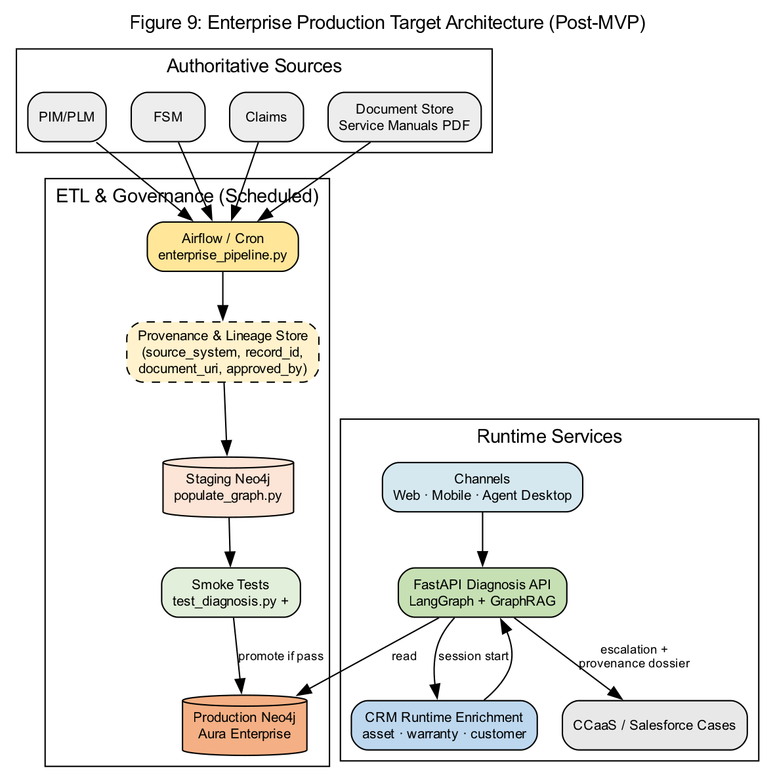
Figure 9: Enterprise Production Target

Graphviz Source: 09-enterprise-production.dot
// Figure 9: Enterprise Production Target Architecture (roadmap)
digraph EnterpriseProduction {
graph [
rankdir=TB
label="Figure 9: Enterprise Production Target Architecture (Post-MVP)"
labelloc=t
fontsize=14
fontname="Arial"
bgcolor="white"
]
node [shape=box, style="rounded,filled", fontname="Arial", fontsize=10]
edge [fontname="Arial", fontsize=9]
subgraph cluster_sources {
label="Authoritative Sources"
PIM [label="PIM/PLM", fillcolor="#EDEDED"]
FSM [label="FSM", fillcolor="#EDEDED"]
Claims [label="Claims", fillcolor="#EDEDED"]
Manuals [label="Document Store\nService Manuals PDF", fillcolor="#EDEDED"]
}
subgraph cluster_etl_ops {
label="ETL & Governance (Scheduled)"
Airflow [label="Airflow / Cron\nenterprise_pipeline.py", fillcolor="#FFE699"]
Prov [label="Provenance & Lineage Store\n(source_system, record_id,\ndocument_uri, approved_by)", fillcolor="#FFF2CC", style="rounded,dashed,filled"]
Staging [label="Staging Neo4j\npopulate_graph.py", shape=cylinder, fillcolor="#FCE4D6"]
Smoke [label="Smoke Tests\ntest_diagnosis.py +", fillcolor="#E2EFDA"]
ProdNeo [label="Production Neo4j\nAura Enterprise", s
// ... (see docs/graphviz/09-enterprise-production.dot)

2. Graphviz DOT File Reference
- 01-system-context.dot → rendered/png/01-system-context.png + rendered/svg/
- 02-module-block.dot → rendered/png/02-module-block.png + rendered/svg/
- 03-langgraph-workflow.dot → rendered/png/03-langgraph-workflow.png + rendered/svg/
- 04-graphrag-diagnosis.dot → rendered/png/04-graphrag-diagnosis.png + rendered/svg/
- 05-neo4j-ontology.dot → rendered/png/05-neo4j-ontology.png + rendered/svg/
- 06-etl-pipeline.dot → rendered/png/06-etl-pipeline.png + rendered/svg/
- 07-escalation-decision.dot → rendered/png/07-escalation-decision.png + rendered/svg/
- 08-runtime-sequence.dot → rendered/png/08-runtime-sequence.png + rendered/svg/
- 09-enterprise-production.dot → rendered/png/09-enterprise-production.png + rendered/svg/

3. Module-to-Diagram Mapping
- 01-system-context: Full platform + enterprise boundary
- 02-module-block: All packages under config/, graph/, agents/, ui/, utils/, data/
- 03-langgraph-workflow: agents/diagnosis_graph.py — build_diagnosis_graph()
- 04-graphrag-diagnosis: graph/graph_rag.py — diagnose(), list_products(), match_symptoms(), rank_failure_modes()
- 05-neo4j-ontology: graph/populate_graph.py + data/synthetic_diagnosis_data.json
- 06-etl-pipeline: graph/enterprise_pipeline/pipeline.py + transformers/ontology_builder.py
- 07-escalation-decision: graph/graph_rag.py lines 239–245 + utils/escalation_store.py
- 08-runtime-sequence: ui/app.py → run_diagnosis() end-to-end
- 09-enterprise-production: Target architecture per docs/05-Enterprise-Implementation-Roadmap

