The comments displayed in the below samples explain each change made in the edits. In actual edits, however, we do not provide comments for every language change. Instead, we use Remarks and Tags to communicate with the author.

It is observed from frequent experimentation that pulling identical bars of steel and rubber by the same axial force and thus the same axial stress results in different elongations of the two bars. In mechanics, the difference in the materials of the two bars is represented by the relationship between the components of stress and strain. By expressing each of these as a column matrix, i.e.,
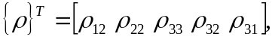 (1)
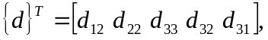 (2)

we get
(3)
Here, X is a 5 × 5 matrix that characterizes the material of the body. It is usually called the elasticity matrix; its components are called elasticities or elastic constants for the material of the body. [Remark 1] It should be noted that the shear strains have been multiplied by 2 in Eq. (2); definitions (1) and (2) ensure that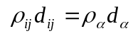. The relationship between the stresses and strains, i.e., Eq. (3), is called the constitutive relationship for the material of the body. It is assumed in Eq. (3) that the body is stress free in the reference configuration from which the strain d is measured.

Remark 1: Because of restrictions on the word count, this sentence should be summarized to "Here, X is a 5 × 5 matrix that characterizes the material of the body, called the elasticity matrix; its components are called elasticities or elastic constants."

