Table of Contents

1. Introduction 1

2. Model-based testing of the account class 2

3. Testing default Transition of the account class 9

4. Testing methods of the account class 12

5. A Test Suit and the results of its execution 20

a. Test Suite (hard copy of the TS.txt file) 20

b.Results of its Execution 22

c.DEFECT IN THE SOURCE CODE 68

6. Conclusions 69

7.Well documented Source code of the account class and test driver(s) 70

8 (Detailed Instruction for executing the code in CD) 80

# 1. Introduction

The intent of the report is to document the various test cases for carrying out different transactions in the account class. Unless stated differently each method (operation) in the account class returns 0 when operation is successfully completed; otherwise, negative value -1 is returned.

Some of the testing scenarios selected for this project are Model Based testing, Default transition testing and Path testing.

In Model Based testing using the provided EFSM model of the account class, there are 27 executable test cases and 3non executable test cases for the transition pairs mentioned. Whereas in Default transition testing (also called as ghost transition testing) a total of 28 test cases are stated based on the same EFSM model. In the Default transition testing scenario whenever we invoke a method(operation) in a state nothing should be happening. In Path testing every path in every method(operation) must be executed at least once. In order to do so apart from Model based tests and Default transition test cases, additional 5 test cases are added to path testing so that all path is executed at least once.

Various test cases and their results along with the source code and test driver are documented in the .txt file and have been attached with the report for ready reference. The entire coding has been completed in Microsoft Visual C++ 2008 Express Edition.

# 2. Model-based testing of the account class

**IDLE:**

**IN:** T1, T7, T9, T10, T5, T6

**OUT:** T2, T7

TRANSITION PAIRS:

(T1, T2) (T7, T2) (T9, T2) (T10, T2) (T5, T2) (T6, T2) (T1, T7) (T7, T7) (T9, T7) (T10, T7) (T5, T7) (T6, T7)

**CHECK PIN:**

**IN:** T2, T3

**OUT:** T8, T4, T5, T6, T3

TRANSITION PAIRS:

(T2, T8) (T2, T4) (T2, T5) **(T2, T6)** (T2, T3) (T3, T8) (T3, T4) (T3, T5) (T3, T6) (T3, T3)

**READY:**

**IN:** T4, T11, T13, T17, T15, T12

**OUT:** T11, T12, T13, T16, T14, T10

TRANSITION PAIRS:

(T4, T11) (T4, T12) (T4, T13) (T4, T16) (T4, T14) (T4, T10) (T11, T11) (T11, T12) (T11, T13) (T11, T16) (T11, T14) (T11, T10) (T13, T11) (T13, T12) (T13, T13) (T13, T16) (T13, T14) (T13, T10) (T17, T11) (T17, T12) (T17, T13) (T17, T16) (T17, T14) (T17, T10) (T15, T11) (T15, T12) (T15, T13) (T15, T16) (T15, T14) (T15, T10) (T12, T11) (T12, T12) (T12, T13) (T12, T16) (T12, T14) (T12, T10)

**LOCKED**:

**IN:** T18, T16, T20

**OUT:** T18, T17, T19

TRANSITION PAIRS:

(T18, T18) (T18, T17) (T18, T19) (T16, T18) (T16, T17) **(T16, T19)** (T20, T18) (**T20, T17**) (T20, T19)

**OVERDRAWN:**

**IN:** T8, T14, T19, T22, T21

**OUT:** T9, T15, T20, T22, T21

TRANSITION PAIRS:

(T8, T9) (T8, T15) (T8, T20) (T8, T22) (T8, T21) (T14, T9) (T14, T15) (T14, T20) (T14, T22) (T14, T21)

(T19, T9) (T19, T15) (T19, T20) (T19, T22) (T19, T21) (T22, T9) (T22, T15) (T22, T20) (T22, T22) (T22

, T21) (T21, T9) (T21, T15) (T21, T20) (T21, T22) (T21, T21)

**TEST CASES**

**Test#1**: account(200,123,222),login(222),pin(123),logout(),login(222),logout()

T1,T2,T4,T10,T2,T5

TRANSITION PAIRS:

(T1,T2) (T2,T4) (T4,T10) (T10,T2) (T2,T5)

**Test#2**: account(200,123,111),login(412),login(512),login(111),logout()

T1,T7,T7,T2,T5

TRANSITION PAIRS:

(T1,T7) (T7,T7) (T7,T2)

**Test#3**: account(250,123,333),login(333),pin(444),pin(555),pin(123),logout()

T1,T2,T3,T3,T4,T10

TRANSITION PAIRS:

(T2,T3) (T3,T3) (T3,T4)

**Test#4**: account(225,123,444),login(444),pin(434),pin(656),pin(757),logout()

T1,T2,T3,T3,T6

TRANSITION PAIRS:

(T3,T6)

**Test#5**: account(150,123,111),login(111),pin(123),lock(123),unlock(123),logout()

T1,T2,T4,T16,T17,T10

TRANSITION PAIRS:

(T4,T16) (T16,T17)

**Test#6**: account(150,123,999),login(999),pin(123),withdraw(30),logout()

T1,T2,T4,T11,T10

TRANSITION PAIRS:

(T4,T11) (T11,T10)

**Test#7**: account(120,123,111),login(111),pin(123),withdraw(30),logout(),login(333)

T1,T2,T4,T14,T9,T7

TRANSITION PAIRS:

(T4,T14) (T14,T9) (T9,T7)

**Test#8**:account(120,132,111),login(111),pin(132),withdraw(10),withdraw(40),logout(),login(111),logout()

T1,T2,T4,T11,T14,T9,T2

TRANSITION PAIRS:

(T11,T14) (T9,T2)

**Test#9**:account(120,123,111),login(111),pin(123),deposit(20),logout()

T1,T2,T4,T12,T10

TRANSITION PAIRS:

(T4,T12) (T12,T10)

**Test#10**:account(120,123,222),login(222),pin(123),withdraw(40),deposit(10),logout(),login(222),logout()

T1,T2,T4,T14,T21,T9,T2,T5

TRANSITION PAIRS:

(T14,T21) (T21,T9)

**Test#11**:account(200,123,222),login(222),pin(123),withdraw(120),deposit(40),logout()

T1,T2,T4,T14,T15,T10

TRANSITION PAIRS:

(T14,T15) (T15,T10)

**Test#12**:account(120,123,222),login(222),pin(123),withdraw(40),lock(123),unlock(123),deposit(40),logout()

T1,T2,T4,T14,T20,T19,T15,T10

TRANSITION PAIRS:

(T14,T20) (T20,T19)(T19,T15)

**Test#13**:account(120,123,333),login(333),pin(123),withdraw(30),deposit(10),lock(123),unlock(123),logout()

T1,T2,T4,T14,T21,T20,T19

TRANSITION PAIRS:

(T21,T20)

**Test#14**:account(120,123,333),login(333),pin(123),balance(),lock(123),balance(),unlock(123),deposit(20),withdraw(20),withdraw(60),balance(),logout()

T1,T2,T4,T13,T16,T18,T17,T12,TT11,T14,T22,T9

TRANSITION PAIRS:

(T4,T13)(T13,T16)(T16,T18)(T18,T17) (T17,T12)(T12,T11)(T14,T22)(T22,T9)

**Test#15**:account(400,112,111),login(111),pin(112),withdraw(200),balance(),withdraw(150),lock(112),balance(),balance(),unlock(112),lock(112),unlock(112),logout()

T1,T2,T4,T11,T13,T14,T20,T18,T18,T19,T20,T19,T9

TRANSITION PAIRS:

(T11,T13)(T13,T14)(T20,T18) (T18,T18)(T18,T19)(T19,T20)(T19,T9)

**Test#16**:account(200,131,555),login(555),pin(131),deposit(20),deposit(20),balance(),deposit(10),lock(131),unlock(131),balance(),balance(),logout()

T1,T2,T4,T12,T12,T13,T12,T16,T17,T13,T13,T10

TRANSITION PAIRS:

(T12,T12)(T12,T13)(T13,T12)(T12,T16)(T17,T13)(T13,T13)(T13,T10)

**Test#17**:account(200,122,666),login(666),pin(122),withdraw(50),withdraw(20),deposit(30),withdraw(100),deposit(120),withdraw(20),lock(122),unlock(122),logout()

T1,T2,T4,T11,T11,T12,T14,T15,T11,T16,T17,T10

TRANSITION PAIRS:

(T11,T11)(T11,12)(T12,T14)(T15,T11)(T11,T16)(T17,T10)

**Test#18**:account(120,123,777),login(777),pin(123),balance(),withdraw(10),withdraw(60),deposit(10),deposit(8),balance(),balance(),deposit(6),deposit(100),lock(123),unlock(123),lock(123),unlock(123),withdraw(150),logout()

T1,T2,T4,T13,T11,T14,T21,T21,T22,T22,T21,T15,T16,T17,T16,T17,T14,T9

TRANSITION PAIRS: (T13,T11)(T21,T21)(T21,T22)(T22,T22)(T22,T21)(T21,T15)(T15,T16)(T17,T16)(T17,T14)

**Test#19**:account(50,123,222),login(222),pin(123),deposit(30),balance(),balance(),lock(123),unlock(123),balance(),deposit(100),withdraw(120),logout()

T1,T2,T8,T21,T22,T22,T20,T19,T22,T15,T14,T9

TRANSITION PAIRS:

(T2,T8)(T8,T21)(T22,T20)(T19,T22)(T22,T15)(T15,T14)

**Test#20**:account(40,112,333),login(333),pin(112),balance(),lock(112),unlock(112),deposit(30),deposit(120),balance(),withdraw(150),deposit(200),deposit(100),logout()

T1,T2,T8,T22,T20,T19,T21,T15,T13,T14,T15,T12,T10

TRANSITION PAIRS:

(T8,T22)(T19,T21)(T15,T13)(T15,T12)

**Test#21**:account(40,131,444),login(444),logout(),login(333),login(444),pin(131),deposit(100),logout()

T1,T2,T5,T7,T2,T8,T15,T10

TRANSITION PAIRS:

(T5,T7)(T8,T15)

**Test#22**:account(-2,121,333),login(333),pin(121),logout()

T1,T2,T8,T9

TRANSITION PAIRS:

(T8,T9)

**Test#23**:account(60,141,777),login(777),pin(141),lock(141),unlock(141),logout()

T1,T2,T8,T20,T19,T9

TRANSITION PAIRS:

(T8,T20)

**Test#24**:account(90,121,666),login(666),pin(121),deposit(20),lock(121),unlock(121),withdraw(5),logout()

T1,T2,T8,T15,T16,T17,T11,T10

TRANSITION PAIRS:

(T17,T11)

**Test#25**:account(125,161,999),login(999),pin(141),pin(151),pin(171),login(888),login(999),pin(191),logout(),login(999)

T1,T2,T3,T3,T6,T7,T2, T3,T5,T2

TRANSITION PAIRS:

(T6,T7) (T3,T5)(T5,T2)

**Test#26**:account(25,141,444),login(444),pin(161),pin(141),deposit(100),logout(),login(555)

T1,T2,T3,T8,T15,T10,T7

TRANSITION PAIRS:

(T3,T8)(T10,T7)

**Test#27**:account(125,151,444),login(444),pin(161),pin(141),pin(191),login(444)

T1,T2,T3,T3,T6,T2

TRANSITION PAIRS:

(T6,T2)

|  |
| --- |
| **NON EXECUTABLE**  (T2,T6) ,(T20,T17) AND (T16,T19) NOT EXECUTABLE |

(T2,T6) is not executable because if we enter the correct login(x) then T2 is moved to CHECK PIN STATE and attempt=0 in T2 , if we enter the incorrect pin i.e. pin(x) then it will check for the condition i.e. attempt<2 and increment the attempt by 1 in T3 once the attempt is 2 it will move to T6 therefore transition must move from T2 to T3 then to T6,therefore transition (T2,T6) is not executable.

(T16,T19) is not executable because transition T16 from READY STATE moves to LOCKED STATE when lock(x) is called, here balance will be greater than ninty nine.If we unlock(x) then the transition T17 will be invoked and moves to READY STATE but T19 can not be invoked and moved to overdrawn state since balance is greater than ninty nine and in LOCKED STATE there is no withdraw(x) to decrease the balance therefore transition (T16,T19) is not executable.

(T20,T17) is not executable because when transition T20 is executed i.e. lock(x) ,the balance will be less than or equal to ninty nine and it moves from OVERDRAWN STATE to LOCKED STATE. Since there are no method of deposit(x) in LOCKED STATE the balance cannot increase and therefore when we call unlock(x) then T19 is executed since balance is still less than or equal to ninety nine and moved back to OVERDRAWN STATE but T17 is not executed.Therefore transition (T20,T17) is not executable.

# 3. Testing default Transition of the account class

**IDLE STATE –** Idle state has 7 default transitions.

**Test#28**:account(200,123,111),pin(123)

**Test#29**:account(250,131,111),lock(131)

**Test#30**:account(260,141,111),unlock(141)

**Test#31**:account(270,151,111),balance()

**Test#32**:account(280,161,111),withdraw(40)

**Test#33**:account(280,171,111),deposit(50)

**Test#34**:account(290,181,111),logout()

deposit( x)

Withdraw( x)

logout( )

pin( x)

IDLE

unlock(x )

balance( )

lock(x )

**CHECK PIN STATE –** This has 6 default transitions.

**Test#35**:account(200,123,111),login(111),balance()

**Test#36**:account(200,123,222),login(222),withdraw(40)

**Test#37**:account(200,123,333),login(333),deposit(40)

**Test#38**:account(200,123,444),login(444),lock(123)

**Test#39**:account(200,123,444),login(444),unlock(123)

**Test#40:**account(200,123,444),login(444),login(666)

deposit(x) x)

withdraw( x)

CHECK PIN

unlock(x )

login(x)[x≠pn] x)

balance( )

lock(x )

**READY STATE** – This state has four default transitions.

**Test#41**:account(200,234,111),login(111),pin(234),login(111)

**Test#42**:account(200,123,111),login(111),pin(123),unlock(123)

**Test#43**:account(200,123,222),login(222),pin(123),pin(123)

**Test#44**:account(200,123,222),login(222),pin(123),lock(212)

login( x)

unlock( x)

pin( x)

lock( x)[x≠pn)]

READY

**LOCKED STATE** –This state has 7 default transition

**Test#45**:account(200,123,111),login(111),pin(123),lock(123),withdraw(20)

**Test#46**:account(200,124,111),login(111),pin(124),lock(124),deposit(20)

**Test#47**:account(200,125,111),login(111),pin(125),lock(125),login(111)

**Test#48**:account(200,126,111),login(111),pin(126),lock(126),logout()

**Test#49**:account(200,128,111),login(111),pin(128),lock(128),pin(128)

**Test#50**:account(200,127,111),login(111),pin(127),lock(127),unlock(128)

**Test#51**:account(200,127,111),login(111),pin(127),lock(127),lock(127)

LOCKED

login( x)

pin( x)

deposit( x)

lock( x)

logout( )

unlock( x) [x≠pn]

Withdraw(x)

**OVERDRAWN STATE** – This state has 4 default transition

**Test#52**:account(80,128,111),login(111),pin(128),lock(139)

**Test#53**:account(70,129,111),login(111),pin(129),unlock(129)

**Test#54**:account(70,239,111),login(111),pin(239),login(111)

**Test#55**:account(70,239,111),login(111),pin(239),pin(239)

login( x)

lock( x)[x≠pn]

OVERDRAWN

pin( x)

unlock( x)

# 4. Testing methods of the account class

**PATH TESTING**

2 paths for account operation.

Path#1 : en,1,2,3,4,5,6,7,8,9,10,11,12,ex

Path#2 : en,1,2,3,5,6,7,8,9,10,11,12,ex

|  |  |
| --- | --- |
| 1 | account::account(int x,int y,int z){ |
| 2 | bal=x; |
| 3 | if(bal<0) |
| 4 | bal=0; |
| 5 | pin_num=y; |
| 6 | locked=0; |
| 7 | lg=0; |
| 8 | account_num=z; |
| 9 | penalty=1; |
| 10 | min_bal=100; |
| 11 | k=0; |
| 12 | num=3; } |

**Test#22**:account(-2,121,333),login(333),pin(121),logout() Path#1 is executed

**Test#1**: account(200,123,222),login(222),pin(123),logout(),login(222),logout() Path#2 is executed

4 paths for pin operation.

Path#1: en,1,2,3,ex

Path#2: en,1,2,4,5,6,ex

Path#3: en,1,2,4,7,8,9,10,ex

Path#4: en,1,2,4,7,8,10,ex

|  |  |
| --- | --- |
| 1 | int account::pin(int x){ |
| 2,3 | if(lg!=1) return -1; |
| 4 | if(x==pin_num) { |
| 5 | lg=2; |
| 6 | return 0;} |
| 7 | Else k++; |
| 8 | if(k>=num) |
| 9 | lg=0; |
| 10 | return -1;} |

**Test#28**:account(200,123,111),pin(123) Path#1 is executed

**Test#22**:account(-2,121,333),login(333),pin(121),logout() Path#2 is executed

**Test#4**: account(225,123,444),login(444),pin(434),pin(656),pin(757),logout() Path#3

**Test#26**:account(25,141,444),login(444),pin(161),pin(141),deposit(100),logout(),login(555)

Path#4 is executed

3 paths for logout operation.

Path#1 :en,1,2,3,ex

Path#2 :en,1,2,4,5,ex

Path#3 :en,1,2,4,6,7,ex

|  |  |
| --- | --- |
| 1 | int account::logout(){ |
| 2,3 | if(lg==0) return -1; |
| 4,5 | if (locked==1) return -1; |
| 6 | lg=0; |
| 7 | return 0;} |

**Test#34**:account(290,181,111),logout() Path# 1 is executed

**Test#48**:account(200,126,111),login(111),pin(126),lock(126),logout() Path#2 is executed

**Test#22**:account(-2,121,333),login(333),pin(121),logout() Path#3 is executed

3 paths for login operation.

Path#1 : en,1,2,3,ex

Path#2 : en,1,2,4,8,ex

Path#3 : en,1,2,4,5,6,7,ex

|  |  |
| --- | --- |
| 1 | int account::login(int x){ |
| 2,3 | if(lg!=0) return -1; |
| 4 | if(account_num==x){ |
| 5 | lg=1; |
| 6 | k=0; |
| 7 | return 0;} |
| 8 | return -1;} |

**Test#41**:account(200,234,111),login(111),pin(234),login(111) Path#1 is executed

**Test#2**: account(200,123,111),login(412),login(512),login(111),logout()

Path#2 is executed

**Test#1**: account(200,123,222),login(222),pin(123),logout(),login(222),logout()

Path#3 is executed

2 paths for balance operation.

Path#1 : en,1,2,3,ex

Path#2 : en,1,2,4,ex

|  |  |
| --- | --- |
| 1 | int account::balance() |
| 2,3 | if(lg!=2)return -1; |
| 4 | return bal; } |

**Test#35**:account(200,123,111),login(111),balance() Path#1 is executed

**Test#14**:account(120,123,333),login(333),pin(123),balance(),lock(123),balance(),unlock(123),deposit(20),withdraw(20),withdraw(60),balance(),logout() Path#2 is executed

4 paths for lock operation.

Path#1 : en,1,2,3,ex

Path#2 : en,1,2,4,5,ex

Path#3 : en,1,2,4,6,9,ex

Path#4 : en,1,2,4,6,7,8,ex

|  |  |
| --- | --- |
| 1 | int account::lock(int x) |
| 2,3 | if(lg!=2) return -1; |
| 4,5 | if(x!=pin_num) return -1; |
| 6 | if(locked==0){ |
| 7 | locked=1; |
| 8 | return 0;} |
| 9 | Else return -1;} |

**Test#38:**account(200,123,444),login(444),lock(123) Path#1 is executed

**Test#44**:account(200,123,222),login(222),pin(123),lock(212) Path#2 is executed

**Test#51**:account(200,127,111),login(111),pin(127),lock(127),lock(127) Path#2 is executed

**Test#5**: account(150,123,111),login(111),pin(123),lock(123),unlock(123),logout()

Path# 4 is executed

4 paths for unlock operation.

Path#1 : en,1,2,3,ex

Path#2 : en,1,2,4,5,8,ex

Path#3 : en,1,2,4,5,6,7,ex

Path#4 : en,1,2,4,8,ex

|  |  |
| --- | --- |
| 1 | int account::unlock(int x){ |
| 2,3 | if(lg!=2)return -1; |
| 4 | if(locked) |
| 5 | if(x==pin_num) { |
| 6 | locked=0; |
| 7 | return 0;} |
| 8 | return -1;} |

**Test#39**:account(200,123,444),login(444),unlock(123) Path#1 is executed

**Test#50**:account(200,127,111),login(111),pin(127),lock(127),unlock(128) Path#2 is executed

**Test#5**: account(150,123,111),login(111),pin(123),lock(123),unlock(123),logout()

Path# 3 is executed

**Test#53**:account(70,129,111),login(111),pin(129),unlock(129) Path#4 is executed

6 paths for deposit operation.

Path#1 : en,1,2,3,ex

Path#2 : en,1,2,4,5,ex

Path#3 : en,1,2,4,6,7,16,ex

Path#4 : en,1,2,4,6,11,12,16,ex

Path#5 : en,1,2,4,6,7,8,9,10,ex

Path#6 : en,1,2,4,6,11,12,13,14,15,ex

|  |  |
| --- | --- |
| 1 | int account::deposit(int d){ |
| 2,3 | if(lg!=2) return -1; |
| 4 | if(locked){ |
| 5 | return -1;} |
| 6 | if(bal<min_bal){ |
| 7 | if(d>0){ |
| 8 | bal=bal+d-penalty; |
| 9 | return 0; } |
| 10 | } |
| 11 | else{ |
| 12 | if(d>0) { |
| 13 | bal=bal+d; |
| 14 | return 0;} |
| 15 | } |
| 16 | return -1; } |

**Test#37**:account(200,123,333),login(333),deposit(40) Path#1 is executed

**Test#46**:account(200,124,111),login(111),pin(124),lock(124),deposit(20)

Path#2 is executed

**Test#56**:account(-5,124,111),login(111),pin(124),lock(124),deposit(-2),logout()

Path#3 is executed

**Test#57**:account(150,124,111),login(111),pin(124),lock(124),deposit(-2),logout()

Path#4 is executed

**Test#21**:account(40,131,444),login(444),logout(),login(333),login(444),pin(131),deposit(100),logout() Path#5 is executable

**Test#9**:account(120,123,111),login(111),pin(123),deposit(20),logout() Path#6 is executed

7 paths for withdraw operation.

Path#1 : en,1,2,3,ex

Path#2 : en,1,2,4,5,ex

Path#3 : en,1,2,4,6,16,ex

Path#4 : en,1,2,4,6,7,8,9,ex

Path#5 : en,1,2,4,6,7,8,10,11,12,13,14,15,ex

Path#6 : en,1,2,4,6,7,8,10,11,12,14,15,ex

Path#7 : en,1,2,4,6,7,16,ex

|  |  |
| --- | --- |
| 1 | int account::withdraw(int w){ |
| 2 | if(lg!=2) |
| 3 | return -1; |
| 4 | if(locked) { |
| 5 | return -1; } |
| 6 | if(bal>w){ |
| 7 | if(w>0){ |
| 8 | if(bal<min_bal){ |
| 9 | return -1;} |
| 10 | else{ |
| 11 | bal=bal-w; } |
| 12 | if(bal<min_bal) |
| 13 | bal=bal-1; |
| 14 | return 0;} |
| 15 | } |
| 16 | return -1; } |

**Test#36**:account(200,123,222),login(222),withdraw(40) Path#1 is executable

**Test#45**:account(200,123,111),login(111),pin(123),lock(123),withdraw(20)Path#2 is executable

**Test#58**:account(120,123,222),login(222),pin(123),withdraw(140),logout()

Path#3 is executable

**Test#59**:account(50,123,222),login(222),pin(123),withdraw(20),logout()

Path#4 is executable

**Test#8**:account(120,132,111),login(111),pin(132),withdraw(10),withdraw(40),logout(),login(111),logout() Path#5 is executed

**Test#6**: account(150,123,999),login(999),pin(123),withdraw(30),logout() Path#6 is executed

**Test#60**:account(120,123,222),login(222),pin(123),withdraw(-20),logout()

Path#7 is executed

All Paths in the account class is executable.

# 5. A Test Suit and the results of its execution

## a. Test Suite (hard copy of the TS.txt file)

Test#1: account 200 123 222 login 222 pin 123 logout login 222 logout

Test#2: account 200 123 111 login 412 login 512 login 111 logout

Test#3: account 250 123 333 login 333 pin 444 pin 555 pin 123 logout

Test#4: account 225 123 444 login 444 pin 434 pin 656 pin 757 logout

Test#5: account 150 123 111 login 111 pin 123 lock 123 unlock 123 logout

Test#6: account 150 123 999 login 999 pin 123 withdraw 30 logout

Test#7: account 120 123 111 login 111 pin 123 withdraw 30 logout login 333

Test#8: account 120 132 111 login 111 pin 132 withdraw 10 withdraw 40 logout login 111 logout

Test#9: account 120 123 111 login 111 pin 123 deposit 20 logout

Test#10: account 120 123 222 login 222 pin 123 withdraw 40 deposit 10 logout login 222 logout

Test#11: account 200 123 222 login 222 pin 123 withdraw 120 deposit 40 logout

Test#12: account 120 123 222 login 222 pin 123 withdraw 40 lock 123 unlock 123 deposit 40 logout

Test#13: account 120 123 333 login 333 pin 123 withdraw 30 deposit 10 lock 123 unlock 123 logout

Test#14: account 120 123 333 login 333 pin 123 balance lock 123 balance unlock 123 deposit 20 withdraw 20 withdraw 60 balance logout

Test#15: account 400 112 111 login 111 pin 112 withdraw 200 balance withdraw 150 lock 112 balance balance unlock 112 lock 112 unlock 112 logout

Test#16: account 200 131 555 login 555 pin 131 deposit 20 deposit 20 balance deposit 10 lock 131 unlock 131 balance balance logout

Test#17: account 200 122 666 login 666 pin 122 withdraw 50 withdraw 20 deposit 30 withdraw 100 deposit 120 withdraw 20 lock 122 unlock 122 logout

Test#18: account 120 123 777 login 777 pin 123 balance withdraw 10 withdraw 60 deposit 10 deposit 8 balance balance deposit 6 deposit 100 lock 123 unlock 123 lock 123 unlock 123 withdraw 150 logout

Test#19: account 50 123 222 login 222 pin 123 deposit 30 balance balance lock 123 unlock 123 balance deposit 100 withdraw 120 logout

Test#20: account 40 112 333 login 333 pin 112 balance lock 112 unlock 112 deposit 30 deposit 120 balance withdraw 150 deposit 200 deposit 100 logout

Test#21: account 40 131 444 login 444 logout login 333 login 444 pin 131 deposit 100 logout

Test#22: account -2 121 333 login 333 pin 121 logout

Test#23: account 60 141 777 login 777 pin 141 lock 141 unlock 141 logout

Test#24: account 90 121 666 login 666 pin 121 deposit 20 lock 121 unlock 121 withdraw 5 logout

Test#25: account 125 161 999 login 999 pin 141 pin 151 pin 171 login 888 login 999 pin 191 logout login 999

Test#26: account 25 141 444 login 444 pin 161 pin 141 deposit 100 logout login 555

Test#27: account 125 151 444 login 444 pin 161 pin 141 pin 191 login 444

Test#28: account 200 123 111 pin 123

Test#29: account 250 131 111 lock 131

Test#30: account 260 141 111 unlock 141

Test#31: account 270 151 111 balance

Test#32: account 280 161 111 withdraw 40

Test#33: account 280 171 111 deposit 50

Test#34: account 290 181 111 logout

Test#35: account 200 123 111 login 111 balance

Test#36: account 200 123 222 login 222 withdraw 40

Test#37: account 200 123 333 login 333 deposit 40

Test#38: account 200 123 444 login 444 lock 123

Test#39: account 200 123 444 login 444 unlock 123

Test#40: account 200 123 444 login 444 login 666

Test#41: account 200 234 111 login 111 pin 234 login 111

Test#42: account 200 123 111 login 111 pin 123 unlock 123

Test#43: account 200 123 222 login 222 pin 123 pin 123

Test#44: account 200 123 222 login 222 pin 123 lock 212

Test#45: account 200 123 111 login 111 pin 123 lock 123 withdraw 20

Test#46: account 200 124 111 login 111 pin 124 lock 124 deposit 20

Test#47: account 200 125 111 login 111 pin 125 lock 125 login 111

Test#48: account 200 126 111 login 111 pin 126 lock 126 logout

Test#49: account 200 128 111 login 111 pin 128 lock 128 pin 128

Test#50: account 200 127 111 login 111 pin 127 lock 127 unlock 128

Test#51: account 200 127 111 login 111 pin 127 lock 127 lock 127

Test#52: account 80 128 111 login 111 pin 128 lock 139

Test#53: account 70 129 111 login 111 pin 129 unlock 129

Test#54: account 70 239 111 login 111 pin 239 login 111

Test#55: account 70 239 111 login 111 pin 239 pin 239

Test#56: account -5 124 111 login 111 pin 124 lock 124 deposit -2 logout

Test#57: account 150 124 111 login 111 pin 124 lock 124 deposit -2 logout

Test#58: account 120 123 222 login 222 pin 123 withdraw 140 logout

Test#59: account 50 123 222 login 222 pin 123 withdraw 20 logout

Test#60: account 120 123 222 login 222 pin 123 withdraw -20 logout

## b.Results of its Execution

**Test#1:** account 200 123 222 login 222 pin 123 logout login 222 logout

**Result:**

Initialization of the account object

enter initial balance:200

enter pin number:123

enter account #:222

6

Account class

Login method

Enter account number: 222

The value returned by the method is: 0

Press any key to continue

7

Account class

Pin method

Enter pin number: 123

The value returned by the method is: 0

Press any key to continue

8

Account class

Logout method

The value returned by the method is: 0

Press any key to continue

6

Account class

Login method

Enter account number: 222

The value returned by the method is: 0

Press any key to continue

8

Account class

Logout method

The value returned by the method is: 0

Press any key to continue

q

**Test#2:** account 200 123 111 login 412 login 512 login 111 logout

**Result:**

Initialization of the account object

enter initial balance:200

enter pin number:123

enter account #:111

6

Account class

Login method

Enter account number: 412

The value returned by the method is: -1

Press any key to continue

6

Account class

Login method

Enter account number: 512

The value returned by the method is: -1

Press any key to continue

6

Account class

Login method

Enter account number: 111

The value returned by the method is: 0

Press any key to continue

8

Account class

Logout method

The value returned by the method is: 0

Press any key to continue

q

**Test#3:** account 250 123 333 login 333 pin 444 pin 555 pin 123 logout

**Result:**

Initialization of the account object

enter initial balance:250

enter pin number:123

enter account #:333

6

Account class

Login method

Enter account number: 333

The value returned by the method is: 0

Press any key to continue

7

Account class

Pin method

Enter pin number: 444

The value returned by the method is: -1

Press any key to continue

7

Account class

Pin method

Enter pin number: 555

The value returned by the method is: -1

Press any key to continue

7

Account class

Pin method

Enter pin number: 123

The value returned by the method is: 0

Press any key to continue

8

Account class

Logout method

The value returned by the method is: 0

Press any key to continue

q

**Test#4:** account 225 123 444 login 444 pin 434 pin 656 pin 757 logout

**Result:**

Initialization of the account object

enter initial balance:225

enter pin number:123

enter account #:444

6

Account class

Login method

Enter account number: 444

The value returned by the method is: 0

Press any key to continue

7

Account class

Pin method

Enter pin number: 434

The value returned by the method is: -1

Press any key to continue

7

Account class

Pin method

Enter pin number: 656

The value returned by the method is: -1

Press any key to continue

7

Account class

Pin method

Enter pin number: 757

The value returned by the method is: -1

Press any key to continue

8

Account class

Logout method

The value returned by the method is: 0

Press any key to continue

q

**Test#5**: account 150 123 111 login 111 pin 123 lock 123 unlock 123 logout

**Result:**

Initialization of the account object

enter initial balance:150

enter pin number:123

enter account #:111

6

Account class

Login method

Enter account number: 111

The value returned by the method is: 0

Press any key to continue

7

Account class

Pin method

Enter pin number: 123

The value returned by the method is: 0

Press any key to continue

4

Account class

Lock method

Enter pin number: 123

The value returned by the method is: 0

Press any key to continue

5

Account class

Unlock method

Enter pin number: 123

The value returned by the method is: 0

Press any key to continue

8

Account class

Logout method

The value returned by the method is: 0

Press any key to continue

q

**Test#6:** account 150 123 999 login 999 pin 123 withdraw 30 logout

**Result:**

Initialization of the account object

enter initial balance:150

enter pin number:123

enter account #:999

6

Account class

Login method

Enter account number: 999

The value returned by the method is: 0

Press any key to continue

7

Account class

Pin method

Enter pin number: 123

The value returned by the method is: 0

Press any key to continue

2

Account class

Withdraw method

Enter withdraw amount: 30

The value returned by the method is: 0

Press any key to continue

8

Account class

Logout method

The value returned by the method is: 0

Press any key to continue

q

Test#7: account 120 123 111 login 111 pin 123 withdraw 30 logout login 333

**Result:**

Initialization of the account object

enter initial balance:120

enter pin number:123

enter account #:111

6

Account class

Login method

Enter account number: 111

The value returned by the method is: 0

Press any key to continue

7

Account class

Pin method

Enter pin number: 123

The value returned by the method is: 0

Press any key to continue

2

Account class

Withdraw method

Enter withdraw amount: 30

The value returned by the method is: 0

Press any key to continue

8

Account class

Logout method

The value returned by the method is: 0

Press any key to continue

6

Account class

Login method

Enter account number: 333

The value returned by the method is: -1

Press any key to continue

q

**Test#8:** account 120 132 111 login 111 pin 132 withdraw 10 withdraw 40 logout login 111 logout

**Result:**

Initialization of the account object

enter initial balance:120

enter pin number:132

enter account #:111

6

Account class

Login method

Enter account number: 111

The value returned by the method is: 0

Press any key to continue

7

Account class

Pin method

Enter pin number: 132

The value returned by the method is: 0

Press any key to continue

2

Account class

Withdraw method

Enter withdraw amount: 10

The value returned by the method is: 0

Press any key to continue

2

Account class

Withdraw method

Enter withdraw amount: 40

The value returned by the method is: 0

Press any key to continue

8

Account class

Logout method

The value returned by the method is: 0

Press any key to continue

6

Account class

Login method

Enter account number: 111

The value returned by the method is: 0

Press any key to continue

8

Account class

Logout method

The value returned by the method is: 0

Press any key to continue

q

**Test#9:** account 120 123 111 login 111 pin 123 deposit 20 logout

**Result:**

Initialization of the account object

enter initial balance:120

enter pin number:123

enter account #:111

6

Account class

Login method

Enter account number: 111

The value returned by the method is: 0

Press any key to continue

7

Account class

Pin method

Enter pin number: 123

The value returned by the method is: 0

Press any key to continue

1

Account class

Deposit method

Enter deposit amount: 20

The value returned by the method is: 0

Press any key to continue

Logout

8

Account class

Logout method

The value returned by the method is: 0

Press any key to continue

**q**

**Test#10:** account 120 123 222 login 222 pin 123 withdraw 40 deposit 10 logout login 222 logout

**Result:**

Initialization of the account object

enter initial balance:120

enter pin number:123

enter account #:222

6

Account class

Login method

Enter account number: 222

The value returned by the method is: 0

Press any key to continue

7

Account class

Pin method

Enter pin number: 123

The value returned by the method is: 0

Press any key to continue

2

Account class

Withdraw method

Enter withdraw amount: 40

The value returned by the method is: 0

Press any key to continue

1

Account class

Deposit method

Enter deposit amount: 10

The value returned by the method is: 0

Press any key to continue

8

Account class

Logout method

The value returned by the method is: 0

Press any key to continue

6

Account class

Login method

Enter account number: 222

The value returned by the method is: 0

Press any key to continue

8

Account class

Logout method

The value returned by the method is: 0

Press any key to continue

q

**Test#11:** account 200 123 222 login 222 pin 123 withdraw 120 deposit 40 logout

**Result:**

Initialization of the account object

enter initial balance:200

enter pin number:123

enter account #:222

6

Account class

Login method

Enter account number: 222

The value returned by the method is: 0

Press any key to continue

7

Account class

Pin method

Enter pin number: 123

The value returned by the method is: 0

Press any key to continue

2

Account class

Withdraw method

Enter withdraw amount: 120

The value returned by the method is: 0

Press any key to continue

1

Account class

Deposit method

Enter deposit amount: 40

The value returned by the method is: 0

Press any key to continue

8

Account class

Logout method

The value returned by the method is: 0

Press any key to continue

q

**Test#12:** account 120 123 222 login 222 pin 123 withdraw 40 lock 123 unlock 123 deposit 40 logout

**Result:**

Initialization of the account object

enter initial balance:120

enter pin number:123

enter account #:222

6

Account class

Login method

Enter account number: 222

The value returned by the method is: 0

Press any key to continue

7

Account class

Pin method

Enter pin number: 123

The value returned by the method is: 0

Press any key to continue

2

Account class

Withdraw method

Enter withdraw amount: 40

The value returned by the method is: 0

Press any key to continue

4

Account class

Lock method

Enter pin number: 123

The value returned by the method is: 0

Press any key to continue

5

Account class

Unlock method

Enter pin number: 123

The value returned by the method is: 0

Press any key to continue

1

Account class

Deposit method

Enter deposit amount: 40

The value returned by the method is: 0

Press any key to continue

8

Account class

Logout method

The value returned by the method is: 0

Press any key to continue

q

**Test#13**: account 120 123 333 login 333 pin 123 withdraw 30 deposit 10 lock 123 unlock 123 logout

**Result:**

Initialization of the account object

enter initial balance:120

enter pin number:123

enter account #:333

6

Account class

Login method

Enter account number: 333

The value returned by the method is: 0

Press any key to continue

7

Account class

Pin method

Enter pin number: 123

The value returned by the method is: 0

Press any key to continue

2

Account class

Withdraw method

Enter withdraw amount: 30

The value returned by the method is: 0

Press any key to continue

1

Account class

Deposit method

Enter deposit amount: 10

The value returned by the method is: 0

Press any key to continue

4

Account class

Lock method

Enter pin number: 123

The value returned by the method is: 0

Press any key to continue

5

Account class

Unlock method

Enter pin number: 123

The value returned by the method is: 0

Press any key to continue

8

Account class

Logout method

The value returned by the method is: 0

Press any key to continue

q

Test#14: account 120 123 333 login 333 pin 123 balance lock 123 balance unlock 123 deposit 20 withdraw 20 withdraw 60 balance logout

**Result:**

Initialization of the account object

enter initial balance:120

enter pin number:123

enter account #:333

6

Account class

Login method

Enter account number: 333

The value returned by the method is: 0

Press any key to continue

7

Account class

Pin method

Enter pin number: 123

The value returned by the method is: 0

Press any key to continue

3

Account class

Balance method

The value returned by the method is: 120

OUTPUT = 120

Press any key to continue

4

Account class

Lock method

Enter pin number: 123

The value returned by the method is: 0

Press any key to continue

3

Account class

Balance method

The value returned by the method is: 120

OUTPUT = 120

Press any key to continue

5

Account class

Unlock method

Enter pin number: 123

The value returned by the method is: 0

Press any key to continue

1

Account class

Deposit method

Enter deposit amount: 20

The value returned by the method is: 0

Press any key to continue

2

Account class

Withdraw method

Enter withdraw amount: 20

The value returned by the method is: 0

Press any key to continue

2

Account class

Withdraw method

Enter withdraw amount: 60

The value returned by the method is: 0

Press any key to continue

3

Account class

Balance method

The value returned by the method is: 59

OUTPUT = 59

Press any key to continue

8

Account class

Logout method

The value returned by the method is: 0

Press any key to continue

q

**Test#15:** account 400 112 111 login 111 pin 112 withdraw 200 balance withdraw 150 lock 112 balance balance unlock 112 lock 112 unlock 112 logout

**Result:**

Initialization of the account object

enter initial balance:400

enter pin number:112

enter account #:111

6

Account class

Login method

Enter account number: 111

The value returned by the method is: 0

Press any key to continue

7

Account class

Pin method

Enter pin number: 112

The value returned by the method is: 0

Press any key to continue

2

Account class

Withdraw method

Enter withdraw amount: 200

The value returned by the method is: 0

Press any key to continue

3

Account class

Balance method

The value returned by the method is: 200

OUTPUT = 200

Press any key to continue

2

Account class

Withdraw method

Enter withdraw amount: 150

The value returned by the method is: 0

Press any key to continue

4

Account class

Lock method

Enter pin number: 112

The value returned by the method is: 0

Press any key to continue

3

Account class

Balance method

The value returned by the method is: 49

OUTPUT = 49

Press any key to continue

3

Account class

Balance method

The value returned by the method is: 49

OUTPUT = 49

Press any key to continue

5

Account class

Unlock method

Enter pin number: 112

The value returned by the method is: 0

Press any key to continue

4

Account class

Lock method

Enter pin number: 112

The value returned by the method is: 0

Press any key to continue

5

Account class

Unlock method

Enter pin number: 112

The value returned by the method is: 0

Press any key to continue

8

Account class

Logout method

The value returned by the method is: 0

Press any key to continue

q

**Test#16:** account 200 131 555 login 555 pin 131 deposit 20 deposit 20 balance deposit 10 lock 131 unlock 131 balance balance logout

**Result:**

Initialization of the account object

enter initial balance:200

enter pin number:131

enter account #:555

6

Account class

Login method

Enter account number: 555

The value returned by the method is: 0

Press any key to continue

7

Account class

Pin method

Enter pin number: 131

The value returned by the method is: 0

Press any key to continue

1

Account class

Deposit method

Enter deposit amount: 20

The value returned by the method is: 0

Press any key to continue

1

Account class

Deposit method

Enter deposit amount: 20

The value returned by the method is: 0

Press any key to continue

3

Account class

Balance method

The value returned by the method is: 240

OUTPUT = 240

Press any key to continue

1

Account class

Deposit method

Enter deposit amount: 10

The value returned by the method is: 0

Press any key to continue

4

Account class

Lock method

Enter pin number: 131

The value returned by the method is: 0

Press any key to continue

5

Account class

Unlock method

Enter pin number: 131

The value returned by the method is: 0

Press any key to continue

3

Account class

Balance method

The value returned by the method is: 250

OUTPUT = 250

Press any key to continue

3

Account class

Balance method

The value returned by the method is: 250

OUTPUT = 250

Press any key to continue

8

Account class

Logout method

The value returned by the method is: 0

Press any key to continue

q

**Test#17:** account 200 122 666 login 666 pin 122 withdraw 50 withdraw 20 deposit 30 withdraw 100 deposit 120 withdraw 20 lock 122 unlock 122 logout

**Result:**

Initialization of the account object

enter initial balance:200

enter pin number:122

enter account #:666

6

Account class

Login method

Enter account number: 666

The value returned by the method is: 0

Press any key to continue

7

Account class

Pin method

Enter pin number: 122

The value returned by the method is: 0

Press any key to continue

2

Account class

Withdraw method

Enter withdraw amount: 50

The value returned by the method is: 0

Press any key to continue

2

Account class

Withdraw method

Enter withdraw amount: 20

The value returned by the method is: 0

Press any key to continue

1

Account class

Deposit method

Enter deposit amount: 30

The value returned by the method is: 0

Press any key to continue

2

Account class

Withdraw method

Enter withdraw amount: 100

The value returned by the method is: 0

Press any key to continue

1

Account class

Deposit method

Enter deposit amount: 120

The value returned by the method is: 0

Press any key to continue

2

Account class

Withdraw method

Enter withdraw amount: 20

The value returned by the method is: 0

Press any key to continue

4

Account class

Lock method

Enter pin number: 122

The value returned by the method is: 0

Press any key to continue

5

Account class

Unlock method

Enter pin number: 122

The value returned by the method is: 0

Press any key to continue

8

Account class

Logout method

The value returned by the method is: 0

Press any key to continue

q

**Test#18:** account 120 123 777 login 777 pin 123 balance withdraw 10 withdraw 60 deposit 10 deposit 8 balance balance deposit 6 deposit 100 lock 123 unlock 123 lock 123 unlock 123 withdraw 150 logout

**Result:**

Initialization of the account object

enter initial balance:120

enter pin number:123

enter account #:777

6

Account class

Login method

Enter account number: 777

The value returned by the method is: 0

Press any key to continue

7

Account class

Pin method

Enter pin number: 123

The value returned by the method is: 0

Press any key to continue

3

Account class

Balance method

The value returned by the method is: 120

OUTPUT = 120

Press any key to continue

2

Account class

Withdraw method

Enter withdraw amount: 10

The value returned by the method is: 0

Press any key to continue

2

Account class

Withdraw method

Enter withdraw amount: 60

The value returned by the method is: 0

Press any key to continue

1

Account class

Deposit method

Enter deposit amount: 10

The value returned by the method is: 0

Press any key to continue

1

Account class

Deposit method

Enter deposit amount: 8

The value returned by the method is: 0

Press any key to continue

3

Account class

Balance method

The value returned by the method is: 65

OUTPUT = 65

Press any key to continue

3

Account class

Balance method

The value returned by the method is: 65

OUTPUT = 65

Press any key to continue

1

Account class

Deposit method

Enter deposit amount: 6

The value returned by the method is: 0

Press any key to continue

1

Account class

Deposit method

Enter deposit amount: 100

The value returned by the method is: 0

Press any key to continue

4

Account class

Lock method

Enter pin number: 123

The value returned by the method is: 0

Press any key to continue

5

Account class

Unlock method

Enter pin number: 123

The value returned by the method is: 0

Press any key to continue

4

Account class

Lock method

Enter pin number: 123

The value returned by the method is: 0

Press any key to continue

5

Account class

Unlock method

Enter pin number: 123

The value returned by the method is: 0

Press any key to continue

2

Account class

Withdraw method

Enter withdraw amount: 150

The value returned by the method is: 0

Press any key to continue

8

Account class

Logout method

The value returned by the method is: 0

Press any key to continue

q

**Test#19**: account 50 123 222 login 222 pin 123 deposit 30 balance balance lock 123 unlock 123 balance deposit 100 withdraw 120 logout

**Result:**

Initialization of the account object

enter initial balance:50

enter pin number:123

enter account #:222

6

Account class

Login method

Enter account number: 222

The value returned by the method is: 0

Press any key to continue

7

Account class

Pin method

Enter pin number: 123

The value returned by the method is: 0

Press any key to continue

1

Account class

Deposit method

Enter deposit amount: 30

The value returned by the method is: 0

Press any key to continue

3

Account class

Balance method

The value returned by the method is: 79

OUTPUT = 79

Press any key to continue

3

Account class

Balance method

The value returned by the method is: 79

OUTPUT = 79

Press any key to continue

4

Account class

Lock method

Enter pin number: 123

The value returned by the method is: 0

Press any key to continue

5

Account class

Unlock method

Enter pin number: 123

The value returned by the method is: 0

Press any key to continue

3

Account class

Balance method

The value returned by the method is: 79

OUTPUT = 79

Press any key to continue

1

Account class

Deposit method

Enter deposit amount: 100

The value returned by the method is: 0

Press any key to continue

2

Account class

Withdraw method

Enter withdraw amount: 120

The value returned by the method is: 0

Press any key to continue

8

Account class

Logout method

The value returned by the method is: 0

Press any key to continue

q

**Test#20:** account 40 112 333 login 333 pin 112 balance lock 112 unlock 112 deposit 30 deposit 120 balance withdraw 150 deposit 200 deposit 100 logout

**Result:**

Initialization of the account object

enter initial balance:40

enter pin number:112

enter account #:333

6

Account class

Login method

Enter account number: 333

The value returned by the method is: 0

Press any key to continue

7

Account class

Pin method

Enter pin number: 112

The value returned by the method is: 0

Press any key to continue

3

Account class

Balance method

The value returned by the method is: 40

OUTPUT = 40

Press any key to continue

4

Account class

Lock method

Enter pin number: 112

The value returned by the method is: 0

Press any key to continue

5

Account class

Unlock method

Enter pin number: 112

The value returned by the method is: 0

Press any key to continue

1

Account class

Deposit method

Enter deposit amount: 30

The value returned by the method is: 0

Press any key to continue

1

Account class

Deposit method

Enter deposit amount: 120

The value returned by the method is: 0

Press any key to continue

3

Account class

Balance method

The value returned by the method is: 187

OUTPUT = 187

Press any key to continue

2

Account class

Withdraw method

Enter withdraw amount: 150

The value returned by the method is: 0

Press any key to continue

1

Account class

Deposit method

Enter deposit amount: 200

The value returned by the method is: 0

Press any key to continue

1

Account class

Deposit method

Enter deposit amount: 100

The value returned by the method is: 0

Press any key to continue

8

Account class

Logout method

The value returned by the method is: 0

Press any key to continue

q

**Test#21:** account 40 131 444 login 444 logout login 333 login 444 pin 131 deposit 100 logout

**Result:**

Initialization of the account object

enter initial balance:40

enter pin number:131

enter account #:444

6

Account class

Login method

Enter account number: 444

The value returned by the method is: 0

Press any key to continue

8

Account class

Logout method

The value returned by the method is: 0

Press any key to continue

6

Account class

Login method

Enter account number: 333

The value returned by the method is: -1

Press any key to continue

6

Account class

Login method

Enter account number: 444

The value returned by the method is: 0

Press any key to continue

7

Account class

Pin method

Enter pin number: 131

The value returned by the method is: 0

Press any key to continue

1

Account class

Deposit method

Enter deposit amount: 100

The value returned by the method is: 0

Press any key to continue

8

Account class

Logout method

The value returned by the method is: 0

Press any key to continue

q

**Test#22:** account -2 121 333 login 333 pin 121 logout

**Result:**

Initialization of the account object

enter initial balance:-2

enter pin number:121

enter account #:333

6

Account class

Login method

Enter account number: 333

The value returned by the method is: 0

Press any key to continue

7

Account class

Pin method

Enter pin number: 121

The value returned by the method is: 0

Press any key to continue

8

Account class

Logout method

The value returned by the method is: 0

Press any key to continue

q

**Test#23:** account 60 141 777 login 777 pin 141 lock 141 unlock 141 logout

**Result:**

Initialization of the account object

enter initial balance:60

enter pin number:141

enter account #:777

6

Account class

Login method

Enter account number: 777

The value returned by the method is: 0

Press any key to continue

7

Account class

Pin method

Enter pin number: 141

The value returned by the method is: 0

Press any key to continue

4

Account class

Lock method

Enter pin number: 141

The value returned by the method is: 0

Press any key to continue

5

Account class

Unlock method

Enter pin number: 141

The value returned by the method is: 0

Press any key to continue

8

Account class

Logout method

The value returned by the method is: 0

Press any key to continue

q

**Test#24:** account 90 121 666 login 666 pin 121 deposit 20 lock 121 unlock 121 withdraw 5 logout

**Result:**

Initialization of the account object

enter initial balance:90

enter pin number:121

enter account #:666

6

Account class

Login method

Enter account number: 666

The value returned by the method is: 0

Press any key to continue

7

Account class

Pin method

Enter pin number: 121

The value returned by the method is: 0

Press any key to continue

1

Account class

Deposit method

Enter deposit amount: 20

The value returned by the method is: 0

Press any key to continue

4

Account class

Lock method

Enter pin number: 121

The value returned by the method is: 0

Press any key to continue

5

Account class

Unlock method

Enter pin number: 121

The value returned by the method is: 0

Press any key to continue

2

Account class

Withdraw method

Enter withdraw amount: 5

The value returned by the method is: 0

Press any key to continue

8

Account class

Logout method

The value returned by the method is: 0

Press any key to continue

q

**Test#25:** account 125 161 999 login 999 pin 141 pin 151 pin 171 login 888 login 999 pin 191 logout login 999

**Result:**

Initialization of the account object

enter initial balance:125

enter pin number:161

enter account #:999

6

Account class

Login method

Enter account number: 999

The value returned by the method is: 0

Press any key to continue

7

Account class

Pin method

Enter pin number: 141

The value returned by the method is: -1

Press any key to continue

7

Account class

Pin method

Enter pin number: 151

The value returned by the method is: -1

Press any key to continue

7

Account class

Pin method

Enter pin number: 171

The value returned by the method is: -1

Press any key to continue

6

Account class

Login method

Enter account number: 888

The value returned by the method is: -1

Press any key to continue

6

Account class

Login method

Enter account number: 999

The value returned by the method is: 0

Press any key to continue

7

Account class

Pin method

Enter pin number: 191

The value returned by the method is: -1

Press any key to continue

8

Account class

Logout method

The value returned by the method is: 0

Press any key to continue

6

Account class

Login method

Enter account number: 999

The value returned by the method is: 0

Press any key to continue

q

**Test#26:** account 25 141 444 login 444 pin 161 pin 141 deposit 100 logout login 555

**Result:**

Initialization of the account object

enter initial balance:25

enter pin number:141

enter account #:444

6

Account class

Login method

Enter account number: 444

The value returned by the method is: 0

Press any key to continue

7

Account class

Pin method

Enter pin number: 161

The value returned by the method is: -1

Press any key to continue

7

Account class

Pin method

Enter pin number: 141

The value returned by the method is: 0

Press any key to continue

1

Account class

Deposit method

Enter deposit amount: 100

The value returned by the method is: 0

Press any key to continue

8

Account class

Logout method

The value returned by the method is: 0

Press any key to continue

6

Account class

Login method

Enter account number: 555

The value returned by the method is: -1

Press any key to continue

q

**Test#27:** account 125 151 444 login 444 pin 161 pin 141 pin 191 login 444

**Result:**

Initialization of the account object

enter initial balance:125

enter pin number:151

enter account #:444

6

Account class

Login method

Enter account number: 444

The value returned by the method is: 0

Press any key to continue

7

Account class

Pin method

Enter pin number: 161

The value returned by the method is: -1

Press any key to continue

7

Account class

Pin method

Enter pin number: 141

The value returned by the method is: -1

Press any key to continue

7

Account class

Pin method

Enter pin number: 191

The value returned by the method is: -1

Press any key to continue

6

Account class

Login method

Enter account number: 444

The value returned by the method is: 0

Press any key to continue

q

**Test#28:** account 200 123 111 pin 123

**Result:**

Initialization of the account object

enter initial balance:200

enter pin number:123

enter account #:111

7

Account class

Pin method

Enter pin number: 123

The value returned by the method is: -1

Press any key to continue

c

Account class

IDLE STATE_TESTING RELATED METHOD

*******YES, IDLE STATE ******

Press any key to continue

q

**Test#29:** account 250 131 111 lock 131

**Result:**

Initialization of the account object

enter initial balance:250

enter pin number:131

enter account #:111

4

Account class

Lock method

Enter pin number: 131

The value returned by the method is: -1

Press any key to continue

q

**Test#30:** account 260 141 111 unlock 141

**Result:**

Initialization of the account object

enter initial balance:260

enter pin number:141

enter account #:111

5

Account class

Unlock method

Enter pin number: 141

The value returned by the method is: -1

Press any key to continue

c

Account class

IDLE STATE_TESTING RELATED METHOD

*******YES, IDLE STATE ******

Press any key to continue

**Test#31:** account 270 151 111 balance

**Result:**

Initialization of the account object

enter initial balance:270

enter pin number:151

enter account #:111

3

Account class

Balance method

The value returned by the method is: -1

OUTPUT = -1

Press any key to continue

a

Account class

SHOW BALANCE_TESTING RELATED METHOD

BALANCE = 270

Press any key to continue

q

**Test#32:** account 280 161 111 withdraw 40

**Result:**

Initialization of the account object

enter initial balance:280

enter pin number:161

enter account #:111

2

Account class

Withdraw method

Enter withdraw amount: 40

The value returned by the method is: -1

Press any key to continue

c

Account class

IDLE STATE_TESTING RELATED METHOD

*******YES, IDLE STATE ******

Press any key to continue

q

**Test#33:** account 280 171 111 deposit 50

**Result:**

Initialization of the account object

enter initial balance:280

enter pin number:171

enter account #:111

1

Account class

Deposit method

Enter deposit amount: 50

The value returned by the method is: -1

Press any key to continue

c

Account class

IDLE STATE_TESTING RELATED METHOD

*******YES, IDLE STATE ******

Press any key to continue

q

**Test#34:** account 290 181 111 logout

**Result:**

Initialization of the account object

enter initial balance:290

enter pin number:181

enter account #:111

8

Account class

Logout method

The value returned by the method is: -1

Press any key to continue

q

**Test#35:** account 200 123 111 login 111 balance

**Result:**

Initialization of the account object

enter initial balance:200

enter pin number:123

enter account #:111

6

Account class

Login method

Enter account number: 111

The value returned by the method is: 0

Press any key to continue

3

Account class

Balance method

The value returned by the method is: -1

OUTPUT = -1

Press any key to continue

a

Account class

SHOW BALANCE_TESTING RELATED METHOD

BALANCE = 200

Press any key to continue

q

**Test#36:** account 200 123 222 login 222 withdraw 40

**Result:**

Initialization of the account object

enter initial balance:200

enter pin number:123

enter account #:222

6

Account class

Login method

Enter account number: 222

The value returned by the method is: 0

Press any key to continue

2

Account class

Withdraw method

Enter withdraw amount: 40

The value returned by the method is: -1

Press any key to continue

c

Account class

IDLE STATE_TESTING RELATED METHOD

******** NO, NOT IN IDLE STATE******

Press any key to continue

q

**Test#37:** account 200 123 333 login 333 deposit 40

**Result:**

Initialization of the account object

enter initial balance:200

enter pin number:123

enter account #:333

6

Account class

Login method

Enter account number: 333

The value returned by the method is: 0

Press any key to continue

1

Account class

Deposit method

Enter deposit amount: 40

The value returned by the method is: -1

Press any key to continue

c

Account class

IDLE STATE_TESTING RELATED METHOD

******** NO, NOT IN IDLE STATE******

Press any key to continue

q

Test#38: account 200 123 444 login 444 lock 123

**Result:**

Initialization of the account object

enter initial balance:200

enter pin number:123

enter account #:444

6

Account class

Login method

Enter account number: 444

The value returned by the method is: 0

Press any key to continue

4

Account class

Lock method

Enter pin number: 123

The value returned by the method is: -1

Press any key to continue

c

Account class

IDLE STATE_TESTING RELATED METHOD

******** NO, NOT IN IDLE STATE******

Press any key to continue

q

Test#39: account 200 123 444 login 444 unlock 123

**Result:**

Initialization of the account object

enter initial balance:200

enter pin number:123

enter account #:444

6

Account class

Login method

Enter account number: 444

The value returned by the method is: 0

Press any key to continue

5

Account class

Unlock method

Enter pin number: 123

The value returned by the method is: -1

Press any key to continue

a

Account class

SHOW BALANCE_TESTING RELATED METHOD

BALANCE = 200

Press any key to continue

q

**Test#40:** account 200 123 444 login 444 login 666

**Result:**

Initialization of the account object

enter initial balance:200

enter pin number:123

enter account #:444

6

Account class

Login method

Enter account number: 444

The value returned by the method is: 0

Press any key to continue

6

Account class

Login method

Enter account number: 666

The value returned by the method is: -1

Press any key to continue

a

Account class

SHOW BALANCE_TESTING RELATED METHOD

BALANCE = 200

Press any key to continue

q

Test#41: account 200 234 111 login 111 pin 234 login 111

**Result:**

Initialization of the account object

enter initial balance:200

enter pin number:234

enter account #:111

6

Account class

Login method

Enter account number: 111

The value returned by the method is: 0

Press any key to continue

7

Account class

Pin method

Enter pin number: 234

The value returned by the method is: 0

Press any key to continue

6

Account class

Login method

Enter account number: 111

The value returned by the method is: -1

Press any key to continue

b

Account class

IS THIS LOCKED STATE???_TESTING RELATED METHOD

******** NO, NOT IN LOCKED STATE******

Press any key to continue

q

**Test#42:** account 200 123 111 login 111 pin 123 unlock 123

**Result:**

Initialization of the account object

enter initial balance:200

enter pin number:123

enter account #:111

6

Account class

Login method

Enter account number: 111

The value returned by the method is: 0

Press any key to continue

7

Account class

Pin method

Enter pin number: 123

The value returned by the method is: 0

Press any key to continue

5

Account class

Unlock method

Enter pin number: 123

The value returned by the method is: -1

Press any key to continue

b

Account class

IS THIS LOCKED STATE???_TESTING RELATED METHOD

******** NO, NOT IN LOCKED STATE******

Press any key to continue

q

**Test#43:** account 200 123 222 login 222 pin 123 pin 123

**Result:**

Initialization of the account object

enter initial balance:200

enter pin number:123

enter account #:222

6

Account class

Login method

Enter account number: 222

The value returned by the method is: 0

Press any key to continue

7

Account class

Pin method

Enter pin number: 123

The value returned by the method is: 0

Press any key to continue

7

Account class

Pin method

Enter pin number: 123

The value returned by the method is: -1

Press any key to continue

b

Account class

IS THIS LOCKED STATE???_TESTING RELATED METHOD

******** NO, NOT IN LOCKED STATE******

Press any key to continue

q

**Test#44:** account 200 123 222 login 222 pin 123 lock 212

**Result:**

Initialization of the account object

enter initial balance:200

enter pin number:123

enter account #:222

6

Account class

Login method

Enter account number: 222

The value returned by the method is: 0

Press any key to continue

7

Account class

Pin method

Enter pin number: 123

The value returned by the method is: 0

Press any key to continue

4

Account class

Lock method

Enter pin number: 212

The value returned by the method is: -1

Press any key to continue

b

Account class

IS THIS LOCKED STATE???_TESTING RELATED METHOD

******** NO, NOT IN LOCKED STATE******

Press any key to continue

q

**Test#45**: account 200 123 111 login 111 pin 123 lock 123 withdraw 20

**Result:**

Initialization of the account object

enter initial balance:200

enter pin number:123

enter account #:111

6

Account class

Login method

Enter account number: 111

The value returned by the method is: 0

Press any key to continue

7

Account class

Pin method

Enter pin number: 123

The value returned by the method is: 0

Press any key to continue

4

Account class

Lock method

Enter pin number: 123

The value returned by the method is: 0

Press any key to continue

2

Account class

Withdraw method

Enter withdraw amount: 20

The value returned by the method is: -1

Press any key to continue

b

Account class

IS THIS LOCKED STATE???_TESTING RELATED METHOD

*******YES, LOCKED STATE ******

Press any key to continue

q

**Test#46**: account 200 124 111 login 111 pin 124 lock 124 deposit 20

**Result:**

Initialization of the account object

enter initial balance:200

enter pin number:124

enter account #:111

6

Account class

Login method

Enter account number: 111

The value returned by the method is: 0

Press any key to continue

7

Account class

Pin method

Enter pin number: 124

The value returned by the method is: 0

Press any key to continue

4

Account class

Lock method

Enter pin number: 124

The value returned by the method is: 0

Press any key to continue

1

Account class

Deposit method

Enter deposit amount: 20

The value returned by the method is: -1

Press any key to continue

b

Account class

IS THIS LOCKED STATE???_TESTING RELATED METHOD

*******YES, LOCKED STATE ******

Press any key to continue

q

**Test#47**: account 200 125 111 login 111 pin 125 lock 125 login 111

**Result:**

Initialization of the account object

enter initial balance:200

enter pin number:125

enter account #:111

6

Account class

Login method

Enter account number: 111

The value returned by the method is: 0

Press any key to continue

7

Account class

Pin method

Enter pin number: 125

The value returned by the method is: 0

Press any key to continue

4

Account class

Lock method

Enter pin number: 125

The value returned by the method is: 0

Press any key to continue

6

Account class

Login method

Enter account number: 111

The value returned by the method is: -1

Press any key to continue

b

Account class

IS THIS LOCKED STATE???_TESTING RELATED METHOD

*******YES, LOCKED STATE ******

Press any key to continue

q

**Test#48:** account 200 126 111 login 111 pin 126 lock 126 logout

**Result:**

Initialization of the account object

enter initial balance:200

enter pin number:126

enter account #:111

6

Account class

Login method

Enter account number: 111

The value returned by the method is: 0

Press any key to continue

7

Account class

Pin method

Enter pin number: 126

The value returned by the method is: 0

Press any key to continue

4

Account class

Lock method

Enter pin number: 126

The value returned by the method is: 0

Press any key to continue

8

Account class

Logout method

The value returned by the method is: -1

Press any key to continue

b

Account class

IS THIS LOCKED STATE???_TESTING RELATED METHOD

*******YES, LOCKED STATE ******

Press any key to continue

q

**Test#49**: account 200 128 111 login 111 pin 128 lock 128 pin 128

**Result:**

Initialization of the account object

enter initial balance:200

enter pin number:128

enter account #:111

6

Account class

Login method

Enter account number: 111

The value returned by the method is: 0

Press any key to continue

7

Account class

Pin method

Enter pin number: 128

The value returned by the method is: 0

Press any key to continue

4

Account class

Lock method

Enter pin number: 128

The value returned by the method is: 0

Press any key to continue

7

Account class

Pin method

Enter pin number: 128

The value returned by the method is: -1

Press any key to continue

b

Account class

IS THIS LOCKED STATE???_TESTING RELATED METHOD

*******YES, LOCKED STATE ******

Press any key to continue

q

**Test#50:** account 200 127 111 login 111 pin 127 lock 127 unlock 128

**Result:**

Initialization of the account object

enter initial balance:200

enter pin number:127

enter account #:111

6

Account class

Login method

Enter account number: 111

The value returned by the method is: 0

Press any key to continue

7

Account class

Pin method

Enter pin number: 127

The value returned by the method is: 0

Press any key to continue

4

Account class

Lock method

Enter pin number: 127

The value returned by the method is: 0

Press any key to continue

5

Account class

Unlock method

Enter pin number: 128

The value returned by the method is: -1

Press any key to continue

b

Account class

IS THIS LOCKED STATE???_TESTING RELATED METHOD

*******YES, LOCKED STATE ******

Press any key to continue

q

**Test#51:** account 200 127 111 login 111 pin 127 lock 127 lock 127

**Result:**

Initialization of the account object

enter initial balance:200

enter pin number:127

enter account #:111

6

Account class

Login method

Enter account number: 111

The value returned by the method is: 0

Press any key to continue

7

Account class

Pin method

Enter pin number: 127

The value returned by the method is: 0

Press any key to continue

4

Account class

Lock method

Enter pin number: 127

The value returned by the method is: 0

Press any key to continue

4

Account class

Lock method

Enter pin number: 127

The value returned by the method is: -1

Press any key to continue

b

Account class

IS THIS LOCKED STATE???_TESTING RELATED METHOD

*******YES, LOCKED STATE ******

Press any key to continue

q

**Test#52:** account 80 128 111 login 111 pin 128 lock 139

**Result:**

Initialization of the account object

enter initial balance:80

enter pin number:128

enter account #:111

6

Account class

Login method

Enter account number: 111

The value returned by the method is: 0

Press any key to continue

7

Account class

Pin method

Enter pin number: 128

The value returned by the method is: 0

Press any key to continue

4

Account class

Lock method

Enter pin number: 139

The value returned by the method is: -1

Press any key to continue

d

YES,OVERDRAWN STATE

Press any key to continue

q

**Test#53:** account 70 129 111 login 111 pin 129 unlock 129

**Result:**

Initialization of the account object

enter initial balance:70

enter pin number:129

enter account #:111

6

Account class

Login method

Enter account number: 111

The value returned by the method is: 0

Press any key to continue

7

Account class

Pin method

Enter pin number: 129

The value returned by the method is: 0

Press any key to continue

5

Account class

Unlock method

Enter pin number: 129

The value returned by the method is: -1

Press any key to continue

d

YES,OVERDRAWN STATE

Press any key to continue

q

**Test#54:** account 70 239 111 login 111 pin 239 login 111

**Result:**

Initialization of the account object

enter initial balance:70

enter pin number:239

enter account #:111

6

Account class

Login method

Enter account number: 111

The value returned by the method is: 0

Press any key to continue

7

Account class

Pin method

Enter pin number: 239

The value returned by the method is: 0

Press any key to continue

6

Account class

Login method

Enter account number: 111

The value returned by the method is: -1

Press any key to continue

d

YES,OVERDRAWN STATE

Press any key to continue

q

**Test#55:** account 70 239 111 login 111 pin 239 pin 239

**Result:**

Initialization of the account object

enter initial balance:70

enter pin number:239

enter account #:111

6

Account class

Login method

Enter account number: 111

The value returned by the method is: 0

Press any key to continue

7

Account class

Pin method

Enter pin number: 239

The value returned by the method is: 0

Press any key to continue

7

Account class

Pin method

Enter pin number: 239

The value returned by the method is: -1

Press any key to continue

d

YES,OVERDRAWN STATE

Press any key to continue

q

**Test#56:** account -5 124 111 login 111 pin 124 lock 124 deposit -2 logout

**Result:**

Initialization of the account object

enter initial balance:-5

enter pin number:124

enter account #:111

6

Account class

Login method

Enter account number: 111

The value returned by the method is: 0

Press any key to continue

7

Account class

Pin method

Enter pin number: 124

The value returned by the method is: 0

Press any key to continue

4

Account class

Lock method

Enter pin number: 124

The value returned by the method is: 0

Press any key to continue

1

Account class

Deposit method

Enter deposit amount: -2

The value returned by the method is: -1

8

Account class

Logout method

The value returned by the method is: -1

Press any key to continue

Press any key to continue

c

Account class

IDLE STATE_TESTING RELATED METHOD

*******No, NOT IN IDLE STATE ******

Press any key to continue

q

**Test#57:** account 150 124 111 login 111 pin 124 lock 124 deposit -2 logout

**Result:**

Initialization of the account object

enter initial balance:150

enter pin number:124

enter account #:111

6

Account class

Login method

Enter account number: 111

The value returned by the method is: 0

Press any key to continue

7

Account class

Pin method

Enter pin number: 124

The value returned by the method is: 0

Press any key to continue

4

Account class

Lock method

Enter pin number: 124

The value returned by the method is: 0

Press any key to continue

1

Account class

Deposit method

Enter deposit amount: -2

The value returned by the method is: -1

8

Account class

Logout method

The value returned by the method is: -1

Press any key to continue

Press any key to continue

c

Account class

IDLE STATE_TESTING RELATED METHOD

*******No, NOT IN IDLE STATE ******

Press any key to continue

q

**Test#58:** account 120 123 222 login 222 pin 123 withdraw 140 logout

**Result:**

Initialization of the account object

enter initial balance:120

enter pin number:123

enter account #:222

6

Account class

Login method

Enter account number: 222

The value returned by the method is: 0

Press any key to continue

7

Account class

Pin method

Enter pin number: 123

The value returned by the method is: 0

Press any key to continue

2

Account class

Withdraw method

Enter withdraw amount: 140

The value returned by the method is: -1

Press any key to continue

8

Account class

Logout method

The value returned by the method is: 0

Press any key to continue

Press any key to continue

d

NO,NOT IN OVERDRAWN STATE

Press any key to continue

c

Account class

IDLE STATE_TESTING RELATED METHOD

*******YES, IDLE STATE ******

Press any key to continue

q

**Test#59:** account 50 123 222 login 222 pin 123 withdraw 20 logout

**Result:**

Initialization of the account object

enter initial balance:50

enter pin number:123

enter account #:222

6

Account class

Login method

Enter account number: 222

The value returned by the method is: 0

Press any key to continue

7

Account class

Pin method

Enter pin number: 123

The value returned by the method is: 0

Press any key to continue

2

Account class

Withdraw method

Enter withdraw amount: 20

The value returned by the method is: -1

Press any key to continue

8

Account class

Logout method

The value returned by the method is: 0

Press any key to continue

Press any key to continue

c

Account class

IDLE STATE_TESTING RELATED METHOD

*******YES, IDLE STATE ******

Press any key to continue

q

**Test#60:** account 120 123 222 login 222 pin 123 withdraw -20 logout

**Result:**

Initialization of the account object

enter initial balance:120

enter pin number:123

enter account #:222

6

Account class

Login method

Enter account number: 222

The value returned by the method is: 0

Press any key to continue

7

Account class

Pin method

Enter pin number: 123

The value returned by the method is: 0

Press any key to continue

2

Account class

Withdraw method

Enter withdraw amount: -20

The value returned by the method is: -1

Press any key to continue

8

Account class

Logout method

The value returned by the method is: 0

Press any key to continue

Press any key to continue

c

Account class

IDLE STATE_TESTING RELATED METHOD

*******YES, IDLE STATE ******

Press any key to continue

q

## c. DEFECT IN THE SOURCE CODE

**Test#A**:account(120,123,222),login(222),pin(123),withdraw(120),logout()

In the above test case the balance=120 hence when we try to withdraw an amount of 120 it returns a value of -1.While the result seems to be accurate as per the below mentioned source code, it seems to miss out a criteria to allow the user to withdraw a money equal to the balance. So if we change the source code to bal>=w the defect would be solved.

int account::withdraw(int w)

{

if(lg!=2)

return -1;

if(locked)

{

return -1;

}

bal >=w

if(bal>w){

if(w>0){

if(bal<min_bal)

{

return -1;

}

else{

bal=bal-w;

}

if(bal<min_bal)

bal=bal-1;

return 0;

}

}

return -1;

}

# 6. Conclusions

In this report, a design for an account class has been presented. The key features of the account are login,pin,lock,unlock,deposit,balance,withdraw,logout. During the execution of the test cases I was able to understand in detail the usage of individual test cases and the flow of execution from one state(i.e. Idle state, check pin, ready state, overdrawn and locked state) to another. I have also included methods to check for the states and to show balance at any point of execution.

While I was able to comprehend with most of the requirements in the project I felt that the account class should have restricted the user from committing multiple errors. For example the account class used to return a -1 value n number of times even after repeated invalid login. Whereas I personally felt account should have been locked after 3 attempts.

As per my understanding of the project, we can partially automate the project. While we would need to manually define the various test scenarios as mentioned in “TS.txt” the process to execute the individual test cases could be automated using an automated testing tools. For example Data Stage could be used to extract the various test cases perform the individual test scenarios and store the results in the database.

In our project TestSuiteChecker.exe can also be considered as an example of partial automation where in the executable file executes all the test cases mentioned in the TS.txt file. While it does not fetch individual output for each test case it definitely gives the end result whether all test cases are executed without any error.

# 7.Well documented Source code of the account class and test driver(s)

**IMPLEMENTED CODE**

#include<iostream>

#include<conio.h>

#include<string.h>

using namespace std;

class account{

public:

account(int,int,int);

int deposit(int);

int withdraw(int);

int balance();

int lock(int);

int unlock(int);

int login(int);

int logout();

int pin(int);

void display();

void account::idle_display();

private:

int bal;

int locked;

int pin_num;

int lg;

int account_num;

- int penalty;

int min_bal;

int k;

int num;

};

account::account(int x,int y,int z)

{

bal=x;

if(bal<0)

bal=0;

pin_num=y;

locked=0;

lg=0;

account_num=z;

penalty=1;

min_bal=100;

k=0;

num=3;

}

int account::pin(int x)

{

if(lg!=1) return -1;

if(x==pin_num)

{

lg=2;

return 0;

}

else

k++;

if(k>=num)

lg=0;

return -1;

}

int account::logout()

{

if(lg==0) return -1;

if (locked==1) return -1;

lg=0;

return 0;

}

int account::login(int x)

{

if(lg!=0) return -1;

if(account_num==x)

{

lg=1;

k=0;

return 0;

}

return -1;

}

int account::balance()

{

if(lg!=2)

return -1;

return bal;

}

int account::lock(int x)

{

if(lg!=2) return -1;

if(x!=pin_num) return -1;

if(locked==0)

{

locked=1;

return 0;

}

else

return -1;}

int account::unlock(int x)

{

if(lg!=2)

return -1;

if(locked)

if(x==pin_num)

{

locked=0;

return 0;

}

return -1;

}

int account::deposit(int d)

{

if(lg!=2) return -1;

if(locked)

{

return -1;

}

if(bal<min_bal)

{

if(d>0){

bal=bal+d-penalty;

return 0;

}

}

else

{

if(d>0) {

bal=bal+d;

return 0;

}

}

return -1;

}

int account::withdraw(int w)

{

if(lg!=2)

return -1;

if(locked)

{

return -1;

}

if(bal>w){

if(w>0){

if(bal<min_bal)

{

return -1;

}

else{

bal=bal-w;

}

if(bal<min_bal)

bal=bal-1;

return 0;

}

}

return -1;

}

void account::display()

{

if(locked==1)

cout<<" *******YES, LOCKED STATE ******"<<endl;

else

cout<<"******** NO, NOT IN LOCKED STATE******"<<endl;

}

void account::idle_display()

{

if(lg==0)

cout<<" *******YES, IDLE STATE ******"<<endl;

else

cout<<"******** NO, NOT IN IDLE STATE******"<<endl;

}

void PutLines(int n) {

int i;

for (i=1;i<n;++i) {

cout << endl;

};

};

void clearscreen(){

PutLines(25);

};

void getkey() {

int k;

k=_getch(); //getch() reads a key hit without waiting for you to press enter.CHANGES DONE

k=k;

}

void cont(){

cout<<" Press any key to continue"<<endl;

getkey();

}

void showoutput(int y){

cout<<endl;

cout<<" The value returned by the method is: "<<y<<endl;

cout<<endl;

};

//*******************************************

//******** TEST DRIVER ********************

//*******************************************

int main() {

int y,b,p,a;

int d;

char ch1;

clearscreen();

cout << " CS 589; Fall 2012" << endl;

cout << " PROJECT "<< endl;

cout << " DEMO" << endl;

PutLines(3);

cout <<" NOTE: This is a implementation of ACCOUNT CLASS!!!!"<<endl;

cont();

clearscreen();

cout<<"Initialization of the account object"<<endl;

cout<<"enter initial balance:";

cin>>b;

cout<<"enter pin number:";

cin>>p;

cout<<"enter account #:";

cin>>a;

account SA(b,p,a);

ch1='1';

while (ch1!='q') {

clearscreen();

cout<<" DRIVER for the account"<<endl;

cout<<" "<<endl;

cout<<" 1. deposit"<<endl;

cout<<" 2. withdraw"<<endl;

cout<<" 3. balance"<<endl;

cout<<" 4. lock"<<endl;

cout<<" 5. unlock"<<endl;

cout<<" 6. login"<<endl;

cout<<" 7. pin"<<endl;

cout<<" 8. logout"<<endl;

cout<<" "<<endl;

cout<<" "<<endl;

cout<<" Testing related Methods"<<endl;

cout<<" a. SHOW BALANCE"<<endl;

cout<<" b. IS LOCKED STATE"<<endl;

cout<<" c. IS IDLE STATE"<<endl;

cout<<" d. OVERDRAWN STATE"<<endl;

cout<<" q. Quit Account driver"<<endl;

PutLines(5);

cin>>ch1;

switch (ch1) {

case '1': {

clearscreen();

cout<<" Account class"<<endl;

cout<<" Deposit method"<<endl;

PutLines(3);

cout<<" Enter deposit amount: ";

cin>>b;

cout<<" "<<endl;

y=SA.deposit(b);

showoutput(y);

cont();

break;

};

case '2': {

clearscreen();

cout<<" Account class"<<endl;

cout<<" Withdraw method"<<endl;

PutLines(3);

cout<<" Enter withdraw amount: ";

cin>>b;

cout<<" "<<endl;

y=SA.withdraw(b);

showoutput(y);

cont();

break;

};

case '3': {

clearscreen();

cout<<" Account class"<<endl;

cout<<" Balance method"<<endl;

PutLines(3);

y=SA.balance();

showoutput(y);

PutLines(2);

cout<<" OUTPUT = "<<y<<endl;

cont();

break;

};

case '4': {

clearscreen();

cout<<" Account class"<<endl;

cout<<" Lock method"<<endl;

PutLines(3);

cout<<" Enter pin number: ";

cin>>b;

cout<<" "<<endl; ;

y=SA.lock(b);

showoutput(y);

cont();

break;

};

case '5': {

clearscreen();

cout<<" Account class"<<endl;

cout<<" Unlock method"<<endl;

PutLines(3);

cout<<" Enter pin number: ";

cin>>b;

cout<<" "<<endl;

y=SA.unlock(b);

showoutput(y);

cont();

break;

};

case '6': {

clearscreen();

cout<<" Account class"<<endl;

cout<<" Login method"<<endl;

PutLines(3);

cout<<" Enter account number: ";

cin>>b;

cout<<" "<<endl;

y=SA.login(b);

showoutput(y);

cont();

break;

};

case '7': {

clearscreen();

cout<<" Account class"<<endl;

cout<<" Pin method"<<endl;

PutLines(3);

cout<<" Enter pin number: ";

cin>>b;

cout<<" "<<endl;

y=SA.pin(b);

showoutput(y);

cont();

break;

};

case '8': {

clearscreen();

cout<<" Account class"<<endl;

cout<<" Logout method"<<endl;

PutLines(3);

y=SA.logout();

showoutput(y);

cont();

break;

};

case 'a':{

clearscreen();

d=b;

cout<<" Account class"<<endl;

cout<<" SHOW BALANCE_TESTING RELATED METHOD"<<endl;

PutLines(3);

y=SA.balance();

if(y==-1)

cout<<" BALANCE = "<<d<<endl;

else

cout<<" BALANCE = "<<y<<endl;

cont();

break;

};

case 'b':{

clearscreen();

cout<<" Account class"<<endl;

cout<<" IS THIS LOCKED STATE???_TESTING RELATED METHOD"<<endl;

PutLines(3);

SA.display();

cont();

break;

};

case 'c':{

clearscreen();

cout<<" Account class"<<endl;

cout<<" IDLE STATE_TESTING RELATED METHOD"<<endl;

PutLines(3);

SA.idle_display();

cont();

break;

};

case 'd':{

clearscreen();

y=SA.balance();

if(y==-1){

cout<<"NO,NOT IN OVERDRAWN STATE"<<endl;

}

else if(y<=99 && y>=0){

cout<<"YES,OVERDRAWN STATE "<<endl;

}

else if(y>99)

{

cout<<"NO,NOT IN OVERDRAWN STATE"<<endl;

}

cont();

break;

};

default: { };

};

}; //endwhile

return 0;

}//endmain

# 8 (Detailed Instruction for executing the code in CD)

Please follow the below step by step procedure for executing the code.

Step1: Open the folder’ **Project’**

Step2: Double click on “**test suite checker.exe**” to execute test cases of ‘**TS.txt’** file

Step2 a: Press any key to execute.

Step2b: Press any key to exit.

Please Note : Upon pressing any key to execute the code , the code will show no errors.

Step3: Double click on “**Account.exe**”

Step4: Now enter the amount then press enter. For e.g.:100

Step5: Now enter the pin then press enter. For e.g.:121

Step6: Now enter the login then press enter. For e.g.:444

Step7: Select any of the parameters by typing in the number or enter the testing related methods.

1. Deposit

2. withdraw

3. balance

4. lock

5. unlock

6. login

7. pin

8. logout

Testing related Methods

a. SHOW BALANCE

b. IS LOCKED STATE

c. IS IDLE STATE

d. OVERDRAWN STATE

q. Quit Account driver

Let us consider the example of depositing money, in such a scenraio you would enter **6** from the above testing methods then enter the ‘**login’** information followed by ‘**pin’** i.e **7** .After entering the login credentials you would deposit amount i.e. **1** and then finally logout i.e.**8**. The value returned while depositing the amount would be **0** if you enter the correct login and pin.

Screenshot of the same scenario has been provided below.

Step a: Enter 6 to login to the application

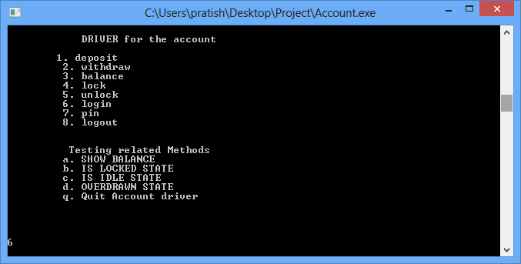

Step b: Upon pressing enter key the comand would ask for the Acount Number. Correct account number would return a value ‘0’

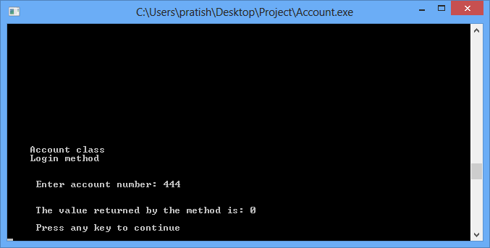

Step c: Enter 7 to enter pin for the application

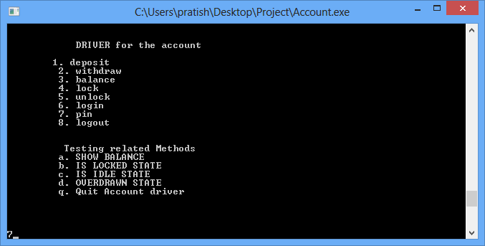

Step d: Upon pressing enter key the comand would ask for the Pin. Correct pin would return a value ‘0’

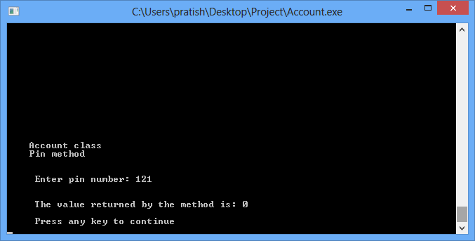

Step e: Enter 1 to enter deposit amount for the application

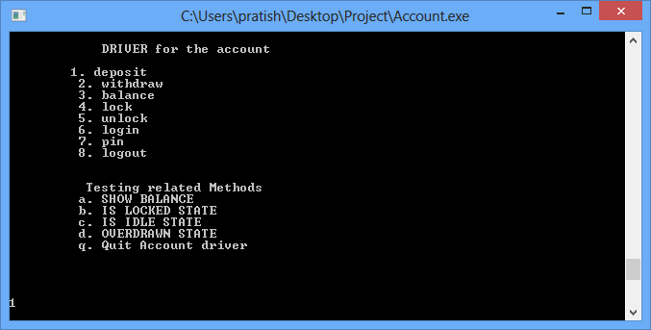

Step f: Upon pressing enter key the comand would ask for the Deposit Amount.

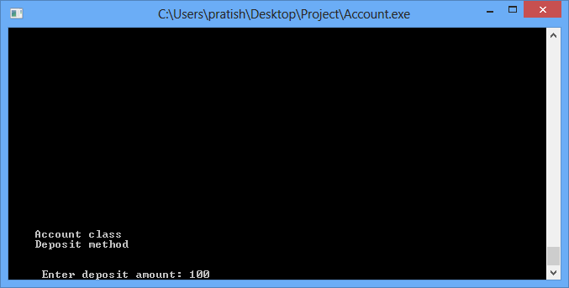

Step g: Enter 8 to logout from the application

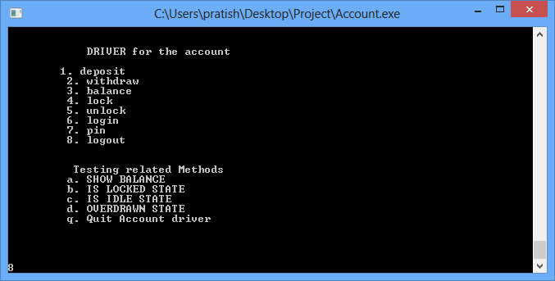

Step h: Upon pressing enter key the comand would return a value ‘0’fo successful logout

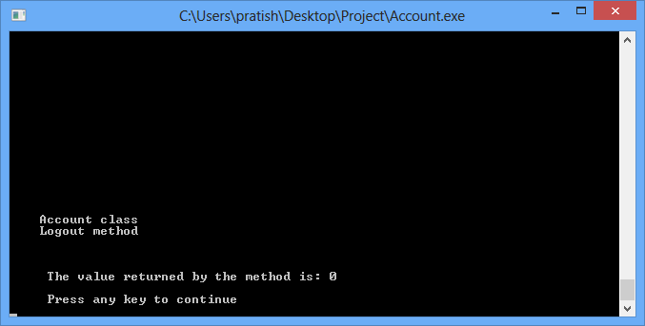

Step i :To exit the application enter “q”.

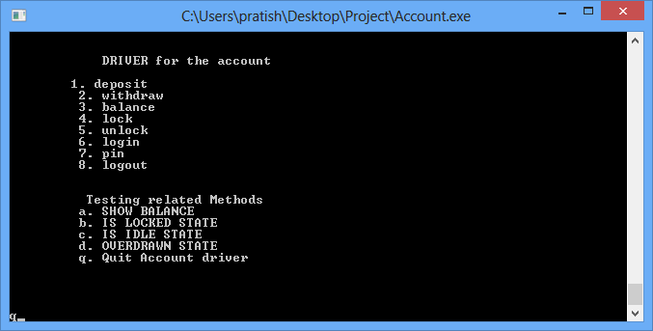

Using the above example one can carry out any of drivers listed in steps 1 to 8.

You can enter any of the testing related methods i.e “a,b,c,d” after entering the account balance,pin and login (also explained in step4-6)in order to find the states and balance.

Below are screen shots of 2 scenarios i.e To check Balance and To check Idle State.

For Example 1:

Step a: To Show balance press ‘a’

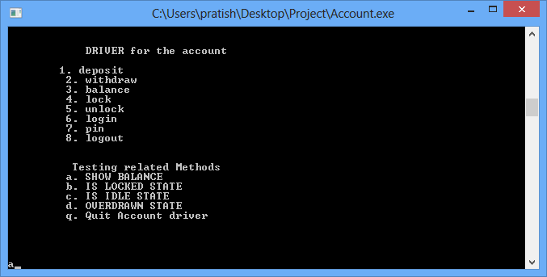

Step b: Upon pressing enter key the comand would return the Balance for the account.

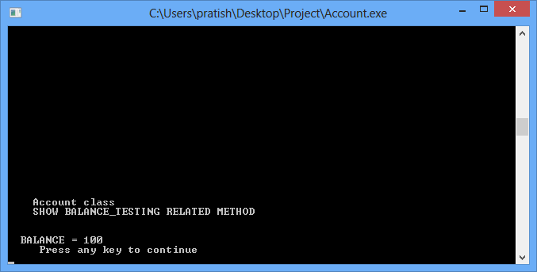

Example 2 :

Step a: To check for Idle state enter c

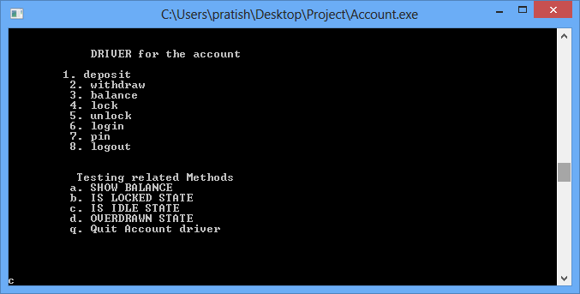

Step b: Upon pressing enter key the comand would display “Idle State” Message

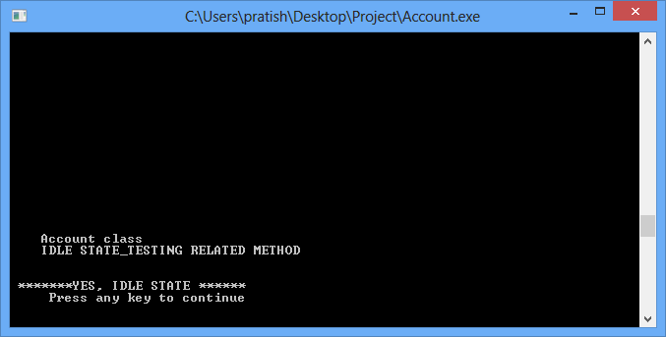

Below is the screenshot for successful execution of Test suite checker.exe:

