**Dhir Thacker | 17070122019 | CSE-1**

**SD lab assignment 6 (R-assignment 2)**

**Exploratory data analysis in R**

A snippet of the 911.csv dataset

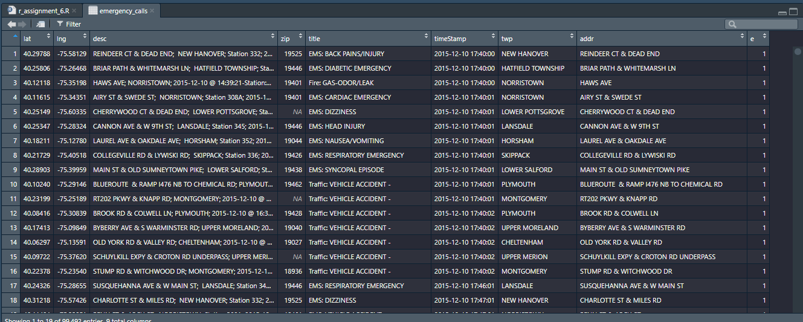

* Loading the dataset and import required libraries and packages

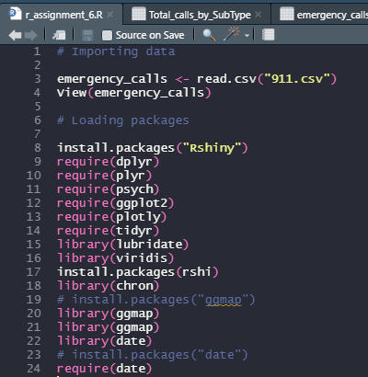

* Summarizing the data

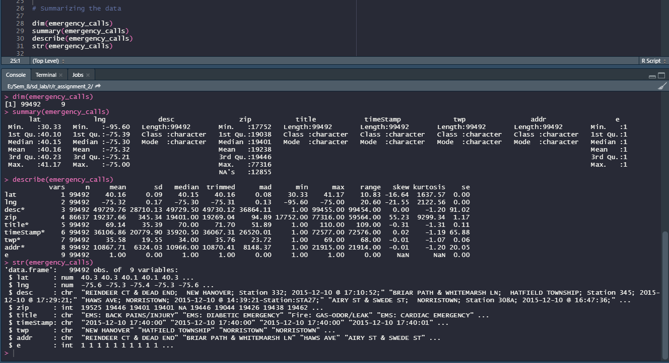

* Checking variable classes

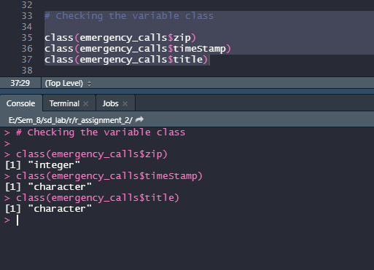

* Cleaning data
  + Removing ‘e’ column

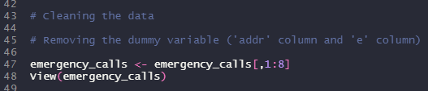

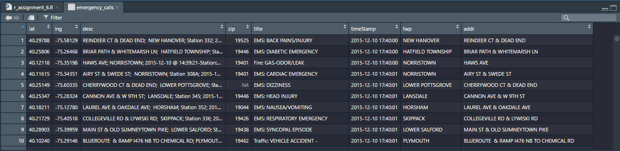

* + Changing class of timestamp to date

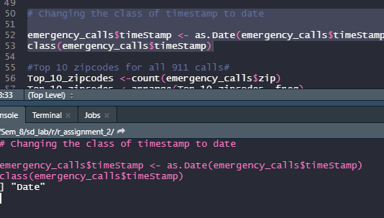

* Top 10 zipcodes with the most number of 911 calls

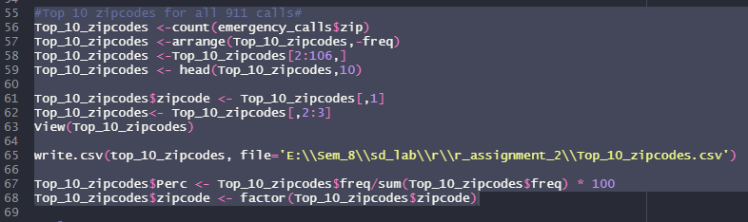

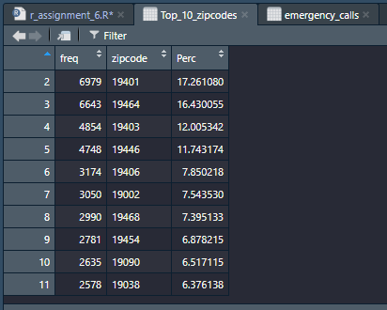

**TOP 10 ZIPCODES WITH MOST NO. OF 911 CALLS**

**TOP 10 ZIPCODES WITH MOST PERCENTAGEOF 911 CALLS**

* Splitting title column into type and subtype

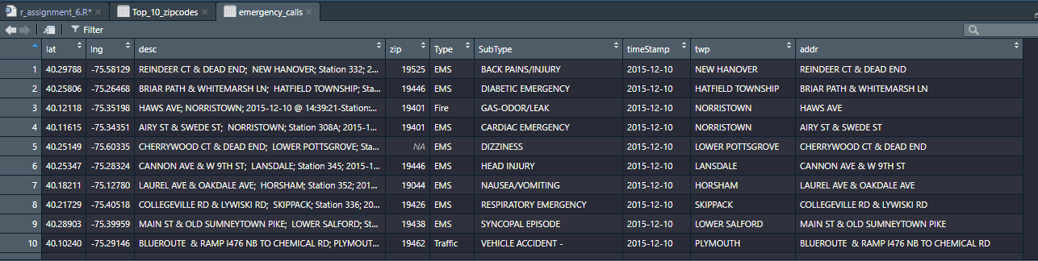

* Splitting date column into year, month, day, hour, weekdays columns

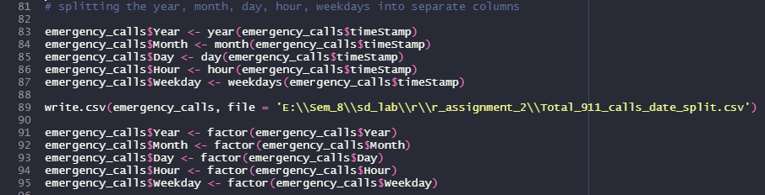

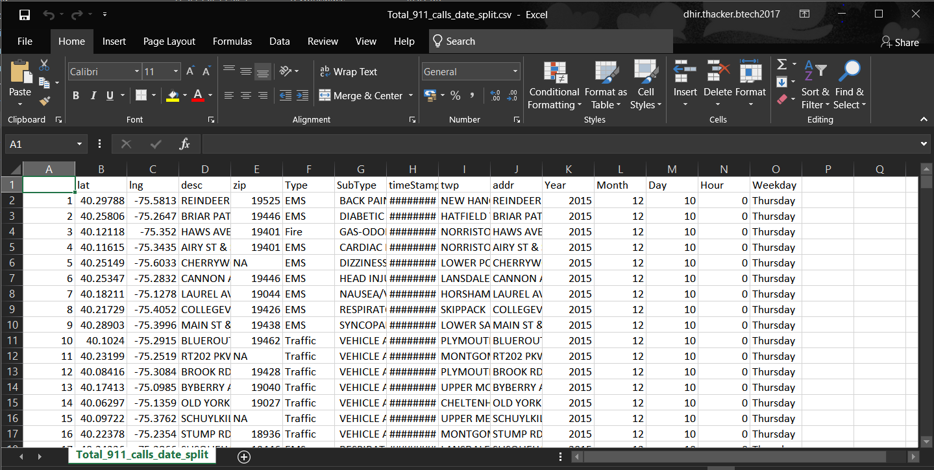

* Type analysis
  + List of total calls by type

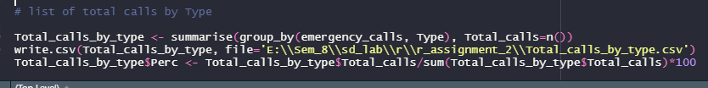

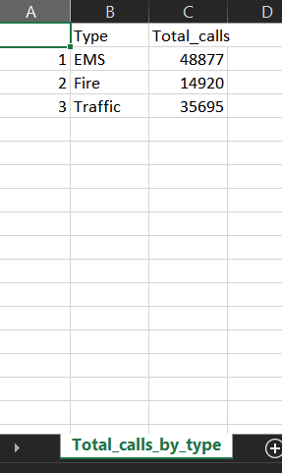

* + List of total calls by zip

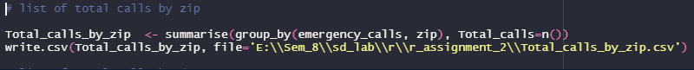

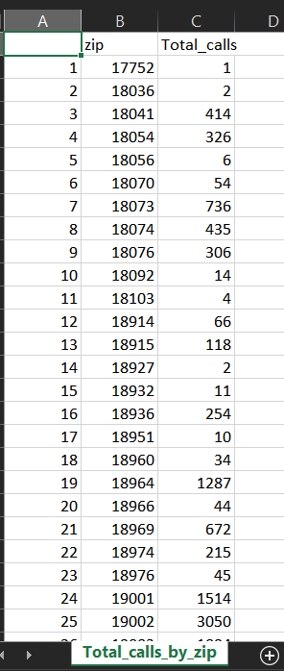

* + List of total calls by date



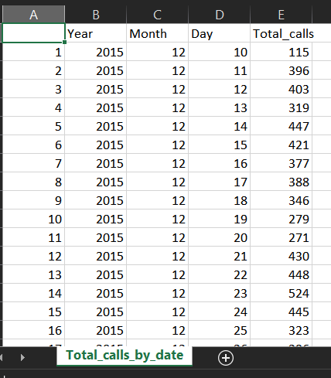

**TOTAL NO.OF 911 CALLS MADE EACH DAY BY DIFFERENT TYPES**

**Important analysis plots**

* Subtype analysis
  + Top 10 subtypes overall

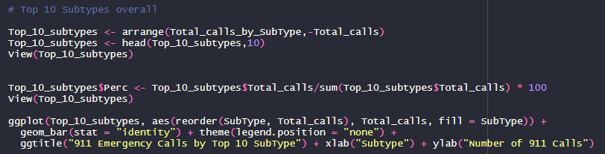

* + Top subtypes by traffic

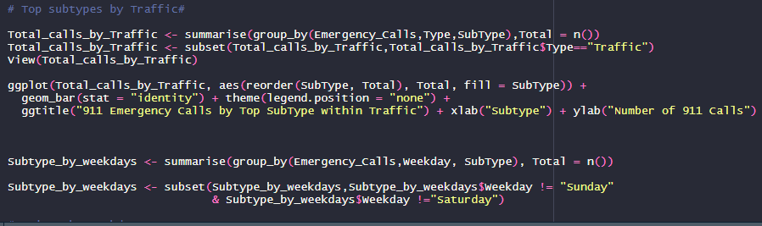

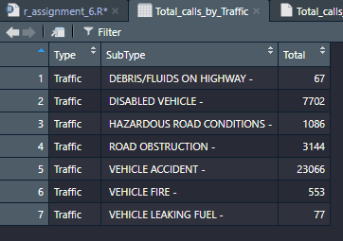

* + Subtype by weekdays

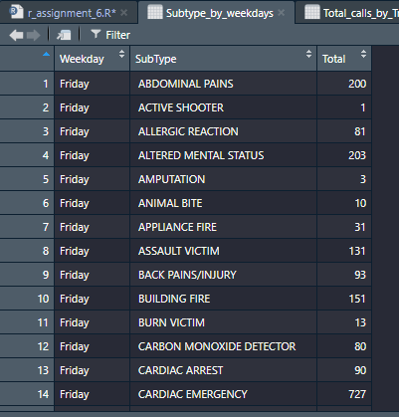

* + Hourly spike by Traffic subtype