**Dhir Thacker | 17070122019 | CSE-1**

**SD lab assignment 4**

**Problem statement :** Write python code loads the any dataset and does some basic data cleaning. Ask some questions on that data set.

**Code screenshots:**

**Part 1) Importing libraries and displaying dataset**

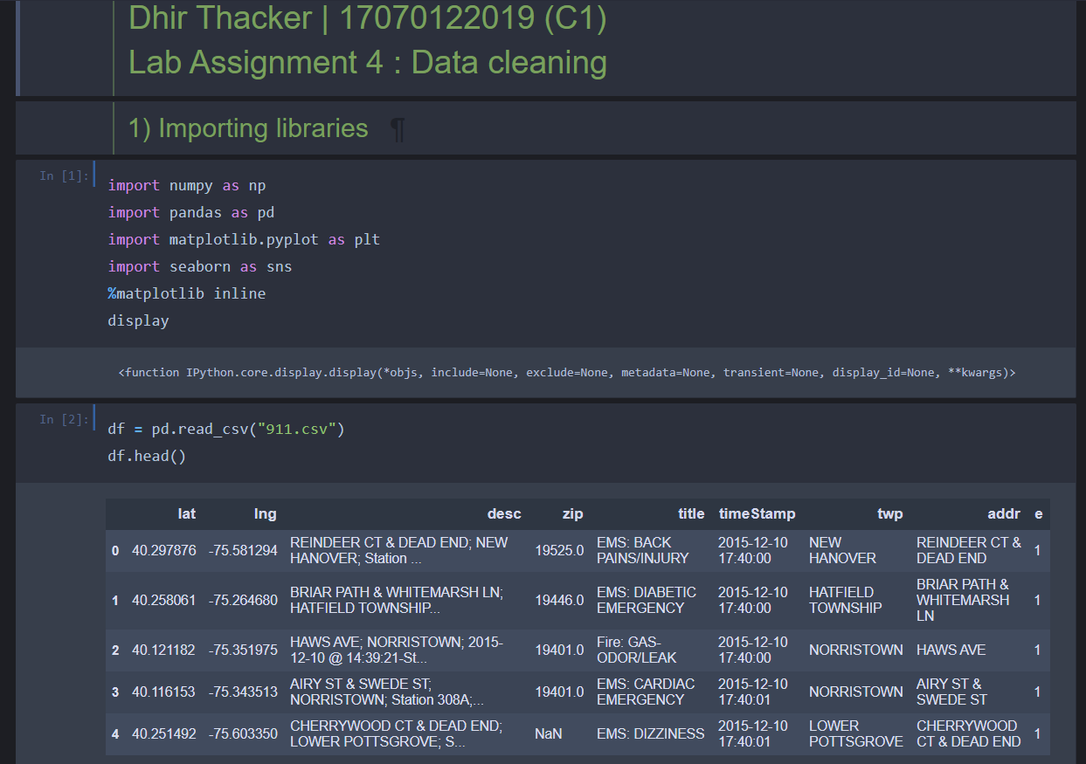

**Part 2) Writing some code to basically understand the structure of the dataset**

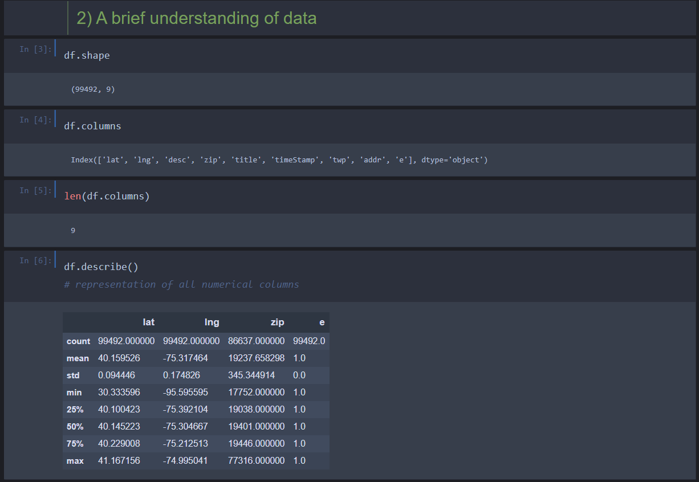

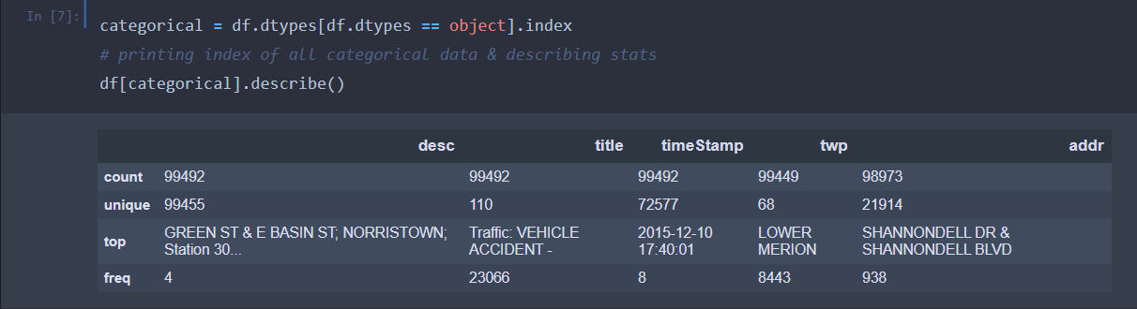

**Part 3) (a) Checking if null values are present**

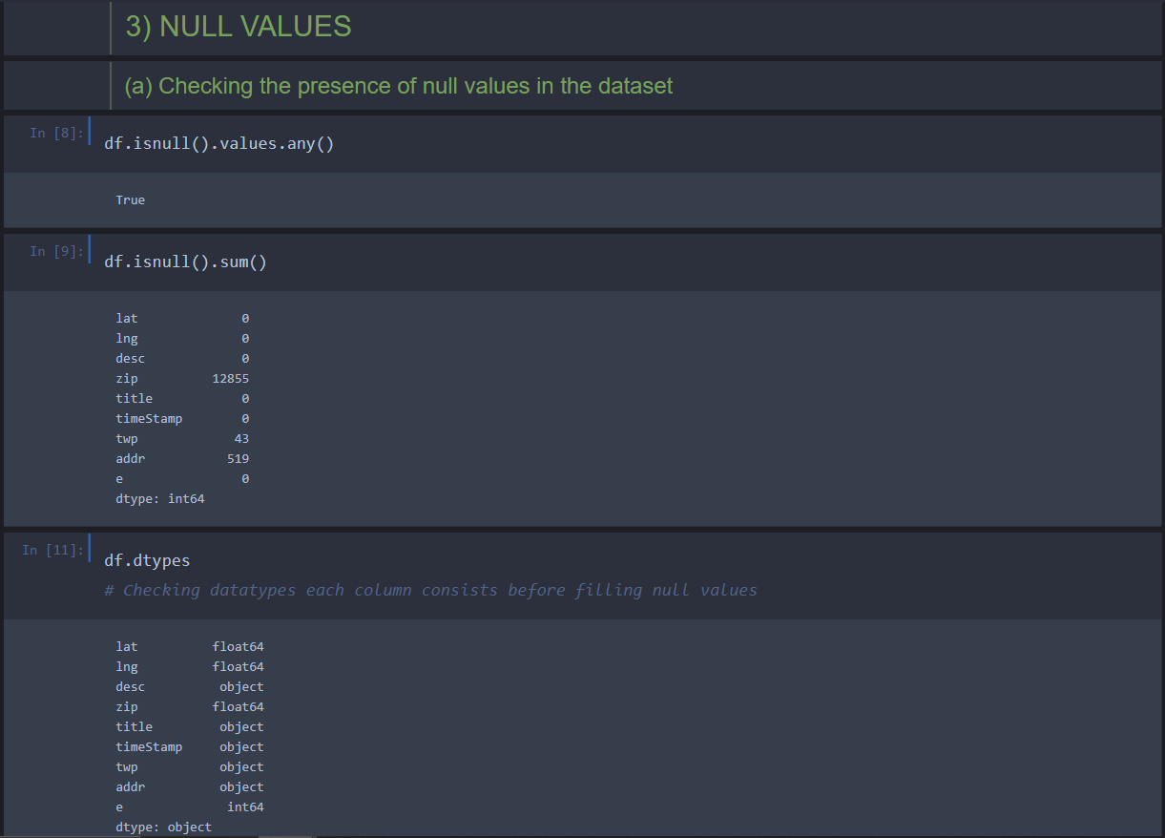

**(b) Filling null values by the forward filling method**

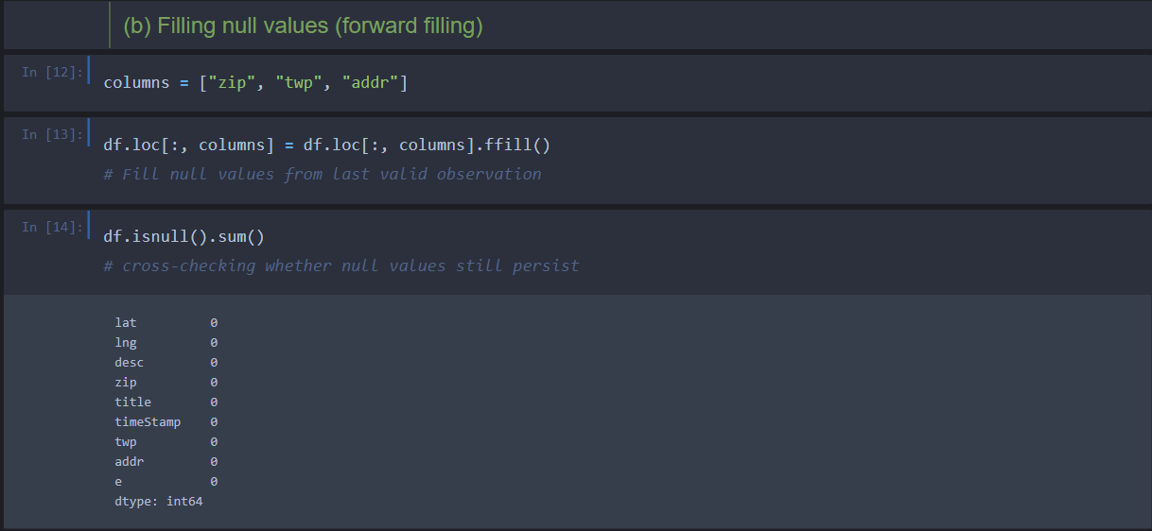

**Part 4) Assessing the target column ‘e’ and understanding that it is not important for further classifications, it is dropped**

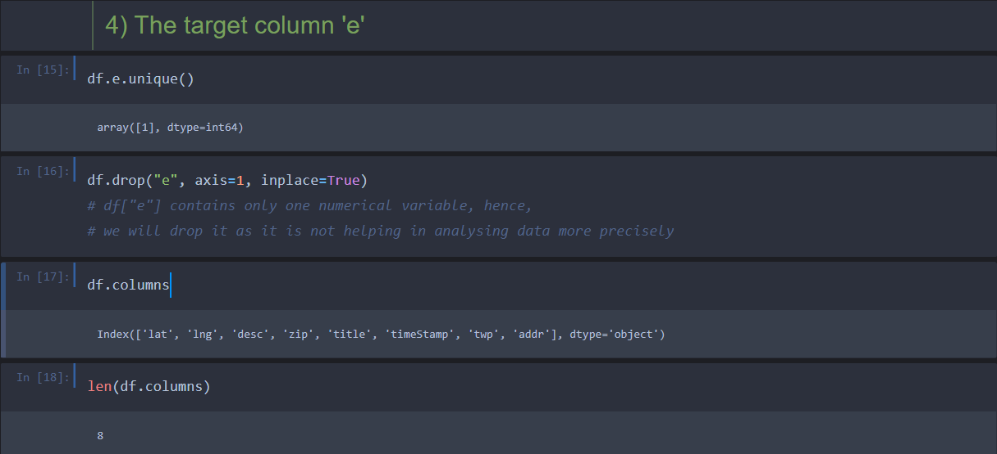

**Part 5) Data Manipulation**

* **Here timestamp is a string. So, first, it will be converted to timestamp format and then the date, hour, day etc. will be retrieved from it**

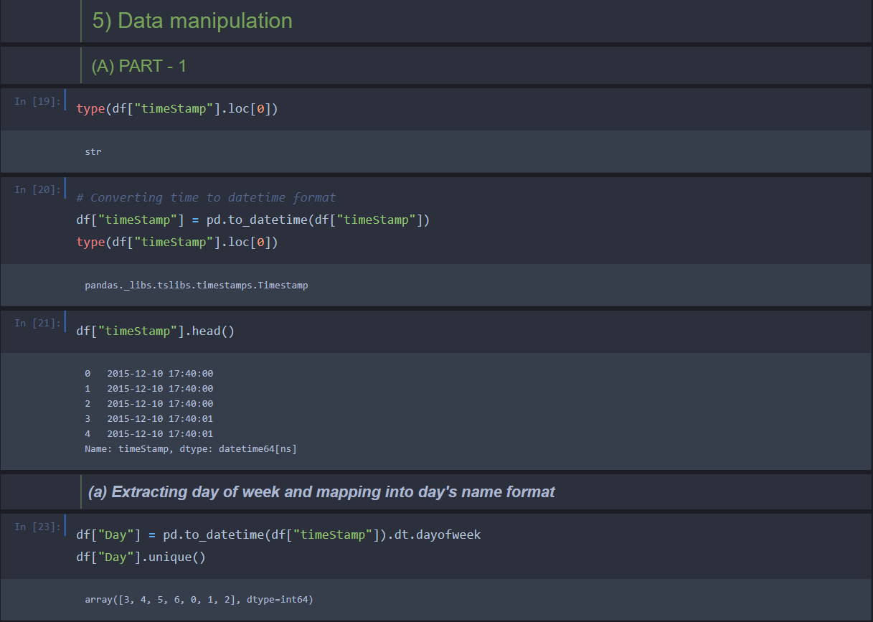

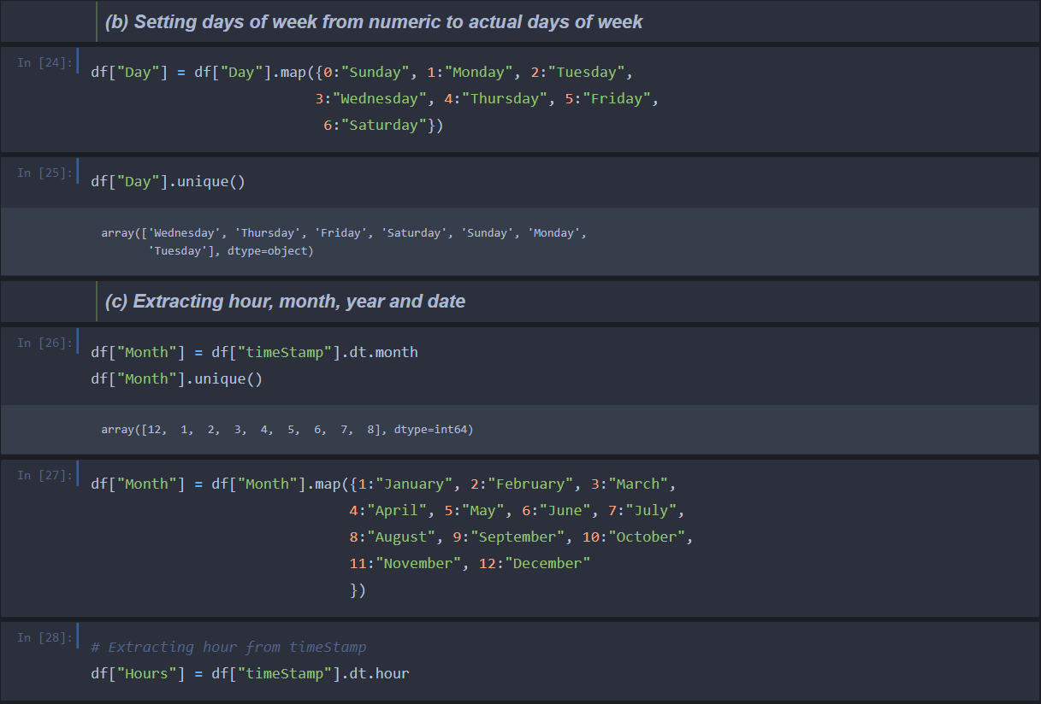

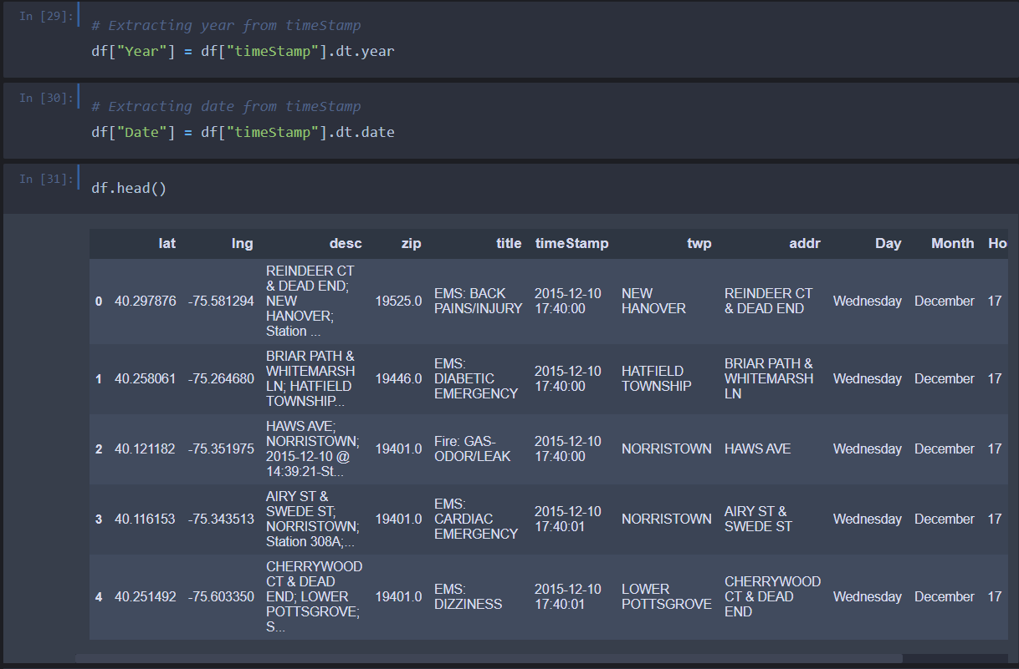

**Part 5) Data manipulation**

**(b) Splitting title column into category and reason and then dropping title column**

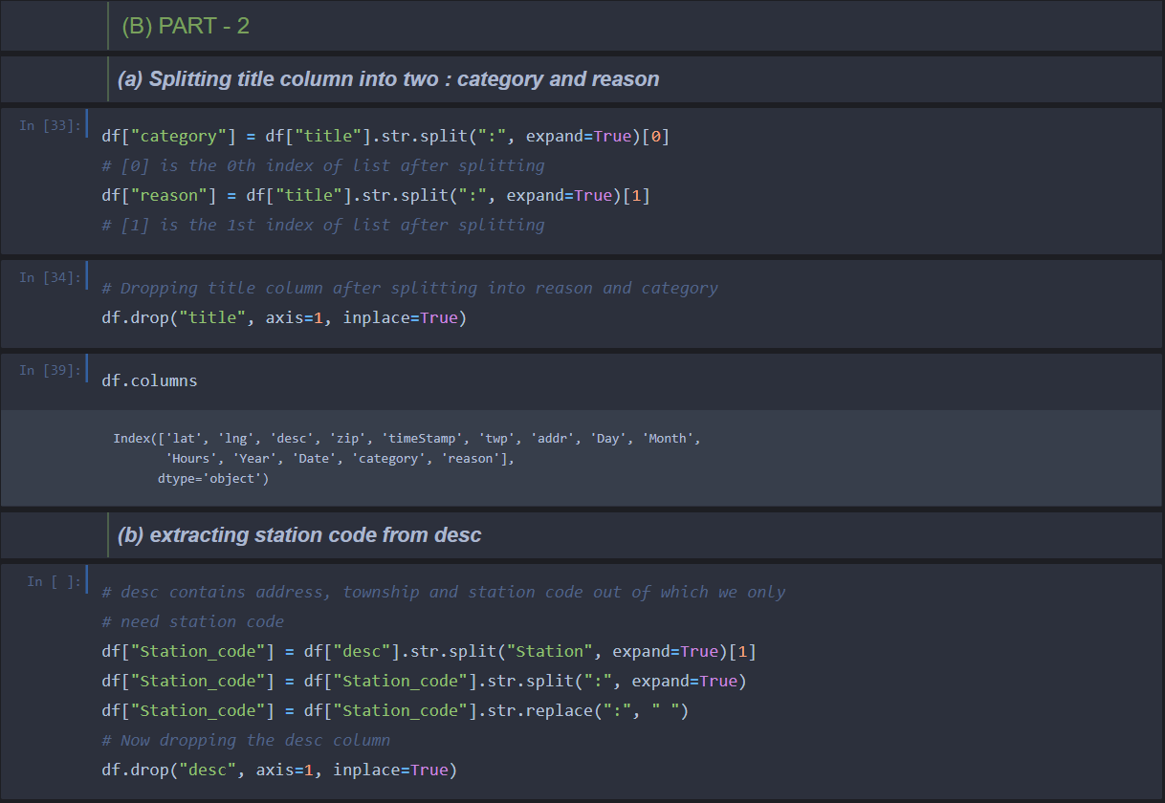

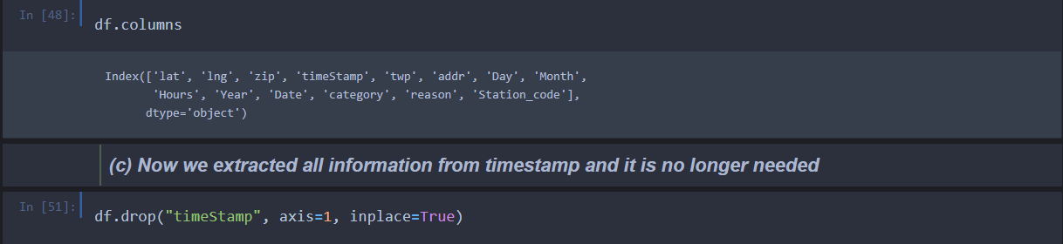

**Part 6) Exploratory data analysis**

