

Cellular Systems Design Specification
Document Revision: 0.1 DRAFT
Issue Date: 19 Oct 2007
Resource Manager Design Specification for Linux OMAP3430

“Texas Instruments™” and “TI™” are trademarks of Texas Instruments
The TI logo is a trademark of Texas Instruments
OMAP™ is a trademark of Texas Instruments
OMAP-Vox™ is a trademark of Texas Instruments
Innovator™ is a trademark of Texas Instruments
Code Composer Studio™ is a trademark of Texas Instruments
DSP/BIOS™ is a trademark of Texas Instruments
eXpressDSP™ is a trademark of Texas Instruments
TMS320™ is a trademark of Texas Instruments
TMS320C28x™ is a trademark of Texas Instruments
TMS320C6000™ is a trademark of Texas Instruments
TMS320C5000™ is a trademark of Texas Instruments
TMS320C2000™ is a trademark of Texas Instruments

All other trademarks are the property of the respective owner.

Copyright © 2005 Texas Instruments Incorporated. All rights reserved.
Information in this document is subject to change without notice. Texas Instruments may have pending patent applications, trademarks, copyrights, or other intellectual property rights covering matter in this document. The furnishing of this document is given for usage with Texas Instruments products only and does not give you any license to the intellectual property that might be contained within this document. Texas Instruments makes no implied or expressed warranties in this document and is not responsible for the products based from this document.

Table of Contents
Table of Contents iii
List of Figures iv
List of Tables iv
Revision History v
Plan Approvals v
1 Introduction 1
1.1 Purpose 1
1.2 Scope 1
1.3 File Path 1
1.4 File Name 1
1.5 References 1
1.6 Definitions 1
2 Architectural Overview 2
2.1 System Diagram 2
2.2 Software Design Interfaces 3
3 Design Rational 3
3.1 Relevant Specifications 3
3.2 Design Trade-offs 3
3.3 Hardware Dependencies 3
3.4 Other Pertinent Design Issues 3
4 Memory Requirements 4
5 Sub-Components 5
6 Data Path 6
7 Call Sequences 8
8 Software Requirements 8
9 Requirements Traceability 9
9.1 Class Structure 9
9.1.1 RMPROXY_ COMMANDTYPE structure 9
9.1.2 RMPROXY_ COMMANDDATATYPE structure 9
9.1.3 enum OMX_COMPONENTINDEXTYPE 9
9.1.4 RESOURCEMANAGER_ COMMANDDATATYPE structure 10
9.1.5 enum RM_ COMMANDDATATYPE 10
9.1.6 enum RESOURCEMANAGER_ ERRORTYPE 11
9.2 States 12
9.3 API Requirements Coverage 13
9.3.1 APIs between OMX components and resource manager proxy 13
9.3.2 APIs between resource manager proxy and resource manager 14
9.4 Non-API Requirements Coverage 15

List of Figures
Figure 1 System Architectural Diagram 2
Figure 2 Data Path Diagram 6
Figure 3 Call Sequences Error! Bookmark not defined.

List of Tables
Table 1 Terms and Acronyms 1

Revision History
REV | DATE | AUTHOR | NOTES
0.1 | 04 Apr 2006 | Richard Gong | Initial draft created

Plan Approvals
REV | APPROVAL 1 | DATE | APPROVAL 2 | DATE
 | Person | dd Mmm YYYY | Person | dd Mmm YYYY

Please read the “Important Notice” on the next page.
IMPORTANT NOTICE
Texas Instruments Incorporated and its subsidiaries (TI) reserve the right to make corrections, modifications, enhancements, improvements, and other changes to its products and services at any time and to discontinue any product or service without notice. Customers should obtain the latest relevant information before placing orders and should verify that such information is current and complete. All products are sold subject to TI’s terms and conditions of sale supplied at the time of order acknowledgment.
TI warrants performance of its hardware products to the specifications applicable at the time of sale in accordance with TI’s standard warranty. Testing and other quality control techniques are used to the extent TI deems necessary to support this warranty. Except where mandated by government requirements, testing of all parameters of each product is not necessarily performed.
TI assumes no liability for applications assistance or customer product design. Customers are responsible for their products and applications using TI components. To minimize the risks associated with customer products and applications, customers should provide adequate design and operating safeguards.
TI does not warrant or represent that any license, either express or implied, is granted under any TI patent right, copyright, mask work right, or other TI intellectual property right relating to any combination, machine, or process in which TI products or services are used. Information published by TI regarding third-party products or services does not constitute a license from TI to use such products or services or a warranty or endorsement thereof. Use of such information may require a license from a third party under the patents or other intellectual property of the third party, or a license from TI under the patents or other intellectual property of TI.
Reproduction of information in TI data books or data sheets is permissible only if reproduction is without alteration and is accompanied by all associated warranties, conditions, limitations, and notices. Reproduction of this information with alteration is an unfair and deceptive business practice. TI is not responsible or liable for such altered documentation.
Resale of TI products or services with statements different from or beyond the parameters stated by TI for that product or service voids all express and any implied warranties for the associated TI product or service and is an unfair and deceptive business practice. TI is not responsible or liable for any such statements.
Following are URLs where you can obtain information on other Texas Instruments products and application solutions:
1 Products |  | 2 Applications
Amplifiers | amplifier.ti.com | Audio | www.ti.com/audio
Data Converters | dataconverter.ti.com | Automotive | www.ti.com/automotive
DSP | dsp.ti.com | Broadband | www.ti.com/broadband
Interface | interface.ti.com | Digital Control | www.ti.com/digitalcontrol
LOGIc | LOGIc.ti.com | Military | www.ti.com/military
Power Mgmt | power.ti.com | Optical Networking | www.ti.com/opticalnetwork
Microcontrollers | microcontroller.ti.com | Security | www.ti.com/security
 |  | Telephony | www.ti.com/telephony
 |  | Video & Imaging | www.ti.com/video
 |  | Wireless | www.ti.com/wireless
Mailing Address: Texas Instruments
Post Office Box 655303 Dallas, Texas 75265

Copyright © 2005, Texas Instruments Incorporated
- Introduction
  - Purpose
This document describes Resource Manager Design specification for OMAP3430.
  - Scope
This document addresses only design specifications for Linux version resource manager.
Additional technical data can be found by referring to the OMAP™SS&P Technical Data Reference Package documents located in this ClearCase® VOB Path:
csdoc\ProcessDocuments\4_Miscellaneous\Product_Development\
The TDRP provides information about technical data artifacts, including their title, standard ClearCase® VOB location, a brief description and the System or Software Checkpoint where the artifact is first introduced into the development process.
  - File Path
This design specification document shall be available in ClearCase® path defined in the project CM Plan:
\\OMAPSW_MPU\linux\systems\src\openmax_il\resource_manager\docs
  - File Name
The file name of this document is OMAPSSP_3430_ResourceManager_DesignSpec.doc.
  - References
All References can be found on the Cellular Systems web site or the World Wide Process and Tools Group web site.
  - Definitions
Terms used in this document can be found in the Cellular Systems Glossary Document. Terms that are introduced in this document are detailed in table 1.

Acronym | Meaning
DSP/BIOS | Digital Signal Processing/Basic Input/Output System
OMX | OMX and Khronos OpenMAX™ 1.1 are used interchangeably in the document.
TN | Task Node
SN | Socket Node
SDP | Software Development Platform
DVFS | Dual-Voltage Frequency Scaling
- Terms and Acronyms

- Architectural Overview
Resource Manager is hardware vendor-specific and will need exist below the IL layer. The main functions of Resource Manager are:
- Implement and manage the resource wait queue(s)
- Keep track of available resources
- Keep track of each component that has resources and which resources they are using
- Notify a component or multiple components that they need to give up their resources when a higher priority component requests the resource
- Notify the highest priority component waiting for a resource when the resource is available
Resource Manager is running as a separate process to keep it as a singleton to handle multiple requests from different OMX components which may running in different processors. The Resource Manager uses a named pipe to communicate with OMX components.

  - System Diagram

App 1
App 2
Component
Component
OMX Core
Resource Manager Proxy
Resource Manager
DVFS
User
Kernel

- System Architectural Diagram

  - Software Design Interfaces
The software design interfaces with hardware, user, operator, software, and other systems should be verified and validated for correctness, consistency, completeness, accuracy, and testability per the OMAP™ SS&P Software Verification and Validation Standard.
Since programming in Linux is C and is not object-oriented, interfaces between Audio Manager and OMX components use structures and directly called APIs functions. However those interfaces should be easily migrated to Symbian OS, in which programming is written in C++.
- Design Rational
  - Relevant Specifications
Khronos 1.1 Specification, TI OMX core architecture documents and TI Qos documents can be used as relevant specifications. Those documents can be found in ClearCase.
  - Design Trade-offs
Resource Manager can either run as an independent OMX component initialized by OMX component, or run as separate process. In OMAP 3430 Resource Manager will execute as separate process and Resource Manager is initialized or de-initialized by OMAP 3430 system. Resource Manager communicates with OMX component via named pipe. The advantages for this approach are to keep Resource Manager more generic and singleton so it can handle multiple requests from different processors.
  - Hardware Dependencies
The hardware dependencies are the OMAP3430 platform, Linux® OS version, the DSP/BIOS™ bridge version and DASF versions.
  - Other Pertinent Design Issues
This design is targeted to Linux OS. However it is possible to migrate to Symbian OS in the future and the migration shouldn’t be too difficult.

- Memory Requirements
There are no memory requirements for resource manager.

- Sub-Components
There are no sub-components for resource manager.

- Data Path

Resource
Manager
OMX Component
Resource Manager Proxy
1) RMProxy_RequestResource
2) write(RMProxy_RequestResource)
3) GetFreeResources()

- Data Path Diagram

The following actions correspond to the sequence numbers showed in Figure 2

- Call Sequences

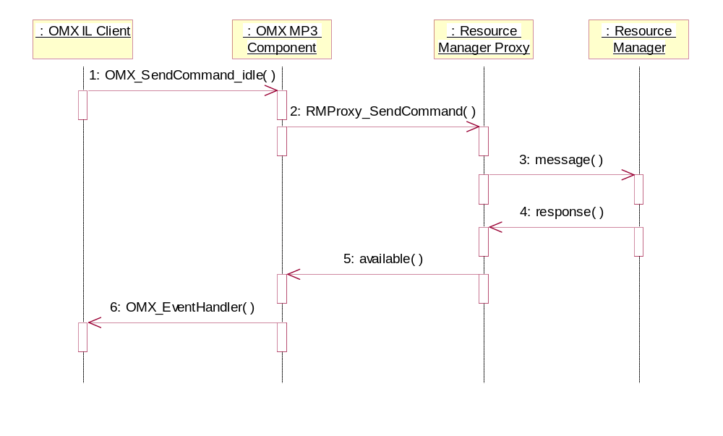
- Resource Manager – Resources Available

The IL client sends the idle command to the component. The component sends the command to the resource manager proxy, which sends the message on to the resource manager server. The resources are available, so the response is passed back to the component, and the component sends the notification to the IL client that the state has been changed to idle via the EventHandler.

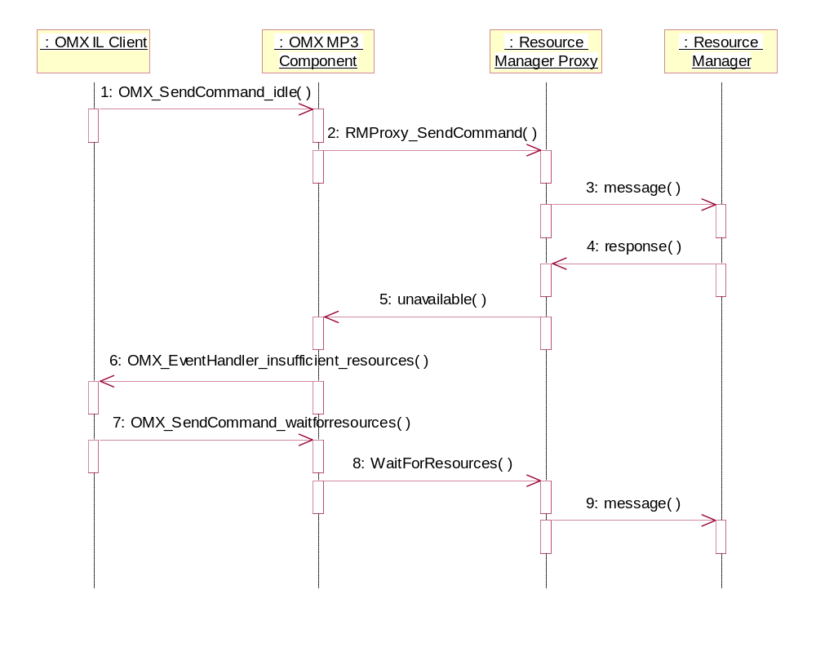
- Resource Manager – Resources Available

The IL client sends the idle command to the component, which passes it down to the Resource Manager server via the resource manager proxy. In this case, the resource is not available, so the resource manager sends the message that resource is not available to the component via the proxy. The component informs the IL client that the resource is not available using the EventHandler. At this point the IL client can, if it chooses, request to be informed when the resource becomes available by setting the state to Wait For Sources.

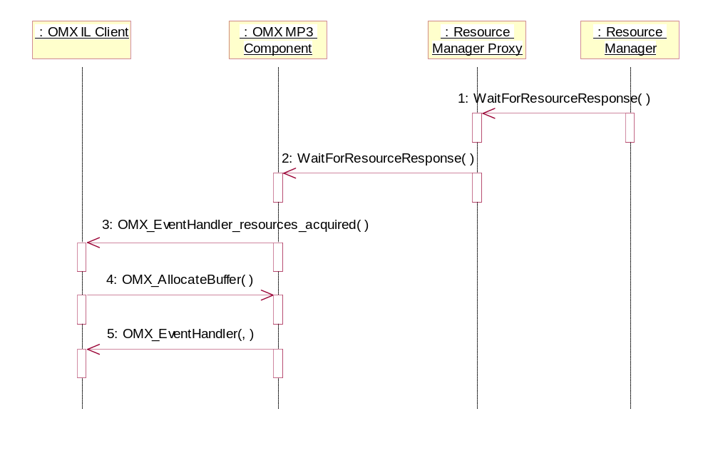

- Resource Manager – Resources Now Available

In this figure the component is in the Wait For Resources state as shown in figure 4. The resource which has been requested has become available, so the resource manager sends the notification to the component via the resource manager proxy. The OMX component then notifies the IL client via the event handler that the resources are now available. At this point, once the IL client allocates all necessary buffers, the component will transition to the idle state.

- Software Requirements
There are no software requirement numbers available for resource manager at the time that this design specification is written. The design for resource manager must comply with Khronos OpenMax 1.1 architectures.

- Requirements Traceability
  - Class Structure
Audio manager is targeted Linux OS and written in C rather than C++ so that there are no class structures for audio manager. Audio manager uses enumeration for EAP and audio routing command.
    - RMPROXY_ COMMANDTYPE structure
The RMPROXY_COMMANDTYPE structure contains the command list for OMX components interface with resource manager proxy.
typedef enum _RMPROXY_COMMANDTYPE {
RMProxy_Init = 1,
RMProxy_RequestResource,
RMProxy_WaitForResource,
RMProxy_FreeResource,
RMProxy_CancelWaitForResource,
RMProxy_StateSet,
RMProxy_Exit
} RMPROXY_COMMANDTYPE;

    - RMPROXY_ COMMANDDATATYPE structure
The RMPROXY_COMMANDDATATYPE structure contains command data definition for OMX components interface with resource manager proxy.
typedef struct _RMPROXY_COMMANDDATATYPE {
OMX_HANDLETYPE hComponent;
RMPROXY_COMMANDTYPE RM_Cmd;
sem_t *sem;
OMX_U32 param1;
OMX_U32 param2;
OMX_ERRORTYPE *RM_Error;
} RMPROXY_COMMANDDATATYPE;

    - enum OMX_COMPONENTINDEXTYPE
The OMX_COMPONENTINDEXTYPE enum contains component type definition, on which resource manager will make preemption decisions.
typedef enum _RM_COMPONENTINDEXTYPE
{

/* audio component*/
OMX_MP3_Decoder_COMPONENT = 0,
OMX_AAC_Decoder_COMPONENT,
OMX_AAC_Encoder_COMPONENT,
OMX_PCM_Decoder_COMPONENT,
OMX_PCM_Encoder_COMPONENT,
OMX_NBAMR_Decoder_COMPONENT,
OMX_NBAMR_Encoder_COMPONENT,
OMX_WBAMR_Decoder_COMPONENT,
OMX_WBAMR_Encoder_COMPONENT,
OMX_WMA_Decoder_COMPONENT,
OMX_G729_Decoder_COMPONENT,
OMX_G729_Encoder_COMPONENT,

/* video*/
OMX_MPEG4_Decode_COMPONENT,
OMX_MPEG4_Encode_COMPONENT,
OMX_H263_Decode_COMPONENT,
OMX_H263_Encode_COMPONENT,
OMX_H264_Decode_COMPONENT,
OMX_H264_Encode_COMPONENT,
OMX_WMV_Decode_COMPONENT,
OMX_MPEG2_Decode_COMPONENT,

/* image*/
OMX_JPEG_Decoder_COMPONENT,
OMX_JPEG_Encoder_COMPONENT,
OMX_VPP_COMPONENT,

/* camera*/
OMX_CAMERA_COMPONENT,
OMX_DISPLAY_COMPONENT
} RM_COMPONENTINDEXTYPE ;
    - RESOURCEMANAGER_ COMMANDDATATYPE structure
The RESOURCEMANAGER_COMMANDDATATYPE structure contains command data definition for resource manager proxy interface with resource manager
typedef struct _RESOURCEMANAGER_COMMANDDATATYPE
{
OMX_HANDLETYPE hComponent;
RM_COMMANDTYPE RM_Cmd;
OMX_U32 param1;
OMX_U32 param2;
RESOURCEMANAGER_ERRORTYPE rm_status;
} RESOURCEMANAGER_COMMANDDATATYPE;
    - enum RM_ COMMANDDATATYPE
The RESOURCEMANAGER_COMMANDDATATYPE enum contains command data definition for resource manager proxy interface with resource manager
typedef enum _RM_COMMANDTYPE {
RM_Init = 1,
RM_RequestResource,
RM_WaitForResource,
RM_FreeResource,
RM_CancelWaitForResource,
RM_StateSet,
RM_Exit
} RM_COMMANDTYPE;
    - enum RESOURCEMANAGER_ ERRORTYPE
The RESOURCEMANAGER_ERRORTYPE enum contains error definition for resource manager proxy interface with resource manager
typedef enum _RESOURCEMANAGER_ERRORTYPE {
RM_ErrorNone = 0,
RM_GRANT,
RM_DENY,
PM_ErrorMax = 0x7FFFFFFF
} RESOURCEMANAGER_ERRORTYPE;
  - States
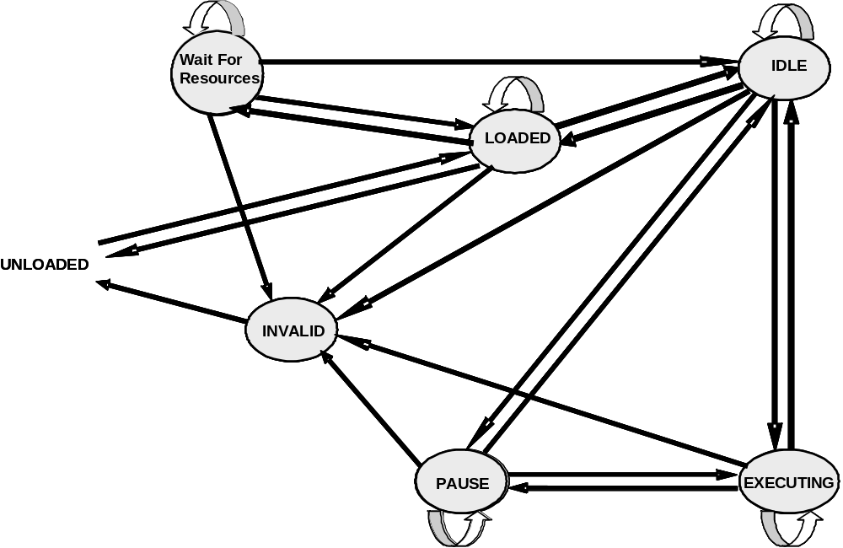
  - API Requirements Coverage
    - APIs between OMX components and resource manager proxy
    - APIs between resource manager proxy and resource manager

  - Non-API Requirements Coverage
There is no Non-API requirements coverage for audio manager.

