PLAYO
VENUE OBSERVATORY
Teammate study guide
and project walkthrough
Historical venue data · PostgreSQL/Supabase · SQL · machine learning · Cloudflare dashboard
Use this guide to understand the project, explain it in a viva, run the live demo and moderate public venue submissions.
Prepared for the project team · 2026

START HERE

How to use this guide
You do not need to read the source code first. Follow the guide in three passes:
1 | Understand the story  Read pages 3–12 to learn why the project exists, how the data was prepared and what the model means.
2 | Practice the website  Use pages 13–18 as a click-by-click walkthrough of the live dashboard and venue submission flow.
3 | Prepare the viva  Use pages 19–23 for deployment, demo order, troubleshooting and short answers to likely questions.
One-sentence project description
We transformed a historical third-party Playo-related venue export into an auditable PostgreSQL/Supabase analytics system with SQL EDA, a leakage-aware rating model and a public Cloudflare dashboard.
Live website
https://playo-venue-observatory.dhivaa2004.workers.dev
GitHub
https://github.com/dhivaa-2004/playo-bdm-capstone

PROJECT

The project in 90 seconds
The original material is a historical third-party Playo-related dataset. It is useful, but it is not a live Playo database. We preserve the raw files, remove only exact duplicates, normalize the content into PostgreSQL and keep source provenance on every historical venue.
SQL views provide the dashboard KPIs. A feature store creates region, coordinate and activity features. The target is avgRating. Entity-grouped splitting prevents the same venue group from entering both train and test. Predictions are written back to PostgreSQL and explained on the public dashboard.
Public venue submissions are a separate feature. They do not change historical KPIs or ML. They start as pending, are protected by Cloudflare Turnstile and become visible only after owner moderation.
Question | Short answer
What problem? | Make historical venue data queryable, reproducible and explainable.
What database? | PostgreSQL hosted by Supabase.
What frontend? | React/Vite dashboard hosted on Cloudflare Workers.
What ML task? | Estimate avgRating from non-leaking historical features.
Is it live Playo data? | No. It is a historical third-party snapshot; the current site was only a domain/schema reference.

SYSTEM

How the full system works
Layer | What it does | Why it matters
Raw archive | Preserves four regional JSON files unchanged. | The evidence can be re-audited.
Python ETL | Profiles, validates, deduplicates and writes load SQL. | Cleaning logic is reproducible.
Supabase | Stores normalized PostgreSQL tables, views and predictions. | The database is the source of dashboard truth.
SQL + ML | Runs EDA, builds feature_store_v1 and evaluates models. | Results are traceable to defined queries and features.
Cloudflare | Serves the React app and API routes. | The project is publicly accessible without ChatGPT hosting.
Critical separation
Historical records drive the research metrics and model. Community submissions stay in submitted_venues and never enter historical KPIs, model training or predictions.
End-to-end flow
Raw files → Python audit/ETL → normalized PostgreSQL → SQL views → feature store → grouped ML → predictions → Worker API → React dashboard

EVIDENCE

Dataset audit and the numbers to remember
Measure | Result | Meaning
Raw rows | 3,701 | Rows across the four source-region files.
Exact-deduplicated venues | 3,697 | Four exact duplicates removed.
Rated venues | 3,186 | 86.2% have avgRating.
Unrated venues | 511 | Missing target, never a zero-star rating.
Activity/service labels | 89 | Not all labels are sports; some are services.
Source regions | 4 | Bangalore, Chennai, Delhi/NCR and Hyderabad.
Deduplicated regional counts
Bangalore | Hyderabad | Delhi / NCR | Chennai
1,358 | 1,085 | 698 | 556
Why no large synthetic expansion?
Synthetic rows would not repair unknown observation dates, geographic selection bias, sparse ratings or missing bookings/prices. The real historical dataset is sufficient for the primary empirical analysis.

EVIDENCE

How to describe the data honestly
Use this exact academic positioning:
Recommended wording
The project uses a historical third-party Playo-related dataset as its empirical base. The current Playo website was reviewed only as a domain/schema reference. The project does not claim that the records are current Playo listings.
Never claim:
- We scraped current Playo venues.
- All records are current and verified.
- A rating prediction measures demand, revenue or popularity.
- Missing ratings mean poor quality.
Provenance fields
Field | Historical value | Community value
source_type | third_party_historical | user_submitted
source_dataset | playo-find-venue-master | public_venue_submissions
is_synthetic | false | false

DATABASE

Database design in plain language
Table | Purpose | Important link
source_regions | Reference list of the four source regions. | venues.region → source_regions.region
venues | One row per historical venue with coordinates and provenance. | Primary key venue_id
venue_ratings | Average rating and rating count. | One-to-one with venues
activity_labels | Controlled list of activity/service labels. | Primary key label
venue_activities | Many-to-many bridge between venues and labels. | venue_id + label
model_runs | Model version, metrics, parameters and split summary. | Primary key run_id
predictions | Prediction per run and venue. | run_id + venue_id
submitted_venues | Moderated public venue submissions. | Separate from venues
venue_correction_reports | Public reports of possible data problems. | Targets historical or submitted venue
Normalization idea
Venue identity, ratings and activities are stored separately. This avoids repeating the same venue information for every activity and makes SQL joins explicit.

DATABASE

Implemented ER diagram
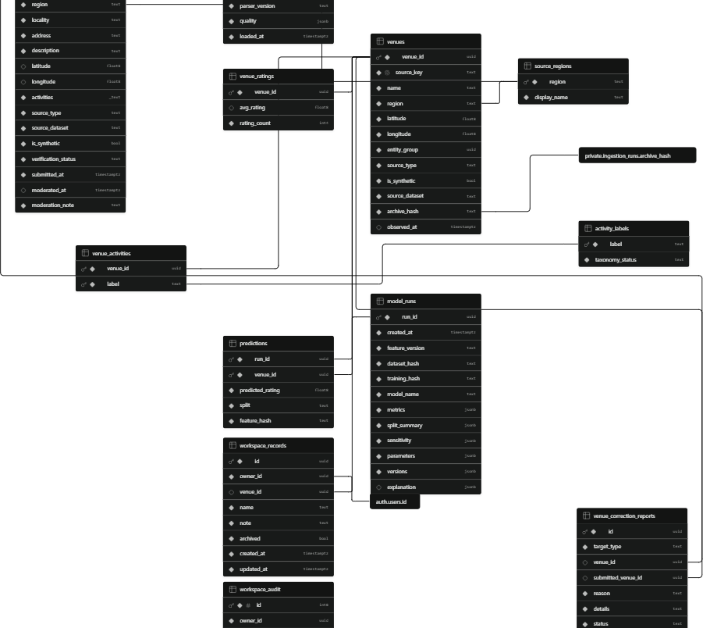
Supplied Supabase ER diagram, cropped only to remove unused white space.
How to explain it
- Start at venues in the middle: it is the historical entity table.
- source_regions and venue_ratings connect directly to venues.
- venue_activities connects venues to activity_labels, creating a many-to-many relationship.
- predictions connects one venue to one model_runs record for each run.
- submitted_venues and venue_correction_reports form a separate moderated path.

PIPELINE

Python ETL: what happens to the raw files
1 | Archive  Calculate a stable archive hash and retain the original files unchanged.
2 | Profile  Count rows, nulls, duplicates, cities/regions, labels, ratings and coordinates.
3 | Normalize  Convert values to defined types and split venues, ratings and activity labels into relational tables.
4 | Deduplicate  Remove exact duplicate records only; do not merge similar names without evidence.
5 | Load  Run the generated SQL in a transaction, then compare table counts with the quality report.
Quality rules to remember
- Coordinates must be valid latitude/longitude values.
- avgRating is either missing or between 1 and 5.
- rating_count cannot be negative.
- Historical records must keep source_type, source_dataset and archive_hash.
- Raw info HTML and phone information are not exposed in the public UI or ML feature store.

ANALYSIS

SQL analysis: what the dashboard is querying
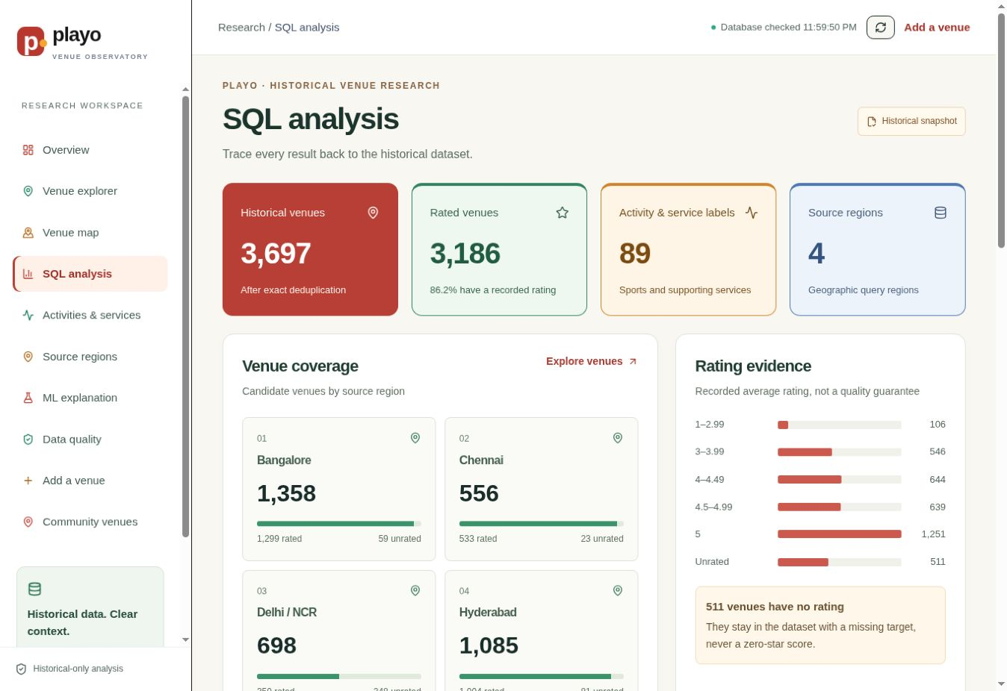
SQL analysis page: database-backed counts, regional coverage and rating evidence.
Click-by-click
1 | Open SQL analysis  In the left sidebar, click SQL analysis.
2 | Read the four KPIs  Historical venues, rated venues, labels and source regions come from Supabase views.
3 | Compare regions  Scroll to regional coverage and note that source regions are query regions, not verified municipal boundaries.
4 | Interpret missing ratings  The unrated category contains missing targets; it is not a zero-star bucket.

MACHINE LEARNING

Feature store and leakage prevention
Use as a feature | Exclude from first model | Reason
Source region | rating | rating is a truncated copy of avgRating.
Latitude/longitude | info HTML | The HTML repeats rating and rating count.
Activity indicators | Name, links, icons, IDs | Identity-like fields encourage memorization.
entity_group for splitting | ratingCount | Used first as a reliability/sensitivity variable.
Target
avgRating is the supervised regression target. Venues without avgRating are excluded from supervised evaluation, then receive an unrated prediction after the model is selected.
Split rule
The train/test split is grouped by entity_group. Result: zero entity-group overlap between train and held-out test data.
Why this matters
Without leakage controls, the model could appear extremely accurate only because a feature already contains the answer or the same entity appears on both sides of the split.

MACHINE LEARNING

How to explain the model results
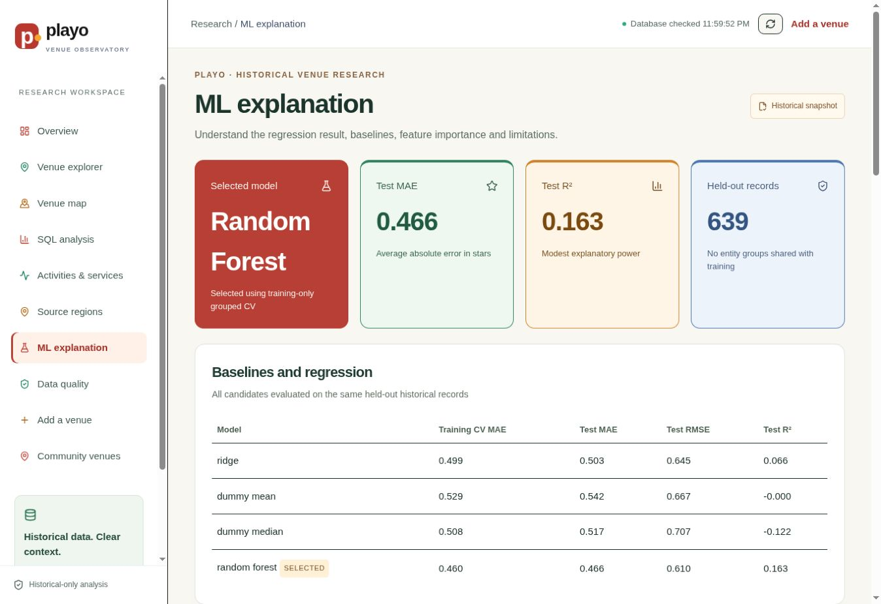
ML explanation page showing selected model, held-out metrics and baselines.
Measure | Value | Plain meaning
Selected model | Random Forest | Chosen by grouped cross-validation.
Test venues | 639 | Unseen entity groups used only for final evaluation.
MAE | 0.466 | Average absolute error is about 0.47 rating stars.
RMSE | 0.610 | Larger errors receive more weight.
R² | 0.163 | The model explains a modest share of rating variation.
Median baseline MAE | 0.517 | The selected model improves on a simple constant prediction.
Correct conclusion
The model has useful research signal, but predictions are estimates—not guarantees of venue quality, demand, popularity or revenue.

WEBSITE

Walkthrough 1: start at Overview
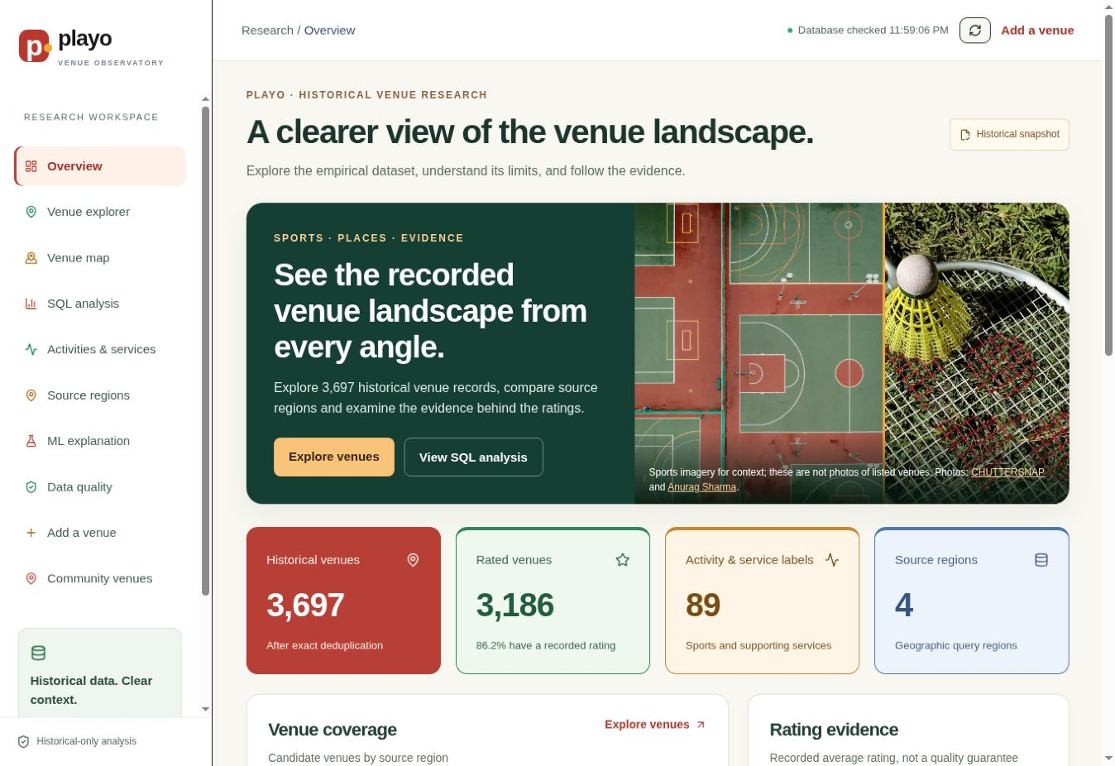
Overview page of the live Cloudflare-hosted dashboard.
1 | Confirm live status  The top-right status should change from Connecting to database to Database checked.
2 | Read scope first  The page says historical venue research and labels the content as a historical snapshot.
3 | Use the KPI cards  Quote 3,697 venues, 3,186 rated venues, 89 labels and four source regions.
4 | Use the sidebar  The sidebar is the recommended demo order; each label is a real route, not a decorative button.

WEBSITE

Venue explorer: search and filter
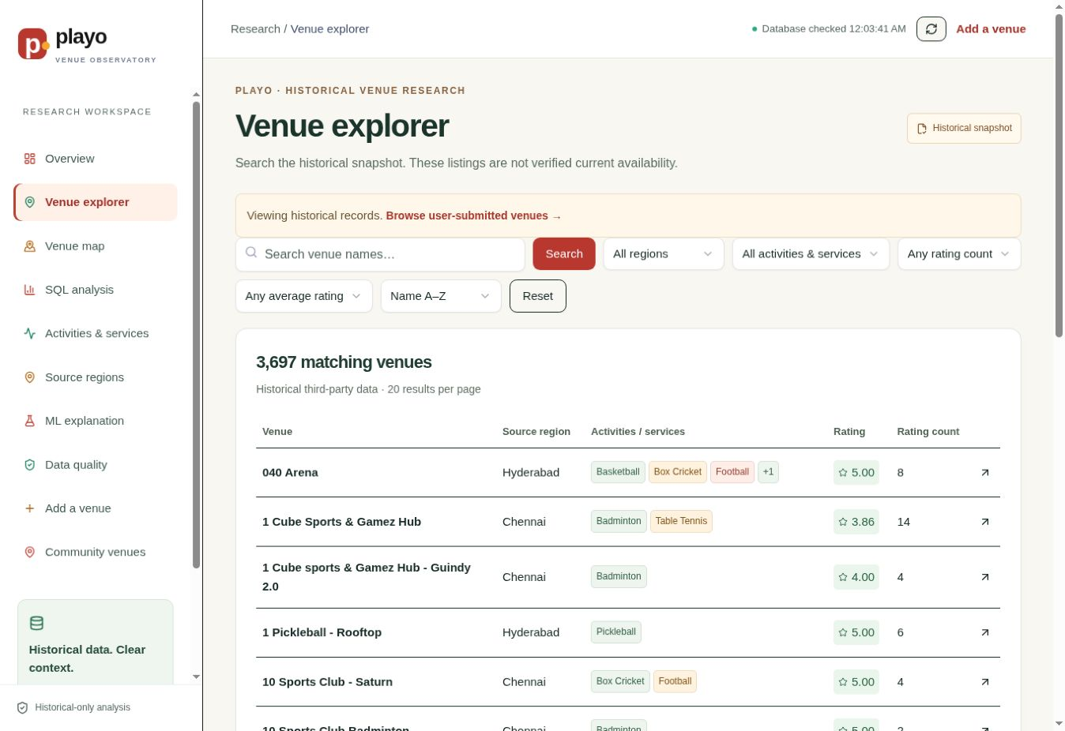
Venue explorer with live filters and historical record rows.
1 | Click Venue explorer  Use the left sidebar.
2 | Search by name  Type a venue name and click Search.
3 | Narrow the results  Choose a source region, activity/service, rating count or minimum average rating.
4 | Open a venue  Click a venue name or the arrow at the right of a row to view its details and prediction context.
Interpretation rule
These are recorded historical listings. Do not describe the table as verified current availability.

WEBSITE

Walkthrough 3: use the Venue map
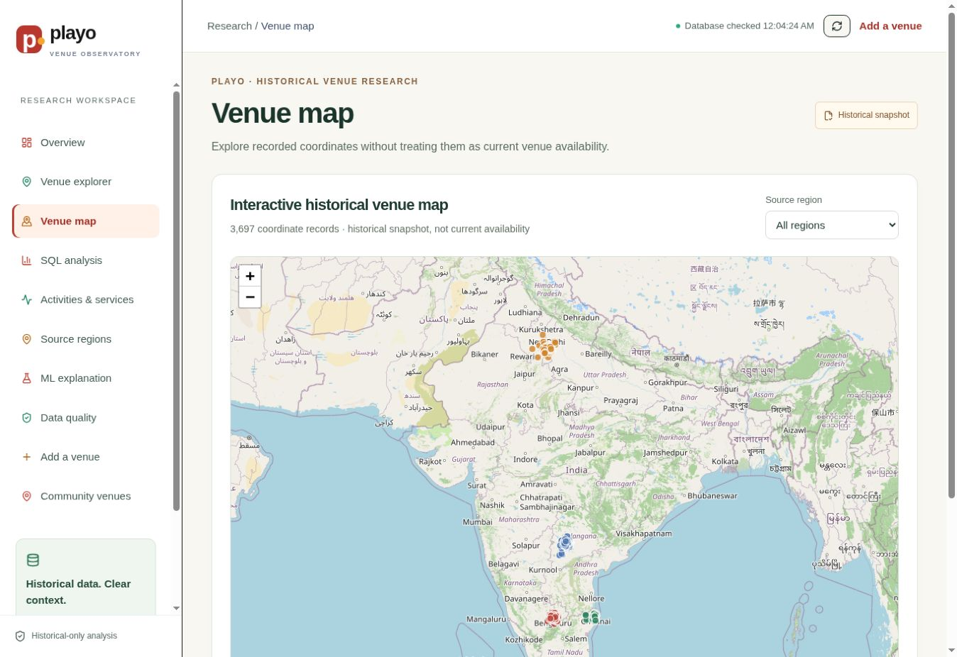
Interactive Leaflet map with 3,697 historical coordinate records.
1 | Click Venue map  Use the left sidebar.
2 | Filter a source region  Use the drop-down at the top-right of the map.
3 | Zoom and inspect clusters  Use +/−. Map points help explain regional concentration.
4 | Keep non-map records available  The Venue explorer remains the complete list; the map is a geographic view, not the only access path.
Map disclaimer
Coordinates and source-region assignments come from the historical third-party dataset and may be outdated or imprecise.

COMMUNITY DATA

Add a venue: public submission
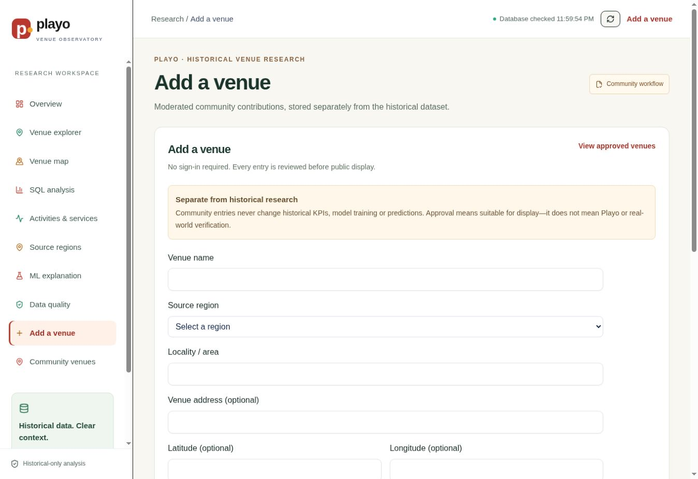
No-sign-in public form. Every new submission is reviewed before public display.
1 | Click Add a venue  Use the sidebar or the top-right action.
2 | Fill required fields  Venue name, source region, locality/area and at least one activity are required.
3 | Optional details  Address, description and coordinates may be added when known.
4 | Pass Turnstile and submit  Cloudflare Turnstile reduces automated spam. The database inserts verification_status = pending.
What pending means
The submission is saved in Supabase immediately, but it is private until an owner changes the status to approved.

COMMUNITY DATA

Owner moderation in Supabase
A public visitor cannot approve their own submission. The owner uses the Supabase dashboard:
1 | Open the project  Supabase Dashboard → dhivaa-2004’s Capstone → Table Editor.
2 | Open submitted_venues  Use the public schema and select the submitted_venues table.
3 | Find the pending row  Check name, region, locality, activities, submitted_at and any duplicate warning.
4 | Set verification_status  Choose approved for public display or rejected when the claim should not be shown.
5 | Record the decision  Set moderated_at and add a short moderation_note. Supabase Table Editor auto-saves the edited cell; there may be no separate Save button.
6 | Verify the public result  Return to Community venues and click Refresh. Only approved rows should appear.
Important
Approval means suitable for display after owner review. It does not mean Playo or real-world verification.

COMMUNITY DATA

Walkthrough 5: Community venues
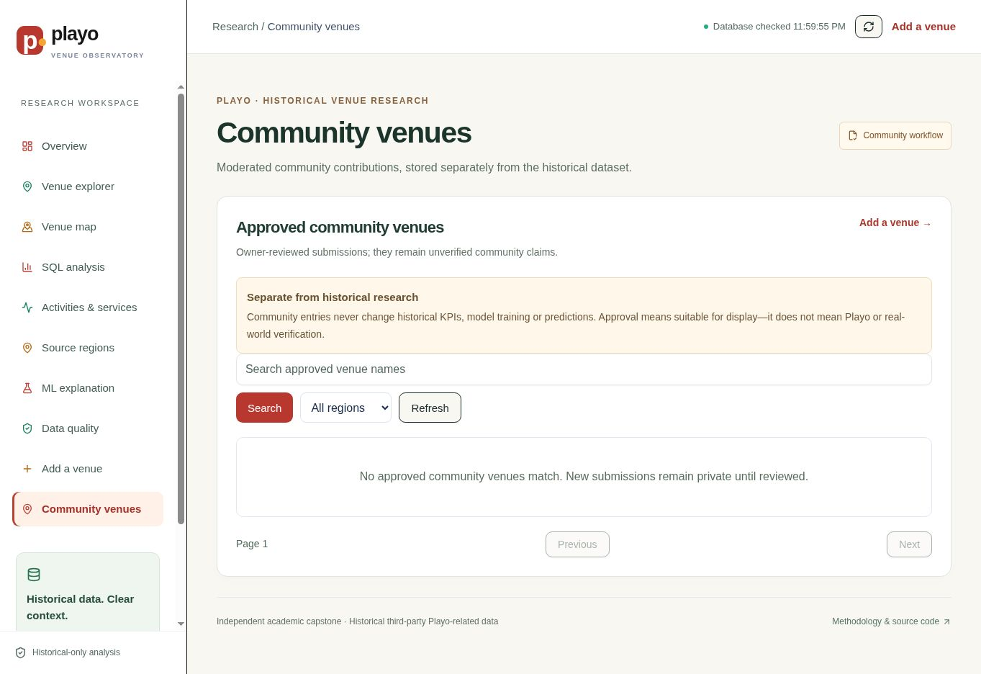
Community page after demo cleanup: no approved rows are currently displayed.
1 | Click Community venues  Use the left sidebar.
2 | Search approved rows  Search by venue name and optionally select a source region.
3 | Understand visibility  Pending and rejected records are not returned by the public policy.
4 | Keep the research separate  Community entries do not change historical counts, SQL analysis, training data or predictions.

DEPLOYMENT

How GitHub, Cloudflare and Supabase work together
Service | Stores / runs | Team action
GitHub | Source code, migrations, documentation, tests and deliverables. | Push reviewed changes to main.
GitHub Actions | Frontend tests, build, deployment and health check. | Open Actions to inspect a failed run.
Cloudflare Workers | Public React assets and Worker API routes. | Check runtime variables and deployment logs.
Supabase | PostgreSQL tables, RLS policies, SQL views and model results. | Use Table Editor for moderation; SQL Editor for controlled queries.
Release flow
GitHub push → automated tests → Vite production build → Cloudflare deploy → production health check
Secrets and keys
- The browser uses only the Supabase publishable key.
- Never commit a service-role key, database password, API token or .env file.
- Deployment values belong in Cloudflare/GitHub environment settings.
- PostgreSQL row-level security—not secrecy of the publishable key—protects public database access.

PRESENTATION

A simple 7-minute live demo script
Time | Screen | What to say
0:00–0:45 | Overview | Define the historical scope and quote the four KPIs.
0:45–1:45 | Venue explorer | Search/filter records and open one venue.
1:45–2:30 | Venue map | Show geographic clusters and the coordinate disclaimer.
2:30–3:30 | SQL analysis | Explain that visible metrics come from database views.
3:30–5:00 | ML explanation | Compare MAE with the baseline and explain modest R².
5:00–6:15 | Add a venue | Show the no-sign-in form and pending moderation flow.
6:15–7:00 | Community venues | Explain approved-only RLS and historical separation.
If the database is slow
Pause until the top-right indicator says Database checked, then continue. Do not refresh repeatedly while the first request is still loading.
Suggested ending
The contribution is not a perfect prediction model. It is a transparent, database-backed workflow where data provenance, analysis, evaluation and public presentation remain connected.

OPERATIONS

Troubleshooting checklist
Symptom | Likely cause | What to check
Sidebar click appears inactive | Old cached deployment or route error. | Hard-refresh, confirm current Workers URL, inspect browser console and Worker health.
Connecting to database stays visible | Supabase request failed or timed out. | Cloudflare env vars, Supabase project status, RLS and API response.
Submitted row not visible publicly | It is pending/rejected or filtered out. | submitted_venues.verification_status must be approved; click Refresh.
Submission is not in Supabase | Turnstile/API validation failed. | Form error message, Worker logs and submission endpoint.
GitHub changed but site did not | Action failed or deployment used an older commit. | GitHub Actions run, build/deploy steps and current commit SHA.
Counts changed unexpectedly | Historical data may have been altered. | Archive hash, ETL quality report and historical table counts.
Do not fix production by editing historical rows manually
Historical corrections should be reproducible through ETL/migrations. Community moderation is the only routine Table Editor workflow.

VIVA

Likely questions and short answers
1 | Why PostgreSQL?  The data has clear entities and many-to-many relationships, so constraints, joins and reproducible SQL are valuable.
2 | Why Supabase?  It provides managed PostgreSQL, RLS and a publishable client API while keeping the database central.
3 | Why not use both rating and avgRating?  rating is a truncated copy of the target, so it would leak the answer.
4 | Why group the train/test split?  To prevent related copies of the same venue entity from appearing in both sets.
5 | Why not train on synthetic data?  The historical sample was sufficient, and synthetic scale would not solve missing dates/features or selection bias.
6 | What does R² = 0.163 mean?  The model explains only a modest amount of rating variation; it is useful for demonstration, not a strong causal/business predictor.
7 | How are public submissions protected?  Turnstile, server validation, duplicate checks, pending status and RLS-approved visibility.
8 | Is this an official Playo product?  No. It is an independent academic capstone based on a historical third-party dataset.

FINISH

Team checklist before submission or demo
1 | Check 1  Open the live Workers URL and wait for Database checked.
2 | Check 2  Confirm the four overview KPIs: 3,697 / 3,186 / 89 / 4.
3 | Check 3  Search one venue and open its detail page.
4 | Check 4  Open SQL analysis and ML explanation.
5 | Check 5  Explain that the model’s MAE is 0.466 and R² is modest at 0.163.
6 | Check 6  Explain that community submissions start pending and remain separate.
7 | Check 7  Confirm no demo/test venue is left approved after testing.
8 | Check 8  Open the GitHub README and presentation files.
9 | Check 9  Never expose service-role keys, database passwords or API tokens.
10 | Ready  Use the historical-snapshot disclaimer in every presentation.
Final message
The project is complete when the data, database, model, dashboard, documentation and deployment all tell the same honest story.

