Week 2 assignment on :UML, Database and NoSQL

**UML**

Configuration:

1. Draw UML diagrams given below online using draw.io

Practice Session :

Draw the diagrams as shown below using draw.io and save the each diagrams differently.Also after drawing every diagram explain what the diagram is saying. Submit the same in git.

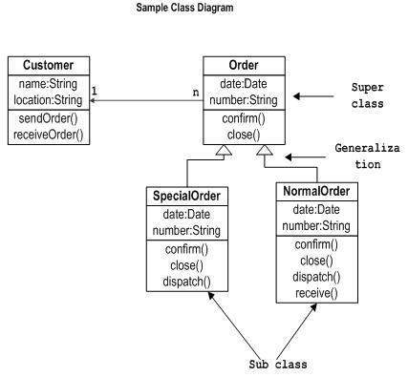Practice 1:Draw a Class Diagram

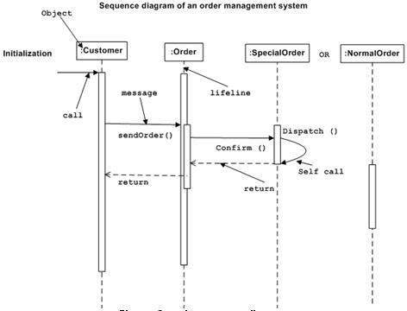

Practice 1: Draw aSequence Diagram

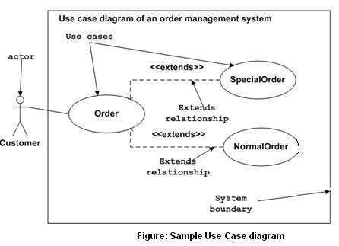Practice 1: Draw a Case Diagram

Practice 1: Draw a Activity Diagram

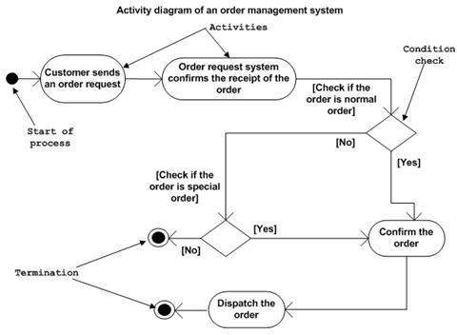

**Database(SQL)**

Configuration:

Install PostgreSQL from the below given site.

* <https://www.filehorse.com/download-postgresql-64/>

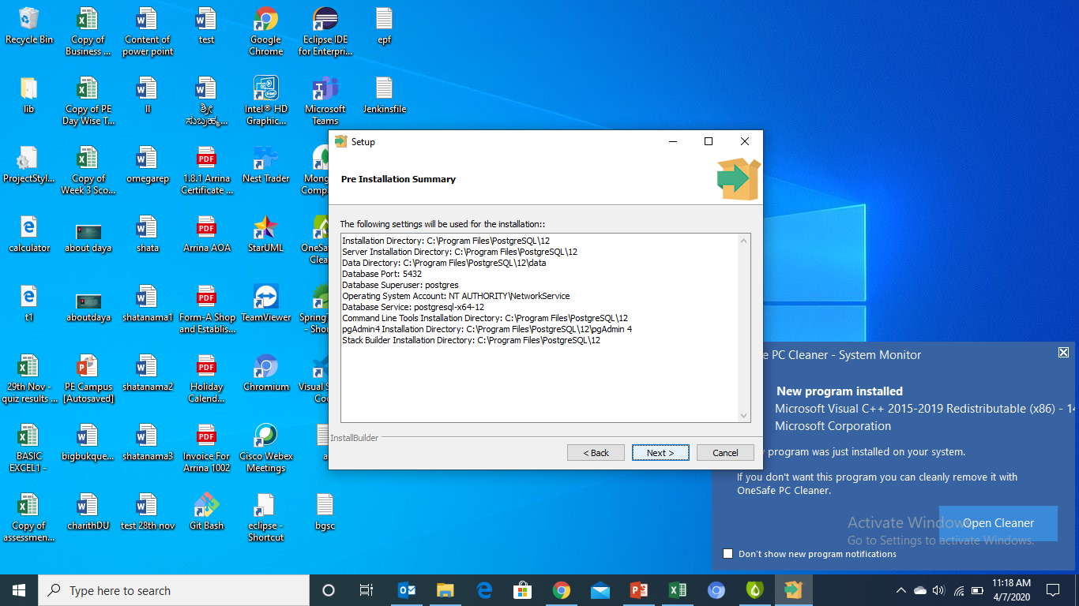

Practice

1. Login to PostgreSQL (command prompt)
2. Create a Database PJPpractice
3. Display all the database
4. Change the data base to PJPpractice
5. Display all the tables.
6. Create a table test ( id integer fname character(30);

After creating the table do the following

1. Add a column lanme to the table test
2. Rename the columnname lanme to last_name
3. Add the constraint primary key to the column id
4. Drop the column last_name
5. Rename the table name to test1.

Question EFddl, efdmland efques file are attached along with this. Create the tables as givne in efddl, and insert the data as shown in the efdml finally execute all the query given in efques file.

Store the query and select command for the query in a file and push it to the git.

**NoSQL(MongoDB)**

Configurations:

Download and install MongoDB from Mongodb.com.

Practice

1. Create a database called mongotest
2. Change to mongotestdb
3. Create collection Employee which has id, fname, salary array for 12months(jan..dec), city
4. Insert data at list 12 data into Employee collection
5. Practice CRUD operations.

Questions:

 Write a MongoDB query on Employee collection

1. to display all the documents in the collection.

db.mongotestdb.find().pretty()

2. to display the fields _id, fname for all the documents in the collection.

db.mongotestdb.find({},{"fname":1})

3.  to display the all fields but exclude the field id for all the documents in the collection.

db.mongotestdb.find({},{"id":0}).pretty()

4 to display the first 5 Employees

db.mongotestdb.find({},{"id":0}).pretty()

5.to display the next 5 Employees after skipping first 5

db.mongotestdb.find().limit(5).skip(5).pretty()

6.  to find the Employee who stay in Gurgaon city

db.mongotestdb.find({"city":"Gurgaon"})

7.  to find the Employee who jan salary is less than 20000

8.  to find the Employee who jan salary is less than 20000 and who stay in Gurgaon city.

9. to find the total salary of jan month for all the employee.

10. count how any employee stay in Gurgaon city.