AMDSF: An Agentic Multi-Domain Space Mission Decision Support Framework
Dhivya V.  Department of Computer Science and Engineering  Sri Eshwar College of Engineering  Coimbatore, India | Ms.S.Saradha.  Department of Computer Science and Engineering  Sri Eshwar College of Engineering  Coimbatore, India | Dhanushya T.  Department of Computer Science and Engineering  Sri Eshwar College of Engineering  Coimbatore, India | Devadharsini S.  Department of Computer Science and Engineering  Sri Eshwar College of Engineering  Coimbatore, India

Abstract— Space mission design requires the coordinated assessment of orbital debris, space weather, mission feasibility, and satellite coverage. This paper presents AMDSF (Agentic Multi-Domain Space Mission Decision Support Framework), a web-based multi-agent architecture that integrates four specialized domain agents through a shared mission profile and a central orchestrator. The debris agent retrieves Two-Line Element (TLE) data when available, performs SGP4 orbital propagation, transforms coordinates using Astropy, and applies cKDTree-based spatial filtering and time-of-closest-approach screening with numerical refinement. The weather agent evaluates external NOAA SWPC and NASA DONKI results through rule-based classification, but returns an unavailable status when required feeds cannot be obtained. The feasibility agent checks a configured prototype vehicle catalog, payload, orbit, duration, and budget constraints. The coverage agent provides a documented prototype estimate; population reach and revisit time are unavailable in the current implementation. The orchestrator combines domain-level statuses into a reviewable recommendation and blocks full readiness interpretation when required information is missing. In the China Earth Observation Mission execution reported here, the absence of mission TLE information produced an insufficient-data debris result, unavailable weather data produced an unavailable weather result, and the orchestrator returned readiness 35 as an incomplete-data handling outcome rather than validated mission readiness. The paper distinguishes implemented software functionality, unit-tested behavior, prototype estimates, and independently validated scientific results.
Index Terms-Agentic systems, space mission planning, space situational awareness, orbital debris, space weather, mission feasibility, satellite coverage, multi-objective optimization, multi-agent systems, decision support.
I. Introduction
Modern mission planning requires that decisions be made with regard to a number of technical aspects. An orbit selected for its ability to access a target may also dictate a degree of exposure to conjunctions and a revisit behavior [1], [2], [3]; a launch epoch may meet the needs of an orbital geometry but encounter incompatible space-weather conditions at the same time; and a vehicle configuration that meets the payload requirements may exceed budgetary or mission-duration constraints. When the aspects are analyzed with stand-alone software tools, the same mission assumptions may need to be submitted multiple times and the outcome of analysis in separate domains may not be comparable or reveal conflicts to a final decision-maker. The proposed architecture addresses this integration gap by emphasizing a shared mission context. The planner defines the mission once, four domain agents evaluate that profile independently and an orchestrator combines the returned evidence into an auditable recommendation record. The focus is on traceable integration rather than autonomous mission execution.
The point of this work is to describe an explicit software architecture for preliminary multi-domain mission assessment. This architecture aims to (i) maintain a coherent mission specification across all modules, (ii) expose domain assumptions and outputs as opposed to hiding them in a composite score, (iii) maintain cross-domain conflicts during synthesis, and (iv) provide recommendations that are subject to human review. An additional goal is to distinguish implemented prototype functions from future research components so that simulation-mode demonstrations are not mistaken for validated operational capability.
Unlike conventional approaches that address individual mission domains through separate analysis workflows, AMDSF provides a unified architecture in which specialized agents evaluate a common mission profile. Its primary contribution is the coordination of heterogeneous domain assessments through a centralized orchestrator while preserving the outputs of individual agents. This enables mission planners to examine multiple mission-related conditions, identify potential conflicts, and review consolidated recommendations within a single decision-support environment. The framework builds upon established domain-specific techniques rather than claiming the development of new orbital or environmental algorithms. Its focus is on modular integration, shared mission-context management, and coordinated decision support with human oversight.

The main contributions of the proposed work are:
- Developing a shared mission-context architecture integrating orbital debris, space weather, mission feasibility, and satellite coverage assessments.
- Implementing specialized domain agents with distinct responsibilities and defined assessment outputs.
- Integrating the domain agents through a centralized orchestration mechanism to generate consolidated mission recommendations.
- Implementing a web-based prototype that demonstrates multi-domain mission assessment through a simulation-mode mission scenario.
- Identifying implementation limitations and establishing a validation-oriented direction for future work.
The structure of this paper is as follows. Section II provides a survey of the literature that supports the four problem domains of the analysis and describes the integrated model of multi-agent. In Section III, the mission representation is defined; the end-to-end process is described; agents’ roles and orchestration mechanism; and the application interface. In Part IV report the figures obtained from prototype development; describe the current evaluation strategy; identify the primary limitations. Finally, Part V concludes the paper and outlines the next steps of research.
II. Literature Survey
The literature supporting the architecture can be grouped into five themes: orbital-debris evolution and conjunction analysis; space-weather observation and forecasting; constraint handling and multiobjective optimization; satellite coverage and mission analysis; and agent-based decision systems. The cited works provide foundational knowledge relevant to each agent in the architecture, and the current work attempts to unify all of these contributions in a single mission-support context, rather than proposing new algorithms for propagation, forecasting, or optimization.
The foundational works on orbital debris begin with the observational theories of Kessler and Cour-Palais on breakup-driven collision risk dynamics, and the EVOLVE breakup model for characterizing evolving debris environments [4], [5]. Vallado et al. describe the SGP4 orbital propagation algorithm for TLE-based conjunction analysis [6]. NASA’s own procedures for collision avoidance and probability analysis distinguish between screening processes and the covariance analysis required to assess a realistic probability of collision [4], [9]–[11]; this is important context, as the debris agent described in this paper performs only the screening tasks, without attempting a full dynamic analysis of the uncertainty. In the space-weather domain, Camporeale et al. survey machine learning methods for nowcasting and forecasting, while Bobra et al. and Couvidat et al. evaluate machine learning techniques for solar-flare prediction [10], [11]. Finally, the operational context for space-weather prediction is provided by NOAA SWPC and NASA DONKI, whose human analyst teams represent the rule-based procedures implemented in the current weather-forecasting module [12], [13].
The optimization literature provides a pathway to extending the rule-based feasibility module. Deb and others have developed NSGA-II, a multi-objective evolutionary optimization algorithm; Coello Coello has provided a survey on constraint-handling methods [14], [15]. Research on satellite range-scheduling and constellation-design [16], [17] show the relevance of these methods for space operations. Walker's formulation of constellations and Wertz and Larson's mission-analysis treatment provide the geometric relationship of orbit, access, coverage and revisit [2], [3]. Wooldridge, Jennings, and Russell and Norvig provide foundational concepts on multi-agent and intelligent-agent systems, respectively [18]–[20]. Together, these works provide justification for the architectural choice of specialized agents, connected by a shared mission context. The resulting research gap is primarily integrative; heterogeneous domain results must be consistent, explainable, traceable when presented as one planning workflow.
Ref. | Focus Area | Key Contribution | Relevance to Proposed Architecture
[4], [5] | Orbital debris | Debris growth and breakup environment modeling | Motivates persistent debris awareness
[6] | Orbit propagation | SGP4 propagation and TLE-based analysis | Foundation for current debris agent
[4], [9]- [11] | Conjunction assessment | Screening practice and collision-probability methods | Defines the boundary between screening and operational PC
[10], [11] | Space-weather ML | Forecasting surveys and solar-flare prediction | Motivates future learned forecasting
[12], [13] | Operational weather | NOAA SWPC and NASA DONKI data products | Context for current weather agent
[14], [15] | Optimization | NSGA-II and constraint-handling methods | Basis for future feasibility optimization
[5]- [6], [2]- [3] | Coverage & mission analysis | Scheduling, constellation design, and mission trade-offs | Supports coverage model and future optimization
[18]-[20] | Agent-based systems | Multi-agent and intelligent-agent foundations | Supports shared-context architecture
Table 2.1. Summary of Literature Survey
Research Gap and Architectural Positioning
The reviewed literature establishes the importance of individual techniques for orbital propagation, conjunction assessment, space-weather monitoring, mission feasibility analysis, and satellite coverage estimation. These techniques provide the methodological foundations for their respective mission domains. AMDSF builds upon these established approaches by integrating their assessments within a shared mission-context architecture. The proposed framework connects four specialized agents through a centralized orchestrator, enabling consistent mission inputs, coordinated domain-level outputs, and consolidated recommendations. Its architectural contribution lies in the integration and coordination of heterogeneous mission assessments rather than the introduction of new domain-specific algorithms.
Aspect | Existing Domain-Specific Approaches | AMDSF
Orbital Analysis | Specialized orbital analysis methods | Debris Agent
Weather Assessment | Separate environmental analysis | Weather Agent
Mission Feasibility | Constraint-based assessment | Feasibility Agent
Satellite Coverage | Geometric coverage analysis | Coverage Agent
Mission Context | Domain-dependent inputs | Shared Mission Profile
Assessment Coordination | Domain-level processing | Central Orchestrator
Recommendation | Individual domain outputs | Consolidated Mission Recommendation
Human Review | Application-dependent | Human-in-the-Loop Workflow

Table 2.2. Architectural Positioning of AMDSF

III. Workflow
A mission request is expressed with M = {O, T, L, V, Q, E, B, C}, with O being the mission objective, T the target region, L the launching site or country, V the launch vehicle, Q the orbit, E the target epoch, B the description of the budget and the payload enve- lope, and C other constraints. Four domain functions operate on this shared representation: D(M), debris; W(M), space weather; F(M), feasibility; and G(M), coverage. The mission orchestrator produces a reviewable synthesis R = Oᵣ (D, W, F, G, M). A fundamental design requirement is that L and T be kept as distinct entities; a target region is what the mission is intended to observe and serve, not the location from which it is launched or landed. This distinction allows for exchange of different mission types while preserving the intent of each. The system retains information about the sources, assumptions, domain outputs,es and conflicts, so that the final recommendation is not an inscrutable black box but something that can be reasoned about.
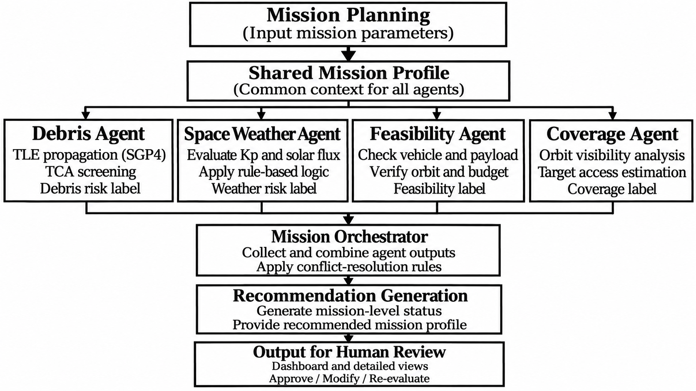
Fig. 3.1. End-to-end workflow of the AMDSF multi-agent decision-support architecture.
The prototype follows the pipeline Mission Planning → {Debris, Weather, Feasibility, Coverage} → Mission Orchestrator → Recommendation. The mission-planning wizard creates a shared flight profile, after which the agents consume it and return structured assessments. When valid mission and catalog TLEs are supplied, the debris agent propagates objects via SGP4, applies cKDTree spatial filtering, and refines the time of closest approach. The weather agent classifies available NOAA SWPC Kp and NASA DONKI CME information using configured rules, or returns an unavailable state if external retrieval fails. The feasibility agent evaluates the configured prototype vehicle catalog, payload, orbit, duration, and budget constraints. The coverage agent computes a bounded swath-based prototype estimate; it does not currently provide validated access geometry, population reach, or revisit events. The orchestrator applies rule-based status and conflict handling and does not autonomously launch a spacecraft.

Agent Interfaces and Orchestration Mechanism
The four domain agents operate on a common mission profile while performing separate domain-specific assessments. Each agent processes the relevant mission parameters and returns its assessment to the central orchestrator. The debris agent evaluates orbital-object proximity using TLE-based propagation and spatial screening. The weather agent classifies environmental conditions using available space-weather indicators. The feasibility agent checks engineering and budget constraints, while the coverage agent estimates target accessibility and revisit characteristics. The orchestrator receives these domain-level outputs and applies its coordination logic to generate a consolidated mission recommendation. Individual agent assessments remain identifiable, allowing users to inspect domain-level results and understand their contributions to the final recommendation. Human review remains essential before accepting the proposed mission configuration.

Agent | Input Parameters | Processing Responsibility | Output
Debris Agent | Mission orbit, TLE data | SGP4 propagation, KD-tree filtering and TCA screening | Candidate encounters and risk classification when valid TLE data are available; otherwise explicit data status
Weather Agent | Kp, solar flux, CME and geomagnetic indicators | Threshold- and event-based evaluation | Weather classification or unavailable status with source metadata
Feasibility Agent | Vehicle, payload, orbit and budget | Mission constraint checking | Feasibility status and prototype cost estimate
Coverage Agent | Orbital parameters and target region | Visibility and revisit analysis | Prototype coverage estimate; population and revisit unavailable in current implementation
Mission Orchestrator | Outputs from four agents | Rule-based coordination and conflict resolution | Consolidated recommendation with missing-data handling
Table 3.1. Functional Responsibilities of AMDSF Domain Agents
The web application has been developed with seven primary views including Dashboard/Mission Operations console, Mission Planning, Debris Intelligence, Space Weather, Mission Feasibility, Coverage Intelligence, and Recommendation. The repository link is https://github.com/dhivya-1010/AMDSF.git. The views share a mission context. The figures show a simulation-mode China Earth Observation Mission targeting the Beijing Metropolitan Area from a configured 550 km low Earth orbit and using the configured 2026-10-15 preferred date. These are configured scenario inputs and interface illustrations, not evidence that the displayed values are measured orbital, environmental, coverage, or operational results.
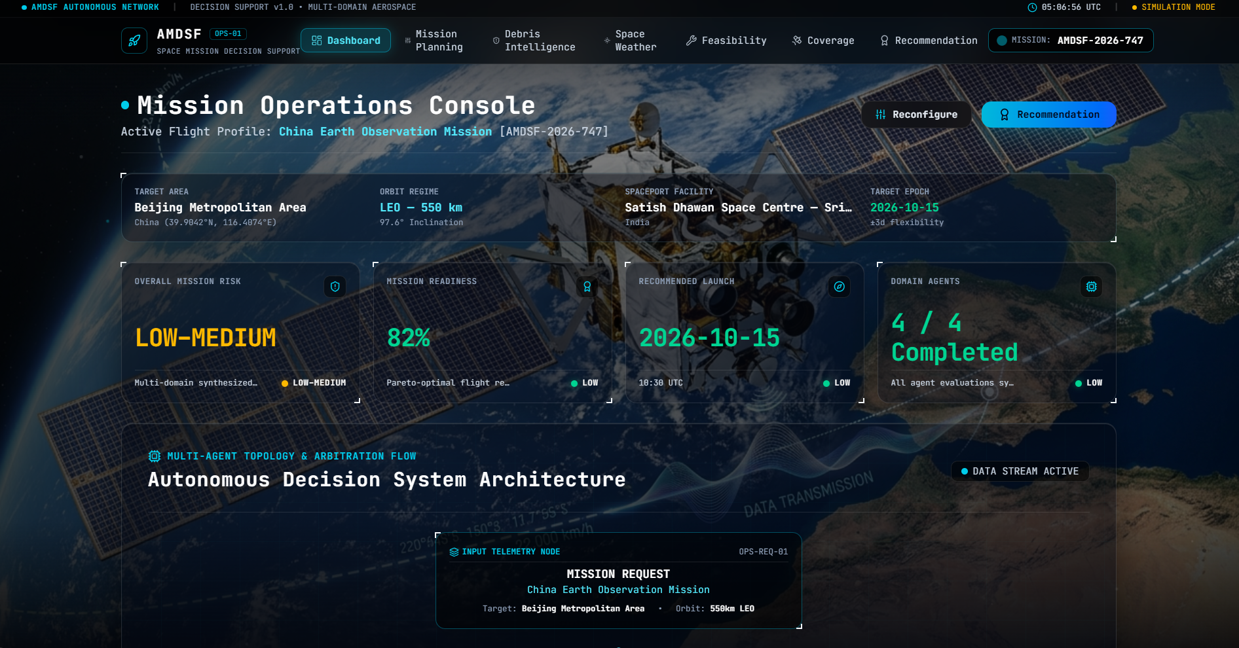
Fig. 3.2. Mission Operations Console showing the shared mission context and synthesized status.
Mission Operations Console provides a single-window view of the mission by graphically displaying the current mission profile with target region, orbit, launch pad, mission risk, readiness, recommended launch date, and completion for each of the domain agents. In addition, the dashboard shows the multi-agent topology and arbitration flow that visually represents how the autonomous decision support system is analyzing the mission domain and combining the analysis to form a recommendation. Using the console, one can view the mission conditions, analyze the results, and make decisions.
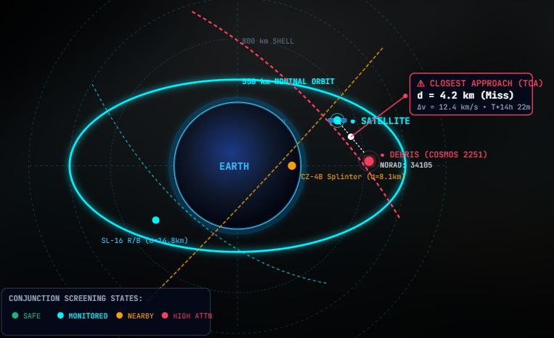
Fig. 3.3. Satellite-debris conjunction risk screening.
The diagram is an interface illustration of the debris-screening workflow, not a verified conjunction measurement. In the executed China scenario, mission TLE information was not supplied and the CelesTrak retrieval was unavailable; consequently, the backend returned INSUFFICIENT_DATA and did not calculate a minimum separation, relative velocity, TCA, nearby-object count, or debris-risk score.
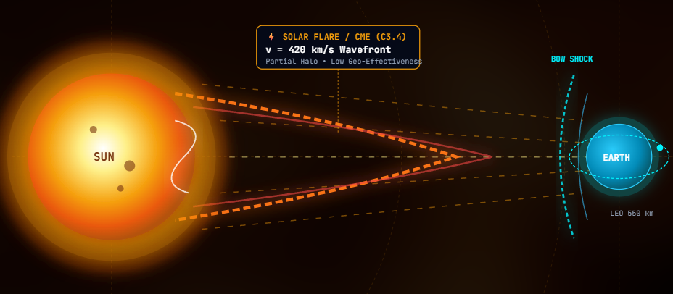
Fig. 3.4. Space-weather agent assesses solar activity and mission weather risk.
The Weather Agent requests environmental information from NOAA SWPC and NASA DONKI and applies the configured threshold rules only when the required observations are available. If external retrieval fails, the corrected implementation returns an unavailable status rather than presenting stale or synthetic Kp, CME, or solar-environment values as current observations.
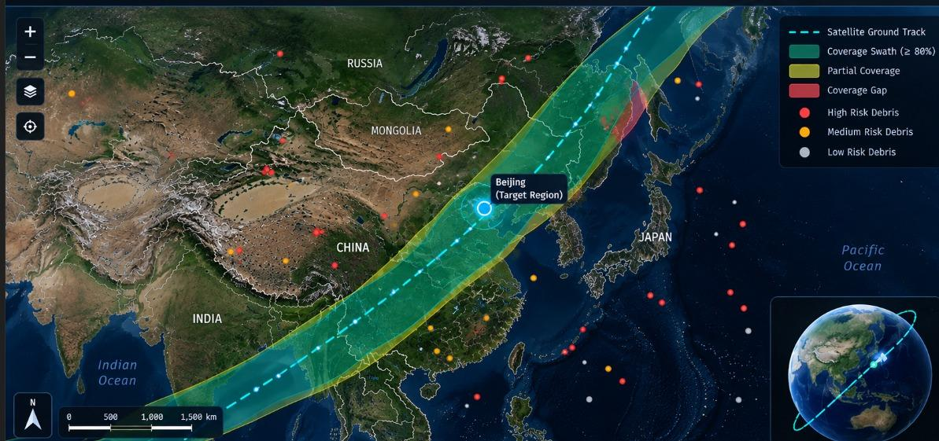
Fig. 3.5. Prototype coverage estimate and configured target context; validated ground-track and debris-risk visualization are not available in the current implementation.
The figure should be read as an interface illustration of the configured target and coverage workflow. The current backend produces a bounded prototype coverage estimate from configured altitude, target radius, latitude, and inclination inputs. It does not generate validated ground-track access geometry, population reach, revisit events, or debris-risk zones; therefore the figure does not establish those measurements.
The study considers ten interconnected capabilities. The first seven are implemented to varying degrees in the current prototype, while the remaining items are limitations or proposed evaluation requirements:
- A mission specification shared between all views.
- TLE/SGP4 propagation and catalog screening when valid mission and catalog TLE data are available [6].
- cKDTree spatial filtering and numerical time-of-closest-approach screening for candidate objects [4], [9]–[11].
- Rule-based monitoring of NOAA SWPC Kp and NASA DONKI CME information when external data are available [12], [13].
- Vehicle, payload, orbit, duration, launch-site, and budget constraint checking against a configured prototype catalog.
- A bounded prototype coverage estimate; validated satellite visibility, population reach, and revisit analysis are not implemented.
- Rule-based coordination of agent statuses and conflict handling.
- Simulation-epoch display and comparison scaffolding; no validated launch-window calculation.
- Human-readable assumptions, status explanations, and review checkpoints.
- Reproducible source snapshots, formal uncertainty accounting, and a machine-readable audit trail are not established by the current prototype and remain future work.
The main idea is to introduce a shared mission context instead of performing all domain analysis separately. The mission description is defined once and used by all four agents to perform domain analysis. Every agent takes only relevant information, performs a structured analysis, and returns its results to the orchestrator. There is no need to input the same information multiple times as it is used as a single source of information for all domains. The information includes mission objective, region of target, launch location, launch vehicle, payload, orbit, launch time, budget, weather constraints, and coverage requirements.
The shared context includes user-configured mission requirements and each agent's status and outcome. The debris agent may add measured encounter data only when valid TLE inputs and propagation succeed; the weather agent adds source status and environmental data when feeds are available; the feasibility agent adds prototype-catalog compatibility and cost estimates; and the coverage agent adds its prototype estimate while explicitly marking population and revisit data as unavailable when unsupported.
The architecture supports traceability at the level of returned inputs, calculations, statuses, and explanations, but it should not be described as a complete audit trail. A full reproducible record would additionally require frozen external responses, timestamps, configuration snapshots, software versions, and machine-readable lineage for each execution.
For preliminary assessment, the mission can be seen as a constrained multi-objective problem, where x represents the decision variables to be optimized, including orbital parameters, candidate launch time, vehicle type, and other configurable mission parameters. The system considers four objective functions, representing debris exposure, weather suitability, mission feasibility, and coverage performance, F(x) = [f_d (x), f_w (x), f_f (x), f_c (x)]. The current implementation does not pursue global optimization over the search space. Instead, these values are utilized to implement rule-based screening and comparison of alternative candidates [14], [15].
The debris component utilizes a screening criterion based on the tracks of propagated space objects and a user-defined distance threshold. For each space object, the minimum distance to the mission spacecraft is calculated over the analysis period, and only those objects that satisfy the screening criterion are used for conjunction assessment. This allows a fast first-pass screening, and acknowledging that an actual conjunction assessment requires uncertainty information and collision probability calculations [4], [9]–[11].
The weather component uses threshold- and event-based rules over available source data. The result is a rule-based screening classification, not a statistically validated forecast. When NOAA SWPC or NASA DONKI retrieval fails, the current implementation reports unavailable data and does not substitute stale fallback observations.
Space-Weather Data Sources and Assessment Criteria
The space-weather agent requests planetary Kp information from NOAA SWPC and CME event information from NASA DONKI. When available, Kp ≥ 6 produces HIGH risk, Kp ≥ 4 or at least three CME events produces MEDIUM risk, and other available conditions produce LOW risk. A separate geomagnetic-storm flag uses Kp ≥ 5. These are rule-based classifications of timestamped external data, not validated forecasts. In the China execution, both external feeds were unavailable, so no live Kp or CME measurement was reported.

Indicator | Information Evaluated | Assessment Method
Planetary Kp Index | Geomagnetic activity level | Threshold-based classification
CME Events | Number of detected coronal mass ejection events | Event-count-based classification

Table 4.3. Space-Weather Assessment Parameters
The feasibility aspect evaluates the mission against configured vehicle, payload, orbital, duration, launch-site, and budget constraints. Coverage is reported separately as a prototype performance estimate rather than as validated access or revisit analysis.
Mission Feasibility Evaluation Criteria
The feasibility agent evaluates compatibility with a configured prototype vehicle catalog. The current catalog contains nominal capacities and base costs for three prototype vehicle classes, and the estimated lifecycle cost is calculated as base_cost_m × (1 + duration_days / 365 × 0.08) × (1 + altitude_km / 1000 × 0.12). The result is compared with the configured budget and is labeled a prototype estimate; it does not represent a validated commercial launch quotation. For the China scenario, the configured 250 kg payload, 550 km orbit, 365-day duration, and 50.0M budget produced a feasible result using the prototype catalog and an estimated cost of 13.8M.
Parameter | Evaluation Criteria | Assessment Purpose
Launch Vehicle | Vehicle capability and mission requirements | Vehicle compatibility
Payload | Payload requirements and vehicle capacity | Payload compatibility
Orbital Parameters | Required orbit and configured constraints | Orbital suitability
Budget | Estimated lifecycle cost and available budget | Cost feasibility
Table 4.4. Mission Feasibility Assessment Parameters
The prototype is realized as a web-based decision support application, in which the domain processing modules are combined with an orchestration layer. The interface provides the user with the main point of interaction, whereas the analytical agents process the shared mission context. The process begins with the mission-planning wizard, which validates the request and constructs a standardized mission profile. The orchestrator then conveys the message to the different domain modules, which collate their outputs, and present their finding in a consolidated status view.
For orbital screening, TLE data are propagated using SGP4 [6]. A cKDTree spatial-filtering stage reduces the number of objects subject to time-based inspection at synchronized propagation timestamps. Encounter records may contain object identifiers, closest-approach time, relative separation, and relative velocity when the required data and propagation succeed. The process is preliminary screening and does not replace operational conjunction assessment.
Orbital Data Configuration and Debris Screening Procedure
The debris assessment module retrieves TLE records from CelesTrak and validates record format, checksums, and freshness before propagation. The Python sgp4 implementation propagates the mission satellite and catalog objects over UTC timestamps. SGP4 states are returned in TEME and transformed to ITRS/ECEF using Astropy before spatial calculations. scipy.spatial.cKDTree identifies candidate objects at matching timestamps. For retained candidates, relative position, Euclidean separation, and relative velocity are calculated, and the sampled minimum-separation epoch is refined numerically. The resulting records support preliminary screening and configurable risk classification only. No covariance-aware collision probability is calculated. If mission TLE data or valid catalog data are unavailable, the result is explicitly insufficient_data rather than a fabricated encounter measurement.
Parameter | Configuration / Description
TLE Data Source | CelesTrak General Perturbations (GP) data service
TLE Validation | Format and checksum validation
Propagation Method | SGP4
SGP4 Implementation | Python sgp4 library
Coordinate Transformation | TEME to ITRS using Astropy
Time Standard | UTC
Spatial Filtering | KD-tree using scipy.spatial.cKDTree
TCA Calculation | Sampled minimum separation with bounded numerical refinement
Relative Separation | Euclidean distance in kilometres
Relative Velocity | Calculated from propagated velocity vectors in km/s
Table 4.2. Orbital Debris Assessment Configuration
For space-weather processing, the system requests source-specific NOAA SWPC and NASA DONKI responses. The weather agent records retrieval status and source metadata and returns unavailable when required external data cannot be obtained. Vehicle and cost information remain structured prototype assumptions rather than authoritative launch-provider data.
Coverage processing in the current implementation is limited to a deterministic swath-based prototype estimate. It does not calculate full Earth geometry, validated sensor access windows, population reach, or revisit events. Those metrics remain unavailable unless the required datasets and access propagator are added and independently validated.
Satellite Coverage and Revisit Estimation
The coverage agent computes swath_width_km = orbit_altitude_km × 1.85 and applies the documented bounded estimate coverage = clamp(85 + min(1, swath / max(50, 2 × radius)) × 12 + inclination_boost, 65, 99.4). The output is labeled prototype_estimate. Population reach is unavailable because no attributed population dataset is configured, and revisit time is unavailable because no orbit/sensor access-event propagator is configured. The estimate is not validated orbital coverage and should not be described as a measured ground-track or revisit result.
Parameter | Description | Assessment Purpose
Orbital Parameters | Orbit altitude and configured inclination | Inputs to bounded prototype coverage estimate
Target Region | Configured geographic target and radius | Define target context for the prototype estimate
Sensor Geometry | Swath approximation and inclination adjustment | Compute prototype coverage percentage; not validated access geometry
Ground Track | Not generated by current backend | Validated ground-track analysis unavailable
Coverage Gaps | Not calculated by current backend | Coverage gaps are not validated access gaps
Revisit Time | Not calculated by current backend | Revisit time unavailable without access-event propagation
Population Data | No attributed population dataset configured | Population reach unavailable
Table 4.5. Satellite Coverage Assessment Parameters
The architecture was designed to support the decision-making process, not to dictate mission authorizations through automation. Human approval is required both when defining the candidate set and when recommending a specific mission plan. This allows a human engineer to tweak assumptions, reject a candidate, or reevaluate the supporting domain results before the launch window is finalized. This is especially valuable when incomplete inputs, conflicting constraints, or an out-of-context rule produce unacceptable results.
The explanation layer is thus a vital component of the system, where for each recommendation it is useful to weigh the supporting factors, assumptions, and uncertainties. A candidate may fit within the vehicle and payload constraints but appear to have higher debris risk and lower target access during a specific temporal segment, which will have to be evaluated by the mission analyst. Instead of an automated final score, such scenarios should be resolved by presenting the trade-offs between different metrics.
The human-in-the-loop design supports repeatable reruns when the same mission inputs and available external data are supplied. It does not by itself provide reproducibility: external responses, retrieval timestamps, configuration snapshots, and execution artifacts must be preserved for a research-grade record. Those provenance and audit mechanisms remain future work.
IV. Results and Discussion
Table 4.1 reports one executed China scenario using the corrected repository behavior. Configured mission inputs, computed prototype estimates, and unavailable measurements are labeled separately. The execution was performed on 2026-11-04; external retrieval status and output timestamps are recorded in the scenario log, but the result is not an independently validated experiment.

Interface Metric | China scenario result (execution 2026-11-04) | Source / qualification
Configured mission inputs | 550 km LEO; 250 kg payload; 365 days; 50.0M budget; Beijing target; preferred date 2026-10-15 | User-configured scenario inputs
Mission readiness | 35 | Computed incomplete-data handling outcome; not validated mission readiness
Debris status | INSUFFICIENT_DATA | Computed status; mission TLE absent and CelesTrak retrieval unavailable
Catalog objects analyzed | 0 valid records propagated | Runtime output; not a catalog-size measurement
Nearby objects / minimum separation / relative velocity / TCA | Unavailable | No conjunction screening result was calculated
Debris risk score | Unavailable | No measured encounter; no score substituted
Space-weather status | unavailable | NOAA SWPC and NASA DONKI retrieval failed during execution
Kp index / CME count | Unavailable | No live environmental observation reported
Feasibility status | Feasible | Computed against configured prototype vehicle catalog
Selected vehicle | AeroSpace Small-Lift I (PSLV-Class) | Computed catalog selection
Estimated lifecycle cost | 13.8M | Prototype estimate using documented cost formula; not a commercial quotation
Payload wet mass | 250 kg | Configured mission input
Coverage status / estimate | prototype_estimate / 99.4% | Computed bounded swath estimate; not validated coverage
Population reach / revisit time | Unavailable | No attributed population dataset or access-event propagator
Launch window | Unavailable — complete required data acquisition first | Computed missing-data response; no validated launch window

Table 4.1. Selected corrected China-scenario outputs
The China scenario's 99.4% value is a bounded prototype coverage estimate produced by the configured swath formula. It is not a validated coverage measurement. Population reach and revisit time are unavailable because the current implementation has no attributed population dataset or access-event propagator.
Interpretation of Mission-Level Dashboard Outputs
In the corrected China execution, the orchestrator returned readiness 35 because required debris and weather information was unavailable. This value is an incomplete-data handling outcome, not validated mission readiness. The debris result was INSUFFICIENT_DATA because no mission TLE was supplied and the live catalog could not be retrieved; therefore no minimum separation, relative velocity, nearby-object count, or debris-risk score was measured. NOAA SWPC and NASA DONKI retrievals also failed, so Kp, CME count, and weather risk were unavailable. Feasibility produced a 13.8M prototype cost estimate for the configured mission inputs, while coverage produced a 99.4% prototype estimate with population reach and revisit time unavailable.
The dashboard and comparison views should therefore be interpreted as status and data-flow displays. They do not establish collision probability, launch-window validity, global optimization, weather-forecast skill, demographic reach, or operational mission readiness. A preferred mission date is a configured simulation epoch; the corrected orchestrator does not calculate a validated launch time when required data are missing.
The supplied execution does not constitute a controlled scientific experiment. A reproducible evaluation would require frozen TLE and weather responses, source timestamps, coordinate-frame assumptions, configuration, software versions, independent reference cases, and predefined acceptance criteria. The current unit and integration tests verify selected software behaviors; they do not establish real-world orbital accuracy, forecast skill, validated coverage performance, or operational safety.
•The interface is explicitly marked simulation mode; displayed values are not independently verified experimental measurements.
• TLE/SGP4 propagation with KD-tree screening and TCA does not provide a covariance-aware operational probability-of-collision assessment [4], [9]–[11].
• Rule-based weather classification is not a statistically trained forecast and depends on configured thresholds and data freshness.
• Feasibility conclusions depend on the completeness and currency of vehicle, payload, orbit, and cost assumptions.
• Coverage estimates are sensitive to orbit parameters, sensor geometry, target boundaries, elevation masks, sampling, and population data.
• Rule-based orchestration keeps priorities inspectable but does not establish global optimality or calibrated mission risk.
• A functional web interface demonstrates workflow integration but does not by itself establish scientific validity or operational reliability.

A complete evaluation should combine software-level verification with domain-specific validation. Existing tests can verify mission-profile parsing, parameter propagation, coordinate handling, threshold evaluation, unavailable-data handling, and aggregation behavior. Independent validation remains necessary for SGP4 reference cases, conjunction screening, weather classification, feasibility assumptions, and coverage geometry.
Debris propagation should be compared with independently documented SGP4 reference cases, and conjunction screening should be evaluated with controlled trajectories having known closest approaches. Weather classifications should be tested against timestamped source observations under fixed thresholds. Feasibility should be tested at payload, altitude, duration, and budget boundaries. Coverage validation requires an independent access-geometry simulator and attributed population data; these are not supplied by the current prototype.
Performance measures such as execution time, agent latency, catalog size, candidate count, and memory usage should be reported only from controlled benchmark runs with a specified environment. They are not established by the current manuscript execution.

Scenario | Test Configuration | Evaluation Objective
S1 – Baseline Mission | Nominal mission parameters | Verify normal agent execution
S2 – Dense Debris | Increased orbital-catalog size | Evaluate debris-screening behavior
S3 – Adverse Weather | Adverse environmental indicators | Verify weather classification
S4 – Restrictive Feasibility | Modified payload or budget constraints | Evaluate feasibility decisions
S5 – Coverage Variation | Modified orbit or target region | Evaluate coverage and revisit estimates

Table 4.6. Proposed Experimental Scenarios for AMDSF Evaluation
The proposed evaluation scenarios provide a structured basis for assessing the behavior of the four domain agents under different mission conditions. Each scenario is intended to modify specific mission parameters while maintaining the remaining inputs consistently, enabling the effects of individual changes to be examined. The evaluation should consider domain-specific correctness, consistency of agent outputs, repeatability of recommendations, and the ability to identify conflicting mission constraints. These scenarios represent a proposed evaluation protocol and are not reported as completed experimental results in the current prototype study.
Performance Metric | Evaluation Method | Purpose
End-to-End Execution Time | Measure total workflow execution time | Evaluate overall response time
Agent Execution Time | Record individual agent processing time | Identify computational bottlenecks
Memory Consumption | Measure memory usage during execution | Evaluate resource requirements
Catalog Processing | Record number of orbital objects processed | Assess debris-processing workload
Candidate Encounters | Count objects retained after spatial filtering | Evaluate screening effectiveness
Scalability | Repeat tests with increasing catalog sizes | Examine scaling behaviour
Repeatability | Execute identical scenarios multiple times | Check consistency of outputs
Table 4.7. Performance Metrics for AMDSF Evaluation
The performance metrics provide a basis for evaluating the computational efficiency and scalability of AMDSF. Execution time and memory consumption should be measured under a controlled environment using consistent mission configurations and increasing orbital-catalog sizes. Individual agent latencies and end-to-end execution time can help identify processing bottlenecks, while the number of retained candidate encounters indicates the workload reduction achieved during debris screening. Repeated executions using identical inputs can further assess the consistency of the generated outputs. These metrics define the proposed benchmarking methodology; quantitative performance results are not established in the current simulation-mode demonstration.
Human factors should be assessed independently from numerical correctness. Mission engineers should be able to identify the assumptions underlying a recommendation, trace individual warnings to their originating agents, and determine how the recommendation changes when mission parameters are modified. A future user study can therefore examine task-completion time, error identification, explanation comprehension, and decision consistency across controlled scenarios.
Use toward operational research would require stronger provenance and configuration controls. Each analysis should preserve mission inputs, TLE and weather source responses, retrieval timestamps, threshold configuration, coordinate-frame assumptions, software versions, and agent outputs. The current prototype exposes selected statuses and assumptions but does not yet provide a complete machine-readable audit trail.
The system should also maintain a clear distinction between authoritative inputs and derived outputs. Raw source measurements and catalog records should be separated from propagated states, filtered encounters, classifications, and recommendation text. This will allow upstream data sources to be replaced without modifying the underlying analytical logic, and reduce the possibility of a derived status being mistaken for an original observation.
Conventional preliminary mission studies often divide analysis into domain-specific activities performed using separate tools or by different teams. Such workflows can provide detailed specialist analysis, but require mission assumptions to be repeatedly transferred between tools. The proposed architecture addresses this integration challenge by maintaining a common mission context and explicitly connecting the outputs generated by each domain. The contribution is therefore primarily architectural and workflow-oriented; it does not claim novelty for the individual propagation, weather, feasibility, or coverage algorithms considered independently.
The modular architecture permits future replacement of domain modules while preserving shared interfaces. Future work could add covariance-aware probability-of-collision analysis, statistical space-weather models, validated access geometry, attributed population datasets, and optimization methods. None of these capabilities should be inferred from the current prototype.
The architecture is suitable as a platform for controlled software experiments, but reproducibility claims require preserved inputs, external-response snapshots, configuration, environment, and output artifacts. Those materials are not fully bundled with the current manuscript execution.
For research use, the prototype can be exercised using a fixed set of representative mission scenarios. Each scenario defines the same core mission profile, but varies a controlled parameter (such as orbit altitude, inclination, candidate epoch, target region, payload class, or budget limit) in order to separate the behavior of the architecture from uncontrolled changes in the mission scenario. This approach also enables a comparison of the response of the four agents under repeatable conditions.
A baseline scenario serves to ensure that all four agents receive the same mission identifiers and parameters. Additional stress scenarios can be generated by a dense orbital catalog, adverse environmental indicators, a restrictive payload constraint, a demanding coverage requirement, or other means. The expected mission result may not be feasible, but the system should correctly expose the constraint or conflict that precludes a candidate from satisfying the configured requirements.
Parameter-sensitivity experiments can help identify discontinuities introduced by rule thresholds. For example, a small change to an environmental indicator near a configured boundary may toggle the weather status from nominal to watch. Recording the input value and the resultant classification allows researchers to determine if the threshold behavior is intentional and whether the interface communicates the change clearly. Similar tests can be made for debris screening distance, budget limits, payload compatibility, and coverage thresholds.
The same scenario framework can also be used to compare rule-based and learning-based agents. A learning-based replacement receives the same normalized mission context and produces output through the same interface contract. The researcher can therefore compare the accuracy, latency, explanation quality, and sensitivity in a controlled manner without modifying the surrounding application. This represents a controlled pathway for introducing machine-learning components while retaining the transparency of the current rule-based architecture.
A demonstration result is not a validated scientific result. Interface percentages, readiness indicators, and status labels describe configured inputs, computed prototype outputs, or data availability. The present paper therefore treats the system as an architectural proof of concept and identifies the validation steps required before operational claims can be made.
The current prototype distinguishes incomplete information from available measurements through explicit status fields. It does not provide formal uncertainty accounting or covariance-based uncertainty propagation. Future work may attach uncertainty descriptors to debris, weather, feasibility, and coverage outputs after the required methods and datasets are implemented.
When catalog or weather data are unavailable or stale, the interface should identify that status rather than present a current observation. This distinction is essential because a missing-data state is not evidence of nominal environmental conditions or mission safety.
The orchestrator avoids treating missing measurements as safe results and returns an incomplete-data recommendation state. It does not silently infer unavailable parameters, and its readiness value under missing-data conditions must not be interpreted as an engineering assurance.
The modular design also enables the number of mission scenarios as well as the number of analytical modules to scale independently. Scenario-level parallelism can be exploited by analyzing candidate launch epochs or orbital configurations in parallel, as long as the domain agents operating on them have access to a shared mission context. The orchestrator can then aggregate results of these tasks asynchronously to a shared mission identifier.
Scalability is of particular concern for analyzing debris, as the number of potential objects in the space catalog can be large. Processing this space catalog can be optimized by first applying coarse spatial filtering, followed by time-of-closest-approach screening, thus reducing the number of pairwise comparisons required. The current prototype identifies KD-tree filtering for this purpose. The current prototype can be expanded in future work to other approaches such as alternate indexing schemes, batch orbit propagation, caching of repeated states, distributed execution, and more, depending on the growth of the catalog and the analysis period.
The scalability considerations would also need to affect the data layer, as external space-weather feeds, orbital catalogues, vehicle databases, and target datasets might have incompatible update schedules or data representations. By normalizing the internal representation of this data, the individual agent could be made resilient to updates to its source adapters. This would decouple the source-specific updates from the rest of the processing pipeline, and would also enable experimenting with replacing one source by another.
A research-grade reproducible record would need to capture the mission profile, external input snapshots, retrieval timestamps, configuration parameters, software version identifiers, agent outputs, and recommendation text. The current prototype provides selected provenance fields and human-readable explanations, but a complete machine-readable audit trail remains future work.
Such an audit trail would support diagnosis of input anomalies, retrieval failures, propagation errors, threshold behavior, and aggregation rules. At present, reviewers should use the repository code, test outputs, and execution logs together; the dashboard alone is not a sufficient scientific record.
V. Conclusion and Future Work
This paper presented a unified agentic architecture for preliminary multi-domain space-mission decision support. The current prototype integrates TLE/SGP4 debris screening with Astropy TEME-to-ITRS transformation, cKDTree filtering, and numerical TCA refinement when valid orbital data are available; rule-based NOAA SWPC/NASA DONKI weather assessment with explicit unavailable states; prototype vehicle-compatibility and cost estimation; a bounded prototype coverage estimate; and rule-based orchestration. In the reported China execution, missing mission TLE and unavailable external weather feeds led to INSUFFICIENT_DATA and unavailable statuses, and readiness 35 represented incomplete-data handling rather than validated mission readiness. The implementation does not claim collision probability, operational collision avoidance, validated revisit performance, global optimization, or independently validated mission readiness.
Future work should establish frozen datasets, source provenance, external SGP4 reference cases, independent conjunction and coverage validation, attributed population data, formal uncertainty methods, and a machine-readable audit trail. Subsequent extensions may incorporate covariance-aware collision-probability analysis, validated access geometry, statistical weather models, and multi-objective optimization, but these should be reported only after implementation and testing. Human review remains mandatory for any mission decision.
REFERENCES:
[1] NASA, "Spacecraft Conjunction Assessment and Collision Avoidance Best Practices Handbook," NASA, 2023.
[2] J. G. Walker, "Satellite constellations," Journal of the British Interplanetary Society, vol. 37, pp. 559–572, 1984.
[3] J. R. Wertz and W. J. Larson, Eds., Space Mission Analysis and Design, 3rd ed. Torrance, CA, USA: Microcosm Press, 1999.
[4] D. J. Kessler and B. G. Cour-Palais, "Collision frequency of artificial satellites: The creation of a debris belt," Journal of Geophysical Research, vol. 83, no. A6, pp. 2637–2646, 1978.
[5] N. L. Johnson, P. H. Krisko, J.-C. Liou, and P. D. Anz-Meador, "NASA's new breakup model of EVOLVE 4.0," Advances in Space Research, vol. 28, no. 9, pp. 1377–1384, 2001.
[6] D. A. Vallado, P. Crawford, R. Hujsak, and T. S. Kelso, "Revisiting Spacetrack Report #3," in Proc. AIAA/AAS Astrodynamics Specialist Conference, 2006, AIAA Paper 2006-6753, doi: 10.2514/6.2006-6753.
[7] S. Alfano, "Relating position uncertainty to maximum conjunction probability," Journal of the Astronautical Sciences, vol. 53, no. 2, pp. 193–205, 2005.
[8] R. P. Patera, "General method for calculating satellite collision probability," Journal of Guidance, Control, and Dynamics, vol. 24, no. 4, pp. 716–722, 2001.
[9] A. Morselli, R. Armellin, P. Di Lizia, and F. Bernelli-Zazzera, "A high order method for orbital conjunctions analysis: Monte Carlo collision probability computation," Advances in Space Research, vol. 55, no. 1, pp. 311–333, 2015, doi: 10.1016/j.asr.2014.09.003.
[10] E. Camporeale, "The challenge of machine learning in space weather: Nowcasting and forecasting," Space Weather, vol. 17, no. 8, pp. 1166–1207, 2019, doi: 10.1029/2018SW002061.
[11] M. G. Bobra and S. Couvidat, "Solar flare prediction using SDO/HMI vector magnetic field data with a machine-learning algorithm," The Astrophysical Journal, vol. 798, no. 2, Art. no. 135, 2015.
[12] NOAA Space Weather Prediction Center, "Data access and space weather products." [Online]. Available: https://www.swpc.noaa.gov/content/data-access.
[13] NASA, "Open APIs: DONKI (Space Weather Database Of Notifications, Knowledge, Information)." [Online]. Available: https://api.nasa.gov/.
[14] K. Deb, A. Pratap, S. Agarwal, and T. Meyarivan, "A fast and elitist multiobjective genetic algorithm: NSGA-II," IEEE Transactions on Evolutionary Computation, vol. 6, no. 2, pp. 182–197, 2002, doi: 10.1109/4235.996017.
[15] C. A. Coello Coello, "Theoretical and numerical constraint-handling techniques used with evolutionary algorithms: A survey of the state of the art," Computer Methods in Applied Mechanics and Engineering, vol. 191, nos. 11–12, pp. 1245–1287, 2002.
[16] Y.-J. Song, X. Ma, X.-J. Li, L.-N. Xing, and P. Wang, "Learning-guided nondominated sorting genetic algorithm II for multi-objective satellite range scheduling problem," Swarm and Evolutionary Computation, vol. 49, pp. 194–205, 2019, doi: 10.1016/j.swevo.2019.06.008.
[17] Z. Yan, J. Tian, and H. Li, "Optimization of regional coverage satellite constellation by improved NSGA-II algorithm," Chinese Journal of Space Science, vol. 24, no. 1, pp. 43–50, 2004, doi: 10.11728/cjss2004.01.20040107.
[18] M. Wooldridge, An Introduction to MultiAgent Systems, 2nd ed. Chichester, U.K.: Wiley, 2009.
[19] N. R. Jennings, "On agent-based software engineering," Artificial Intelligence, vol. 117, no. 2, pp. 277–296, 2000.
[20] S. Russell and P. Norvig, Artificial Intelligence: A Modern Approach, 4th ed. Hoboken, NJ, USA: Pearson, 2021.

