Milestone 4: Testing, Validation & Security
- Objective: Validate end-to-end flow execution, verify system accuracy, and ensure proper security and access controls.
- Key Deliverables & Actions:
  - End-to-End Functional Testing: Created test tickets (e.g., Short Description: "Projector not turning on") and verified that saving and reloading the form automatically populates the dependent fields (Category: Hardware, Subcategory: Projector).
  - Notification Verification: Monitored System Logs (sys_email. list) and used the Preview Email feature to confirm that automated notification emails are instantly generated and sent to the caller.
  - Security & Data Integrity Validation: Conducted role-based testing to verify user access rights, ensuring data accuracy and secure record handling across the ticket lifecycle.
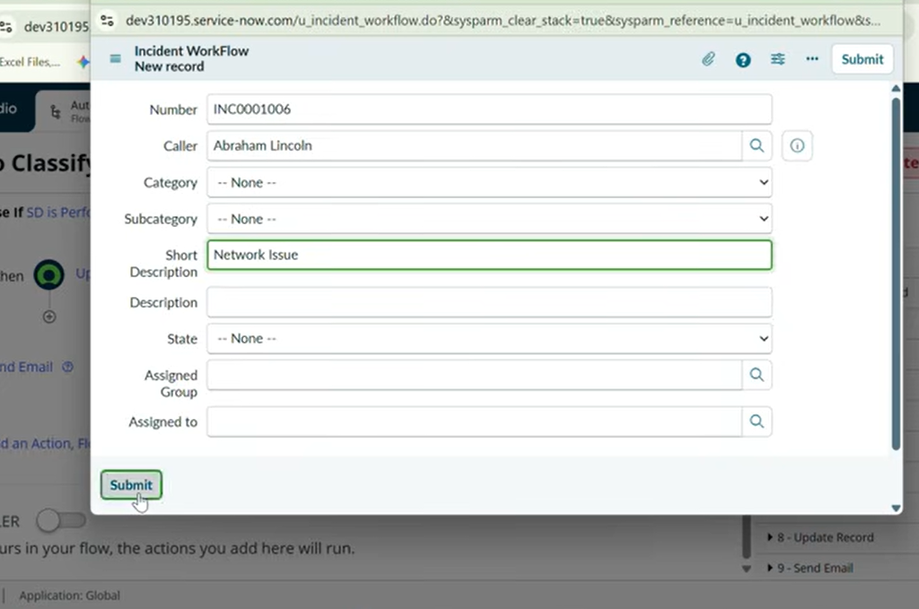

Milestone 5: Deployment & Conclusion
- Objective: Package the completed solution using ServiceNow Update Sets, perform export/migration readiness, and finalize project documentation.
- Key Deliverables & Actions:
  - Update Set Finalization: Located the active update set (Project Update Set), updated its state from In Progress to Complete, and saved the changes.
  - XML Export & Migration: Used the Export to XML option under Related Links to download the complete Update Set, enabling seamless transfer across instances or backup storage.

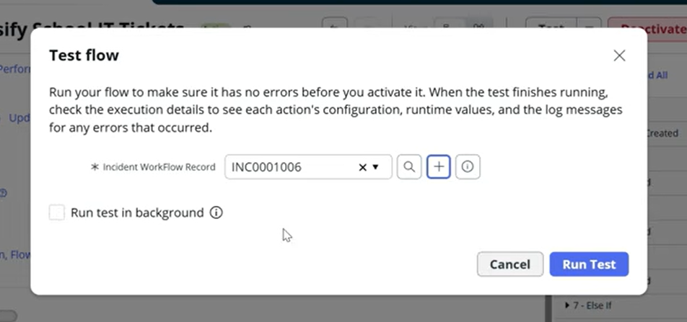

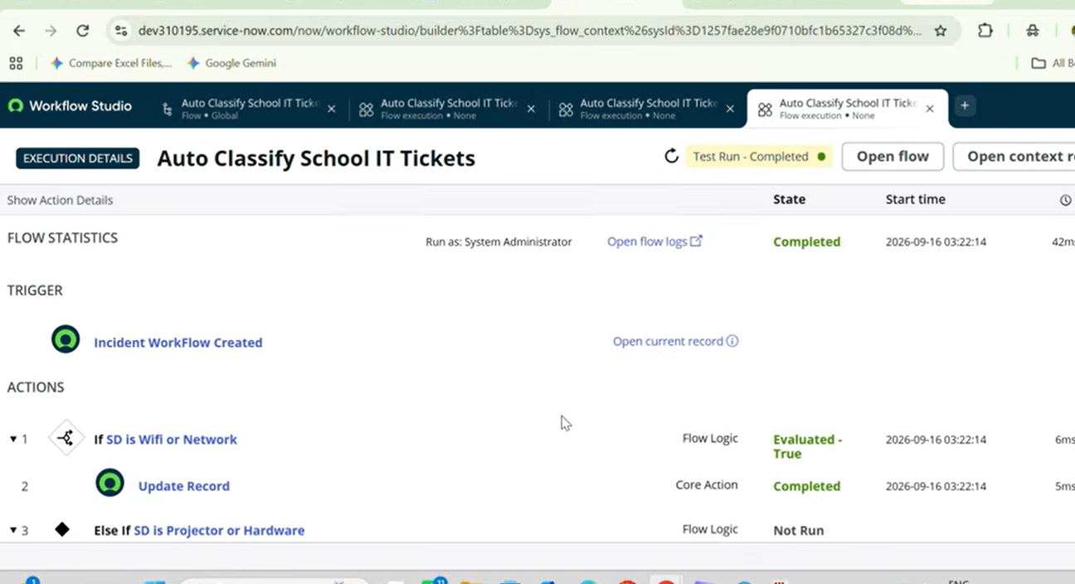

Project Conclusion:
Successfully delivered a no-code ServiceNow automation solution that eliminates manual classification overhead for school IT helpdesks, accelerates issue response times, and provides a scalable base for future enhancements (e.g., SLA tracking, automated assignment rules, or predictive intelligence).

